代码：

library(readxl)

library(forecast)

library(tseries)

file_path <- "文件存储路径"

data <- read_excel(file_path)

rain_ts <- ts(data$降水, start = 1951, frequency = 1)

plot(rain_ts, main = "重庆市年降水量", ylab = "降水量", xlab = "年份")

par(mfrow = c(2, 1))

acf(rain_ts, main = "自相关图 (ACF)")

pacf(rain_ts, main = "偏自相关图 (PACF)")

adf_test <- adf.test(rain_ts)

print(adf_test)

sarima_model <- auto.arima(rain_ts, seasonal = TRUE)

summary(sarima_model)

sarima_forecast <- forecast(sarima_model, h = 5)

plot(sarima_forecast, main = "SARIMA模型预测")

ets_model <- ets(rain_ts)

summary(ets_model)

ets_forecast <- forecast(ets_model, h = 5)

plot(ets_forecast, main = "ETS模型预测")

par(mfrow = c(2, 1))

plot(sarima_forecast, main = "SARIMA模型预测")

plot(ets_forecast, main = "ETS模型预测")

结果：

1. 绘制时间序列图

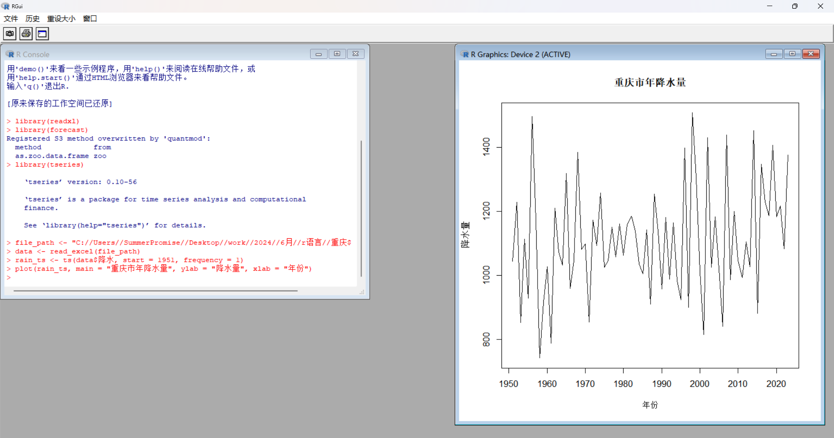



1. 绘制自相关图 (ACF) 和偏自相关图 (PACF)

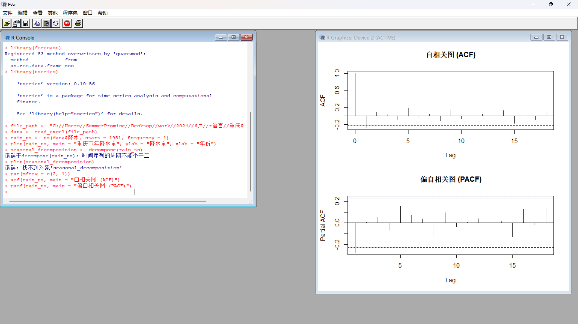

1. 验证平稳性：

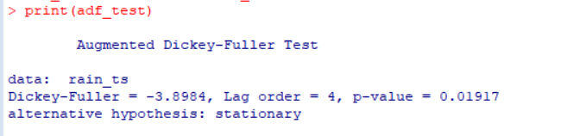

* **Dickey-Fuller 统计量**：-3.8984
* **滞后阶数 (Lag order)**：4
* **p-value**：0.01917

由于 p-value 为 0.01917，明显小于常用显著性水平（如 0.05），我们拒绝原假设。这意味着时间序列是平稳的。

4.比较两种模型预测

