# 网络安全实践课程实验报告

网络端口扫描系统

张一白

161320224

目录

网络安全实践课程实验报告 1

1. 实验要求 3

2. 实验环境 3

3. 系统设计与实现 3

4. 使用说明 5

5. 程序运行截图 5

6. 源代码 5

## 实验要求

采用socket，设计并实现一个网络扫描器，能够检查给定IP地址范围的主机端口状态。

## 实验环境

Darwin Summers-MBP.lan 15.5.0 Darwin Kernel Version 15.5.0: Tue Apr 19 18:36:36 PDT 2016; root:xnu-3248.50.21~8/RELEASE_X86_64 x86_64

Linux Ubuntu-Dev 4.4.0-24-generic #43-Ubuntu SMP Wed Jun 8 19:27:37 UTC 2016 x86_64 x86_64 x86_64 GNU/Linux

## 系统设计与实现

（重点流程图+说明）

采用TCP Connect方式多线程扫描，如果能与目标端口成功建立连接则目标端口开放。

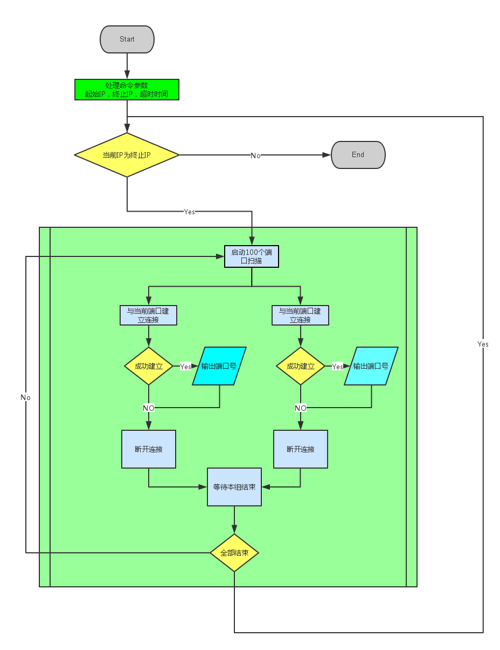

## 使用说明

编译：

clang main.c –o scanner –O2 -lpthread (Mac OS X/Linux/BSD with clang)

gcc main.c –o scanner –O2 –lpthread (Mac OS X/Linux/BSD with gcc)

运行:

Usage: ./scanner start_ip end_ip [options]

-t n

--timeout=n Set timeout to n, default: 2 (sec).

如 ./scanner 211.65.102.2 211.65.102.5 –t 1

## 程序运行截图

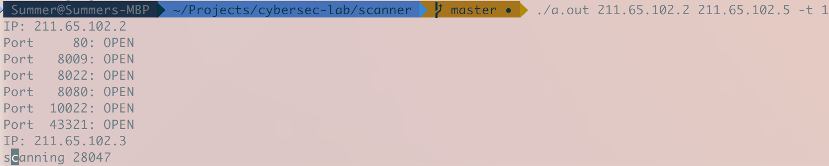



## 源代码

|  |
| --- |
| //  // main.c  // scanner  //  // Created by Summer on 6/9/16.  // Copyright © 2016 summer. All rights reserved.  //  #include <unistd.h>  #include <sys/types.h> // socket  #include <sys/socket.h> // socket  //#include <sys/ioctl.h> // ioctl  #include <sys/fcntl.h>  #include <net/if.h> // ifreq  #include <netinet/tcp.h> // tcp  #include <netinet/in.h> // tcp  #include <arpa/inet.h>  #include <string.h> // strcpy  #include <stdio.h> // printf  #include <errno.h>  #include <pthread.h>  int do_connect_scan(in_addr_t addr, int port);  void set_timeout(int sec);  int scan_ip(unsigned int ip);  int print_help(char *argv0);  void *connect_scan(void *args);  struct timeval tout;  typedef struct {  in_addr_t addr;  int tgt_port;  int result;  } scan_args;  int main(int argc, const char * argv[]) {  unsigned int start, end, i, j, k, timeout = 2;  if(argc < 3)  return print_help(argv[0]);  start = ntohl(inet_addr(argv[1]));  end = ntohl(inet_addr(argv[2]));  if (i == INADDR_NONE || j == INADDR_NONE)  return print_help(argv[0]);  else if(i>j)  return print_help(argv[0]);  for (i=3; i<argc; ++i)  {  if(strstr(argv[i], "-t") == argv[i])  if(i +1 < argc)  {  if(EOF == sscanf(argv[i + 1], "%d", &timeout))  return print_help(argv[0]);  }  else  return print_help(argv[0]);  else if(strstr(argv[i], "--timeout="))  if(EOF == sscanf(argv[i], "--timeout=%d", &timeout))  return print_help(argv[0]);  }  set_timeout(timeout);  for(k = start; k <= end; ++k)  {  scan_ip(htonl(k));  }  return 0;  }  int scan_ip(in_addr_t addr)  {  int i, j;  scan_args args_list[100];  pthread_t pth_list[100];  struct in_addr i_addr;  i_addr.s_addr = addr;  printf("IP: %s \n", inet_ntoa(i_addr));  for(i=0; i<600; ++i)  {  for(j = 0; j<100; ++j)  {  args_list[j].addr = addr;  args_list[j].tgt_port = i * 100 + (j + 1);  printf("scanning %d\r",args_list[j].tgt_port);  fflush(stdin);  pthread_create(pth_list + j, NULL, connect_scan, args_list + j);  }  for(j = 0; j<100; ++j)  {  pthread_join(pth_list[j], NULL);  if(args_list[j].result)  printf("\rPort%7d: OPEN\n", args_list[j].tgt_port);  }  }  return 0;  }  int print_help(char *argv0)  {  printf("Usage: %s start_ip end_ip [options]\n", argv0);  printf("\t-t n\n");  printf("\t--timeout=n\t\t Set timeout to n, default: 2.\n");  return 0;  }  void *connect_scan(void *args)  {  scan_args *p = (scan_args *) args;  p->result = do_connect_scan(p->addr, p->tgt_port);  //printf("%d ", p->tgt_port);  return NULL;  }  void set_timeout(int sec)  {  tout.tv_sec = sec;  tout.tv_usec = 0;  }  int do_connect_scan(in_addr_t addr, int port)  {  int fd, res, valopt, retflag = 1;  long arg;  unsigned int temp;  fd_set set;  struct sockaddr_in tgt_addr;  fd = socket(AF_INET, SOCK_STREAM, IPPROTO_TCP);  tgt_addr.sin_addr.s_addr = addr;  tgt_addr.sin_family = AF_INET;  tgt_addr.sin_port = htons(port);    arg = fcntl(fd, F_GETFL, NULL);  arg |= O_NONBLOCK;  fcntl(fd, F_SETFL, arg);    // Trying to connect with timeout  res = connect(fd, (struct sockaddr *)&tgt_addr, sizeof(tgt_addr));  if (res < 0) {  if (errno == EINPROGRESS) {  //fprintf(stderr, "EINPROGRESS in connect() - selecting\n");  while (1)  {  FD_ZERO(&set);  FD_SET(fd, &set);  res = select(fd + 1, NULL, &set, NULL, &tout);  if (res < 0 && errno != EINTR)  {  //fprintf(stderr, "Error connecting %d - %s\n", errno, strerror(errno));  retflag = 0;  goto ret;  }  else if (res > 0)  {  // Socket selected for write  temp = sizeof(int);  if (getsockopt(fd, SOL_SOCKET, SO_ERROR, (void*)(&valopt), &temp) < 0)  {  //fprintf(stderr, "Error in getsockopt() %d - %s\n", errno, strerror(errno));  retflag = 0;  goto ret;  }  // Check the value returned...  if (valopt)  {  //fprintf(stderr, "Error in delayed connection() %d - %s\n", valopt, strerror(valopt));  retflag = 0;  goto ret;  }  break;  }  else  {  //fprintf(stderr, "Timeout in select() - Cancelling!\n");  retflag = 0;  goto ret;  }  }  }  else  {  //fprintf(stderr, "Error connecting %d - %s\n", errno, strerror(errno));  retflag = 0;  goto ret;  }  }  ret:  close(fd);  return retflag;  } |