# Mall wifi

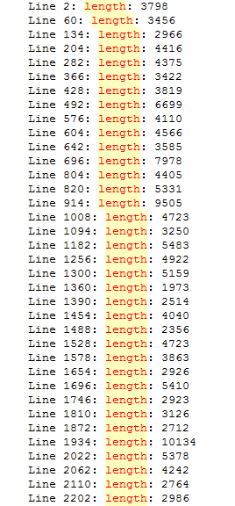

Mall shop

Line 2: shoplength: 71

Line 4: shoplength: 132

Line 6: shoplength: 114

Line 8: shoplength: 104

Line 10: shoplength: 73

Line 12: shoplength: 88

Line 14: shoplength: 109

Line 16: shoplength: 70

Line 18: shoplength: 94

Line 20: shoplength: 89

Line 22: shoplength: 76

Line 24: shoplength: 86

Line 26: shoplength: 104

Line 28: shoplength: 93

Line 30: shoplength: 81

Line 32: shoplength: 53

Line 34: shoplength: 80

Line 36: shoplength: 75

Line 38: shoplength: 76

Line 40: shoplength: 62

Line 42: shoplength: 76

Line 44: shoplength: 86

Line 46: shoplength: 68

Line 48: shoplength: 72

Line 50: shoplength: 76

Line 52: shoplength: 78

Line 54: shoplength: 59

Line 56: shoplength: 92

Line 58: shoplength: 93

Line 60: shoplength: 137

Line 62: shoplength: 128

Line 64: shoplength: 113

Line 66: shoplength: 87

Line 68: shoplength: 83

Line 70: shoplength: 89

Line 72: shoplength: 78

Line 74: shoplength: 68

Line 76: shoplength: 124

Line 78: shoplength: 220

Line 80: shoplength: 122

Line 82: shoplength: 108

Line 84: shoplength: 90

Line 86: shoplength: 73

Line 88: shoplength: 85

Line 90: shoplength: 62

Line 92: shoplength: 74

Line 94: shoplength: 97

Line 96: shoplength: 78

Line 98: shoplength: 90

Line 100: shoplength: 46

Line 102: shoplength: 71

Line 104: shoplength: 79

Line 106: shoplength: 79

Line 108: shoplength: 93

Line 110: shoplength: 94

Line 112: shoplength: 80

Line 114: shoplength: 80

Line 116: shoplength: 61

Line 118: shoplength: 83

Line 120: shoplength: 81

Line 122: shoplength: 67

Line 124: shoplength: 120

Line 126: shoplength: 75

Line 128: shoplength: 125

Line 130: shoplength: 96

Line 132: shoplength: 69

Line 134: shoplength: 71

Line 136: shoplength: 118

Line 138: shoplength: 83

Line 140: shoplength: 68

Line 142: shoplength: 58

Line 144: shoplength: 92

Line 146: shoplength: 89

Line 148: shoplength: 87

Line 150: shoplength: 123

Line 152: shoplength: 79

Line 154: shoplength: 69

Line 156: shoplength: 80

Line 158: shoplength: 74

Line 160: shoplength: 109

Line 162: shoplength: 66

Line 164: shoplength: 76

Line 166: shoplength: 95

Line 168: shoplength: 99

Line 170: shoplength: 79

Line 172: shoplength: 125

Line 174: shoplength: 58

Line 176: shoplength: 94

Line 178: shoplength: 91

Line 180: shoplength: 89

Line 182: shoplength: 74

Line 184: shoplength: 96

Line 186: shoplength: 78

Line 188: shoplength: 72

Line 190: shoplength: 77

Line 192: shoplength: 82

Line 194: shoplength: 91

,如果我们能够通过分析找出真正 对位置判断有效的数据分量,就可以明显提高定位系统的精度.为此,本文提出了一种基于主成分分析的指纹定 位模型,通过主成分分析技术,找到不同环境条件下影响定位精度的主要分量,提高指纹的可区分度,进而提高 指纹定位的精度.同时,主成分分析也能够对指纹向量进行降维处理,提升指纹定位算法的处理效率.主成分分 析方法是从数据源优化的角度来提高定位精度,因此可以应用于大部分的指纹算法以提高精度

1. 记录含有多个相同的bssid:13019条

RSS随时间变化，而且有时变化得很显著。不过在五分钟内RSS的变化基本不会超过20dB

同一个商店bssid很多，有部分只出现一次，能否删除，

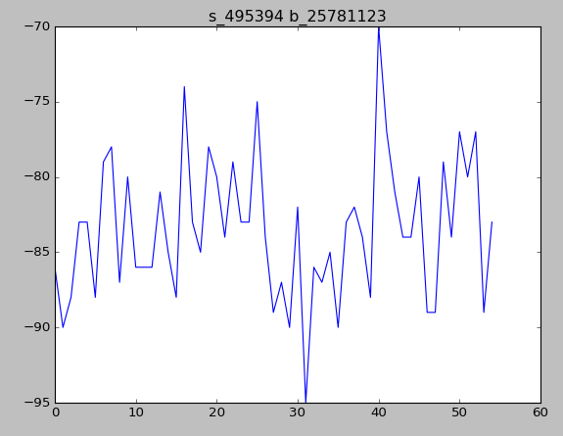

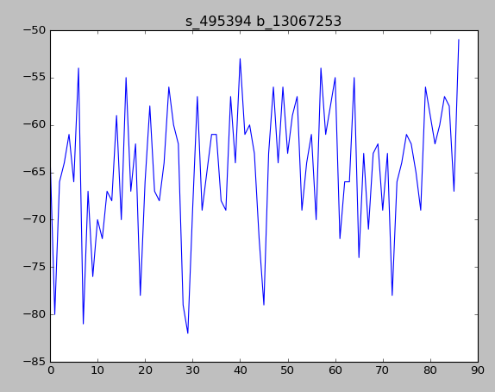

Shop_id的信息看成一篇文档，bssid看成词，（关键词提取）测试集给出词，来判断该文本属于哪一类



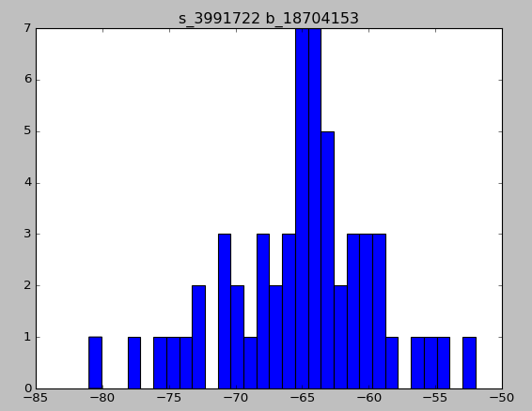

Linux统计文件个数

ls -l |grep "^-"|wc -l

0.944

Train_data:

user_id,shop_id,time_stamp,longitude,latitude,wifi_infos

Test_data

row_id,user_id,mall_id,time_stamp,longitude,latitude,wifi_infos

-20

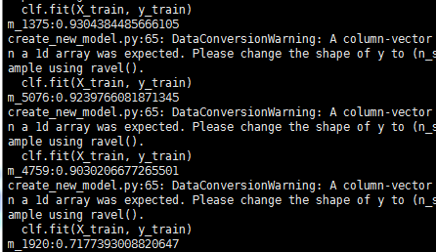

-10

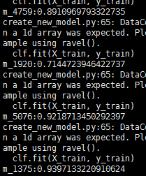



Libgbm,fm,ffm

0.8782 -15，-100为默认值，没有去除缺失值（没选到bssid）样本 rf_change_label_100

0.84，0为默认值

将时间因素考虑进去

周六和周日单独建模？

时间越近，建模越好？

显然，基于bagging的随机森林模型和基于boosting的Gradient Tree Boosting模型有着不少共同的参数。随机森林的子模型需要拥有较低的偏差，整体模型的训练过程旨在降低方差，记得上面说到，有两种方式，第一增加模型数量，第二减少模型之间的相关度，因此，n_estimators默认值为10 ， 且子模型不是弱模型(max_depth默认值设置为None，也就是说树的深度足够深)，同时，降低子模型的相关度(max_features设置为总特征数的开方)；另一方面，GradientTreeBoosting的子模型都是有着较低的方差，整个模型的目的是为了降低偏差，因此，需要较多的子模型(n_estimators)且子模型为弱模型(max_depth默认为3)，但是降低子模型之间的相关度并不会显著减少整体模型的方差(max_features设置为None)

0.879 rf estimator 50

0.8806,增加连接的bssid

加入扫描数特征预测很奇怪

0.881左右融合特征 取前三与特征选择20的交集

变为100个估算器 0.8829

加了经纬度0.884左右

0.8829换了连接的bssid

不加前三0.8824

换了连接的bssid,加了经纬度前五位

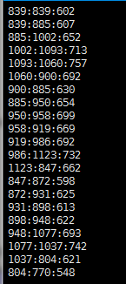

每一天和前一天的重合

经纬5位150estimator 0.8944

50 estimator 0.8918

中位数 0.8914

修改强度距离计算 0.89498

按距离找特征