**Project Based Learning Report**

on

Configuring a Cisco Router as a DHCP Server

Submitted in the partial fulfillment of the requirements

For the Project based learning in “**Computer Communication Networks**”

in

Electronics & Communication Engineering

By

**PRN NAME**

2114110480 Manisha Kumari

2114110481 Summi Kumari

2214110606 Arpita Shree

Under the guidance of Course In-charge

**Prof. Harshada Mhetre**

Department of Electronics & Communication Engineering

Bharati Vidyapeeth

(Deemed to be University)

College of Engineering,

Pune – 411043

**Academic Year: 2023-24**

**Bharati Vidyapeeth**

**(Deemed to be University)**

**College of Engineering,**

**Pune – 411043**

**DEPARTMENT OF ELECTRONICS & COMMUNICATION ENGINEERING**

**CERTIFICATE**

Certified that the Project Based Learning report entitled, “Configuring a Cisco Router as a DHCP Server ”. Is work done by

**PRN NAME**

2114110480 Manisha Kumari

2114110481 Summi Kumari

2214110606 Arpita Shree

in partial fulfillment of the requirements for the award of credits for Project Based Learning (PBL) in “**Computer Communication Networks**” of Bachelor of Technology Semester VI, in Electronics and Communication.

**Date:**

**Prof. Harshada Mhetre Dr. Arundhati A. Shinde**

**Course In-charge Professor & Head**

**INDEX: -**

|  |  |  |
| --- | --- | --- |
| **SR.No.** | **Title** | **Page No.** |
| 1. | Problem Statement with Solution | 2 |
| 2. | Description about Project | 3 |
| 3. | Advantage & Disadvantage | 4 |
| 4. | Applications | 5 |
| 5. | Introduction to CISCO PACKET TRACER | 6 |
| 6. | Flowchart | 7 |
| 7. | Algorithm | 8 |
| 8. | DHCP Server Realtime & Simulation | 9-10 |
| 9. | Course Outcome & Conclusion | 11 |
| 10. | References & Github-Link | 11 |

**Problem Statement: -**

**Configuring a Cisco Router as a DHCP Server**

We have been tasked with configuring a Cisco router as a DHCP server for a small office network. The network consists of multiple devices, including computers, printers, and VoIP phones. The router serves as the gateway to the internet and will now also handle DHCP leases to dynamically assign IP addresses to devices on the network.

**Solution:-**

Requirements:

Configure the Cisco router to act as a DHCP server.

Define a pool of IP addresses to be assigned dynamically to devices on the network.

Ensure that the DHCP server provides IP addresses, subnet mask, default gateway, DNS server addresses, and any other necessary network parameters.

Set appropriate lease durations for IP addresses.

Ensure that DHCP requests from different VLANs or subnets are handled correctly if the network is segmented.

Verify that DHCP is functioning correctly by testing IP address assignment on various device

**DESCRIBTION ABOUT PROJECT: -**

The project objective revolves around configuring a Cisco router to fulfill the role of a DHCP server within the confines of a small office network. This endeavor encompasses several key tasks aimed at streamlining network management and facilitating seamless connectivity for devices. Firstly, the configuration entails defining a DHCP pool, delineating specific IP address ranges, subnet masks, and lease durations to govern the dynamic allocation of IP addresses to connected devices. Furthermore, crucial network parameters such as default gateway and DNS server addresses are configured within the DHCP pool to ensure comprehensive network accessibility. Additionally, considerations are made to accommodate potential network segmentation, ensuring DHCP requests are appropriately handled across different VLANs or subnets. Security measures, including the implementation of DHCP snooping, may also be incorporated to safeguard against unauthorized DHCP servers. Following the configuration process, rigorous testing is conducted to verify the functionality of the DHCP setup, ensuring that devices seamlessly obtain IP addresses from the designated DHCP server. Comprehensive documentation of the configuration settings and any troubleshooting undertaken serves as a valuable resource for future maintenance and reference.

* Configure the Cisco router to operate as a DHCP server.
* Define a DHCP pool specifying IP address ranges, subnet masks, and lease durations.
* Set default gateway and DNS server addresses within the DHCP pool.
* Ensure compatibility and proper handling of DHCP requests across different VLANs or subnets.
* Implement security measures such as DHCP snooping to prevent unauthorized DHCP servers.
* Verify DHCP functionality through rigorous testing on various devices.
* Document configuration settings and troubleshooting steps for future reference and maintenance.

**Advantage:-**

1. **Simplified Network Management:** Using a Cisco router as a DHCP server simplifies network management by automating the assignment of IP addresses to devices. This eliminates the need for manual configuration of IP addresses on each device, reducing administrative overhead.
2. **Dynamic IP Address Allocation:** DHCP allows for dynamic allocation of IP addresses, ensuring efficient utilization of available IP addresses within the network. Devices can obtain IP addresses automatically when connected to the network, streamlining the onboarding process for new devices.
3. **Centralized Control**: Configuring the Cisco router as a DHCP server provides centralized control over IP address assignment and configuration parameters. Administrators can define DHCP pools and set lease durations, default gateway settings, DNS server addresses, and other parameters from a single point of control.
4. **Scalability:** DHCP is scalable and can accommodate networks of varying sizes. As the network expands or contracts, administrators can easily adjust DHCP configurations to meet changing requirements without significant manual intervention.

**Disadvantages:-**

1. **Single Point of Failure:** Relying on a single Cisco router as the DHCP server creates a single point of failure. If the router experiences issues or goes offline, devices may be unable to obtain IP addresses, resulting in network connectivity issues.
2. **Limited Feature Set:** While Cisco routers offer basic DHCP functionality, they may lack advanced features available in dedicated DHCP server solutions. Advanced DHCP features such as DHCP failover, DHCP reservations, and granular access control may be limited or unavailable on Cisco routers.
3. **Security Concerns:** DHCP spoofing and rogue DHCP server attacks are potential security concerns when using a Cisco router as a DHCP server. Without proper security measures such as DHCP snooping, unauthorized DHCP servers could distribute incorrect network configuration parameters, leading to network disruptions or security breaches.

**Applications:-**

1. Small to Medium-sized Networks: Configuring a Cisco router as a DHCP server is well-suited for small to medium-sized networks where simplicity and cost-effectiveness are paramount. It provides an easy-to-implement solution for automating IP address assignment without the need for additional hardware or software.
2. Branch Offices: In branch office environments with limited IT resources, using a Cisco router as a DHCP server can streamline network management by consolidating DHCP services onto existing network infrastructure. This simplifies deployment and maintenance while ensuring consistent network configurations across multiple locations.
3. Temporary or Ad-hoc Networks: Cisco routers can be deployed as DHCP servers in temporary or ad-hoc network setups, such as conferences, events, or temporary workspaces. They provide a quick and efficient way to allocate IP addresses to transient devices without requiring dedicated DHCP server hardware.
4. Remote Access Networks: For remote access networks where connectivity to centralized DHCP servers may be unreliable or impractical, configuring a Cisco router as a DHCP server locally at the remote site can ensure reliable IP address assignment for connected devices, enhancing network availability and accessibility.
5. Edge Networking Environments: In edge networking environments where devices are connected directly to the internet or where there's a need for localized network services, configuring a Cisco router as a DHCP server can be advantageous. This setup enables efficient IP address assignment and network configuration for edge devices such as IoT devices, sensors, or point-of-sale terminals, without the need for additional infrastructure.
6. Remote or Mobile Workforce Support: Configuring a Cisco router as a DHCP server can be beneficial for supporting remote or mobile workforces. In scenarios where employees frequently move between different locations or connect from remote sites, having DHCP services available on Cisco routers at those sites ensures consistent and automatic IP address assignment, simplifying network connectivity for remote workers. This approach reduces reliance on central DHCP servers and enhances flexibility for employees working from various locations.

**Introduction to CISCO PACKET TRACER:**

Cisco Packet Tracer is a network simulation tool developed by Cisco Systems that allows users to design, configure, and troubleshoot network infrastructures in a virtual environment. It is widely used by students, educators, and network professionals for learning, teaching, and practicing networking concepts and scenarios.

Key Features:

* Network Simulation: Packet Tracer provides a simulated environment where users can create and configure networks consisting of routers, switches, PCs, servers, and other networking devices. This allows users to design and experiment with various network topologies without the need for physical hardware.
* Device Emulation: The software emulates Cisco networking devices, including routers, switches, and access points, with support for a wide range of Cisco IOS software features and commands. Users can configure these virtual devices to replicate real-world networking scenarios.
* Protocols and Technologies: Packet Tracer supports a variety of networking protocols and technologies, including TCP/IP, IPv6, VLANs, DHCP, NAT, OSPF, EIGRP, and more. Users can practice implementing and troubleshooting these protocols in a safe and controlled environment.
* Visualization Tools: The software offers visualization tools such as the Packet Tracer Activity Wizard, which guides users through interactive network simulations. Users can view real-time network traffic, device status, and packet flows to gain insights into network behavior.
* Educational Resources: Packet Tracer includes a comprehensive library of networking devices, protocols, and pre-built network topologies, making it an invaluable tool for educational purposes. Cisco Networking Academy provides a wealth of instructional materials, tutorials, and labs to support learning with Packet Tracer.

**FLOWCHART:-**

Start

Access Cisco Router CLI

Enter global configuration mode

Define DHCP Pool

End

Test DHCP functionality

Save configuration changes

Verify DHCP configuration

Set lease duration

Specify IP address range, subnet mask, default gateway, and DNS server addresses

**Algorithm:-**

* Access the Cisco router's Command-Line Interface (CLI) to initiate the configuration process.
* Enter global configuration mode to make changes to the router's configuration settings.
* Define a DHCP pool using the "ip dhcp pool" command, specifying a unique name for identification.
* Within the DHCP pool configuration, specify the IP address range, subnet mask, default gateway, and DNS server addresses that will be assigned to DHCP clients.
* Optionally, set the lease duration for IP addresses within the DHCP pool using the "lease" command to determine how long IP addresses are leased to devices.
* Verify the DHCP configuration to ensure correctness and proper implementation using show commands such as "show running-config" or "show ip dhcp pool".
* Save the configuration changes to the router's non-volatile memory using the "write memory" or "copy running-config startup-config" command to preserve settings across reboots.
* Test the DHCP functionality by connecting devices to the network and verifying that they receive IP addresses from the configured DHCP pool, ensuring successful configuration and operation**.**

**DHCP Server:-**

**Realtime:-**

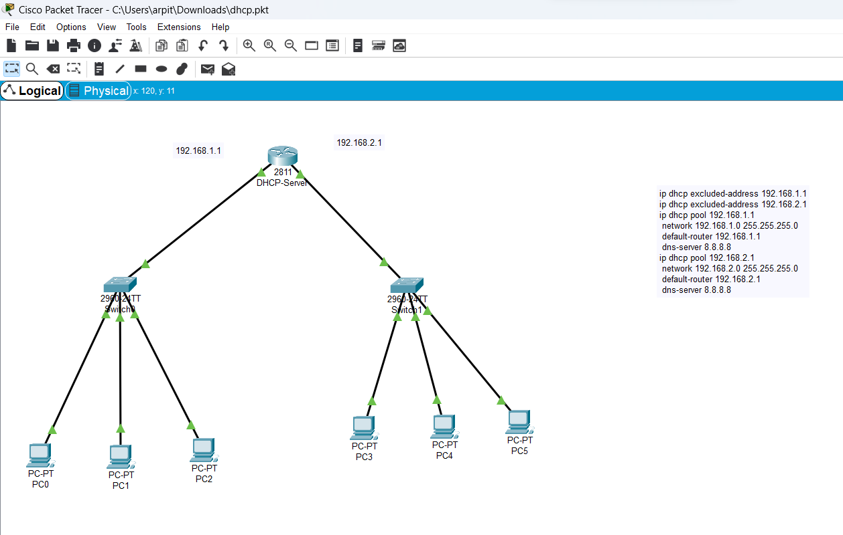

**Simulation:-**

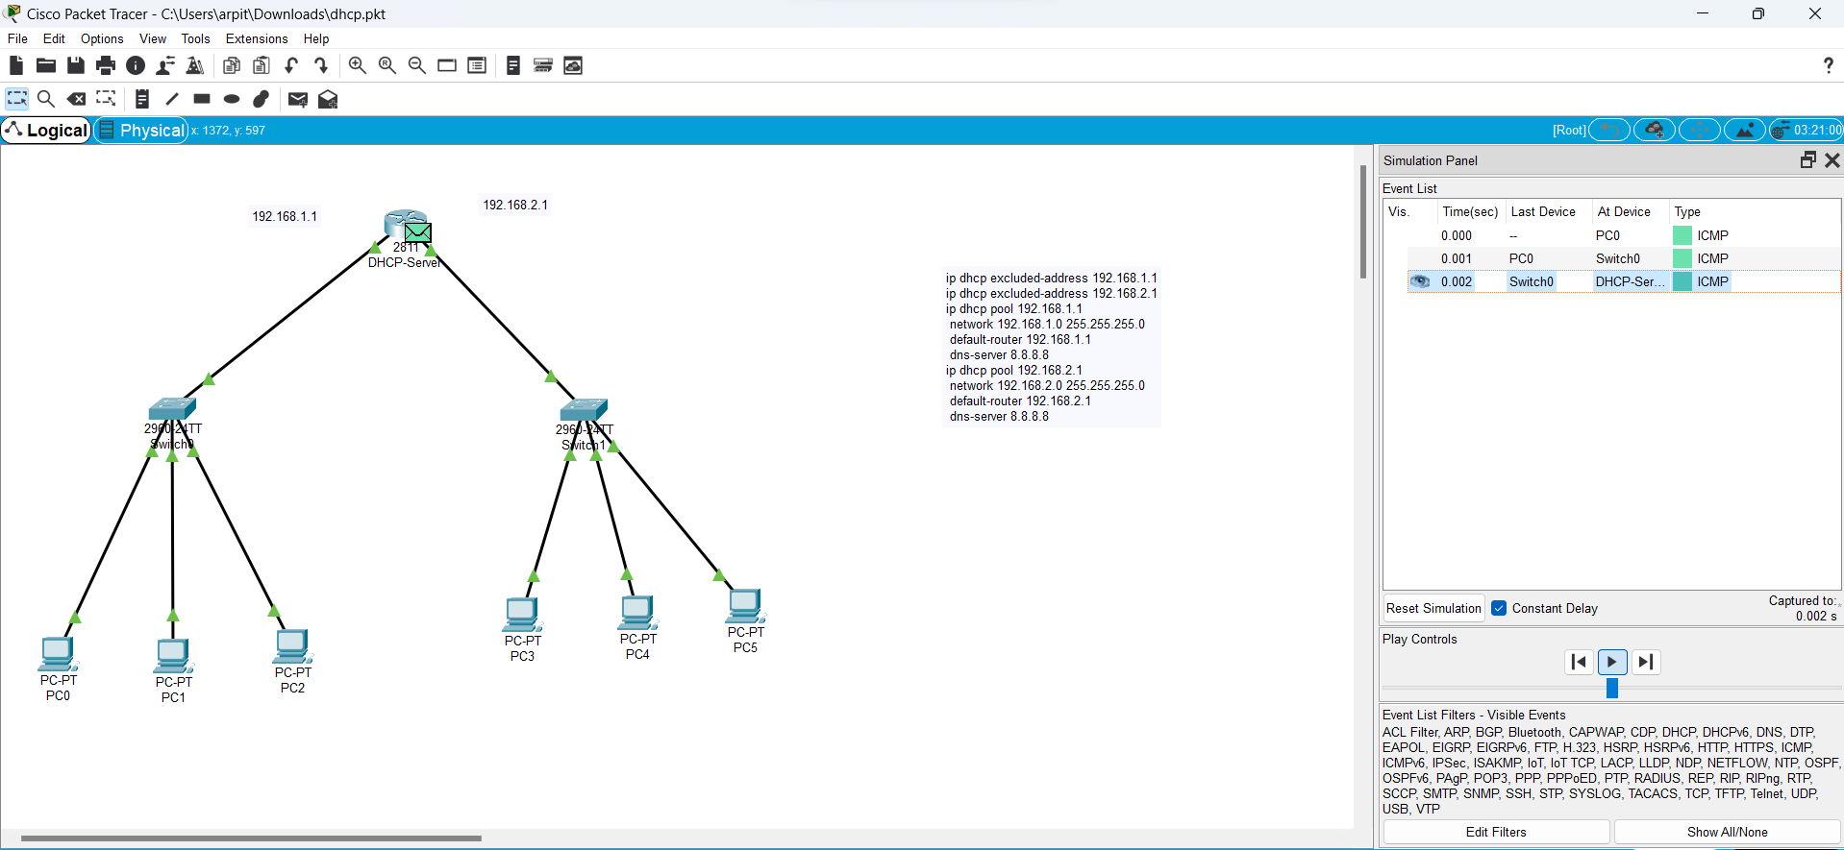

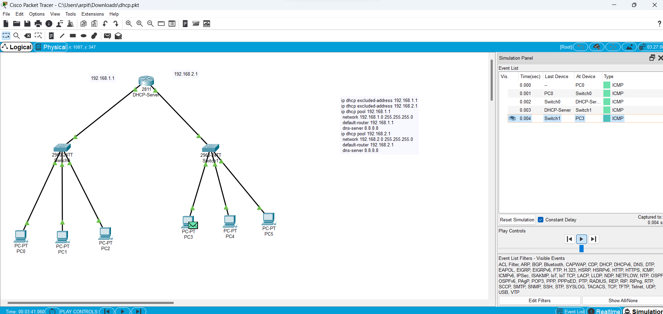

**COURSE OUTCOME:-**

**CO4 :** To interpret the various routing techniques.

Hence through this PBL **CO4** is Satisfied.

**CONCLUSION:-**

In this PBL, configuring a Cisco router as a DHCP server is a fundamental aspect of network administration, offering numerous benefits such as simplified network management, dynamic IP address allocation, and centralized control over network configurations. By following the outlined steps, network administrators can effectively set up DHCP services on Cisco routers, providing automatic IP address assignment to connected devices while ensuring proper configuration of default gateway, DNS server addresses, and lease durations. Additionally, verifying the DHCP configuration and conducting thorough testing are essential steps to ensure the reliability and functionality of the DHCP server. Overall, the process enables efficient network operations, enhances scalability, and supports seamless connectivity for devices within the network.

**References:-**

**https://www.geeksforgeeks.org/how-to-configure-dhcp-server-on-a-cisco-router/**

**https://www.networkstraining.com/cisco-dhcp-configuration/**