Professional Development Policy

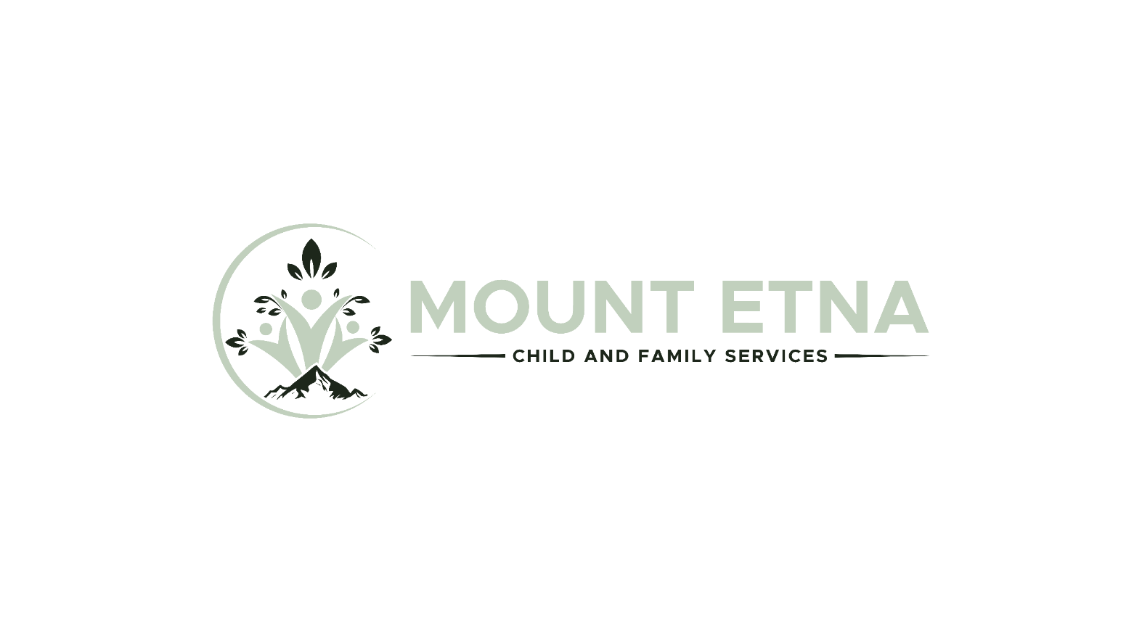

SUMMARY
Mount Etna Child & Family Services (the “Business”) supports employees who want to pursue further education or training for their professional development. The Professional Development Policy (the “Policy”) sets out requirements for reimbursement of professional development courses, programs, or activities undertaken by employees.

SCOPE
This Policy applies to all employees of the Business who have completed their probationary period.

POLICY STATEMENT
The Business has established the following rules around reimbursement of professional development activities:

• Courses, programs, or activities must be relevant to an employee’s role and beneficial to the Business.
• The Policy does not cover personal development; training or development that does not support job-related skills or job-related effectiveness are not reimbursed.
• Employees must seek approval from the Business before beginning a course, program, or activity for which they expect to receive reimbursement.
• Approval will be at the Business’s discretion, taking into account the relevancy to the employee’s role, the benefit to the Business, and budget availability.
• Employees may be required to demonstrate proof of attendance or completion of a course, program, or activity.
• All professional development efforts should respect cost and time limitations, as well as individual and business needs.
• The Business will not reimburse expenses for repeated courses, programs, or activities due to unsuccessful attempts.
• The Business has the right to perform an evaluation at any time during the course, program, or activity to ensure quality and obtain useful information for future applicants.

TERMINATION OF EMPLOYMENT
If an employee’s employment is terminated for any reason whatsoever, whether occasioned by the employee or by the Business for cause or without cause, the employee must refund the Business the costs covered by the Business under this Policy, as follows:

When Termination Occurs | Refund
Less than 12 months after completion of course, program, or activity | 100%
More than 12 months but less than 24 months after completion of course, program, or activity | 50%

REVIEW OF THE POLICY
This Policy will be reviewed and may be amended from time to time based on the needs and experiences of the Business.

ACKNOWLEDGEMENT & AGREEMENT

I acknowledge that I have read, understand, and agree to abide by the Professional Development Policy.

SIGNATURE:
Employee
NAME:
Print
DATE:

