Right to Disconnect Policy

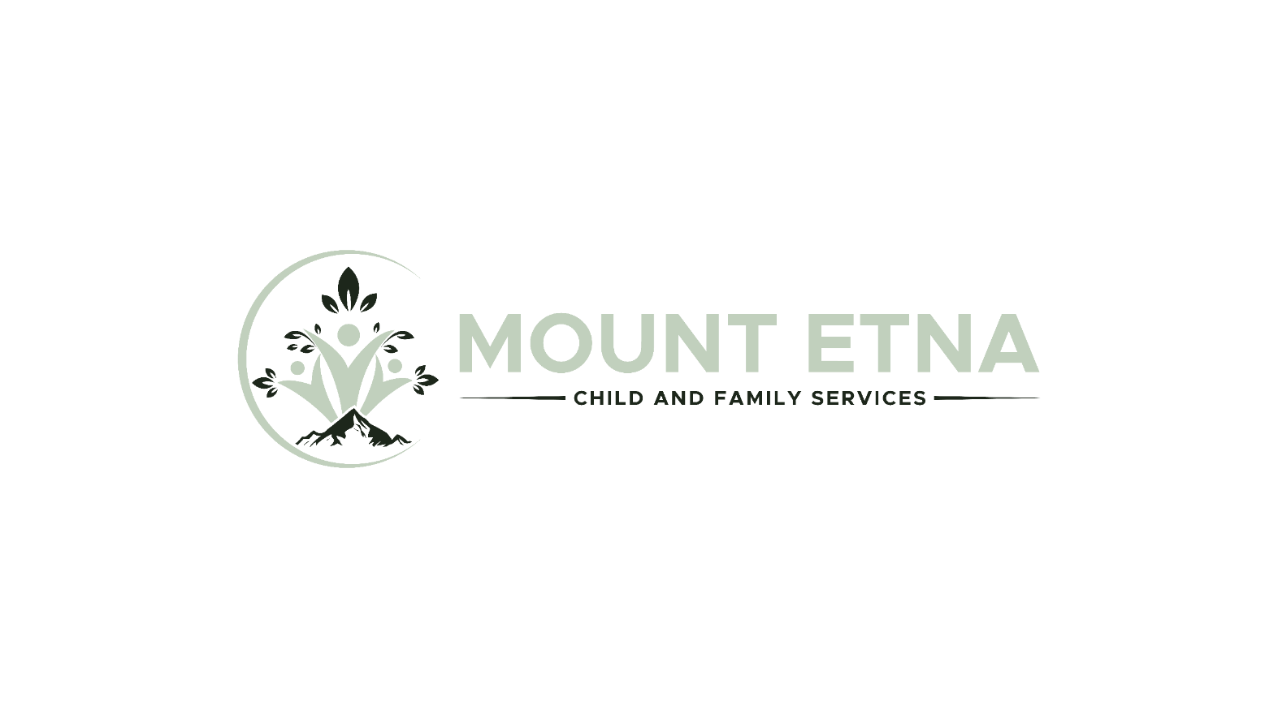

SUMMARY

Mount Etna Child & Family Services is committed to the health and wellbeing of our employees. It is of the utmost importance to the Business and we encourage and support our employees to prioritize their own wellbeing.

The company recognizes that our employees have the right to, and should, disconnect from work outside of their normal working hours unless there is an agreement to do so (for example while “on-call”).

APPLICATION AND SCOPE

This Policy is made pursuant to the requirements of the Working for Workers Act, 2021. This Policy will be reviewed and updated on an annual basis or as necessary to account for legislative changes.
For purpose of this Policy and as per the Employment Standards Act, 2000 (“ESA”), “disconnecting from work” is defined as follows:
• “not engaging in work-related communications, including emails, telephone calls, video calls or the sending or reviewing of other messages, so as to be free from the performance of work”

Employees must receive and sign off on this policy within 30 days from their date of hire.

EMPLOYMENT STANDARDS

The Business is committed to ensuring that its employment practices are in compliance with the ESA, the Ontario Human Rights Code (the “Code”) and other applicable employment-related legislation.

EMPLOYER AND EMPLOYEE OBLIGATIONS

Management must ensure that employees are able to disconnect from work outside of normal working hours. Should an employee have concerns surrounding their working time or is unable to disconnect from work, it is important that this is brought to the attention of management in order to resolve any concerns.
Management should be mindful of the time in which emails are being sent. Should management notice that a member of their team is sending emails during non-working hours or are logging in excessively, they should speak to the employee as soon as possible, as this may indicate they are finding it difficult to manage their workload during normal working hours.

COMMUNICATIONS

Employees have the right to disconnect from work outside normal working hours. Emails should be checked and/or sent only during normal working hours, whilst also appreciating that where work patterns differ, some employees may send communications at a time which is inconvenient to another i.e., where one employee works during the weekend, and another does not. Where this is the case, the sender should give consideration to the timing of their communication and understand that the recipient will not be expected to respond until their return to work.
Where a manager sends communications outside normal working hours, employees should not feel the need to respond to said communications until their return to work.

AUTOMATIC REPLIES

All employees are required to activate an automatic response when taking vacation or a leave of absence. The response should advise the sender that you are unavailable, including the start and end date of the period of vacation or leave of absence and that you will respond to their email on your return or contact details for the employee filling in should be provided in the automatic response.

In addition to the above, management will notify you should you be required to activate an automatic response at the end of your normal working day, which will simply advise the sender of your normal working hours and that you will respond to their email on your return to work.

MEETING

All employees should be mindful of the time of those whom they are inviting to attend a meeting, ensuring those invited play an active role and have something to contribute to the matters being discussed. Meetings, either virtual or in person, should only be scheduled within the attending employees’ working hours.

ELECTRONIC DEVICES

Some employees may be provided with handheld devices such as a mobile phone, laptop, tablet etc. These devices are provided to employees to allow flexibility in how such employees complete their work. This does not imply that the employee makes themselves available for work at all times.

EMPLOYEE WELLBEING

As previously mentioned, the health and wellbeing of our employees is of great importance to us, and we strongly encourage our employees to adapt, if needed, and maintain a good work-life balance.
The Business encourages all employees, including those who work remotely or work a flexible arrangement, to book in time with family/friends, engage in an activity after their normal working day, mute their work email accounts after working hours have ended and store their work-related electronic devices in a secure place when outside of working hours in order to allow themselves to switch off and properly disconnect from work.
In addition, it is important that those undertaking a flexible working arrangement or remote working disconnect themselves from work, monitor their working hours and remember to take their breaks as this is also important for their own wellbeing.
REVIEW OF THE POLICY

This Policy will be reviewed and may be amended from time to time based on the needs and experiences of the Business.

ACKNOWLEDGEMENT & AGREEMENT

I acknowledge that I have read, understand and agree to abide by the Right to Disconnect Policy.

SIGNATURE:
Employee
NAME:
Print
DATE:

