Back Drill Procedure

**CAM**

* Rename back drill layer as per customer supplied fabrication information.
* Back drill layer name in Genesis => bdrill_X-X (Ex: 8-Layer, bdrill_1-5)
* Please set drill span to the end layer as per Back drill layer name in Genesis.
* If back drill top to top OR bot to bot, then set back drill span from Top Layer to Top Layer OR Bot Layer to Bot Layer in Genesis matrix and name of back drill layer should use Outer layer to next inner layer in CAM.

For example: 12 Layer job, Do not cut layer: Layer 11, back drill name should be bdill_12-11. Set drill span from Layer 12 to Layer 12 in matrix.

* If back drill size information is not provided in print,
  + Use back drill size 9mil larger than Via drill bit size (Minimum 8 mil larger than via drill bit size). Ex: For 10 mil drill size via, Back drill size=19 mil nominal & 18 mil minimum.
  + via drill + 4 mil= Copper pad sizeàCopper pad + 5 mil= Back drill size.
* Back Drill to copper => Use same parameter of NPTH to copper.
* If the back drill hole to copper clearance is 5mil to 7mil on inner layers => Use vision back drill.
* If the copper pads are missing on via hole of back drill location=> Provide 2mil copper annular ring on outer layer.
* Copper pads must be smaller than back drill holes.
* If Back drill holes are required to be epoxy filled (Special process), then remove copper pads from outer layer from that location.

**FYI: No maximum/minimum limits for back drill size.**

**PANEL & ET**

* Check for back drill layer name from Top layer to Top layer or Bottom layer to Bottom Layer, if this type of back drill layer required then after Panelization at the time of drill output extend drill span to next inner layer to output drill program.
* For example: 12 Layer job, back drill 12-11à Name back drill as bdrill_12-11 and set drill span from Layer 12 to Layer 12 in matrix. At the time of drill output changed drill span to Layer 12 to Layer 11.
* Need to change drill span back to original condition before ET output, Top to top & Bot to bot in Gensis matrix

**AB-CPN & IPC-2221**

* Use back drill size same as used in PCB step.
* Remove copper from all layers (except DNC layer and outer layers)
* If copper pad/GND is not found on DNC layer, add copper pad/GND on back drill section manually.
* If via fill required for back drill hole location, add via hole on back drill section same as PCB step.
* AB-CPN and IPC-2221 coupons should match PCB step data.

**FYI: Leave back drill hole as plated on coupons section & non-plated on PCB step.**

**ARKEO**

* Add back drill structure in Arkeo stack.
* Set back drill span name per DNC (Do not cut) layer.
* Add stub value as specified in supplied data.
* If stub length value is not provided in supplied data, use 5 mil stub value as standard.
* Stub length tolerance is +/-4 mil. If specified tolerance differs, confirm with Hollister Engineering.
* If back drill top to top OR bot to bot, then set back drill span from Top Layer to Top Layer OR Bot Layer to Bot Layer required, then use back drill span name in Arkeo stack as per DNC layer and add stub length value as per fab print or 5 mil.
* Also, if back drill top to top OR bot to bot and back drill depth is <=5 mil use 3 mil stub length and add “Remove only Outer pad” note at back drill step in traveler.
* Back drill without via fill and Via fill at back drill locations => Traveler auto-generates back drill process sequence.
* Once we generate traveler, it will add “TOP Side Back Drilling required: See Print” OR “BOTTOM Side Back Drilling required: See Print” note at Back drill step. We need to add Back drill file output file name, Depth information and DNC layer information manually in traveler.
* **For example:**

** 93340-bd_12-11.dri Depth:0.005" Does NOT Cut: Lyr 11

* If “Use a flat-end mill bit for this backdrilling process” type fab note provided in job, please add a note on the backdrill step “Must use end mill bit for backdrill per fab note. See below snapshot for example.

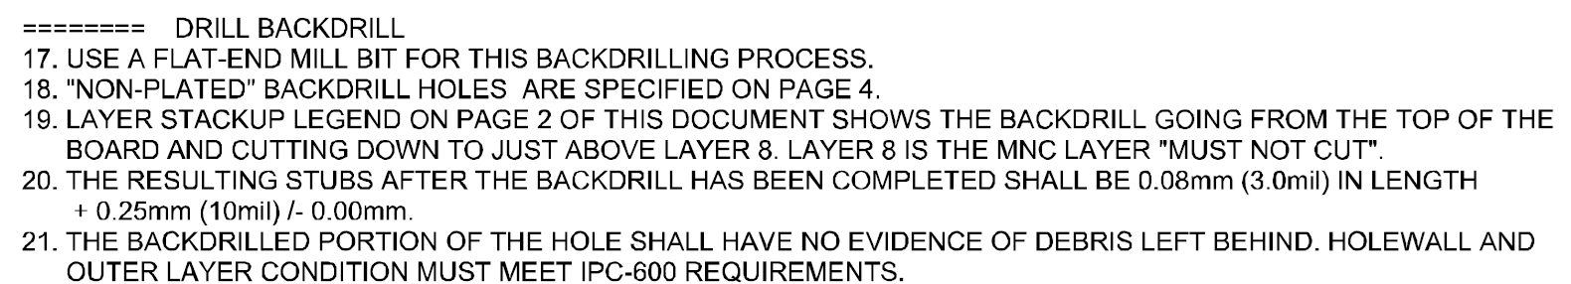

**DRILL OUTPUT**

* At the time of drill output of back drill file, check mark “Controlled Depth” option in drill card generator pop up and add Depth value as per stack up. Refer below snapshot for example.

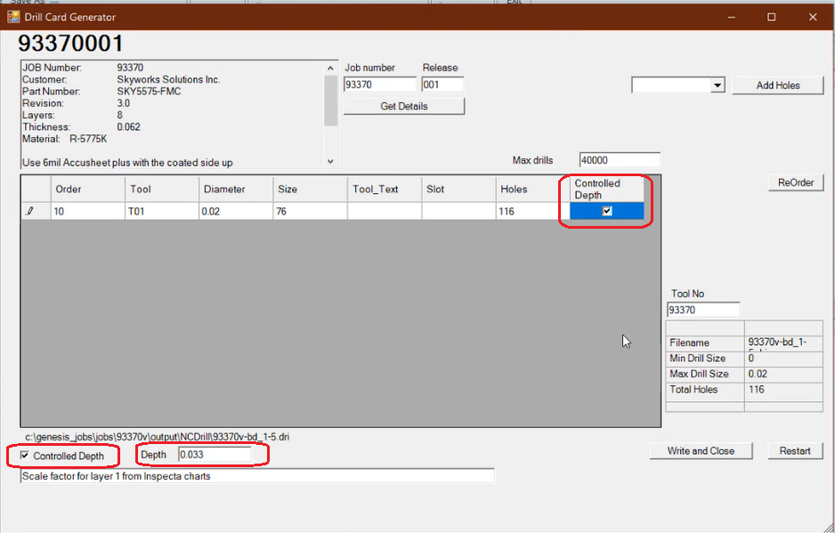

**Back Drill holes with epoxy fill (Special Process)**

* If back drill holes are required to be filled with non-conductive epoxy fill material as per fab print, then follow a special process in traveler per reference tool. We need to edit travelers manually for this special process.
* If Back drill holes are required to be filled with epoxy, then remove copper pads from the outer layer from that location. We need to follow the same edits in coupons as well.
* Refer below snapshots for example of fabrication notes where back drill holes are required to be filled with non-conductive epoxy fill material.

**Tool # x3332:**



**Tool # x1315:**

