#include<stdio.h>
#include<iostream>
using namespace std;
#define MaxNum 100
int ArrivalTime[MaxNum];
double ServiceTime[MaxNum];
double FinishTime[MaxNum];
double WholeTime[MaxNum];
double AVEWholeTime[MaxNum];
double AVEWeightWholeTime[MaxNum];
double WeightWholeTime[MaxNum];
double AverageWT_FCFS,AverageWT_SJF;
double AverageWWT_FCFS,AverageWWT_SJF;
double AllTime,WeightAllTime;
double a[MaxNum];
int b[MaxNum];
int c[MaxNum];
int d[MaxNum];
void FCFS();
void SJF();

void FCFS()
{
int ProcessNum;
cout<<"----------先来先服务算法----------"<<endl;
cout<<"请输入进程个数：";
cin>>ProcessNum;
cout<<"输入进程到达时间：";
cout<<endl;
for(int i=0;i<ProcessNum;i++)
{
cin>>ArrivalTime[i];
//cout<<endl;
}
cout<<endl;
cout<<"请输入进程服务时间：";
cout<<endl;
for(int i=0;i<ProcessNum;i++)
{
cin>>ServiceTime[i];
//cout<<endl;
}
cout<<endl;
for(int i=0;i<ProcessNum;i++)
{
FinishTime[i]=ServiceTime[i];
}
for(int i=0;i<ProcessNum;i++)
{
FinishTime[i+1]=FinishTime[i]+FinishTime[i+1];
}
for(int i=0;i<ProcessNum-1;i++)
{
cout<<"时刻"<<FinishTime[i]<<":第"<<i+2<<"个进程开始运行。"<<endl;
}
cout<<"PCFS完成时间：";
for(int i=0;i<ProcessNum;i++)
{
cout<<FinishTime[i]<<" ";
}
cout<<endl;
cout<<"PCFS周转时间：";
for(int i=0;i<ProcessNum;i++)
{
WholeTime[i]=FinishTime[i]-ArrivalTime[i];
}
for(int i=0;i<ProcessNum;i++)
{
cout<<WholeTime[i]<<" ";
}
cout<<endl;
cout<<"PCFS平均周转时间：";
for(int i=0;i<ProcessNum;i++)
{
AVEWholeTime[i]=WholeTime[i];
//cout<<AVEWholeTime[i]<<endl;
}
for(int i=0;i<ProcessNum;i++)
{
AVEWholeTime[i+1]=AVEWholeTime[i]+AVEWholeTime[i+1];
//cout<<AVEWholeTime[i+1]<<endl;
AllTime=AVEWholeTime[i+1];

}
cout<<AllTime<<" ";
AverageWT_FCFS=AllTime/ProcessNum;
cout<<"平均周转时间"<<AverageWT_FCFS<<endl;
cout<<"PCFS带权周转时间：";
for(int i=0;i<ProcessNum;i++)
{
WeightWholeTime[i]=WholeTime[i]/ServiceTime[i];
}
for(int i=0;i<ProcessNum;i++)
{
cout<<WeightWholeTime[i]<<" ";
}
cout<<endl;
cout<<"PCFS平均带权周转时间：";
for(int i=0;i<ProcessNum;i++)
{
AVEWeightWholeTime[i]=WeightWholeTime[i];
//cout<<AVEWeightWholeTime[i]<<endl;
}
for(int i=0;i<ProcessNum;i++)
{
AVEWeightWholeTime[i+1]=AVEWeightWholeTime[i]+AVEWeightWholeTime[i+1];
WeightAllTime=AVEWeightWholeTime[i+1];
//cout<<WeightAllTime<<endl;
}
AverageWWT_FCFS=WeightAllTime/ProcessNum;
cout<<"平均带权周转时间"<<AverageWWT_FCFS<<endl;
}
void SJF()
{
int ProcessNum;
cout<<"----------短作业优先算法----------"<<endl;
cout<<"请输入进程个数：";
cin>>ProcessNum;
cout<<"输入进程到达时间：";
cout<<endl;
for(int i=0;i<ProcessNum;i++)
{
cin>>ArrivalTime[i];
//cout<<endl;
}
cout<<endl;
cout<<"请输入进程服务时间：";
cout<<endl;
for(int i=0;i<ProcessNum;i++)
{
cin>>ServiceTime[i];
//cout<<endl;
}
cout<<endl;
for(int i=0;i<ProcessNum;i++)
{
a[i]=ServiceTime[i];
}
for(int i=1;i<ProcessNum-1;i++)//实现从第一位开始排序
{
double exchange;
for(int j=i+1;j<ProcessNum;j++)
{
if(a[i]>a[j])
{
exchange=a[i];
a[i]=a[j];
a[j]=exchange;
}
}
}
FinishTime[0]=ServiceTime[0];
for(int i=1;i<ProcessNum;i++)//获取数组下标
{
//b[0]=0;
for(int j=1;j<ProcessNum;j++)
{
if(a[i]==ServiceTime[j])
{
b[i]=j;
//cout<<j<<endl;
break;
}
}
}
for(int i=1;i<ProcessNum;i++)
{
//cout<<FinishTime[b[i-1]]<<" "<<ArrivalTime[b[i]]<<endl;
//cout<<b[i]<<" "<<endl;
/**
***通过下边的转换，使得完成时间小于到达时间时
***下一个进程和下下一个进程顺序交换
**/
if(FinishTime[b[i-1]]<ArrivalTime[b[i]])
{
//cout<<b[i]<<" "<<b[i+1]<<endl;
int temp;
temp=b[i];
b[i]=b[i+1];
b[i+1]=temp;
}
//cout<<b[i]<<" "<<endl;
a[i]=ServiceTime[b[i]];
a[i]=a[i-1]+a[i];
//cout<<a[i]<<" "<<endl;
FinishTime[b[i]]=a[i];
}
for(int i=0;i<ProcessNum-1;i++)
{
cout<<"时刻"<<FinishTime[i]<<":第"<<i+2<<"个进程开始运行。"<<endl;
}
cout<<"SJF完成时间：";
for(int i=0;i<ProcessNum;i++)
{
cout<<FinishTime[i]<<" ";
}
cout<<endl;
cout<<"SJF周转时间：";
for(int i=0;i<ProcessNum;i++)
{
WholeTime[i]=FinishTime[i]-ArrivalTime[i];
}
for(int i=0;i<ProcessNum;i++)
{
cout<<WholeTime[i]<<" ";
}
cout<<endl;
cout<<"SJF 平均周转时间：";
for(int i=0;i<ProcessNum;i++)
{
AVEWholeTime[i]=WholeTime[i];
//cout<<AVEWholeTime[i]<<endl;
}
for(int i=0;i<ProcessNum;i++)
{
AVEWholeTime[i+1]=AVEWholeTime[i]+AVEWholeTime[i+1];
//cout<<AVEWholeTime[i+1]<<endl;
AllTime=AVEWholeTime[i+1];

}
//cout<<AllTime;
AverageWT_SJF=AllTime/ProcessNum;
cout<<"平均周转时间"<<AverageWT_SJF<<endl;
cout<<"SJF带权周转时间：";
for(int i=0;i<ProcessNum;i++)
{
WeightWholeTime[i]=WholeTime[i]/ServiceTime[i];
}
for(int i=0;i<ProcessNum;i++)
{
cout<<WeightWholeTime[i]<<" ";
}
cout<<endl;
cout<<"SJF平均带权周转时间：";
for(int i=0;i<ProcessNum;i++)
{
AVEWeightWholeTime[i]=WeightWholeTime[i];
//cout<<AVEWeightWholeTime[i]<<endl;
}
for(int i=0;i<ProcessNum;i++)
{
AVEWeightWholeTime[i+1]=AVEWeightWholeTime[i]+AVEWeightWholeTime[i+1];
WeightAllTime=AVEWeightWholeTime[i+1];
//cout<<WeightAllTime<<endl;
}
AverageWWT_SJF=WeightAllTime/ProcessNum;
cout<<"平均带权周转时间"<<AverageWWT_SJF<<endl;
}
void main()
{
char flag='Y';
char n;
cout<<"----------调度算法FCFS && SJF-----------"<<endl;;
while(flag=='Y'||flag=='y')
{
cout<<endl;
cout<<"1、先来先服务 FCFS 算法 ."<<endl;
cout<<"2、短作业优先 SJF 算法."<<endl;
cout<<"请您选择算法的序号："<<endl;
cin>>n;
switch(n)
{
case'1':
FCFS();
break;
case'2':
SJF();
break;
default:
cout<<endl;
cout<<"您输出有误!"<<endl;
break;
}
cout<<endl;
cout<<"是否继续调度算法FCFS && SJF，按'Y'or'y'钮继续,按照'N'or'n'键退出"<<endl;
cin>>flag;
}
}
【实验结果】
先来先服务算法
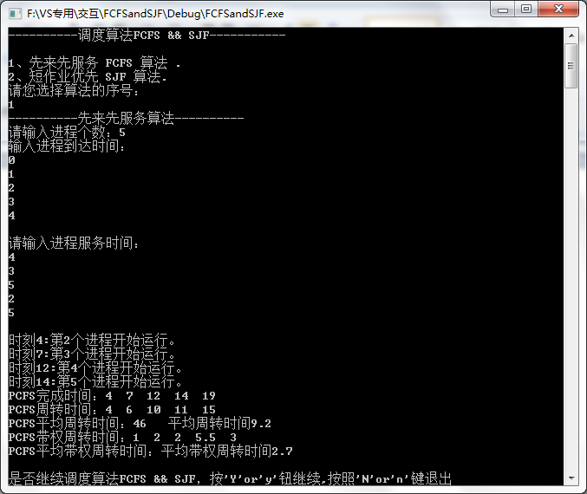
短作业优先算法
