#include<iostream>
using namespace std;

float sumTr;
float sumTr_Ts;
class process
{public:
process(int id,float c,float s):PID(id),come(c),Ts(s){}
void fTr(){Tr=finsh-come;}
void fTr_Ts(){Tr_Ts=Tr/Ts;}
int PID;
int grade;
float come;
float Ts;
float Tr;
float Tr_Ts;
float begin;
float finsh;

};
void fgrade(process *A)
{
for(int i=0,i<4,i++)
A[i].grade=i;
}

void minCome(process *A,int low,int high)
{//利用快速排序找到最早到来的程序，并排序
A[0]=A[low];
float pivotkey=A[low].come;
while (low<high)
{
while(low<high&&((A[high].come)>=pivotkey)) --high;
A[low]=A[high];
while(low<high&&((A[low].come)<=pivotkey)) ++low;
A[high]=A[low];

}
fgrade(A);

}
void minTs(process *A,int low,int high)
{//利用快速排序找到服务时间最短的程序，并排序
A[0]=A[low];
float pivotkey=A[low].TS;
while (low<high)
{
while(low<high&&((A[high].Ts)>=pivotkey)) --high;
A[low]=A[high];
while(low<high&&((A[low].Ts)<=pivotkey)) ++low;
A[high]=A[low];

}
fgrade(A);

}

void fcfs(,process *A)
{
minCome(A,0,3);
A[0].finsh=A[0].Ts;
sumTr=A[0].Tr;
sumTr_Ts=A[0].Tr_Ts;
for(i=1,i<4,i++)
{
A[i].begin=A[i-1].finsh;
A[i].finsh=A[i].begin+A[i].Ts;
A[i].Tr=A[i].finsh-A[i].come;
A[i].Tr_Ts=(A[i].Tr)/(A[i].Ts);
sumTr+=A[i].Tr;
sumTr_Ts+=A[i].Tr_Ts;
}
fgrade(A);

}
void sjf(process *A)
{

minCome(A,0,3);
A[0].finsh=A[0].Ts;
sumTr=A[0].Tr;
sumTr_Ts=A[0].Tr_Ts;
minTs(A,1,3);
for(i=1,i<4,i++)
{
A[i].begin=A[i-1].finsh;
A[i].finsh=A[i].begin+A[i].Ts;
A[i].Tr=A[i].finsh-A[i].come;
A[i].Tr_Ts=(A[i].Tr)/(A[i].Ts);
sumTr+=A[i].Tr;
sumTr_Ts+=A[i].Tr_Ts;
}
fgrade(A);
}

void print(process *A)
{
cout<<"进程号 优先级数 到达时间 服务时间 周转时间 带权周转时间"<<endl;
for (i=0,i<4,i++)
{cout<<<<" "<<A[i].PID<<" "<<A[i]grade<<" "<<A[i]come<<" "<<A[i]Ts<<" "<<A[i]Tr<<" "<<A[i]Tr_Ts<<endl;}
}

int main()
{
process (*A)[4]=
{
process(0,0,4);
process(1,4,4);
process(2,7,5);
process(3,12,2);
};
int n;
cout<<"请选择算法所对应的数字：FCFS（），SJF（）";
cin>>n;
if (n=1) {fcfs(A);}
else if(i=2){sfj(A);}
else{cout<<"输入错误";}
print(A);
cout<<"平均周转时间为:"<<(sumTr)/4<<"平均带权周转时间为:"<<(sumTr_Ts)/4<<endl;

return 0;
}

输出结果：

当为输入1
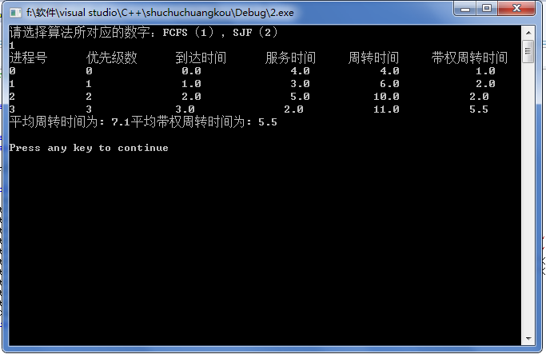
当为输入2
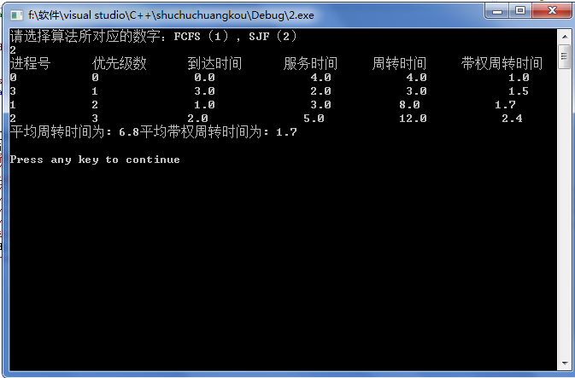

我采用的是先将优先级排好，再计算的方法写的。

