《操作系统》课程实验报告
实验名称 | Linux命令及虚拟机 |  |  |  |  | 实验序号 | 1
姓 名 | 陈超敏 | 系院专业 | 信管 | 班 级 | 1018 | 学 号 | 10207180562
实验日期 | 2012年11月 |  | 指导教师 | 丘文峰 |  | 成 绩
一、实验目的和要求、
1,、了解Linux操作系统的发行版本;
2了解Vitural Box的使用;
3、掌握Red Hat Linux 系统的安装方法;
4、熟悉Red Hat Linux操作系统的环境;
5、掌握Red Hat Linux 系统下各类常用的命令使用
二、实验预习内容
1、Red Hat Linux 系统的安装方法;
2、Red Hat Linux操作系统的环境;
3、Red Hat Linux 系统下各类常用的命令使用
三、实验设备
配置名 配置参数
硬盘 ≥8GB
内存 ≥1GB
磁盘文件格式 NTFS, 以支持大的镜像文件
操作系统 Win32 XP +
软件 V irtualBox Red Hat Linux Server ISO安装软件包
四、实验内容及步骤
1．安装VirtualBox。
下载并安装VirtualBox。
如果要求需要安装权限， 点击“继续”按安装指示，完成安装过程；
下载 Red Hat Linux Server，由于文件比较大(3GB)，所以需要一点时间；创建虚拟机。双击运行VirtualBox,进入主界面后，点击“New” 创建一个新的虚拟机；进入虚拟机创建向导， 点击"Next"；安装Red Hat Linux点击存储；启动虚拟机进入安装界面；安装完成，重新引导；第一次登陆，初始化系统配置， 点下一步；成功安装，进入桌面。
2．参考命令说明完成实验

五、实验结果、分析与心得
1． 《粘贴你的结果》可以截屏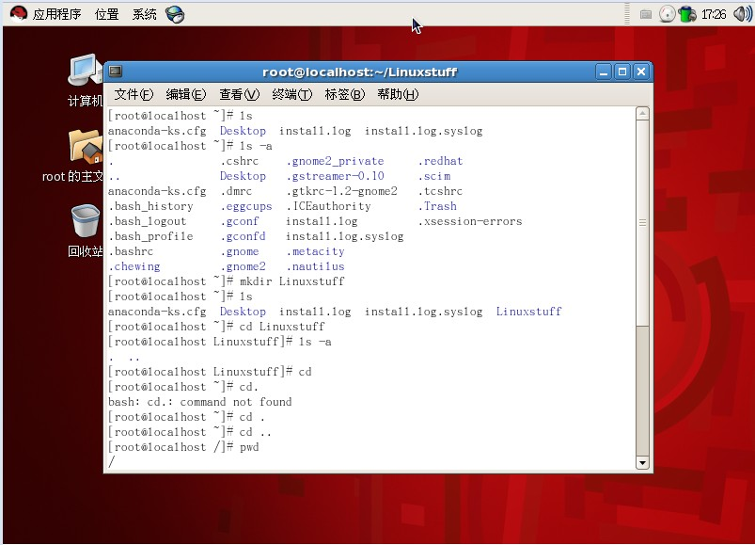
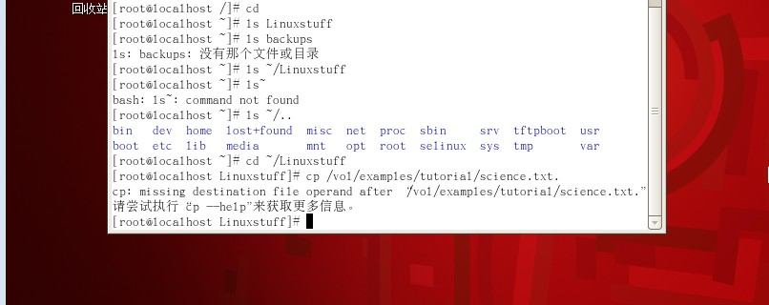
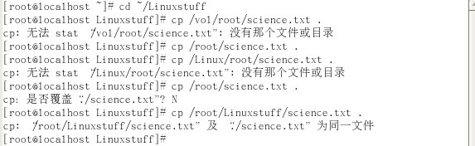
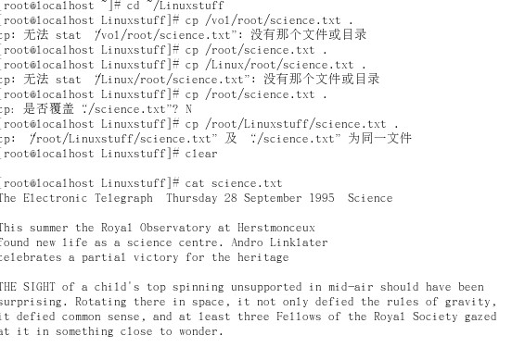
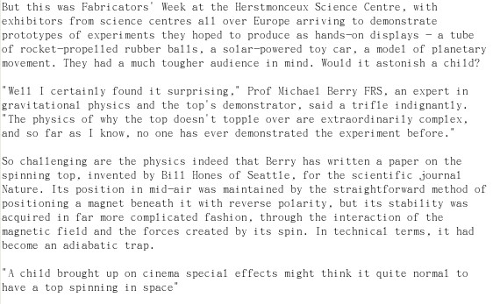
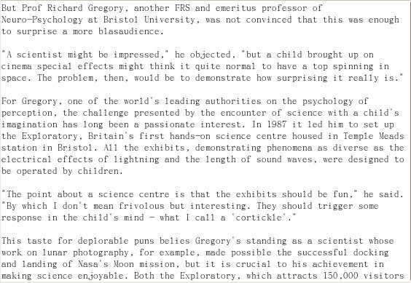
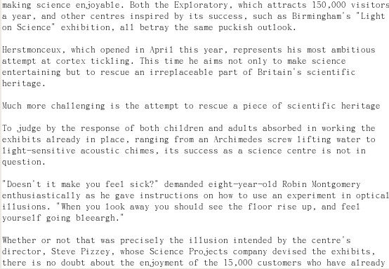
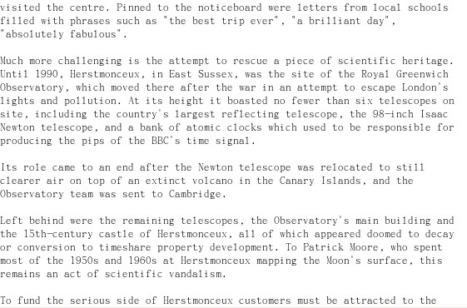
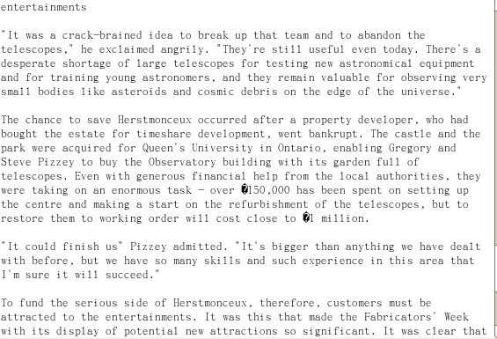
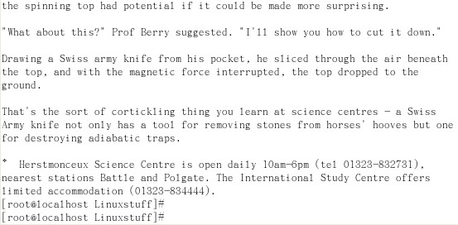
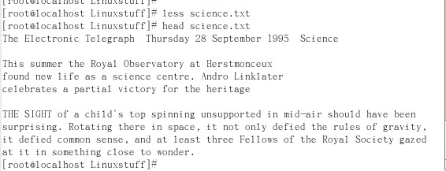
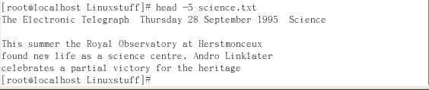
the top, and with the magnetic force interrupted, the top dropped to the
ground.
That's the sort of cortickling thing you learn at science centres - a Swiss
Army knife not only has a tool for removing stones from horses' hooves but one
for destroying adiabatic traps.
* Herstmonceux Science Centre is open daily 10am-6pm (tel 01323-832731),
nearest stations Battle and Polgate. The International Study Centre offers
limited accommodation (01323-834444).
[root@localhost Linuxstuff]#
The Electronic Telegraph Thursday 28 September 1995 Science

This summer the Royal Observatory at Herstmonceux
found new life as a science centre. Andro Linklater
celebrates a partial victory for the heritage

THE SIGHT of a child's top spinning unsupported in mid-air should have been
surprising. Rotating there in space, it not only defied the rules of gravity,
it defied common sense, and at least three Fellows of the Royal Society gazed
at it in something close to wonder.

But this was Fabricators' Week at the Herstmonceux Science Centre, with
exhibitors from science centres all over Europe arriving to demonstrate
prototypes of experiments they hoped to produce as hands-on displays - a tube
of rocket-propelled rubber balls, a solar-powered toy car, a model of planetary
movement. They had a much tougher audience in mind. Would it astonish a child?

"Well I certainly found it surprising," Prof Michael Berry FRS, an expert in
gravitational physics and the top's demonstrator, said a trifle indignantly.
"The physics of why the top doesn't topple over are extraordinarily complex,
and so far as I know, no one has ever demonstrated the experiment before."

So challenging are the physics indeed that Berry has written a paper on the
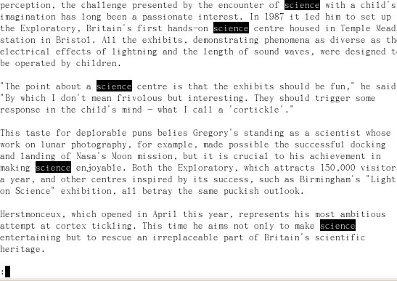
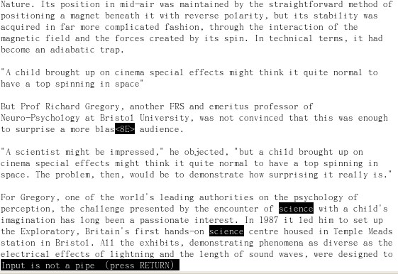
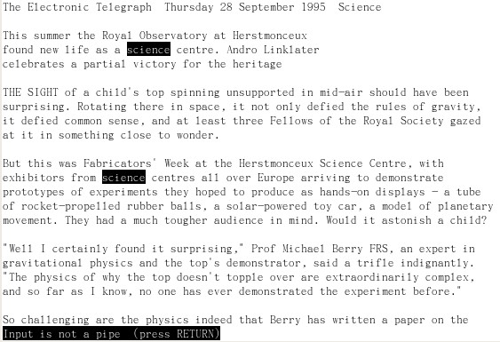
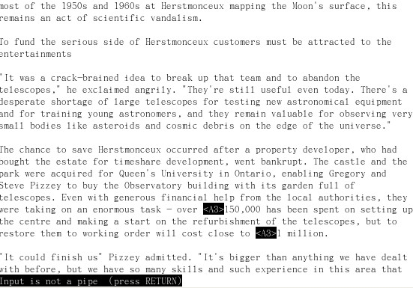
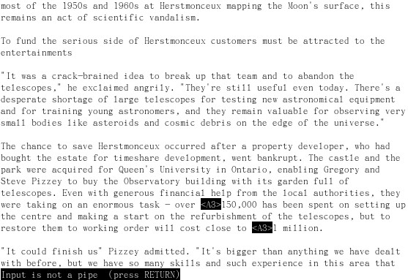
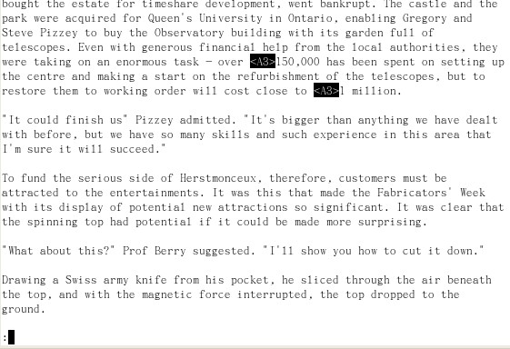
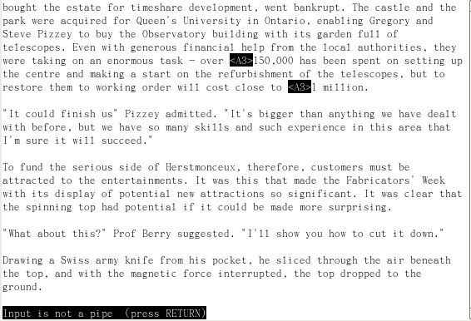

2．分析你的结果，例如为什么会无序的输出
因为命令的指示，作用。
3．心得
很多事情要认真去做才会知道自己会不会做，就像安装red hat linux，还没开始的时候 ，你会觉得很难，但当牛安装了你才知道：不难。半个钟就能搞定了安装了。要运用的话，还是需要认真去学习，不懂的话要主动问，不过，后面的；练习题，我还是有点难以理解，，，
教师评语：

成绩:

教师签字：

