User Task Manager API Documentation
Base API URL: http://localhost:8000/api-docs
USER API
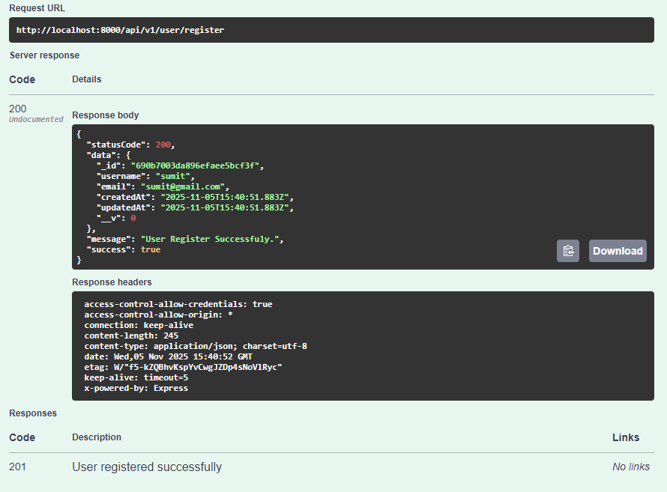
- User Register:
URL: # user/register
Method: Post
- User Login:
URL: #user/login
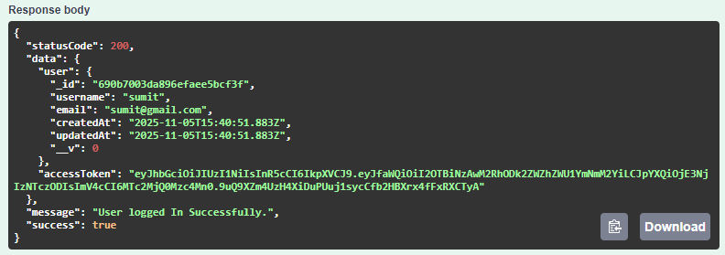
Method:Post

- User Logout:
URL: #user/logout
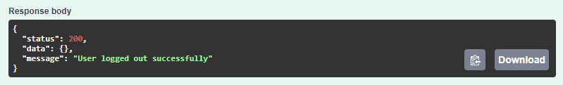
Method: post

- User Password Change:
URL: #user/changePassword
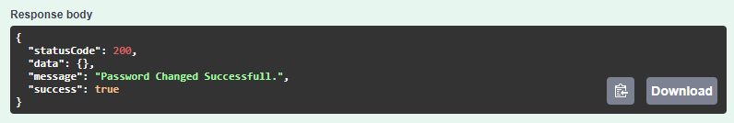
Method: Post

- User profile:
URL: #user/getUser
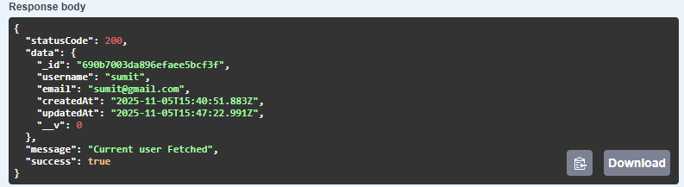
Method: Get

- User Update
URL: #user/updateUser
Method: PUT
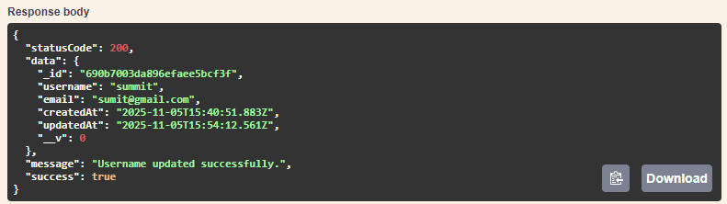

TASK API
- Task Create
URL: #task/createTask
Method: post
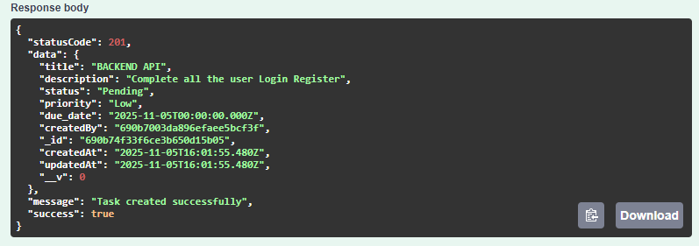
- Get All Task (includes filter, sort and pagination)
URL: # task/getAllTAsk
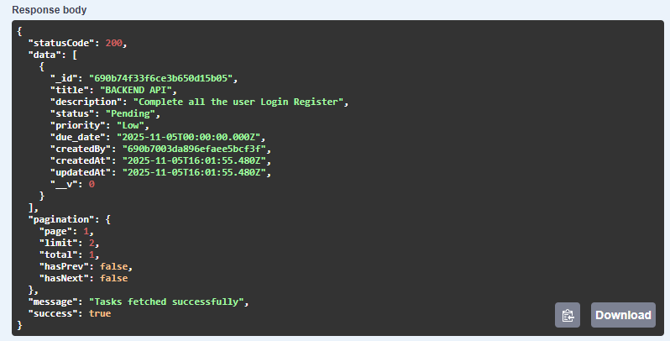
Method: Get

- Task by id
URL: # task/: taskId
Method: Get
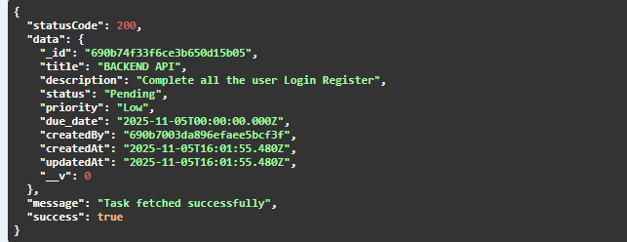
- Task by id
URL: # task/: taskId
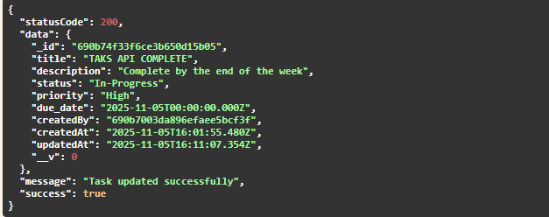
Method: Get

- Task Delete
URL: #task/delete
Method: Delete

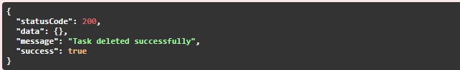
LABEL API
- Create Label
URL: #label/createLabel
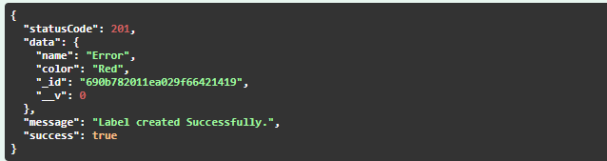
Method: POST

- Update Label By ID
URL: #label/: label_id
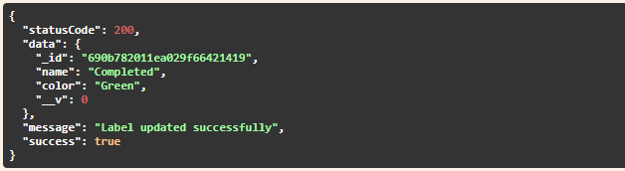
Method: PUT

- Get All Labels
URL: #label/ getAllLabels
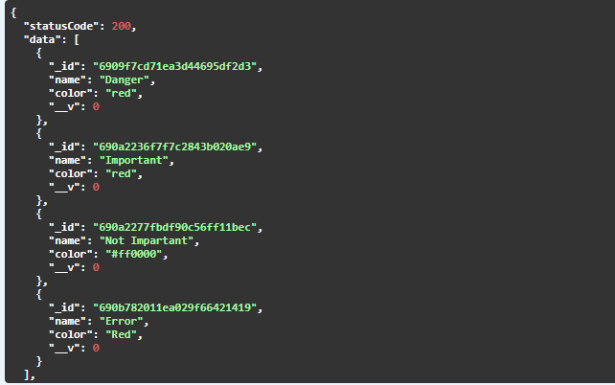
Method: Get

- Get Label By Id
URL: #label/{id}
Method: Get
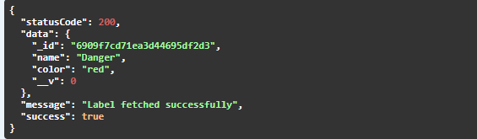

- Delete Label
URL: #label/{id}
Model: Delete
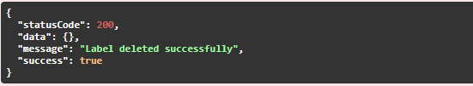

TaskLabels API
- Create TaskLabel
URL: # tasklabel/{taskId}/labels
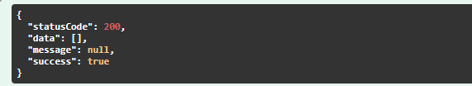
Method: POST

- Get Label By Task id
URL: #tasklabel/{taskID}/labels
Method: Get
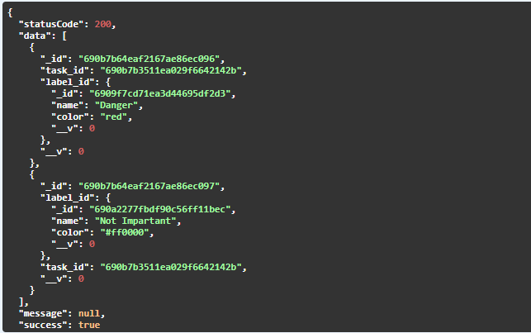

- Get Label By label Id
URL: #tasklabel/label/{label_id}
Method: Get
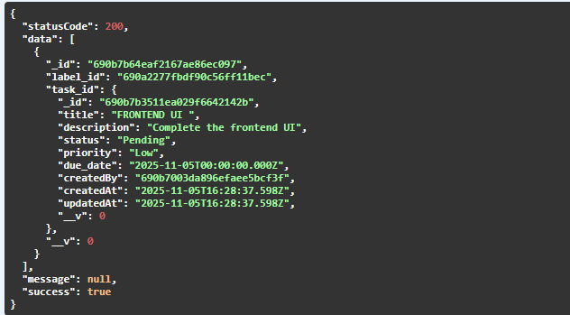

-------- THE END ---

