2023/2024
CS5803 Data Visualisation
Average time spent by a user on social media

Summiya Alam
2340875
- Introduction
Visualization of data is one of the key aspects of data analysis and interpretation. Most of the Exploratory Data Analysis (EDA) and data cleaning is supported by graphs (Unwin, 2020). With the variety of data types available, there are variety of graphs. They can identify correlation, variance, outliers, missing or duplicate values, rankings, deviation, distribution and much more (CS5703 Week-19, 2024).
  - Data
For development of interactive data visualization design, first step is to select dataset. The aim of this coursework is development of comprehensive design with static graphs, dashboards and interactive story-telling infographics based on a persona. The dataset is “Average Time Spent by User on Social Media”. This is an open-source dataset from Kaggle https://www.kaggle.com/datasets/imyjoshua/average-time-spent-by-a-user-on-social-media available in csv format as a small file of 86KB. This dataset inspires to explore and identify various aspects of people’s life who are using social media. This dataset is artificially created by using a python library called ‘NumPy’. The original data has twelve parameters and 1000 rows. For this coursework, only a subset of variables relevant to persona is used.
Name | Description | Domain
Age | Age of a user in years | Integer
time_spent | Amount of time spent on social media by the user (hours) | Integer
platform | Social media platform where the user spends time | Nominal
Interests | Users’ primary area of interest / hobby | Nominal
Location | Country of residence for the user | Nominal
Income | Yearly income of user in US dollars | Integer
Time spent in days | Amount of time spent by the user on social media (days) | Integer
Income group | Grouped field generated from income. Created 10 groups each from 10k to 19k | Ordinal
Time Spent group | Hours of time split into 3 groups | Ordinal

  - Persona and Questions
The persona is a Researcher named Dr. Alex, working in Brunel University London. For past few years, he has been observing the overwhelming amount of social media indulgence in students and his colleagues. In his opinion, it has significantly changed the work ethics and attitude of people. The aim of Dr. Alex is to identify and understand the usage of social media among people based on their age, location, income and platform. Dr. Alex came up with the following simple questions
- Question 1: What are the regional locations of people with maximum and minimum spending times on social media?
- Question 2: What is the income of people who are spending maximum time on social media platforms?
- Question 3: How does the usage of social media vary across younger and older users? Is it more popular among younger people?
The more complex question is
- Question 4: Which social media platforms are most popular among people with maximum spending time and the lowest income?

  - User requirements specification
Following requirements should be fulfilled.
- R1. To answer question 1, see relation between location and time_spent
  - Location is geographical variable and time_spent is a numerical variable. This question addresses the ranking of areas that have maximum and minimum spending time. Referring to (CS5703 Week 19, 2024), bar graph is an appropriate choice. Location can be on x-axis and on y-axis, there can be time_spent. The highest bar will be the area with users of most social media time and vice versa.
- R2. To answer question 2, see the correlation between income and time_spent.
  - Income and time_spent both are continuous variables. To observe the correlation, scatter plot is a suitable option (CS5703 Week-19, 2024). Income can be on y-axis and time_spent on x-axis. For positive correlation, people with more spending time will have have higher salary. For negative correlation, people who spend more time on social media have lower salary.
- R3. To answer question 3, see time_spent and age
  - To interpret trends from the data, mostly time series line charts are recommended (CS5703 Week-19, 2024). In this scenario, both variables are continuous. Age filter can be added.
- R4. To answer question 4, see platforms for people with maximum time_spent and lowest income.
  - The variables are platform, time_spent and income. Bubble chart of time_spent (x-axis) and income (y-axis) can be generated. Platform can be color encoded. For this exercise, time_spent can be created into a group to adjust the chart scaling and visuals. Within three groups, lowest bubble would be the lowest income, encoded with the platform used. Question 3 graph can be used as a tooltip.
R5. As non-functional requirements, Dr Alex needs to have computer with the hardware specifications of “16V-CPU, 128GB system memory and 50GB minimum disk space”. Software requirements include Tableau prep builder and Windows 8 or above (www.tableau.com, n.d.).

- Design
This section of report contains preliminary idea of how the design is going to look like before the actual Tableau implementation. Design approaches and theories learnt in the module are used as guidelines. Referring to the table 1, the dashboard is going to contain 4 types of charts (clustered bar chart, map, circle views chart and scatter plot). The placement of charts on the dashboard complies with the principles of proximity and similarity while maintaining the natural reading order and sequencing (CS5703 Week-19, 2024).
- The first chart, referring to question 4, has planar (time_spent and income) and retinal (Platform) variables, Jacques Bertin’s image theory (CS5703 Week-18, 2024). Minimizing chart junk and reducing non-data pixel is adhered.
- The rest of the charts, from questions 1 to 3, have two variables each. Following the bertin’s theory (CS5703 Week-18, 2024), they are encoded spatially. Mackingly’s guide to the data encoding is used to develop chart type for each question (CS5703 Week-18, 2024).
- From HCI point of view, this design is kept minimal to avoid Cognitive load to the memory (Bannert, 2002). Chart is kept simple, with defined results and synchronised views. This keeps the load off from working memory. The activity theory of HCI is applicable to this research scenario, as the activities (social media time spent) and subjects (people) are interacting and that interaction is important to Dr. Alex (Roth, 2004). Another applicable HCI theory is Consistency theory (Satzinger, 1998).
Average time spent by user on social media
Goal: How does usage of social media vary based on person’s age, platform, location, income and demographics.
Question 1: What are the regional locations of people with the maximum and minimum spending times on social media?
Question 2: What is the income of people who are spending maximum time on social media platforms?
Question 3: How does the usage of social media vary across younger and older users? Is it more popular among younger people?
Question 4: Which social media platforms are most popular among people with maximum spending time and lowest income?
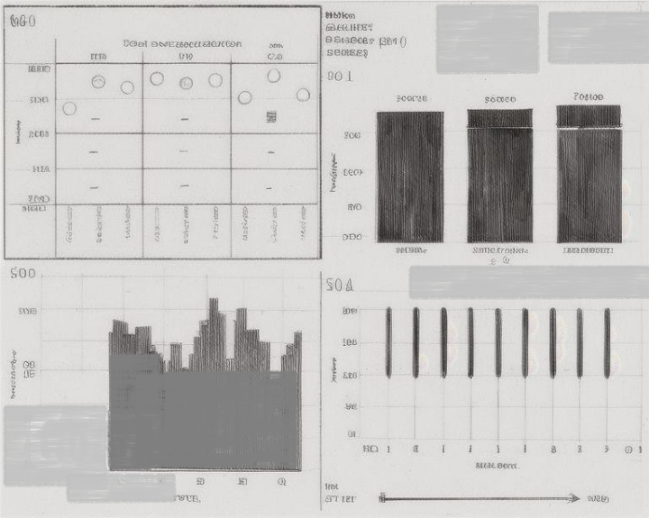
Result: Dr. Alex is able to gain insights on the people’s usage of social media according to their age, location, income and platform
Q4, R4. Popular social media platforms in people with low income and high time_spent.
Q2. R2, See the interaction between income and time_spent.
Q1. R1, ranking of areas with highest and lowest time_spent
Q3. R3, Age with time_spent
Table 1: Paper Landscape

- Implementation
This section of report has step by step procedure for implementing tableau visualisation.
First, change the type of location from string to geographic role.
Question 1: What are the regional locations of people with maximum and minimum spending times on social media?
Initially bar graph was selected for this question. While exploring the other options, map is a better choice for geographical data (cognitive limitations).
- Drop location to the blank sheet. It shows three countries.
- Take time_spent and add it to the color marks.
- Select Edit color from color legend to the right of map. Select Red-black diverging palette and check mark the other settings
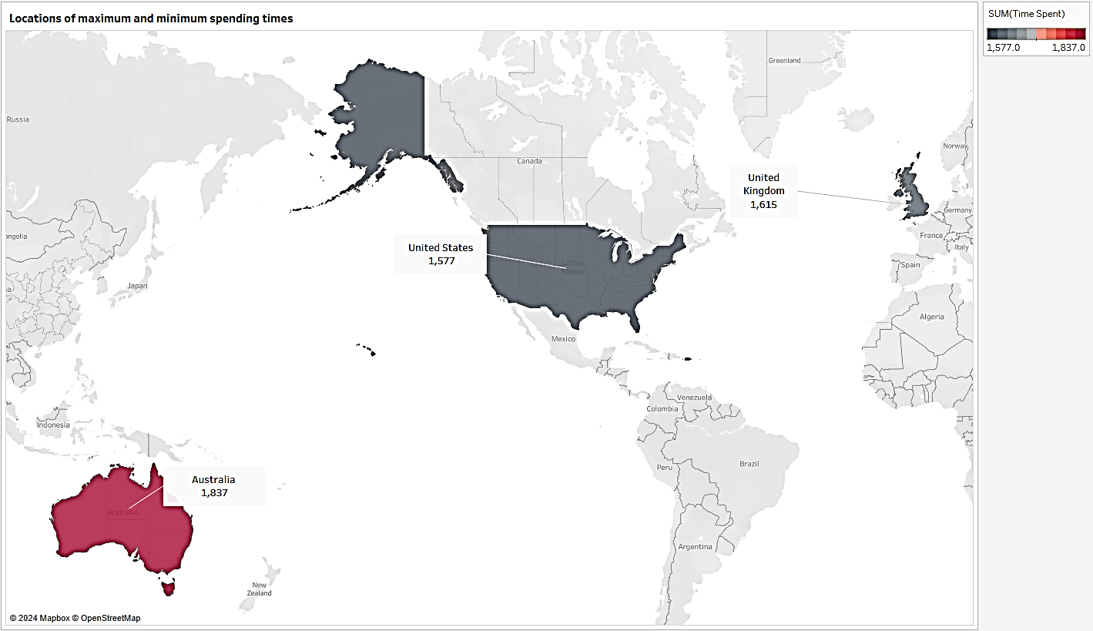
- Dark red shows the highest value, and black shows the lowest value. Add Tableau annotations.
Q1, R1 – Areas with maximum and minimum time_spent
Figure 1: Areas and spending times (Q1)

Answer: Output shows people using social media in each country (cluster analysis). People in Australia have highest spending time (Red). People in United States have the lowest spending time (slightly darker gray than UK).
Question 2: What is the income of people who are spending maximum time on social media platforms?
Initial design and requirements suggest use of scatter plot for this question but the plot showed abnormally scaled values of time_spent and income. To fix it, I grouped the income to 10 groups (from 10k to 19k) and used a calculated field time spent in days by converting hours to days. Change in variables resulted in bar chart.
- Take income group and drop it to rows
- Take time spent in days and drop it to columns
- Select the bar chart and sort time_spent. (Figure 2)
Answer: We can take a look at top 3 peaks of time_spent. Their income value is 19k, 14k, 11k. Maximum spending time is not related to income (No correlation).
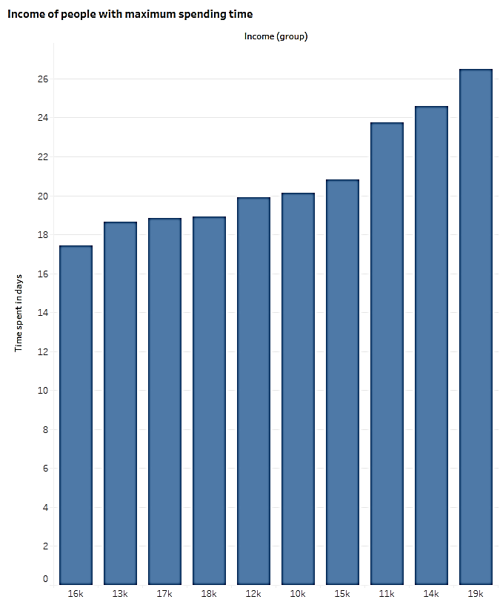

Q2, R2 – Income of people with maximum spending time is 19k, 14k, 11k

Figure 2: Income of people (Q2)

Question 3: How does the usage of social media vary across younger and older users? Is it more popular among younger people?
Initial design suggested line chart. In implementation, it was tricky to implement line chart. The final output is line chart with no age filter.
- Add time_spent on columns and age on rows.
- As age starts from 18, double click on age (y-axis) and change the range to automatic.
- Select the jump line marker from marker card and add time_spent on size. The double use of time_spent accentuates the maximum time. (Figure 3)
Answer: The extreme right vertical line shows the maximum time_spent. The age along y-axis shows that usage time is shared by people from all ages (18 - 64). Except 3 missing data points, every age group has people using social media for 8-9 hours a day.
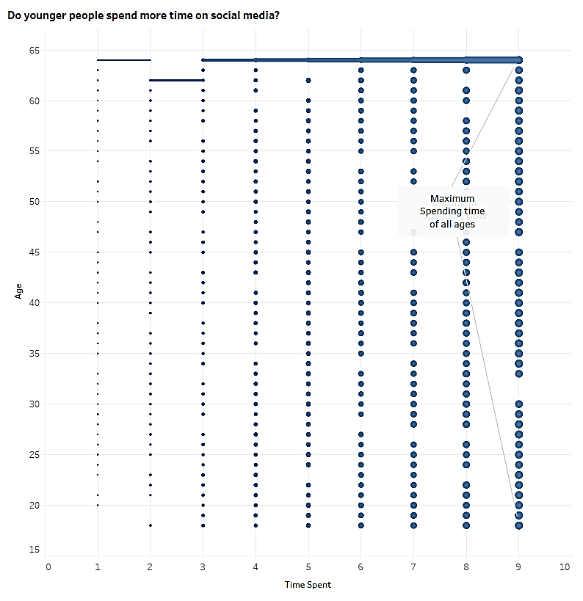

Q3, R3 – People of all age groups (top to bottom) are spending 9h on social media

Figure 3: time_spent by age (Q3)

Question 4: Which social media platforms are most popular among people with maximum spending time and lowest income?
There are three variables in this chart. Instead of using time_spent, a grouped value is used for scaling. The output is the circle views chart.
- Drop platform and time_spent group on columns. Put income on rows.
- Put platform onto the color marker. Select circle view chart.
- From color encoding, edit the colors so that each social media platform has matching color to its logo.
- Click on tooltip. Go to insert and add a sheet of question 3 (age and time_spent) (help.tableau.com).
Answer: Figure 4 shows the solution. Maximum time spending group is 7-9, locate the bubble with lowest income there. The bubble is in blue color showing that people with maximum spending time and lowest income are using Facebook. If cursor goes on top of bubble, tooltip appears to showing the age of people using Facebook (Figure 5).
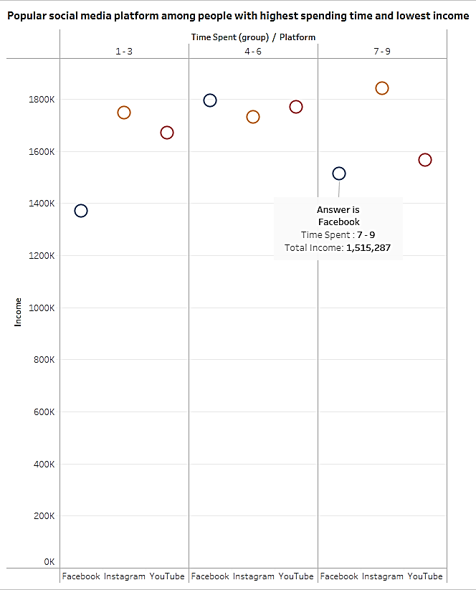

Q4, R4 – Facebook is used by the people with maximum time and lowest income

Figure 4: Popular Social media platforms (Q4)

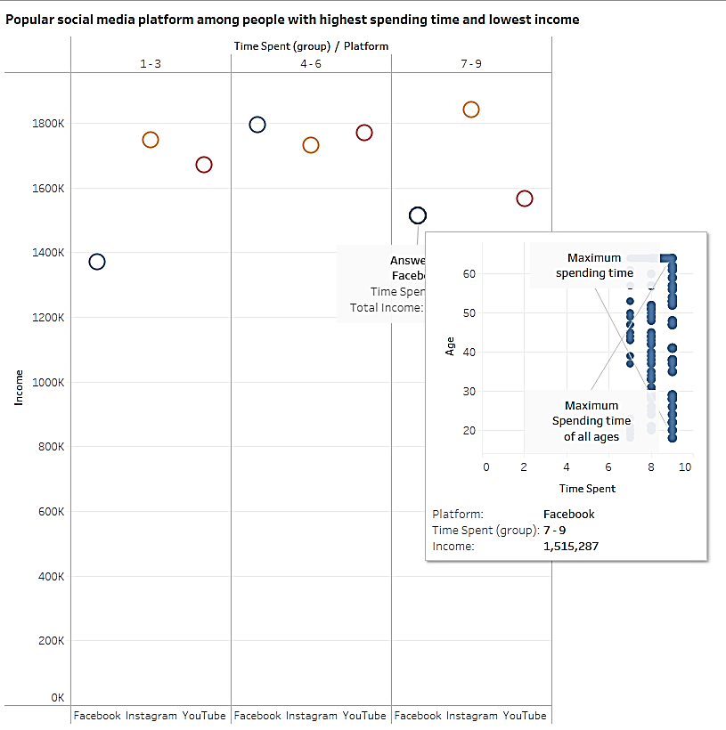

Q4, R4 – age of the people using Facebook with maximum time and lowest income

Figure 5: Q4 with added tooltip from Q3

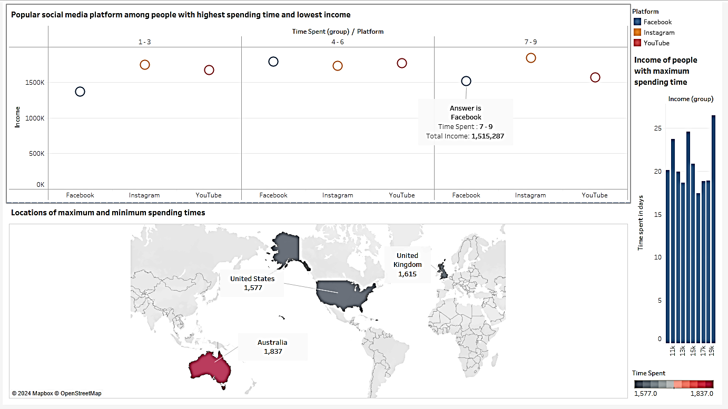
Dashboard: The final dashboard contains three graphs from Question 1, Question 2 and Question 4. Question 3 is the part of dashboard as a tooltip in Question 4. Adding it separately consumed extra space and redundant information casing clutter on dashboard. Dashboard is equipped with interactivity and fixed resolution.
Q4, R4 – Popular social media platform in people with highest time and lowest income
Q2, R2 – interaction between income and time_spent
Q1, R1 – Ranking of areas with highest and lowest time_spent

Figure 6: Dashboard for average time spent

The dashboard provides valuable feedback to Dr. Alex on people’s usage of social media according to their age, platform, location and income.
  - Second Implementation:
Power BI is used for the second attempt to implement the dashboard. Graphs from question 1, 2 and 4 are used to replicate the tableau dashboard. There are not exact same chart types but placement of charts is consistent with original dashboard.
- After loading, transform the data for location variable using locale.
- When screen is ready, start with the graph for question 4. Create the group of 3 bins for time_spent, apply the time spent in bins, income and platform variables to the clustered bar chart.
- For map chart (Question 1), select the map from visualisations and place it below the clustered bar chart. Add locations variable to the location placeholder and time spent on bubble size.
- For third chart (Question 2), select scatter plot, add income and time_spent on x-axis and y-axis. To fix sum values, select don’t summarise option on both variables.
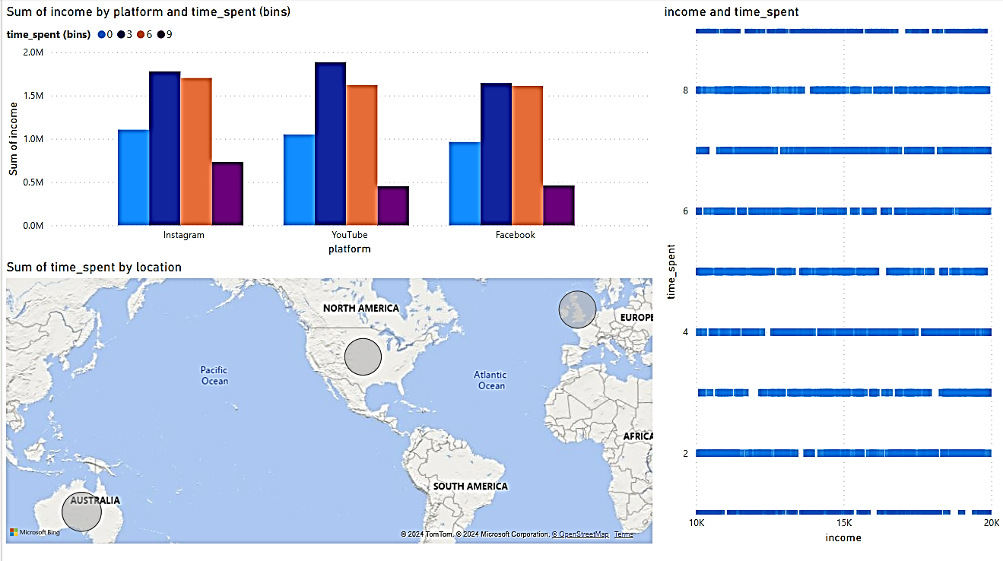
Q1, R1 – Ranking of areas with time_spent
Q2, R2 – interaction between income and time_spent
Q4, R4 – Popular social media platform in people with highest time and lowest income
Figure 7: Power BI dashboard

  - Critical reflection and comparison
Tableau and power BI are both powerful tools. As a novice to both platforms, the comparison may not involve advanced concepts. Tableau has a well-defined user interface with easy-to-handle designing options than Power BI. The controls of Tableau are more elegant. I was unable to find bubble chart for the implementation of first graph (question 4). In map graph, the outcome for tableau is a lot more appealing. I was unable enhance the power BI map look. For the third graph (for question 2), I selected scatter chart as there was already a bar chart in the view. The outcome doesn’t really convey much information and might need more work. The tooltip feature added in Tableau couldn’t be added to Power BI implementation. The answers of other two graphs (question 4 and 1) comply with the answers of Tableau implementations.
- Walkthrough
Dr Alex is interested in discovery of social media usage based on various parameters.
- Story starts with social media being a global phenomenon. People in many countries are spending multiple hours daily (Figure 8). The highest, Australia is zoomed in to show the total number of hours.
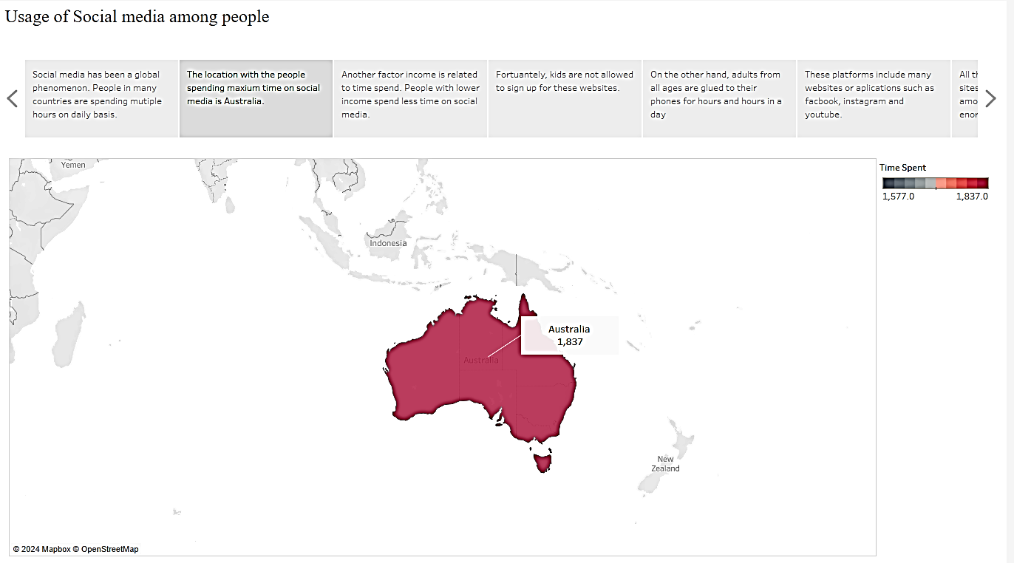
Figure 8: Popularity of social media
- Another factor income is related to time spent. Is it possible that people with lower income spend less time on social media? In graph of question 2 sort the income group in descending order, it shows that people with low income are spending less time on social media (Figure 9).
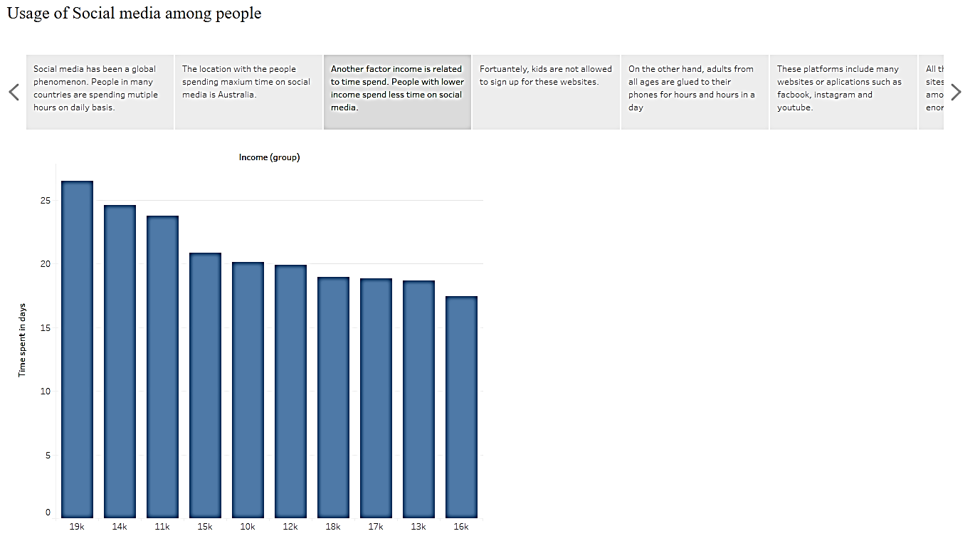
Figure 9: Social media usage and age
- The story proceeds to discover that only adults can sign up for these websites (question 3). Users less than 18 years old cannot sign up for these applications.
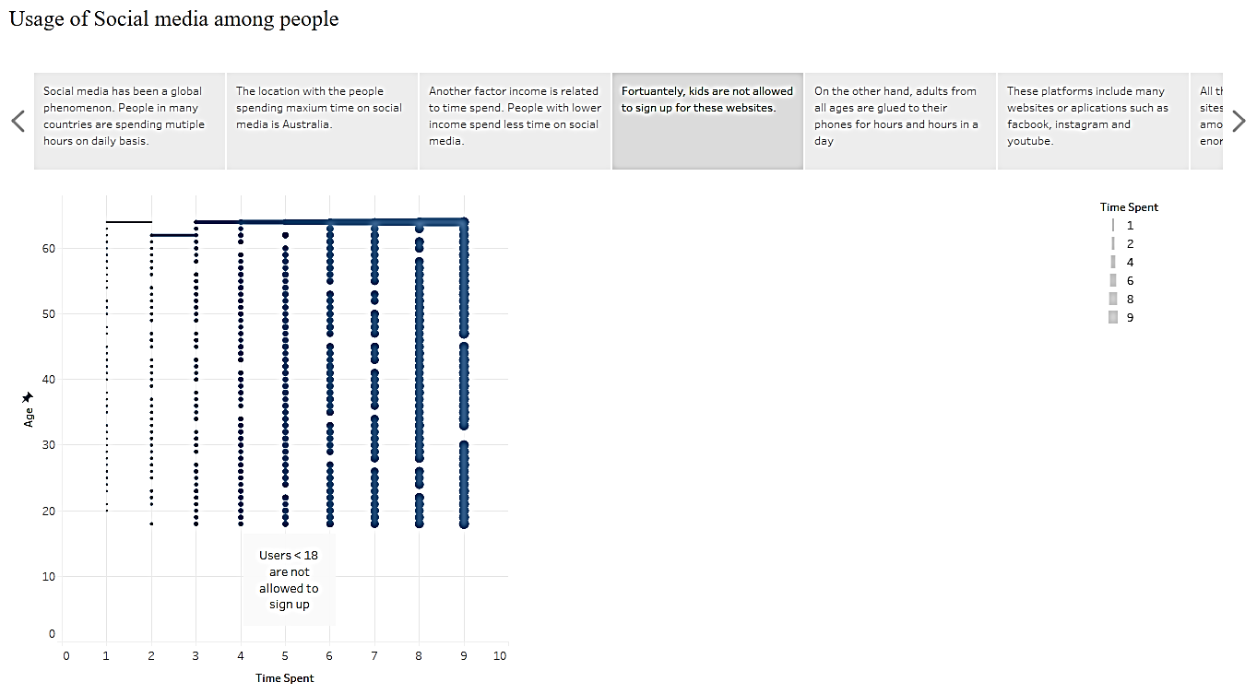
Figure 10: social media and minors

- These platforms used by adults include many websites. The next story highlights three social media platform by eliminating other time spent groups (Figure 11). This is relevant to the question 4.
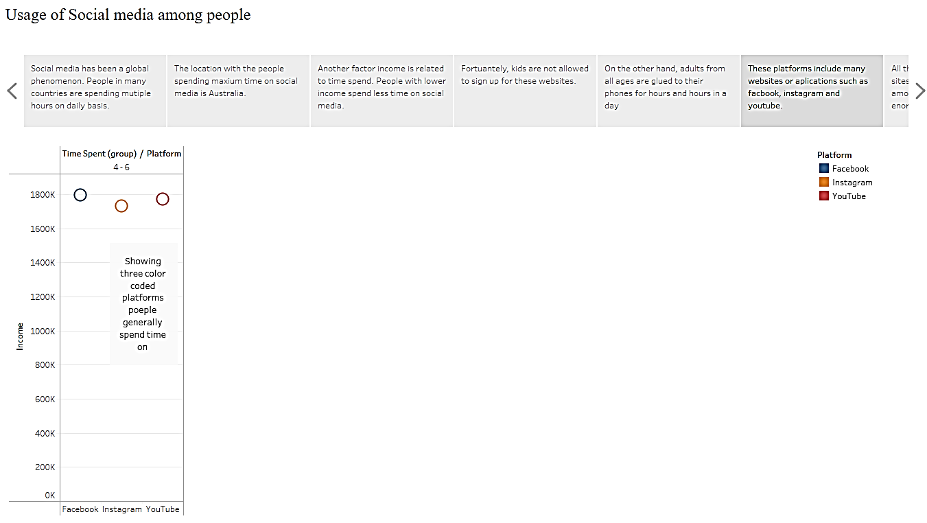
Figure 11: Popular social media platforms
These story boards paint a picture as an answer to Dr. Alex’s questions by stating that the variety of social media platforms are used by people generously, slightly influenced by the age, income and location.
- Discussion and Critical Reflection
Design and implementation of research questions on Average time spent by people on social media is performed in Tableau. Even though we have valuable insights, in my opinion, the dataset doesn’t reflect the real-life usage of social media. This dummy dataset was too clean to show the real-life inconsistencies and complications that could produce interesting outcomes.
As a first time Tableau user, I find it relatively easy and useful tool. The interface is quite simple with elegant features. For me, a lesson learnt is that the result might not always be what one expects even if you know the right kind of visualisation for the variables. It is sometimes difficult to understand where calculated fields are required or how and when to scale the variables. For example, age in thousands (5k, 6k...) does not sit right. Similarly, with another variable time_spent, the value cannot be 100k hours a day. Story telling is an interesting feature of Tableau, but with limited views, it becomes difficult to come up with good story board. Nevertheless, these issues inspired to explore more options. The future goal is to experiment with other datasets by using joins and other advanced integration techniques. Tableau allows statistical modeling (prediction and analysis) in high level languages. This is an important area to focus on in the future.
- Conclusion
Visualisation is an integral part of data analysis. The first step is to select the dataset with enough variety of variables to proceed with development of a persona. The persona articulates few questions. With the given dataset, the goal of Dr. Alex was to understand the usage of social media among people based on their age, location, income and platform. There are four questions, and five requirements (functional and non-functional). For each question there is a graph tailored to each requirement.
The final output is the Tableau dashboard that combines all the graphs. Walkthrough is a way to wrap up the visualisation with the story from those graphs. The results show that massive amount of people spend hours on social media. There are some factors such as age and income that can fluctuate the usage time. Tableau is a primary tool but there is second attempt from Power BI.
This exercise proved very helpful in exploration and learning of tableau. Different visualisation and HCI theories played vital role in deciding the better graphical representations for each variable type. The future goal is to implement and learn more advance concepts offered by Tableau and use them in my dissertation.
- References
Bannert, M. (2002). Managing cognitive load—recent trends in cognitive load theory. Learning and Instruction, 12(1), pp.139–146. doi:https://doi.org/10.1016/s0959-4752(01)00021-4.
help.tableau.com. (n.d.). Create Views for Tooltips (Viz in Tooltip). [online] Available at: https://help.tableau.com/current/pro/desktop/en-us/viz_in_tooltip.htm.
Roth, W.-M. (2004). INTRODUCTION: ‘Activity Theory and Education: An Introduction’. Mind, Culture, and Activity, 11(1), pp.1–8. doi:https://doi.org/10.1207/s15327884mca1101_1.
Satzinger, J.W. and Olfman, L. (1998). User Interface Consistency across End-User Applications: The Effects on Mental Models. Journal of Management Information Systems, 14(4), pp.167–193. doi:https://doi.org/10.1080/07421222.1998.11518190.
Unwin, A. (2020). Why Is Data Visualization Important? What Is Important in Data Visualization? Harvard Data Science Review, [online] 2(1). doi:https://doi.org/10.1162/99608f92.8ae4d525.
www.tableau.com. (n.d.). All technical specifications. [online] Available at: https://www.tableau.com/en-gb/products/techspecs.
CS5703 Week 19(3) Teaching Materials (2023/24). Lecture 3: Representation, Available at https://brightspace.brunel.ac.uk, [Accessed 22 January, 2024].
CS5703 Week 20(4) Teaching Materials (2023/24). Lecture 4: Presentation, Available at https://brightspace.brunel.ac.uk, [Accessed 29 January, 2024]
CS5703 Week 18(2) Teaching Materials (2023/24). Lecture 2: Encoding for Perception, Available at https://brightspace.brunel.ac.uk, [Accessed 15 January, 2024].
Appendix
The appendix material is submitted as a zipped Archive with following files
- Social Media Time spent.csv
- Social Media Usage – Researcher.twbx
- Social media usage – Researcher.pbix
- CS5083_2340875.docx

