2023/2024
CS5811-Distributed Data Analysis
Distributed Analysis for prediction of rain tomorrow

Summiya Alam
2340875
Data Description and Research Question:
The excess of data has spurred the creation of numerous methodologies and technologies. Both manually gathered and automatically generated data must undergo processing to extract insights and create advanced sophisticated prediction systems. The problem arises with the volume of data becomes huge making it extremely challenging to store, transform and transfer. The aim of distributed data analysis is to run multiple data processing jobs simultaneously (as interconnected devices) to distribute the load on memory (Stolpe, 2016).
The purpose of this assessment is to come up with distributed solutions for heterogenous data. Heterogeneous data may include various types and formats of parameters, exhibiting high level of variability among them. It can originate from multiple sources, combined together to obtain results. This process can result in messy datasets characterized by numerous missing and inaccurate values (Wang, 2017). The first task is to develop a research question based on data. To answer the question, develop a strategy by using Machine learning (ML) and High-Performance Computational Infrastructure techniques (HPCI). It is pertinent to evaluate and compare the performance of applied techniques to infer findings.
The dataset used in this report is for rain prediction (will be referred to as weather dataset). It is an opensource dataset acquired from Kaggle (MUTHUKUMAR.J, n.d.). The complete data dictionary is described in Table 1.
Name | Description | Domain
MinTemp | Minimum temperature in degrees Celsius | Integer
MaxTemp | Maximum temperature in degrees Celsius | Integer
Rainfall | The amount of rainfall recorded for the day in millimeters | Integer
Evaporation | Evaporation in 24 hours in millimeters | Integer
Sunshine | Number of hours of bright sunshine in a day | Integer
WindGustDir | The direction of strongest wind gust in 24 hours to midnight | Nominal
WindGustSpeed | The speed(km/h) of strongest wind gust in 24 hours to midnight | Integer
WindDir9am | The direction of wind gust at 9a.m. | Nominal
WindDir3pm | The direction of wind gust at 3p.m. | Nominal
WindSpeed9am | The speed(km/h) of wind at 9a.m. | Integer
WindSpeed3pm | The speed(km/h) of wind at 3p.m. | Integer
Humidity9am | Relative humidity (in percent) at 9a.m. | Integer
Humidity3pm | Relative humidity (in percent) at 3p.m. | Integer
Pressure9am | Atmospheric pressure (HPA) reduced to mean sea level at 9a.m. | Integer
Pressure3pm | Atmospheric pressure (HPA) reduced to mean sea level at 3p.m. | Integer
Cloud9am | Fraction of sky obscured by cloud at 9a.m. | Integer
Cloud3pm | Fraction of sky obscured by cloud at 3p.m. | Integer
Temp9am | Temperature (degrees C) at 9a.m. | Integer
Temp3pm | Temperature (degrees C) at 3p.m. | Integer
RainToday | Indicates if precipitation (in millimeters) in the 24 hours to 9a.m. (yes, no) | Binary
RISK_MM | The amount of rain recorded during the next day | Integer
RainTomorrow | Indicates if precipitation (in millimeters) next day (yes, no) | Binary
Table 1: Data dictionary
The weather dataset contains total of 22 columns and it has 368 observations. The dependent variable is RainTomorrow.
The research question is
Question: How can various distributed data analysis techniques be optimized to accurately predict probability of rainfall tomorrow based on historical weather data, considering factors such as temperature, humidity, wind speed, and atmospheric pressure?
The objectives of this research questions are
- Check the data for any inconsistencies, missing, absurd and duplicated values. Prepare and clean the data for further work on it
- Perform complete exploratory data analysis for visualization of corrected data and uncover underlying patterns. Find correlations and normality distribution.
- Develop and evaluate a machine learning model capable of accurately forecasting rainfall tomorrow’s rain.
- Develop and evaluate the HPCI technique for data analysis.
To address the research question, we will have to apply classification prediction methods.
The next sections of the report contain data preparation and cleaning, exploratory data analysis, machine learning prediction, High performance computational implementation, performance evaluation, discussion and data management plan with author contribution statement.
Data Preparation and Cleaning:
The preparation and cleaning part of dataset is crucial for all subsequent steps. The dataset itself contains 22 columns with heterogeneous datatypes but to make it more diverse, we tried to find other open-source datasets that could be joined together with our weather.csv data. Unfortunately, it was difficult to access such dataset that could be a good fit with our dataset.
The aim of data preparation and cleaning is to perform following tasks.
- After loading the dataset, explore the structure and complete summary of weather.csv (which now weather)
- The structure of dataset shows that it has 10 numerical variables, 7 integer variables and 5 are character variables. This indicates the requirement for change of variable datatypes for all the character variables which are of categorical type. WindGustDir, WindDir9am, WindDir3pm, RainToday and RainTomorrow are converted to factor type.
- Further inspection revealed the missing values in Sunshine, WindGustDir, WindGustSpeed, WindDir9am, WindDir3pm and WindSpeed9am variables. These values are imputed using median values. Imputation from mean carry the same results and doesn’t skew the data (evident from graphs in R markdown file). For imputation of categorical variable, most frequently used value (mode) is used to refill the Non available entries.
- No duplicated or absurd values are found in data. A few outliers may be recognized, but they are retained in the dataset as they could be the plausible values.
The final output of this section is a dataset weather with no missing, duplicated or absurd values. The column names are well defined with no spelling errors. The data is intact for the next stage of processing. The summary is defined in Figure 1.
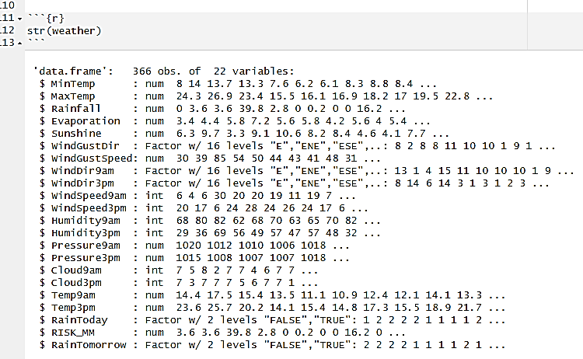
The target variable RainTomorrow for our research query is of categorical type along with RainToday, WindDir3pm, WindDir9am and WindGustDir.
Figure 1: Output of Data Preparation and Cleaning
Exploratory data Analysis:
This section examines the specifics of the weather dataset. It includes individual graphs for each variable, multivariate graphs with our target variable, correlation coefficients, and it further utilizes a supervised learning methodology known as PCA to gain insights from the data.
Univariate Graphs
Each of 22 variables from weather dataset are visualised graphically to analyse them. Histogram plots for numerical variables are applicable for univariate analyses. MinTemp, MaxTemp, WindGustSpeed, Temp9am and Temp3pm are all normally distributed. It means their values are more clustered around mean and their graphs are symmetrical in bell shape. These variables have same mean and median values. Evaporation, WindSpeed9am, Humidity3pm, WindSpeed3pm and RISK_MM are all positively skewed with more values lingering to the left side of the graph. Mean values are higher than the median for these parameters. Sunshine, Humidity9am, Pressure9am, and Pressure3pm are negatively skewed with their majority of values towards the right side of the graph and tail towards the left side. Mean value is smaller than median value for these parameters. Cloud9am and Cloud3pm have mixed distribution with skewness towards the both sides of the graph making them a little irregular in shape and values.

Multivariate Graphs
In multivariate and bivariate graphs, each variable is plotted against our dependant variable which is RainTomorrow. These variables MinTemp, MaxTemp, Rainfall, Evaporation, WindGustSpeed, WindSpeed9am, WindSpeed3pm, Humidity9am, Humidity3pm, Cloud9am, Cloud3pm, Temp9am, Temp3pm, RISK_MM are positively correlated with the target variable which means when the value of variable increases, the chances of rain also increase. However, Sunshine, WindGustDir, WindDir9am, WindDir3pm, Pressure9am, Pressure3pm, RainToday have negative correlation with Rain Tomorrow which indicates that if the value of these variables is higher, there are lower chances of rain.
Correlation Coefficient:
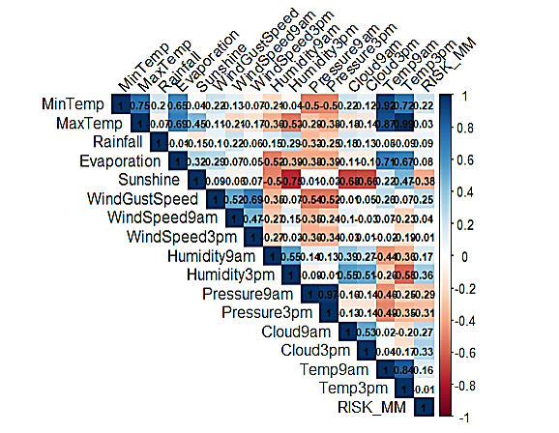
To identify the correlation between variables, we have developed correlation matrix comprising of these continuous variables, MinTemp, MaxTemp, Rainfall, Evaporation, Sunshine, WindGustSpeed, WindSpeed9am, WindSpeed3pm, Humidity9am, Humidity3pm, Pressure9am, Pressure3pm, Cloud9am, Cloud3pm, Temp9am, Temp3pm, and RISK_MM. Pearson’s method is used to calculate the matrix. The values range from -1 to 1, with 1 being highest positive correlating variables and -1 means highest negative correlation. 0 means there is no correlation. We have developed heatmap (Figure 2) to see the results.
Figure 2: Heatmap for correlation matrix
The aim of this matrix is to identify multi-collinearity. These are the few variable pairs that are highly correlated (values greater than 0.60).
- MaxTemp and MinTemp – 0.75
- Pressure9am and Pressure3pm – 0.92
- Temp9am and Temp3pm – 0.84
- Evaporation and MaxTemp – 0.69
- MaxTemp and Temp3pm – 0.99
For implementation of Machine Learning Model, I am not going to get rid of all abovementioned pairs. Only the variable pairs with values greater than 0.80 will be discarded. In my model, I will not use Pressure3pm and Temp3pm as a part of feature selection.
Principal Component Analysis
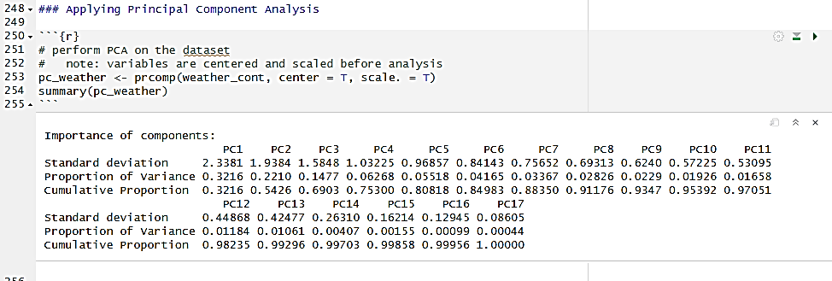
In our weather dataset, there are seventeen numerical variables. Corresponding to these variables, we have seventeen principal components (Keita, 2023). Each component accounts for a certain percentage of the overall variance in the dataset. This information is presented in the Cumulative Proportion section (refer to Figure 3). The first principal component accounts for the almost 32% variance in weather dataset. The second variable (PC 2) has a little higher variance of 54%. This suggests that nearly 54% of the data within the 17 variables of weather dataset can be explained solely by second principal component. PC6 has 86 percent of cumulative variance, which means it can describe the variance of dataset quite accurately.
Figure 3: Cumulative proportion of all Principal Components
There is loading matrix for seventeen components. The loadings of first principal component have positive values for Humidity9am, Humidity3pm, Pressure9am, Pressure3pm, Cloud9am, and Cloud3pm. It has negative values for MinTemp, MaxTemp, Rainfall, Evaporation, Sunshine, WindGustSpeed, WindSpeed9am, WindSpeed3pm, Temp9am, Temp3pm, RISK_MM. It means that probability of rain happening tomorrow is heavily reliant on humidity, pressure and cloud.
There is scree plot for eigen values showing the values from highest to lowest and a Biplot to visualise similar and dissimilar components. Sunshine, Temp3pm and MaxTemp are similar (positively correlated). In loadings (PC1, PC3 and PC4), all three values are in lower number. Pressure 9am and Pressure3pm are similar though they have higher loadings in PC1. The PCA visualisations rank the variance for each variable. Also, if I look at correlation coefficient matrix, these results can be validated.
The subsequent stage involves machine learning prediction. PCA values are not utilized in my model as Neural network is supervised learning algorithm and requires original variables for prediction.
Machine learning Prediction
I am using Neural Network for machine learning prediction to evaluate the likelihood of rain tomorrow. The rationale behind selecting a neural network for this weather dataset lies in its adaptability to diverse tasks and datasets. This enables me to potentially employ the same model across various datasets, even in my own dissertation if required. Another compelling factor is its capacity to capture intricate patterns within the data. Given that the weather dataset comprises 22 variables, the prospect of utilizing a neural network for prediction appeared intriguing. However, the primary and most significant motive is to utilize the neural network for experimentation and educational purposes. This will offer me the opportunity to gain valuable experience in implementing neural networks, fine-tuning them, conducting training, and evaluating results.
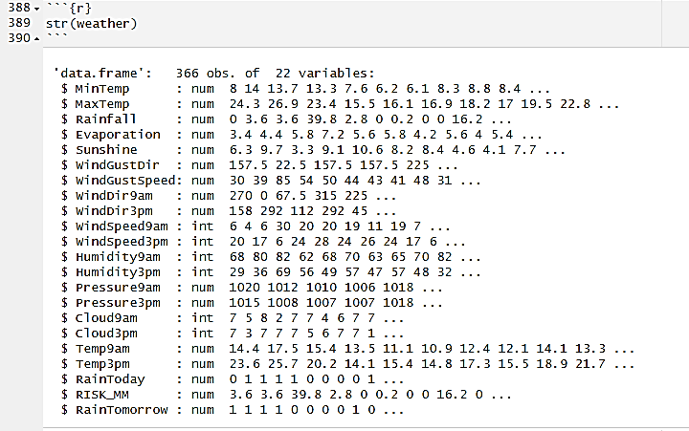
One vital feature of neural network is its capability of only processing the numerical values. As evident from data preparation (Table 1) and exploratory data analysis, weather dataset contains variety of variables. Before implementing the Neural network, I have my own individual data preparation section where I have changed the datatypes of all categorical variables to numerical continuous values. Figure 4 shows the altered datatypes.
Figure 4: Altered Datatypes for Neural Network

Prior to implementation, it's crucial to mention that, due to multicollinearity, I've removed two variables, Pressure3pm and Temp3pm, from the dataset intended for input into the neural network. Throughout the implementation process, I have utilized 13 different libraries to conduct tasks such as data cleaning, EDA, and neural network prediction.
First step is to normalise the data before applying neural network. It is essential to prepare the dataset for modeling by normalising it. This process brings all variables to a common scale, enhancing the efficiency of model training. Without normalisation, a variable with higher values could disproportionately influence the training process and subsequent output. I have applied to all variables except RainToday and RainTomorrow as I want the final classification output in Binary. These binary variables already have fixed range and it is unnecessary to scale them.
Next step is to develop training and testing tests from weather dataset, which has been normalized and no longer contains highly correlated parameters. The division is 70% and 30%. After isolating all the input or independent variables, I have trained three neural networks. Weather_nn_1 has one hidden node, weather_nn_5 has five nodes on one hidden layer and weather_nn_55 has 5 nodes on each of two hidden layers.

Results
The results of three neural network implementations are discussed in this section.
- Weather_nn_1 has one hidden node. The resultant parameters are accuracy, confusion matrix and area under the curve. The accuracy is 0.754. The confusion matrix and area under the curve (AUC) are given in Figure 5.
- Weather_nn_5 has five hidden nodes on one hidden layer. The accuracy is 0.981.
- Weather_nn_55 has five hidden nodes on both hidden layers. The accuracy is 0.945.
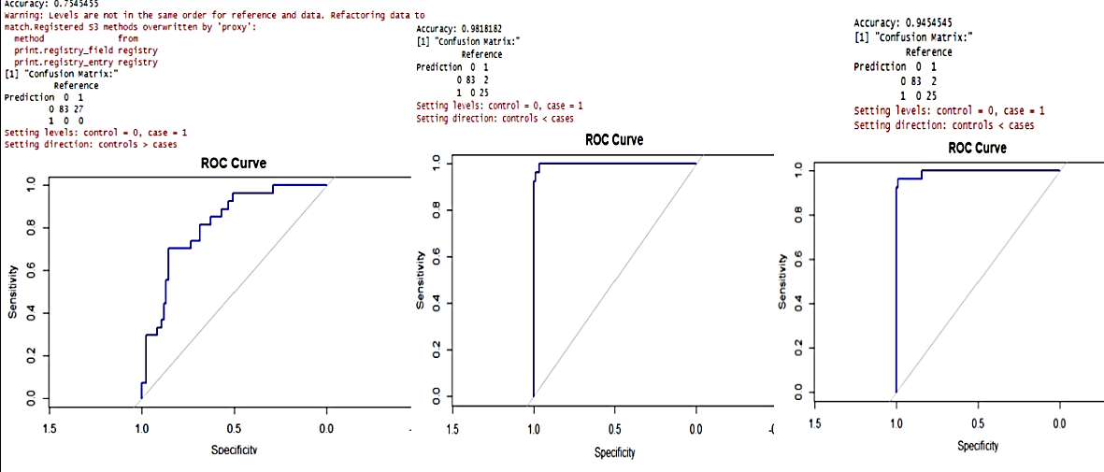
Figure 5: Accuracy, Confusion Matrix and ROC for three Neural Networks

The highest accuracy is achieved by weather_nn_5, as indicated by the area under the curve (AUC) showing distinct classes with higher values. The second-highest accuracy is observed in weather_nn_55, which also displays a higher AUC. On the other hand, weather_nn_1 exhibits the lowest accuracy, with AUC values relatively lower compared to other models.
High Performance Computational Implementation
For this part I have used Apache Spark to perform basic data cleaning. I also apply neural network on weather dataset. I have successfully designed and implemented both parts in Google Colab but there are few limitations in the work.
Data cleaning part is performed on weather dataset will all the variables inclusive. Data cleaning entails following steps
- Install and set the pyspark session
- Load the weather dataset into the content folder of Google Colab.
- Convert WindGustDir, WindGust, WindDir9am, WindDir3pm, RainToday and RainTomorrow columns to numerical type using pandas and pyspark libraries
- Replace the missing values in WindGustDir, WindDir9am, and WindDir3pm with NW, SE and NW.
- Convert Sunshine, WindGustSpeed, and Windspeed9am to float type and calculate median values to replace the missing values.
- At this point all the columns are converted to numerical type and all the missing values are replaced by appropriate methods
- Data is ready to input to Neural Network
In Google Colab, I don’t have enough capability to run a neural network with multiple hidden nodes and layers for all 22 columns. The maximum allowed number of variables are four, with fourth one being the target variable. The selection of the three independent variables is based on their correlation values. Rainfall, Cloud9am, and RISK_MM exhibit the lowest correlation with each other; hence these variables will be utilized. The correlation value among these variables is less than 0.20.
- Install and set the pySpark session
- Load the weather dataset into the content folder of Google Colab.
- First convert the variables to binary (target variable) and numerical types.
- Vector assembler is used to spit dependent and target variables.
- After splitting the data into training and testing sets with a 70-30 ratio, the neural network architecture is specified. It includes 2 nodes in the first hidden layer, 2 nodes in the second hidden layer, and 2 output nodes for binary output.
- The model is created, trained and tested.
- Evaluation measures for this neural network are also accuracy, precision, Recall and F1-score consistent with Machine learning prediction.
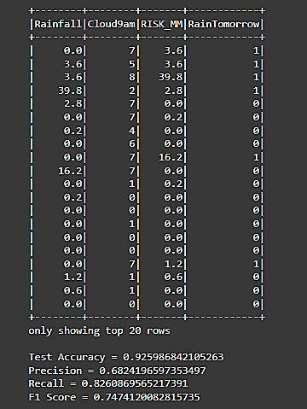
- This model will be referred to as weather_nn_hpci. The evaluation values are shown in Figure 6
Figure 6: Neural Network Model Efficiency

Performance evaluation and comparison of methods
There are numerous performance evaluation metrics for assessing model performance, some of which are already elaborated upon in previous sections of Machine Learning and High-Performance Computation implementation. Accuracy, confusion matrix and Area under the curve are calculated for each model of Neural Network and compared in figure 6. With the help of confusion matrix, we can derive few more measures and compare them.
 | Precision | Recall | F1-score
Weather_nn_1 | 0.754 | 1 | 0.860
Weather_nn_5 | 0.976 | 1 | 0.988
Weather_nn_55 | 0.932 | 1 | 0.965
Table 2: Performance Evaluation Measures for Neural Network
The neural network has no false negatives, it effectively predicts all the outcomes of positive class. Weather_nn_5 has highest precision, accuracy and F1 score. Weather_nn_55 is at second place and weather_nn_1 has lowest precision, accuracy and F1 score.
In addition to these three models, I have also implemented a neural network using pySpark. However, due to space constraints and other factors, the dataset contains only three dependent variables. This has significantly impacted the evaluation metrics of the neural network implementation (evident from Table 2).
The other two methods implemented on this dataset are Random Forest and Support Vector Machines. Both of these methods and the results of neural network are provided Table 3 for comparison.
 | Accuracy | Precision | Recall | F1-score
Weather_nn_1 | 0.754 | 0.754 | 1 | 0.860
Weather_nn_5 | 0.981 | 0.976 | 1 | 0.988
Weather_nn_55 | 0.945 | 0.932 | 1 | 0.965
Weather_nn_hpci | 0.925 | 0.682 | 0.826 | 0.747
Random Forest | 0.790 | 0.932 | 1 | 0.965
Support Vector Machine | 0.981 | 0.976 | 1 | 0.988
Table 3: Comparison of methods
The values presented in Table 3 are not rounded off; instead, they are precise to three decimal places to ensure uniformity in results. My group members (2350639 and 2346388) have implemented Random Forest and Support Vector Machines on the weather dataset. The outcomes closely resemble the results from my Neural Network implementation in Machine Learning. All of these machine Learning models were developed under identical conditions, utilizing the same dataset. After correlation coefficient check, highly correlated variables were removed from each model.
The value of Recall is same for every ML model. With Random Forest accuracy is 80%, precision is 93% and f1 score is 97%. For SVM, accuracy is 98%, precision is 98% and F1 score is 99%. Overall, weather_nn_1 has the lowest accuracy and performance. Two models, weather_nn_5 and SVM, demonstrate the highest performance, showing identical metrics across the board.
The model weather_nn_hpci stands out with differing results. As mentioned earlier, this model lacks comprehensive information and is constrained by limitations. Its accuracy is 93%, precision is 68%, recall (unlike all other models) is 83%, and the F1-score is 75%. These outcomes are notably distinct.

Discussion of the findings
Table 3 presents a comparison of all the models developed for evaluation. While machine learning prediction models exhibit consistent results, high-performance computational implementation yields different outcomes.
The accuracy and precision of the models varies between 75% and 98%. The 75% accuracy indicates moderate performance of the model with one hidden node. While achieving 75% of correct predictions is commendable, a comparison reveals potential for improvement. Accuracy and precision can be increased up to 98% by employing more hidden nodes or utilizing different methods.
Attaining higher values for precision, recall, and F1 score is desirable, but it may also indicate potential data errors. Notably, the recall value remains consistent (at 1) across all machine learning models, suggesting potential overfitting in the training data. This tendency is more likely when dealing with a small number of observations, as is the case with the weather dataset. While the results may appear favorable, the system could struggle to predict rain in real-life scenarios for the following day. The high values of evaluation metrics indicate thorough data scrutiny, ensuring the absence of missing, improper, or duplicated values. However, they may also reveal other issues such as class imbalance and data bias or unfairness. Across all our models, we overlooked class balancing, which could be impacting our final outputs. This imbalance likely contributes to a form of bias evident in our results.
In the case of weather_nn_hpci, a significant concern arises from the considerable disparity between accuracy and precision values. The lower precision values may indicate other potential problem areas. These models struggle with accurately identifying positive instances, often misclassifying negative instances as positive due to the poor quality of negative predictions integrated into the model in some way. Additionally, class imbalance might also be causing this difference. When there are notably fewer negative instances, the model faces difficulty in predicting them accurately.
Considerable improvement is needed on our part to enhance the performance of these models. Overfitting of the training data is evidently present across all models. One lesson learned is the importance of carefully selecting datasets. The weather dataset should have been more diverse, with a significantly larger number of observations than 367. Although there are 22 columns, upon closer examination, it becomes apparent that 2 or 3 columns provide similar information, such as repeated columns of temperature, pressure, wind speed, wind direction, and cloud cover at various hours throughout the day have almost same data. A more diverse range of information could potentially reduce overfitting. Additionally, failing to do class balancing before model implementation is a noteworthy observation in the results. Class imbalance significantly impacts predictions by introducing bias towards the positive class. K-fold cross validation and tunning can be applied to obtain more perspective and avoid these issues. For the HPCI implementation, it would have been beneficial to explore other platforms with more options for data exploration.
The results answer to the research question by implementing various distributed data analysis techniques to accurately predict probability of rainfall tomorrow based on historical weather data, considering factors such as temperature, humidity, wind speed, and atmospheric pressure. The objectives are achieved sequentially throughout the process.
Data Management plan and Author Contribution Statement:
- Overview
Researcher: Summiya Alam, Arvinder Kaur, Yan Cui
Project title: Rain Prediction
Project duration: Up to 150 hours
Project context: Perform distributed data analysis to generate value and insights from heterogenous data using ML and HPCI Implementation
2. Defining your data/research sources
2.1 Where will your data/research sources come from? Open-source dataset is acquired from Kaggle ()
2.2 How often will you get new data? Dataset is acquired once; weekly changes are made as per implementation requirements.
2.3 How much data/information will you generate? 8KB is generated for HPCI implementation. 32KB is goal for Machine learning implementation.
2.4 What file formats will you use? CSV file is used. It can be accessed using R or python.
3. Organising your data
3.1 How will you structure and name your folders and files? Self-explanatory and descriptive names with hierarchical folders for version control.
3.2 What additional information is required to understand each data file? Data description is enough to understand the data.
3.3 What different versions of each data file or source will you create? At the moment I have two, Labeled as weather and weather1.
4. Looking after your data
4.1. Where will you store your data? In laptop and Git hub.
4.2 How will your data be backed up? Online backup, updated after every change.
4.3 How will you test whether you can restore from your backups? Download and assess from online backup to validate the reliability of storage
5. Sharing your data
5.1 Who owns the data you generate? Data insights are generated from open-source dataset. It is no one’s ownership, can be openly shared.
5.2 Who else has a right to see or use this data? It is no one’s ownership, can be seen by anyone interested.
5.3 Who else should reasonably have access to this data when you share it? Anyone interested in the topic
5.4 What should/shouldn’t be shared and why? It can be openly shared
6. Archiving your data
6.1 What should be archived beyond the end of your project? Everything
6.2 For how long should it be stored? As long as it is valid
6.3 When will files be moved into the data archive/repository? After submission
6.4 Where will the data be stored? Online repository GitHub
6.5 Who is responsible for moving data to the data archive and maintaining it? I am responsible for my part.
6.6 Who should have access and under what conditions? Access is not restricted; it is generated from open-source data
7.Executing your plan
7.1 Who is responsible for making sure this plan is followed? All researchers
7.2 How often will this plan be reviewed and updated? Weekly meetings
7.3 What actions have you identified from the rest of this plan? Close the last update on 15th of April, 2024
7.4 What further information do you need to carry out these actions? Communicate with other researchers for intact version control

Author Contribution Statement:
Arvinder Kaur (2350639). and Summiya Alam (2340875). designed and formulated the data collection and cleaning process. Yan Cui (2346388) has performed PCA analysis and type conversion. All three are responsible for exploratory data analysis and graphs formation.
References
Stolpe, M. (2016). The Internet of Things. ACM SIGKDD Explorations Newsletter, 18(1), pp.15–34. doi:https://doi.org/10.1145/2980765.2980768.
Wang, L. (2017). Heterogeneous Data and Big Data Analytics. Automatic Control and Information Sciences, 3(1), pp.8–15. doi:https://doi.org/10.12691/acis-3-1-3.
MUTHUKUMAR.J (n.d.). Weather Dataset. [online] www.kaggle.com. Available at: https://www.kaggle.com/datasets/muthuj7/weather-dataset.
Keita, Z. (2023). R PCA Tutorial (Principal Component Analysis). [online] www.datacamp.com. Available at: https://www.datacamp.com/tutorial/pca-analysis-r.

Appendix
The appendix material is submitted as a zipped Archive with following files
- HPCI for Analysis.zip folder containing two datasets and Google Colab File
- Machine Learning Prediction.zip Containing .rmd file and weather dataset

