**Drone Simulator Software***ZOHA AHSAN*

This is not the final code, just my version of it that shows the what logic I followed.  
Most of the functions that were required have been written.

**Rough Draft of CODE:**

#include <iostream>

#include <conio.h>

#include <cstdlib>

#include <ctime>

using namespace std;

int success = 0;

int fail = 0;

int delay = 0;

void startDay();

int getWeather(int &drain);

bool check_obstacle(int &drain);

void DisplaySummary(int success, int fail, int delay);

int main() {

int drain = 0;

int battery = 100;

srand(time(0));

startDay();

for (int location = 1; location <= 3; location++) {

cout << "--------------------------------------\n";

cout << "Location " << location << " : \n";

int Weather = getWeather(drain);

bool obstacle =check_obstacle(drain);

}

battery -= drain;

DisplaySummary(success, fail, delay);

cout << "Battery Remaining = " << battery << " %" << endl;

_getch();

return 0;

}

void startDay() {

cout << "WELCOME TO THE DELIVERY DRONE SIMULATOR!\n";

cout << "_______________________________________\n";

cout << "Total Battery = 100%"<< endl;

}

int getWeather(int& drain) {

cout << "Weather condition : ";

int Weather = 1 + rand() % 3;

switch (Weather) {

case 1:

cout << "SUNNY\n";

break;

case 2:

cout << "RAINY\n";

break;

case 3:

cout << "WINDY\n";

}

if (Weather == 1) {

drain += 15;

cout << "Proceeds for delivery\n";

success++;

}

if (Weather == 2) {

cout << "Delivery delayed\n";

delay++;

}

if (Weather == 3) {

cout << "Delivery not possible\n";

fail++;

}

return Weather;

}

bool check_obstacle(int& drain) {

int obstacle = 1 + rand() % 2;

switch (obstacle) {

case 1:

cout << "NO OBSTACLE DETECTED\n";

break;

case 2:

cout << "OBSTACLE DETECTED\n";

}

if (obstacle == 1) {

cout << "Proceeds normally\n";

}

if (obstacle == 2) {

drain += 25;

cout << "Reroutes\n";

}

return obstacle;

}

void DisplaySummary(int success, int fail, int delay) {

cout << "_______________________________________\n";

cout << " DELIVERY SUMMARY \n";

cout << "_______________________________________\n";

cout << "Deliveries successful : " << success << endl;

cout << "Deliveries failed : " << fail << endl;

cout << "Deliveries delayed : " << delay << endl;

}

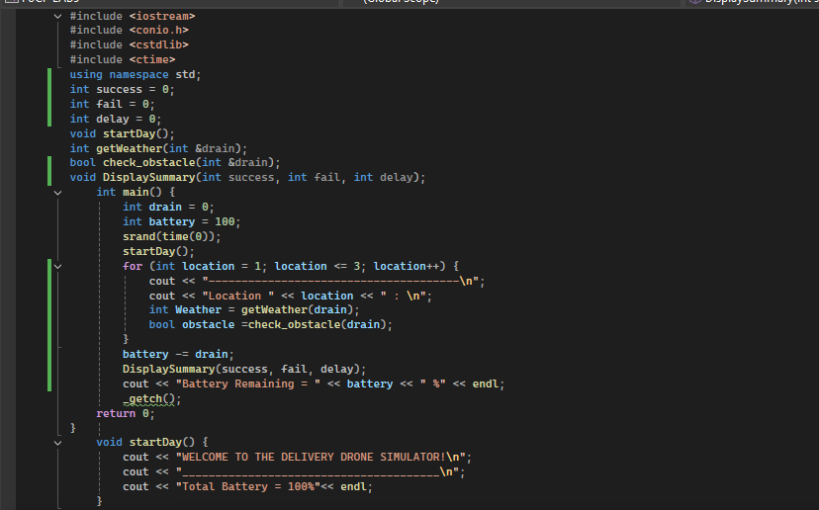

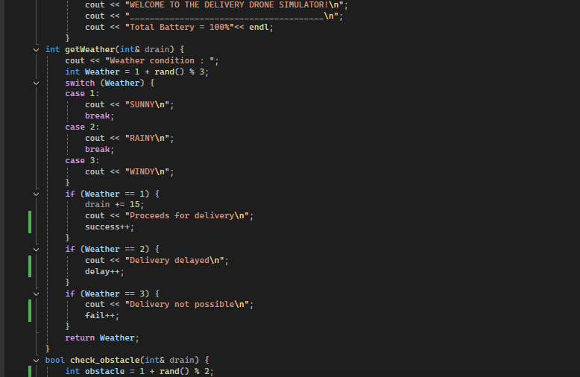

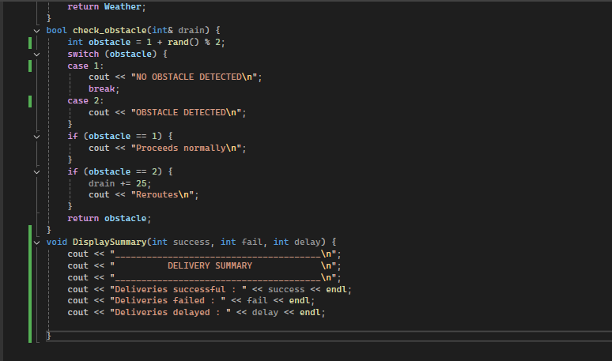

FIRST SAMPLE RUN:

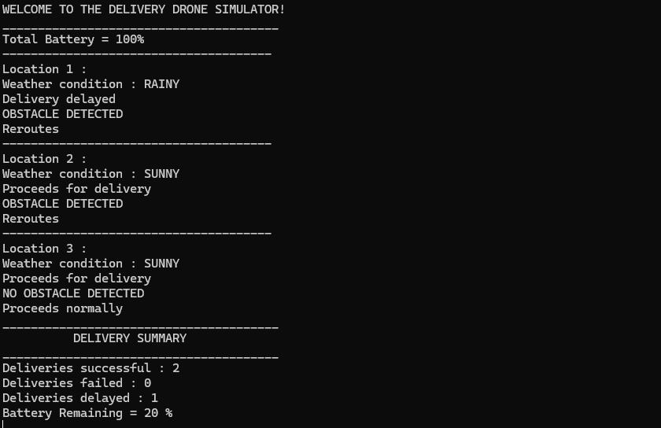

SECOND SAMPLE RUN:

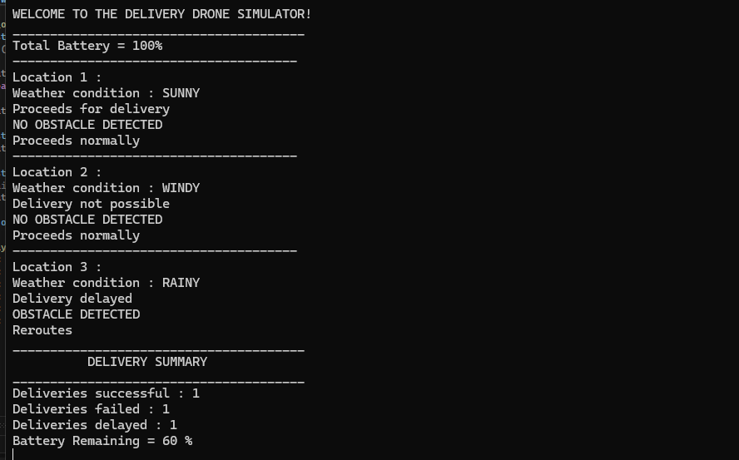

THIRD SAMPLE RUN:

