**Iteration 2:**

After the basic configurations and installations from the iteration 1, started working with the text to voice converter model.

**Prerequisites (for windows machine):** Python 3.10>, espeak-ng software

The python version required to run this model is **python>=3.7, <3.11**

**For windows:**

Link for the executable file: [**https://github.com/espeak-ng/espeak-ng/releases/tag/1.51**](https://github.com/espeak-ng/espeak-ng/releases/tag/1.51)

Download the espeak-ng-X64.msi file from the url linked above and run the executable, add the .exe file path to the environment variables.

**Testing espeak-ng:**

**espeak-ng --help**

The text entered after the espeak-ng command is converted into audio format and can be heard. This indicates that the library is installed successfully.

**Install TTS: (text-to-speech library) to load and work with different models**

Pip install TTS

**Connecting with tts-server and loading different models:**

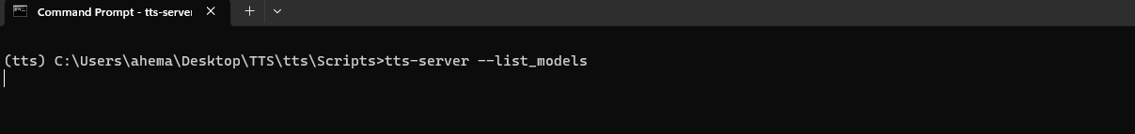

**Checking a model information from the list:**

tts --model_info_by_name tts_models/ja/kokoro/tacotron2-DDC

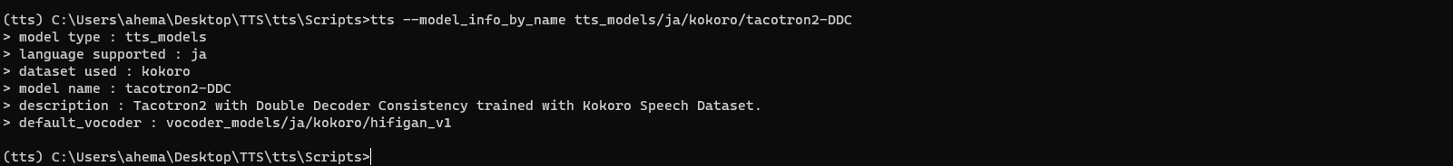

**Loading and working with model:**

**test_model.py:**

from TTS.api import TTS

from playsound import playsound

print("Testing text to voice model..")

language = input("enter the language model you want to work with, you can choose from: \n1. English,\n 2.Japanese,\n 3.French,\n 4.Danish,\n 5.Italian\n enter an option number for ex: 1 or 2\n")

text = input("enter the text to convert.\n")

print('loadig model please be patient...')

if(language == 'English' or language == '1'):

    model = "tts_models/en/ljspeech/vits"

elif(language == 'Japanese' or language == '2'):

    model = "tts_models/ja/kokoro/tacotron2-DDC"

elif(language == 'French' or language == '3'):

    model = "tts_models/fr/css10/vits"

elif(language == 'Danish' or language == '4'):

    model = "tts_models/da/cv/vits"

elif(language == 'Italian' or language == '5'):

    model = "tts_models/it/mai_female/vits"

# Init TTS with the target model name

tts = TTS(model_name=model, progress_bar=False, gpu=False)

print('model loaded successfully!!')

print('converting text to audio...')

# Run TTS

tts.tts_to_file(text=text, file_path="out.wav")

playsound('./out.wav')

**Outcomes and Future works:**

Successfully loaded the model and tested the text to audio converter models for different languages, for the iteration 3 need to work on the front end part of the application.