**Iteration 4:**

After the basic configurations and installations from the iteration 1, we have started working with the text to voice converter model for the iteration 2. We have worked with different language models and tested them with the python code on our console. For the iteration 3 we have started working on the user interface design using the streamlit python framework.

**(Based on the feedback that we received from the flash talk where we shared the progress of the project work, we have made changes to the application by introducing the translate api/ library. Using the googletrans library we are able to translate the text and also detect the language of the text that is entered.)**

**Prerequisites (for windows machine):** Python 3.10>, espeak-ng software

The python version required to run this model is **python>=3.7, <3.11**

**For windows (streamlit installation):**



**Python code using Streamlit:**

**Input /Output:**

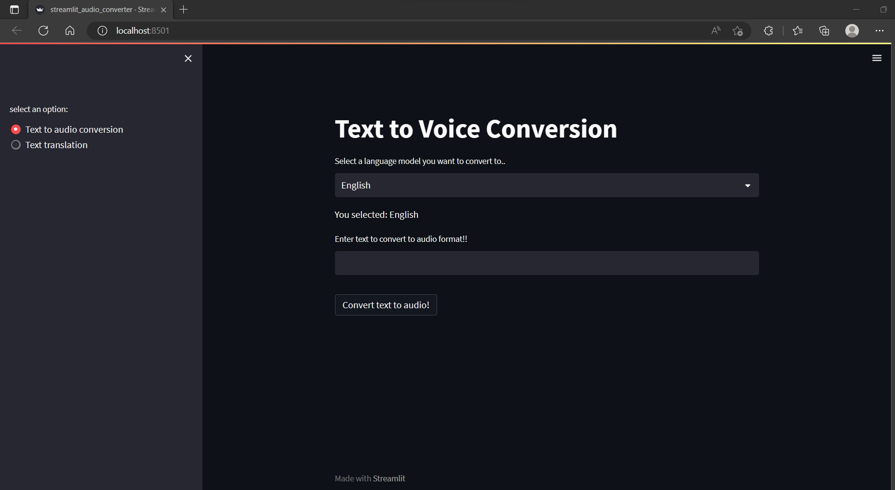

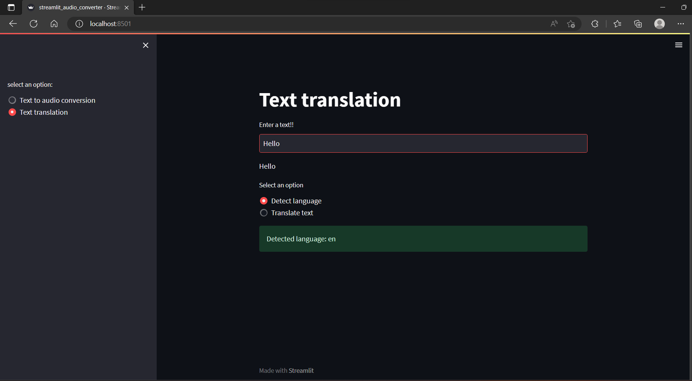

**Outcomes and Future works:**

Successfully created the user interface using the streamlit python framework and tested the model against different languages. Also deployed the code to cloud provider and the service is working. Based on the suggestions by professor from the flash talks we were able to include the text translation and text language detection feature and tested the feature against different languages.