**DESIGN – A study to upgrade ‘MyEntry’ application User Interface.**

Table of Contents

1. Introduction:- 3

2. Login Page:- 3

3. Home Page:- 6

4. Page design on menu selection:- 8

5. Update VISITOR LOGIN TIME 10

6. UPDATE VISTIOR LOGOUT TIME 10

7. ENTER VISITOR DETAILS 11

8. ASSETS MOVEMENT 12

9. ADMIN HOME PAGE:- 13

# Introduction:-

It’s a study about design proposal to enhance the Look & Feel of ‘***MyEntry***‘(A Security application used to log about people & assets move in and out of the development center) application User Interface. The web application is launched by <http://anvesh.wipro.com/MyEntry/>

# Login Page:-

It shows the existing design of the application login page.

* 1. Existing Page:-

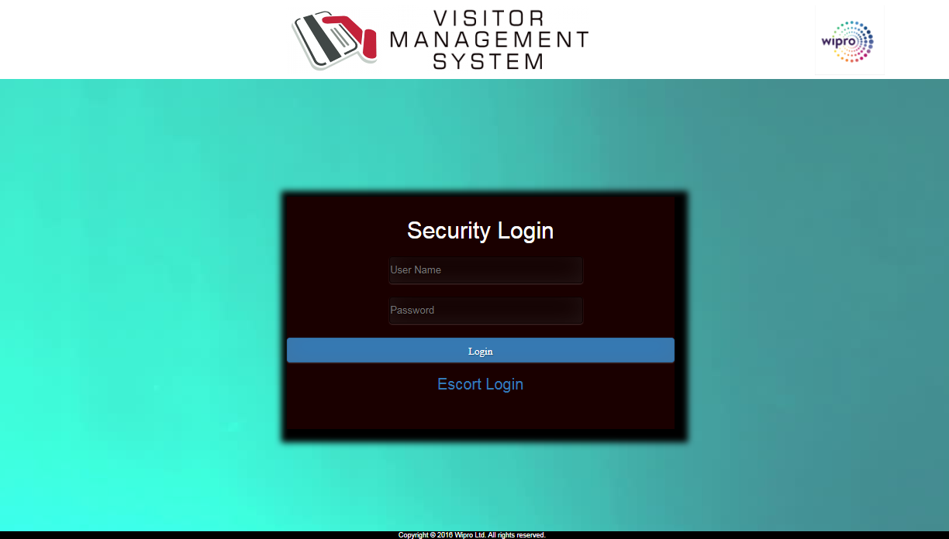

Figure : Security Login

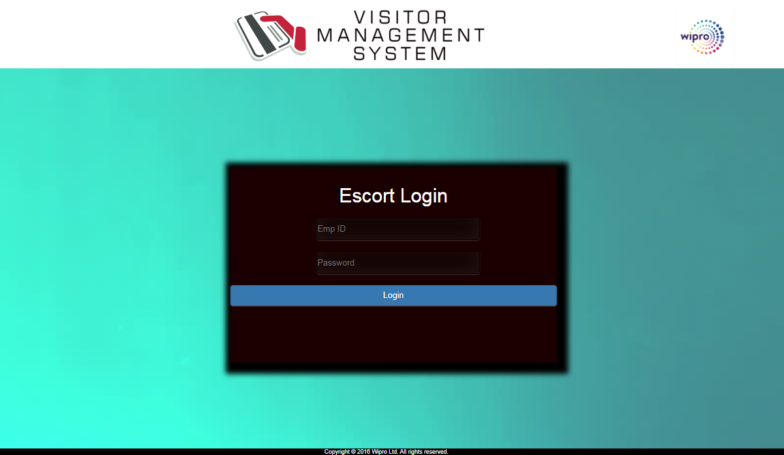

Figure : Escort Login

* 1. Design Proposals:-

Below are the suggestions to login page,

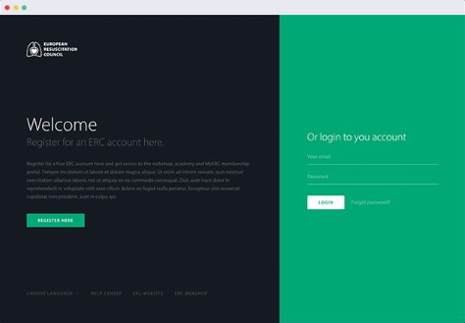

Figure : Option 1

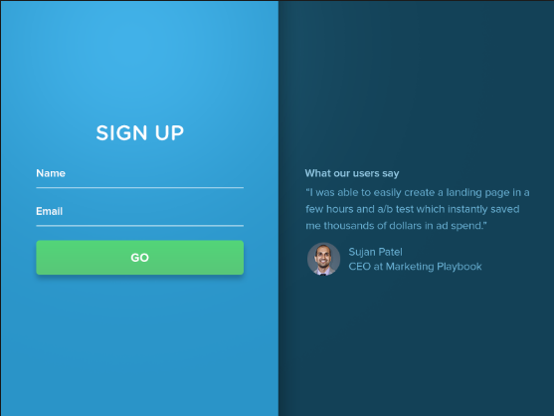

Figure : Option 2

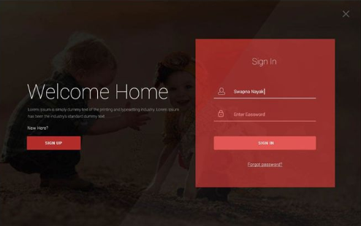

Figure : Option 3

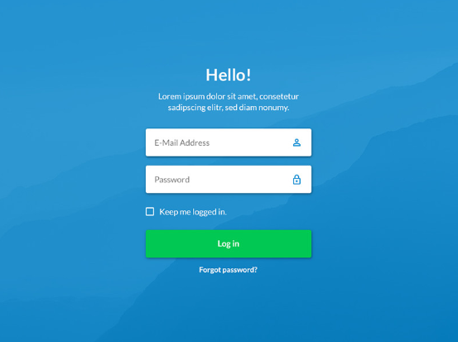

Figure : Option 4

And the below design is proposed for login page,

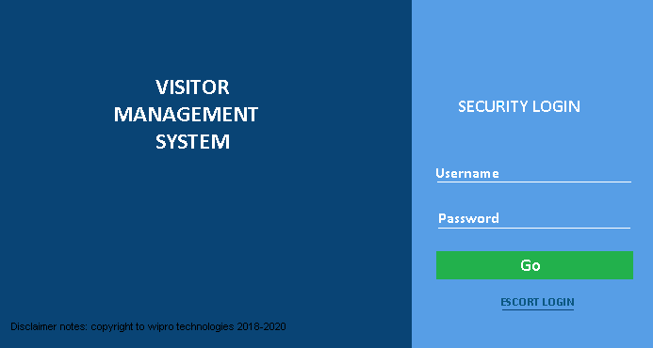

Figure : Proposed login page design

# Home Page:-

On successful ‘Security’ login, below home page displays to users,

* 1. Existing home page design:-

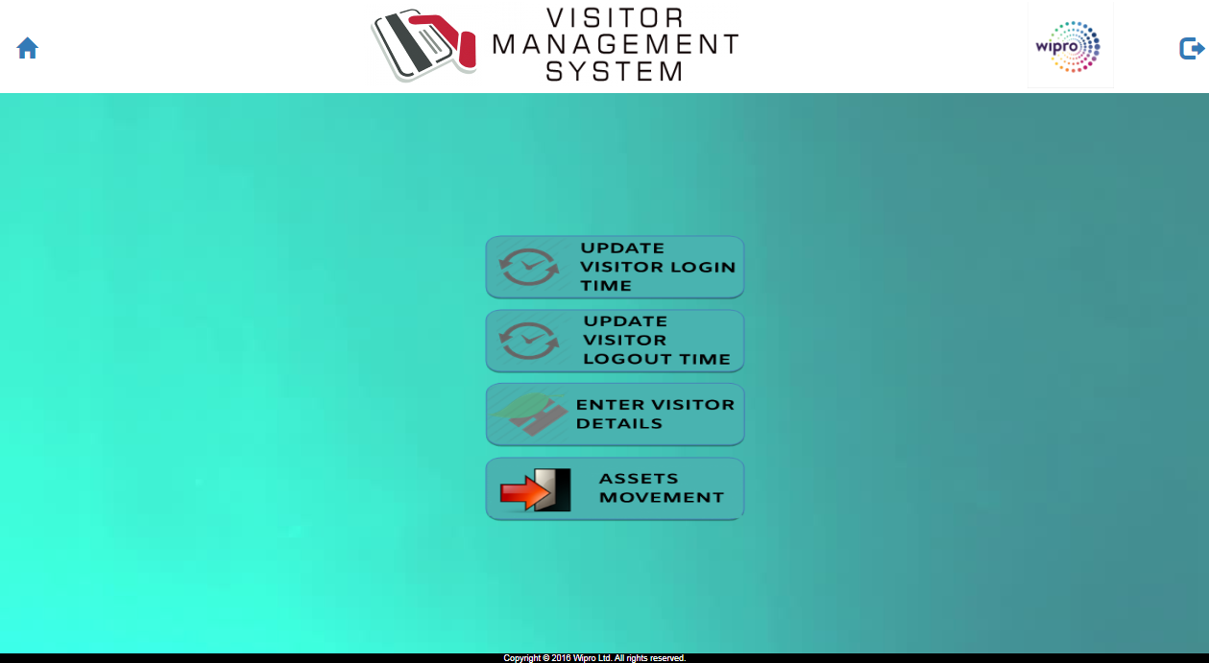

Figure : Existing design for home page

* 1. Design Proposals:-

The design suggestion where it proposes to have all the four menus placed horizontally on top is shown below. On selection of the menu, the controls are opened on the page and allowed to proceed as per user actions. The screen is divided into two and it recommends using banner at the first horizontal space.

The same menus are recommended to provide as image button at the second horizontal space. Hence the proposed the design for home page is,

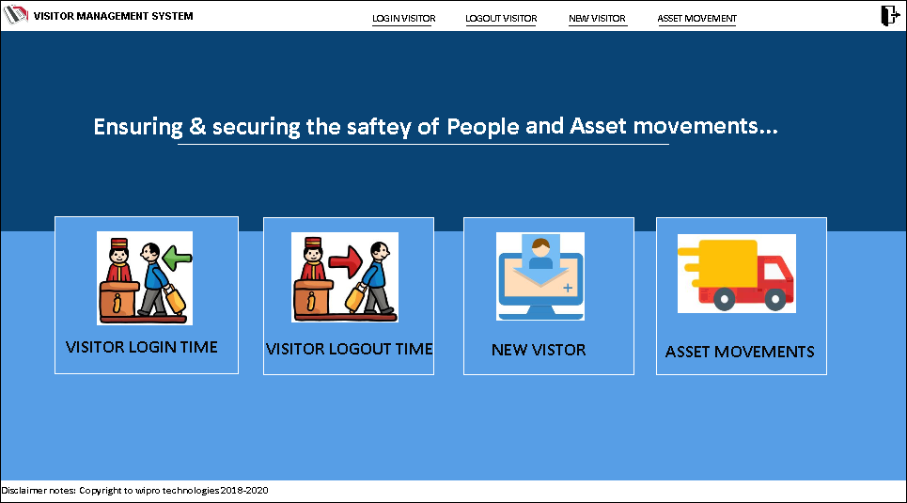

It recommends providing banner (Create using Adobe Photoshop) at the background of horizontal spaces which will provide rich appearance to application home page.

# Design on menu selection:-

On selection of the menu, the respective page having the controls is displayed as shown below. Here it shows page for the selection of ‘Visitor Login Time’. Its advantage is that alternate menus can be selected from current page without going back to home page.

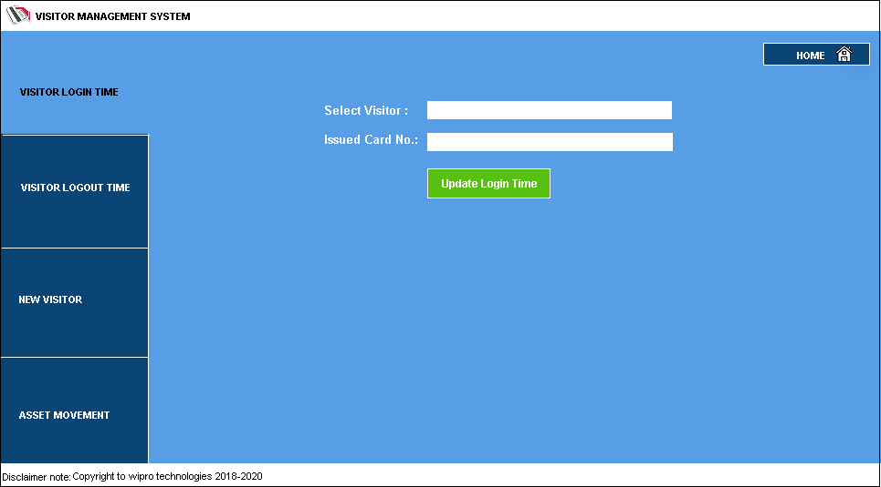

The above is based on general designs available with latest web sites. An example below. It is recommended to align the controls [Textfields, Dropdowns, ListBoxes, Buttons etc] as if packed in a rectangle/square panel.

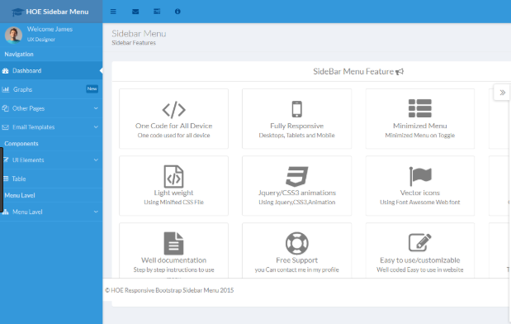

# Update VISITOR LOGIN TIME

* 1. Existing page for updating visitor Login time.

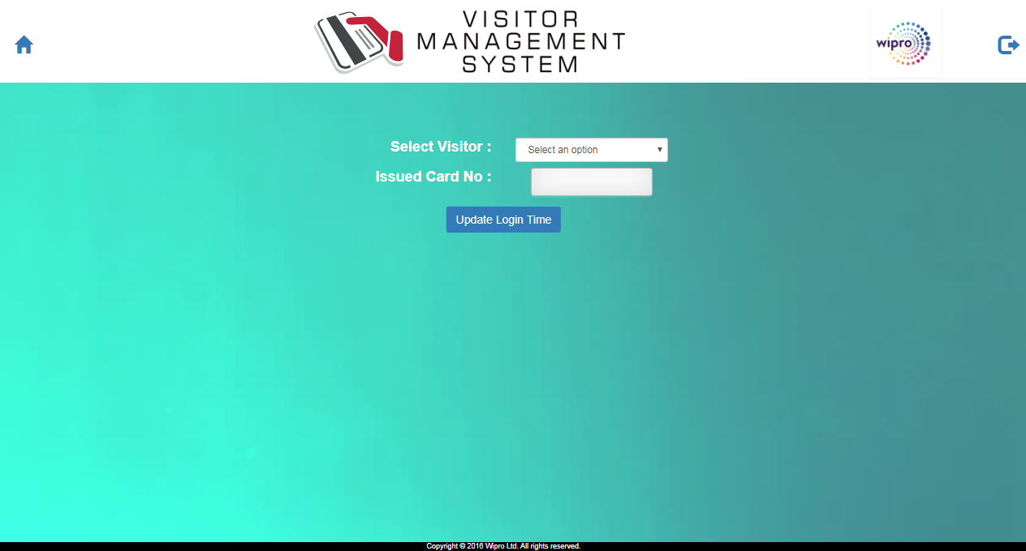

* 1. Design Proposal:

The design mentioned under section: 4 applicable here.

# UPDATE VISTIOR LOGOUT TIME

* 1. Existing page for updating visitor logout time.

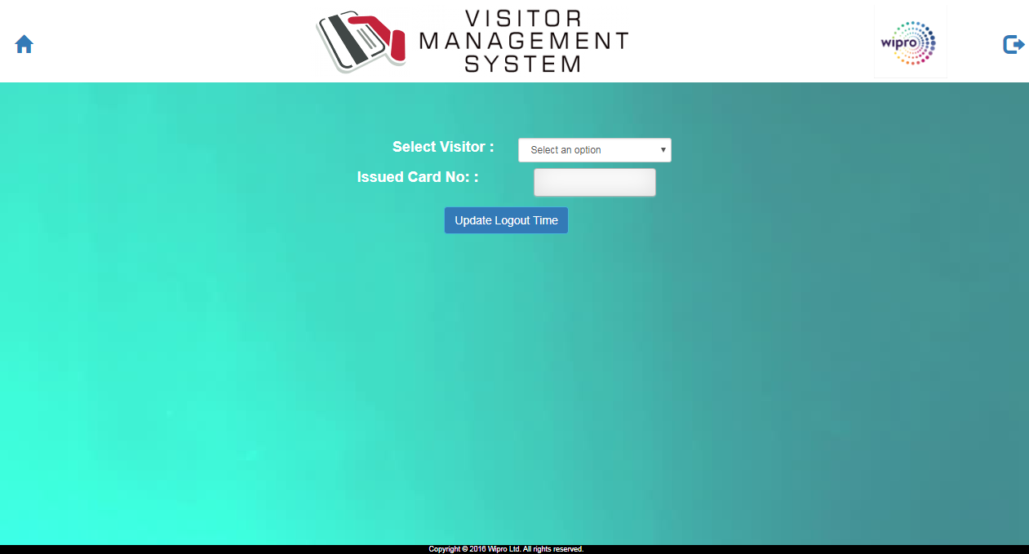

* 1. Design Proposal:

The design mentioned under section: 4 applicable here.

# ENTER VISITOR DETAILS

* 1. Existing design for entering visitor details

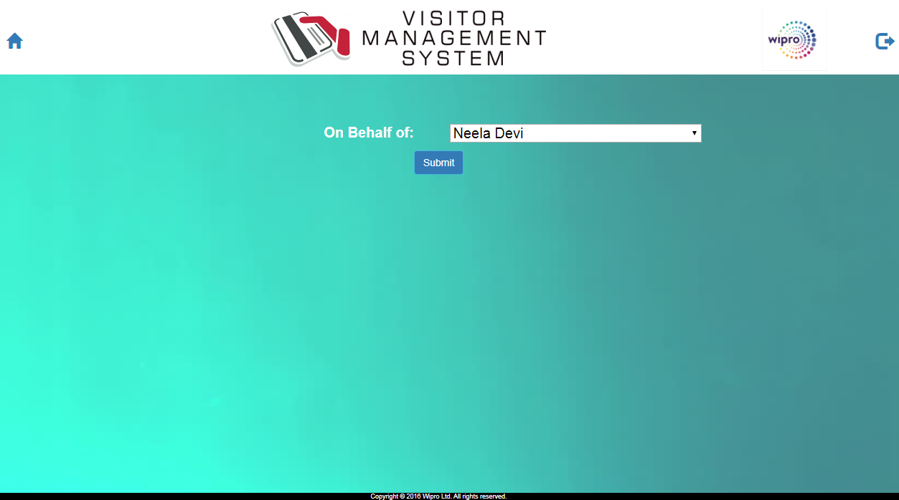

* 1. Design Proposal:-

The design mentioned under section: 4 applicable here.

# ASSETS MOVEMENT

* 1. Existing design for Asset movement:-

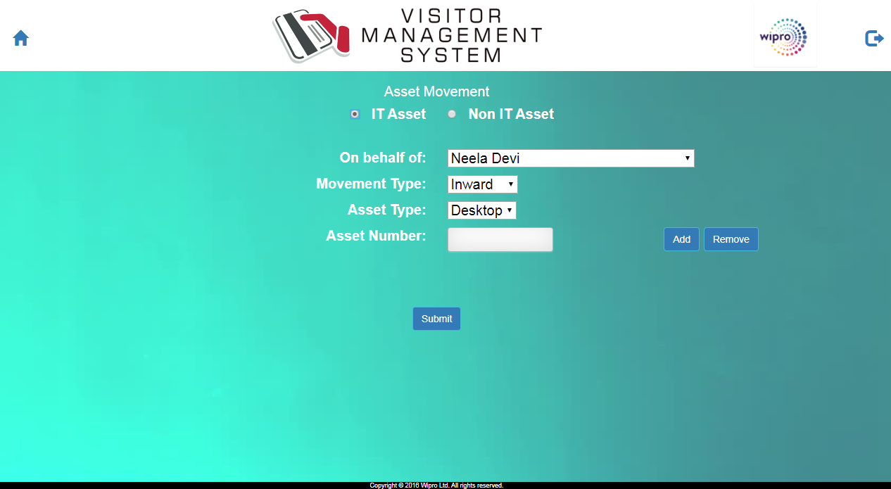

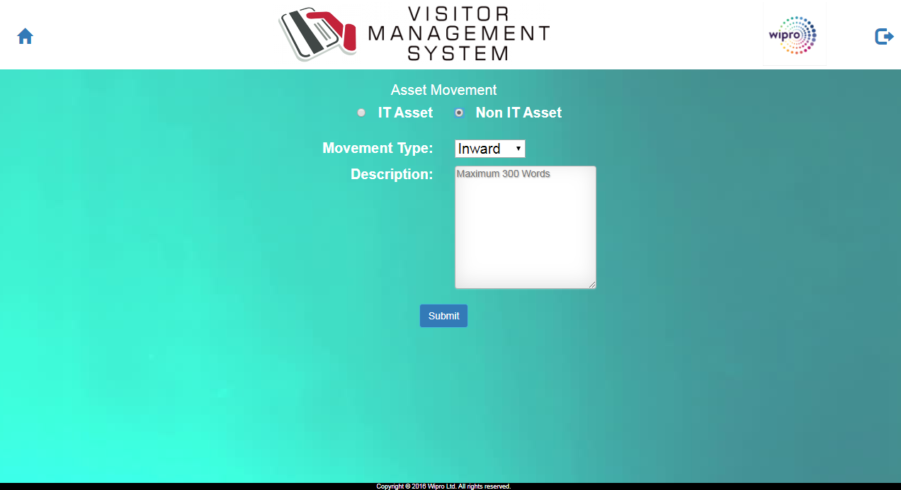

* 1. Design Proposal:-

The design mentioned under section: 4 is applicable here.

# ADMIN HOME PAGE:-

* 1. Existing design

Will be updated**

* 1. Design Proposal

Below design has been proposed for ‘Admin home page’. Upon selection of the image menu selections, respective page containing the controls will be opened. The design of the page is as mentioned in section 4.

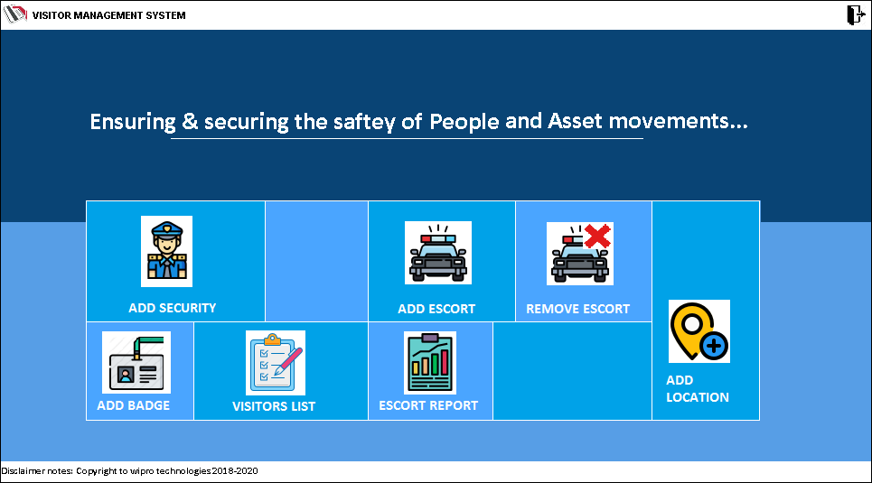

Note: It is recommended to use banners in the background at horizontal space that would give rich appearance for the application.