WEB DESIGN – A study to enhanceapplication page designs...

Table of Contents

1. Introduction 3

2. Login Page 3

3. Home Page 6

4. Update VISITOR LOGIN TIME 7

5. UPDATE VISTIOR LOGOUT TIME 7

6. ENTER VISITOR DETAILS 8

7. ASSETS MOVEMENT 8

# Introduction

An attempt to enhance the Look & Feel of User Interface of ‘***MyEntry***‘(A security application used to log about the users who enter & exit the development center) application. The page address is <http://anvesh.wipro.com/MyEntry/>

# Login Page

* 1. Existing Page:-

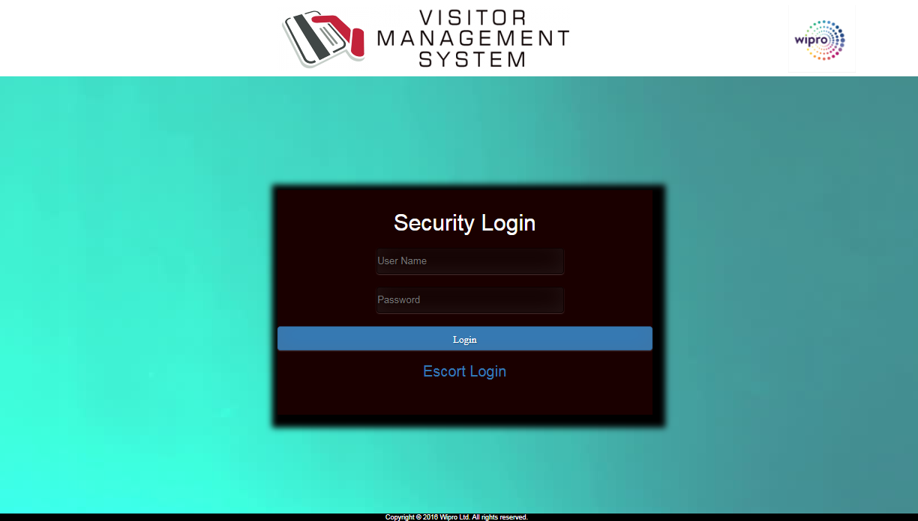

Figure : Security Login

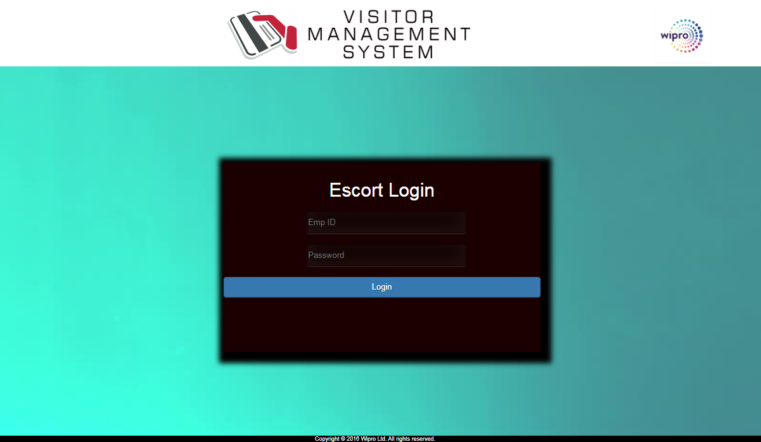

Figure : Escort Login

* 1. Design Proposals:-

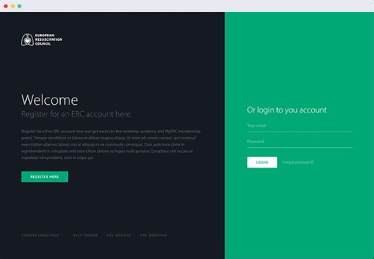

Figure : Option 1

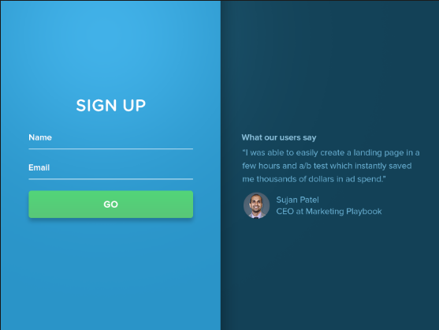

Figure : Option 2

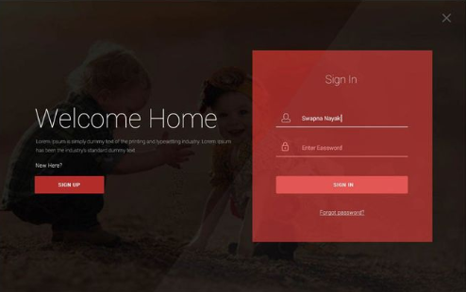

Figure : Option 3

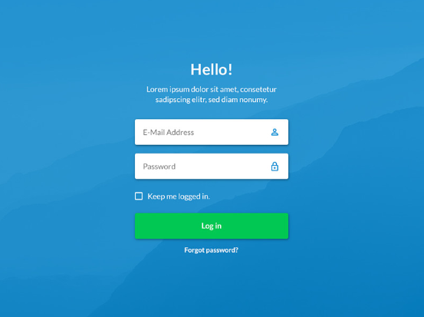

Figure : Option 4

# Home Page

* 1. Existing home page:-

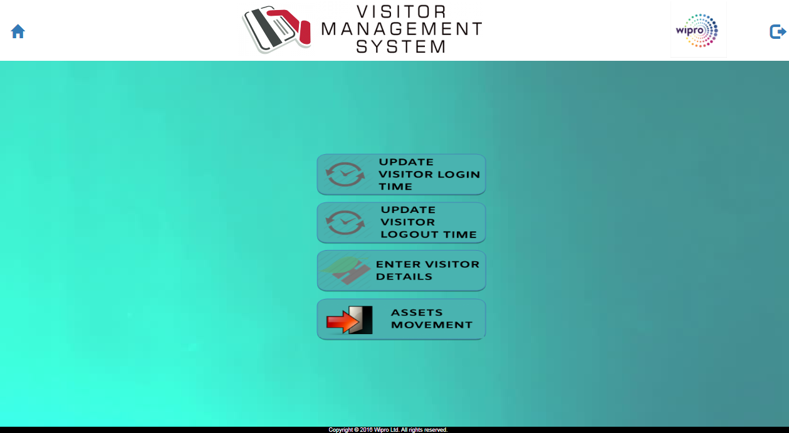

Figure : Existing design for home page

* 1. Design Proposals:-

It propose to have all the four menu on top as a single row as shown below. On selection of the menu, the controls opened in the page and allowed to proceed as per user actions.



It propose to have all the four menu on left vertical pane as a single column as shown below. On selection of the menu, the controls will be opened in the page and allowsuser to proceed as per selections.

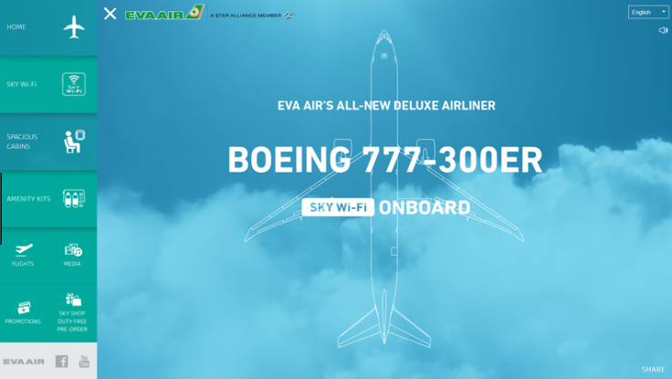

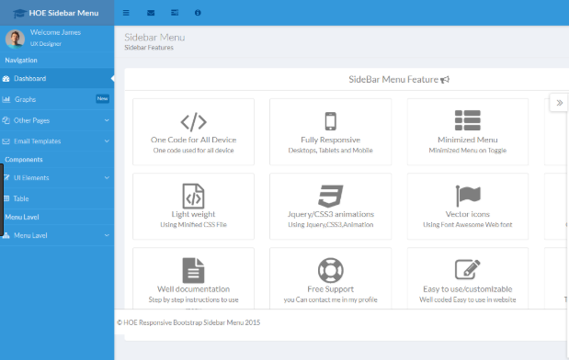

# Update VISITOR LOGIN TIME

* 1. Existing page for updating visitor Login time.

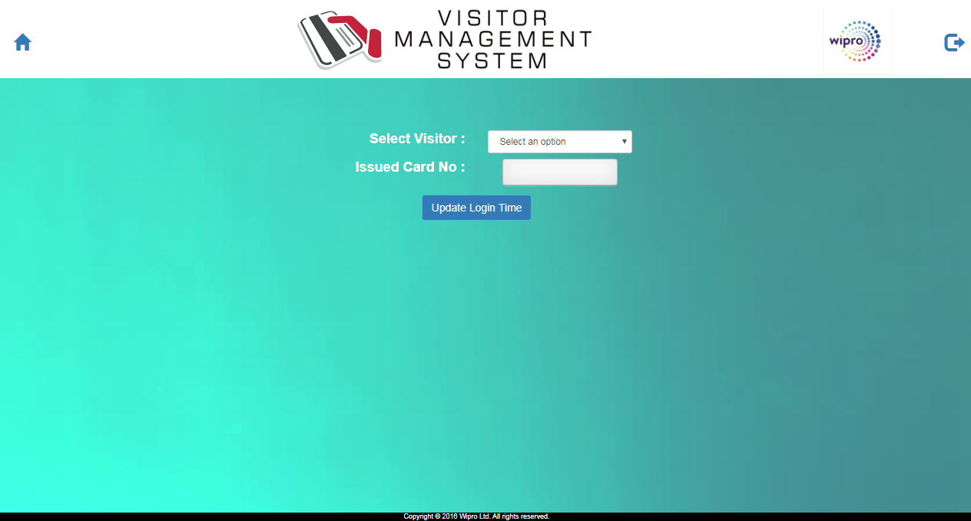

* 1. Design Proposal:

# UPDATE VISTIOR LOGOUT TIME

* 1. Existing page for updating visitor logout time.

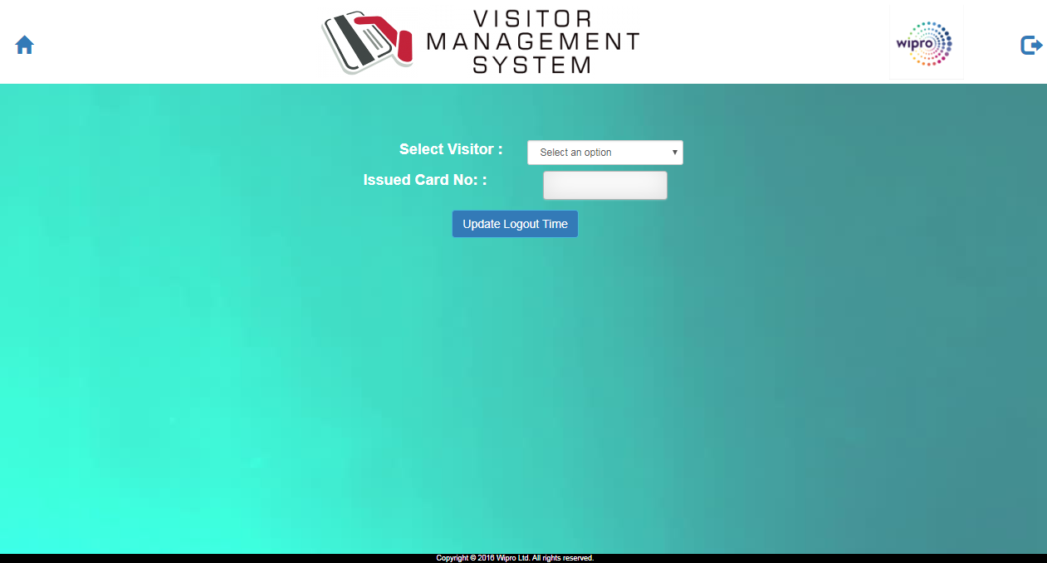

* 1. Design Proposal:

# ENTER VISITOR DETAILS

* 1. Existing design for entering visitor details

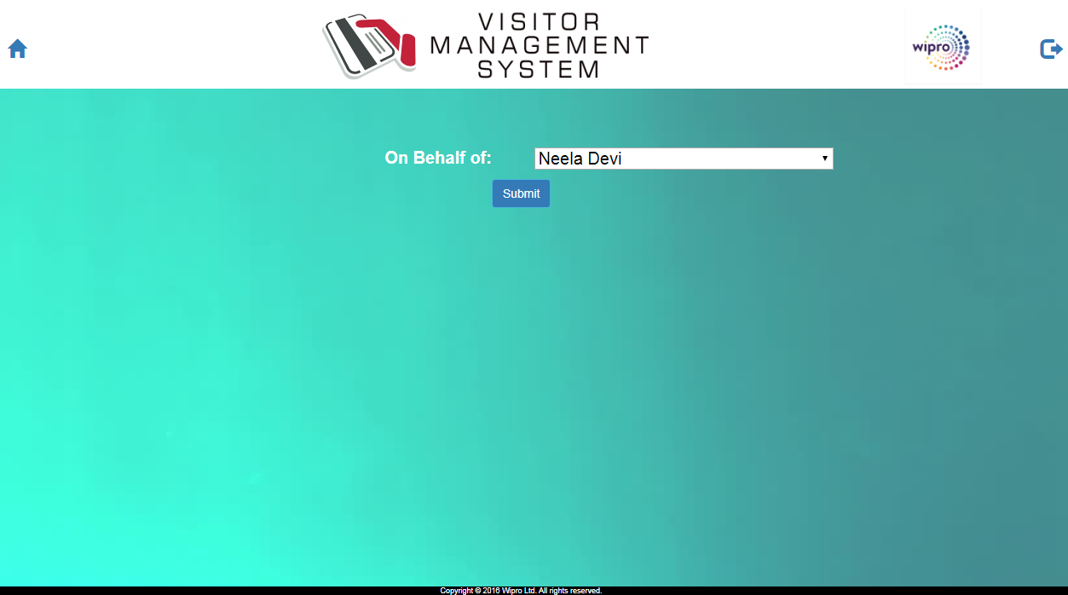

* 1. Design Proposal:-

# ASSETS MOVEMENT

* 1. Existing design for Asset movement:-

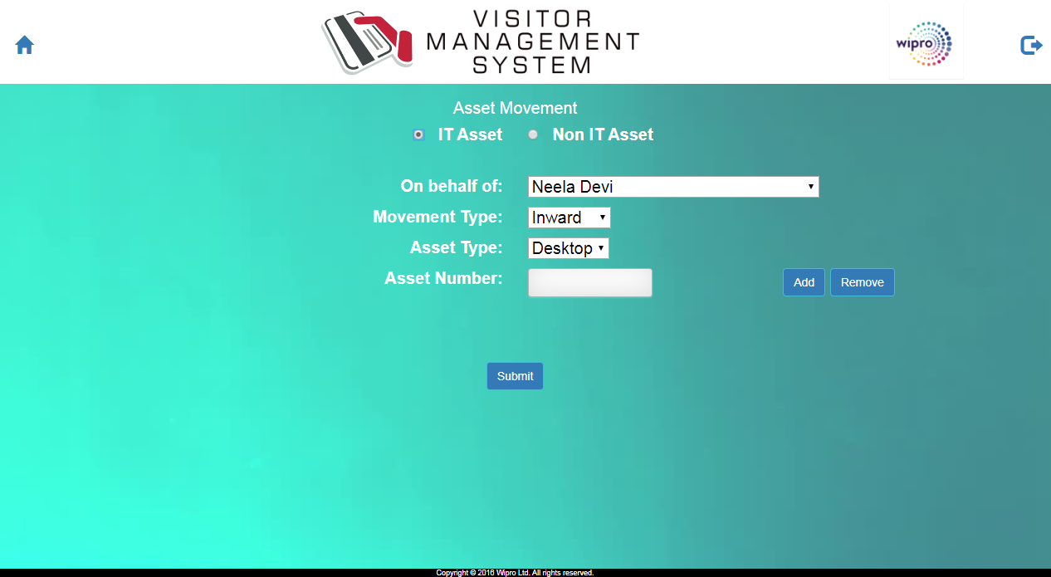

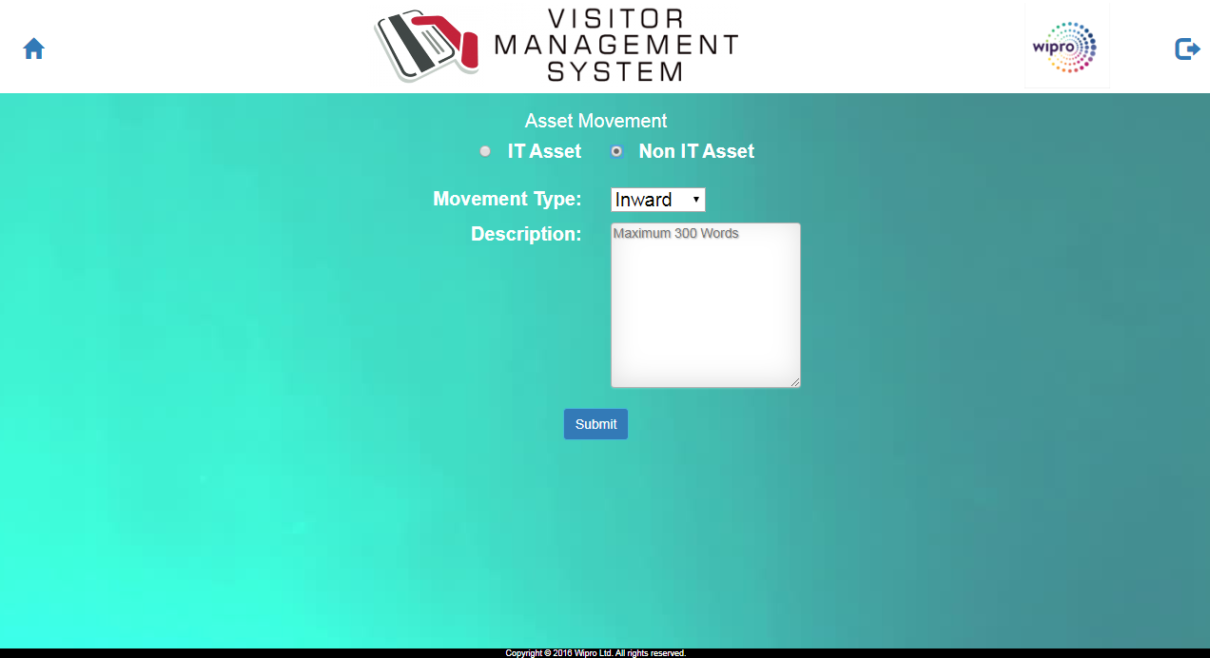

* 1. Design Proposal:-