A report on Ghost vs. Human (crossing the river):

***Introduction:***

Assembly language is a machine language. Devil vs. Human is a games which is developed by this assembly language programming. In this game there are 3 human, 3 devils and and a boat. Using this boat a user have to pass all human and devils to the other bank of the river, with maintaining some conditions.

*Conditions of the game:*

There are some conditions of this game. This conditions are given bellow,

* For each side human(*) must be greater or equal to ghost(#)
* For each step either 1 or 2 character (human or ghosts) can be crossed
* More than two or less than two will not be allowed at a time.
* The boat cannot be empty

*Uniqueness:*

This project is not unique at all. Because this game is already available in online. And the idea is generated from this game. But the code, by which this project is made is completely unique. There is no available assembly language code in online or any other place. At this angle this project is completely unique. There are more than 2000 instructions in assembly language .but in this project only a few instruction used which we learnt in the class.

***Program sample code demo:***

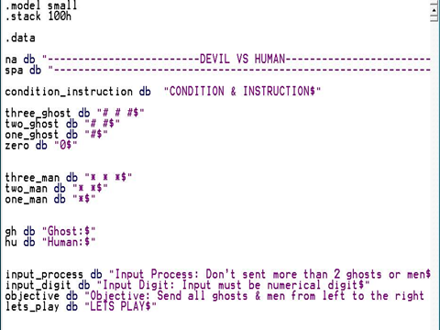

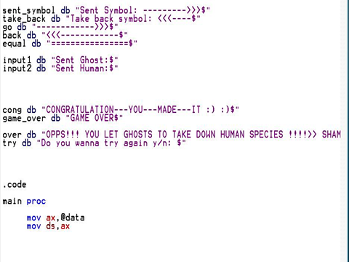

***Program out put sample demo:***

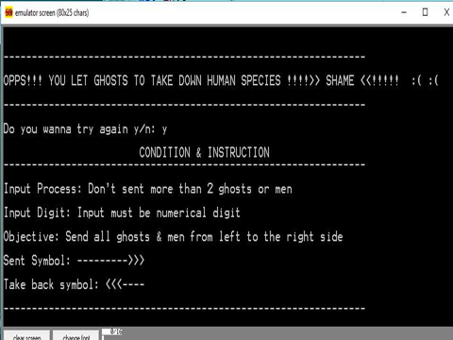

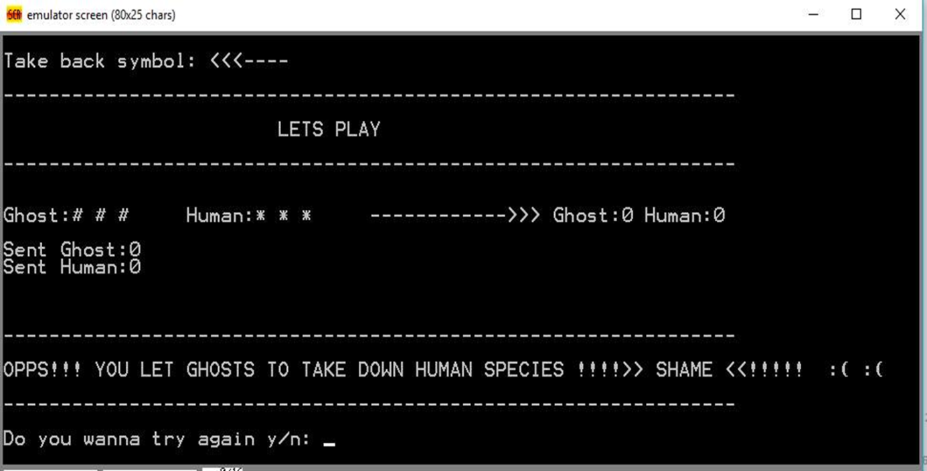

**Finshing demo:**

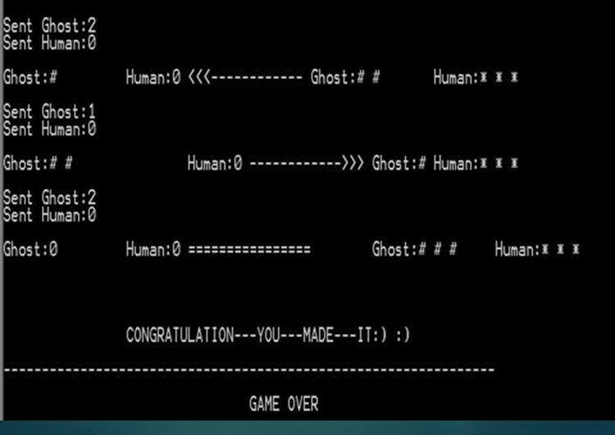

**Obstacle:**

**Obstacle:**

when we maked this game we were facing many problem .

Which included her shortly .

* proper instruction could not found
* Build up algorithm
* Code implementation structure
* Taking short time to arrange set up all logical tasks
* Using lower class language function
* Hard to uses effective operational logical code
* Animation graphics not be uses

When we maked this game we were facing many problem.

Which included here shortly.

* Proper instruction could not found
* Build up algorithm
* Code implementation Structure
* Taking short time to arange set up all logical tasks
* Using lower class language function
* Hard to uses effective operation logical code
* Animation graphics not be uses

**Future plan :**

We have some future plan about this games .

Included here below point :-

* Add graphics to implement attractive games
* Run time effective
* More features will be added
* Add more sample number using game
* Time limitation will be set for over this game
* User defined control(back and move) pattern
* Obejective oriented language implemet for gaming effective purpose
* Scoring system include this game for user satisfiction

**Conclusion:**

This is the most uniqe logical enjoyment game.

Gamer can test their brain to playing this game .

It’s our pride that we are able to making this game

In assembly language .