Lab ASSIGNMENT-1
1)Install redis
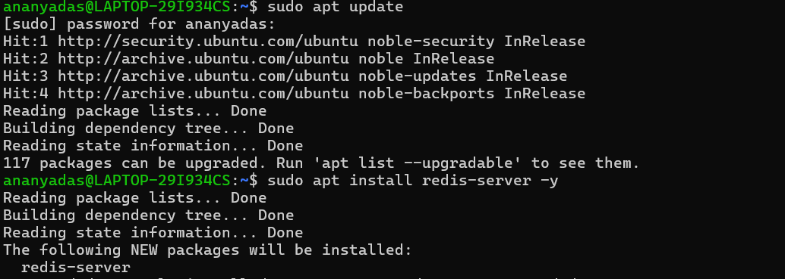
2)set and get key value
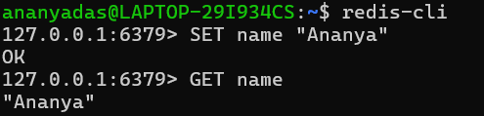
3)INCR
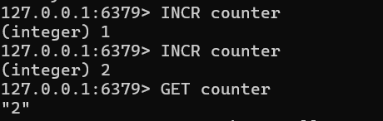
3)EXPIRE(obsoletes a key after sometime)
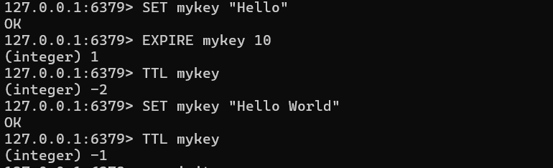
5)NODE server
Server.js code
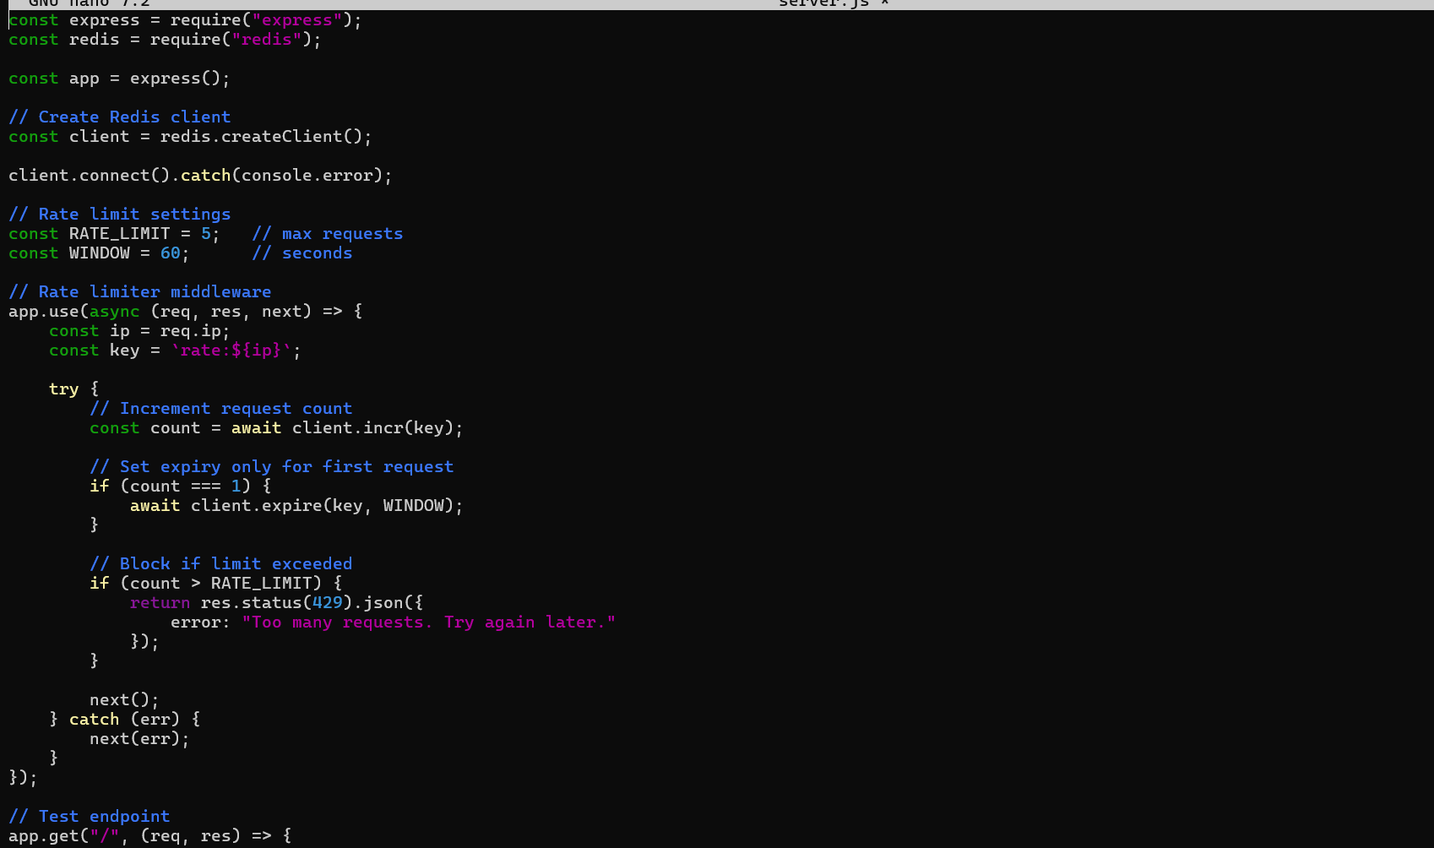
Server running:

Output

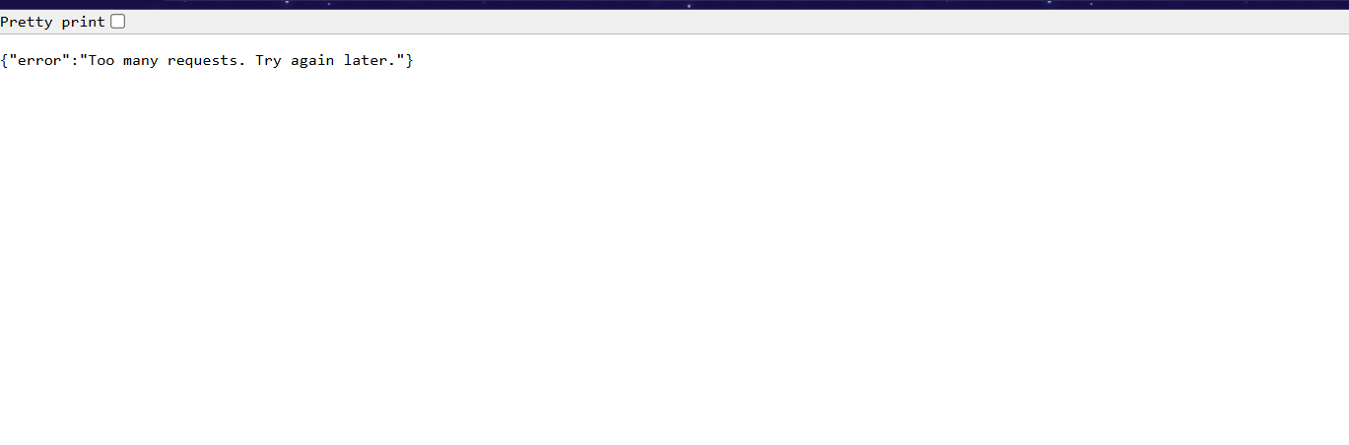

Timed Rate Limiter
