***SMART_MART APPLICATION***

**Application Features**

1. *Registering products:* Each of the product the store is selling needs to be registered. This Aplllication allows the user to register new products that will be sold in the store.
2. *Individual Billing:* When a customer buys some products from the store, the application allows the user to generate the bill for the customer.
3. *Sales Report:* The application allows the user to generate as sales report whenever needed.
4. *Shipment:* When a products goes out of stock and is ordered to receive the shipment for restocking. The application allows the user to keep track of that shipment.
5. *Stocking Report:* The application allows the user to create a stocking report and put those products in the order list which are about to run out of stock

**Application Files**

1. *helper.py* : This files contains FormatTable class. Used for formatting the output in a neatly spaced tabluar form. The column headings and data are passed as a list and then returned in a uniformly spaced string that is then printed on the console.
2. *productObj.py* : File contains the Product, ShippingProduct and StockProduct classes. A Product has some basic attributes like name, number, retail price and description, and at each stage external attributes are added, like when a Product is being shipped, wholesale price and number of units shipped are added to a given product. This realtion is handeled using inheritance in the file.
3. *main.py* : This file is the entry point of the application. The user will run this file to launch the Application. This file contains a Smart_Mart class which consists of an CLI to navigate and use the application.

**User Guide**

**NOTE: THERE ARE NO PRE REGISTERED PRODUCTS. SO THE FIRST STEP IS TO REGISTER NEW PRODUCTS**

**AND FILL UP THEIR STOCK BY RECEIVING THE SHIPMENT.**

1. To run the application run the main.py file.
2. Running the main.py file will open a console window and display a menu.
3. The User has to choose the action that’s needed to be performed. For example below example shows how to register a new product.

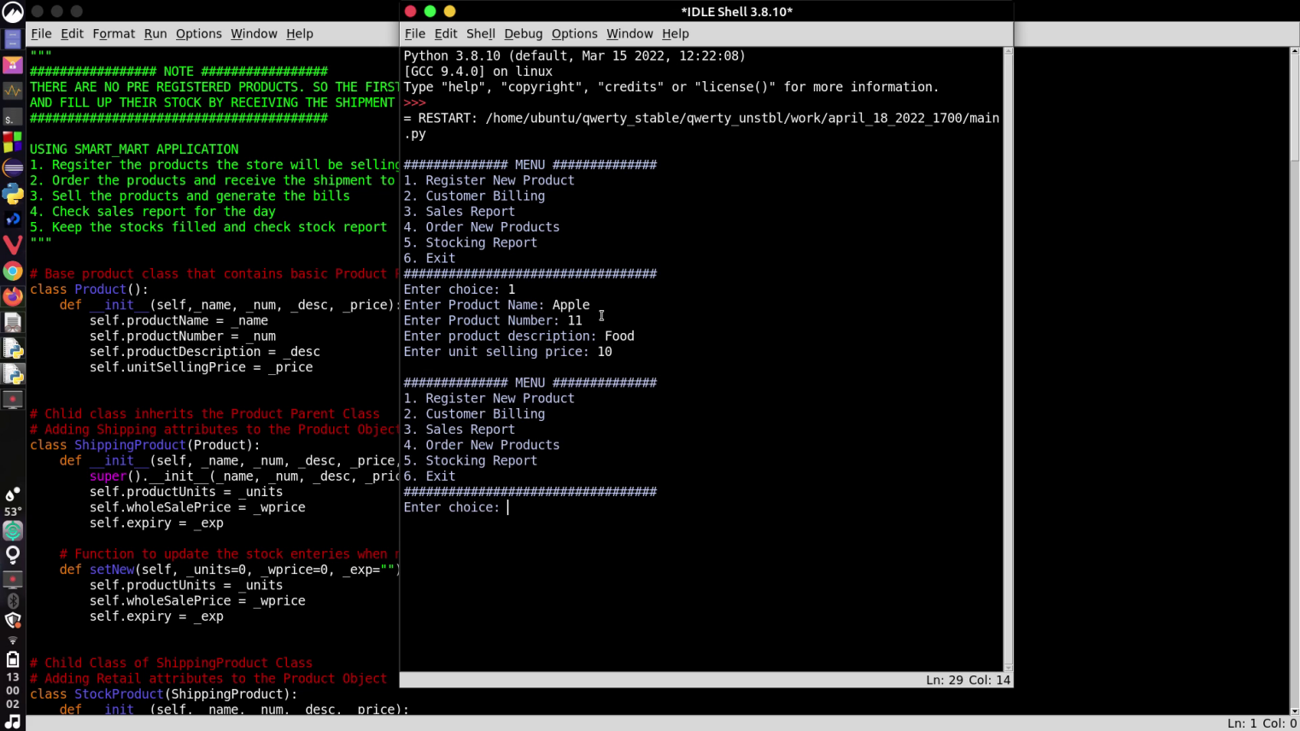User chooses 1 from the menu and is prompted to enter the information about the product to be registered.