***SMART_MART APPLICATION***

**Application Features**

1. *Registering products:* Each of the product the store is selling needs to be registered. This Aplllication allows the user to register new products that will be sold in the store.
2. *Individual Billing:* When a customer buys some products from the store, the application allows the user to generate the bill for the customer.
3. *Sales Report:* The application allows the user to generate as sales report whenever needed.
4. *Shipment:* When a products goes out of stock and is ordered to receive the shipment for restocking. The application allows the user to keep track of that shipment.
5. *Stocking Report:* The application allows the user to create a stocking report and put those products in the order list which are about to run out of stock

**System Requirement**

* Minimum Hardware requriements

1. Computer/Laptop

2. 1 GB Ram

* Software requriements

1. Windows OS/Linux/MacOS

2. Python3

**Application Files**

1. *helper.py* : This files contains FormatTable class. Used for formatting the output in a neatly spaced tabluar form. The column headings and data are passed as a list and then returned in a uniformly spaced string that is then printed on the console.
2. *productObj.py* : File contains the Product, ShippingProduct and StockProduct classes. A Product has some basic attributes like name, number, retail price and description, and at each stage external attributes are added, like when a Product is being shipped, wholesale price and number of units shipped are added to a given product. This realtion is handeled using inheritance in the file.
3. *main.py* : This file is the entry point of the application. The user will run this file to launch the Application. This file contains a Smart_Mart class which consists of an CLI to navigate and use the application.

**User Guide**

**NOTE: THERE ARE NO PRE REGISTERED PRODUCTS. SO THE FIRST STEP IS TO REGISTER NEW PRODUCTS**

**AND FILL UP THEIR STOCK BY RECEIVING THE SHIPMENT.**

1. To run the application run the main.py file.
2. Running the main.py file will open a console window and display a menu.
3. The User has to choose the action that’s needed to be performed. For example below example shows how to register a new product.

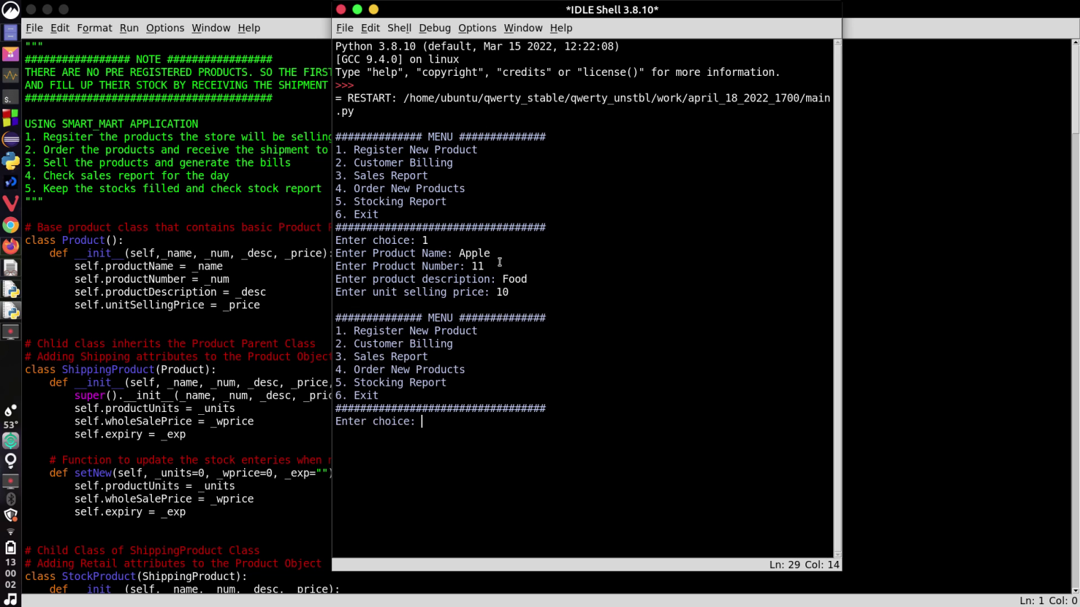User chooses 1 from the menu and is prompted to enter the information about the product to be registered.

**Application Interface**

1. **Main Menu:**User Navigates the application using this menu.

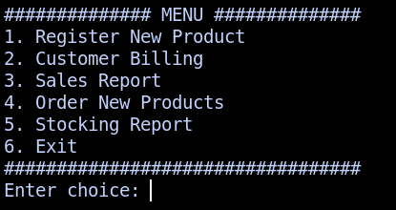

1. **Register New Product:** Each product that the system will be dealing with must be registered.

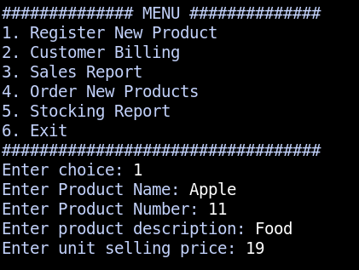

1. 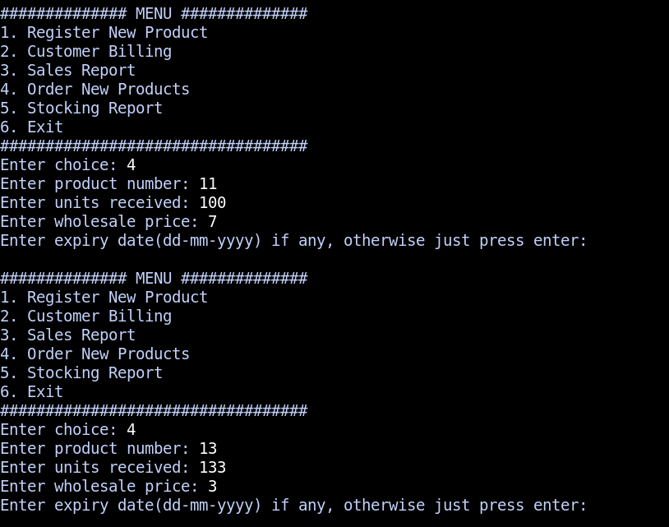**Receiving Shipment:** User can order products in wholesale for the store.
2. **Stock Report:** The report will show the products that are about to finish. The minimum number of the product that should be in store is 10., otherwise, system will put the product on order list.

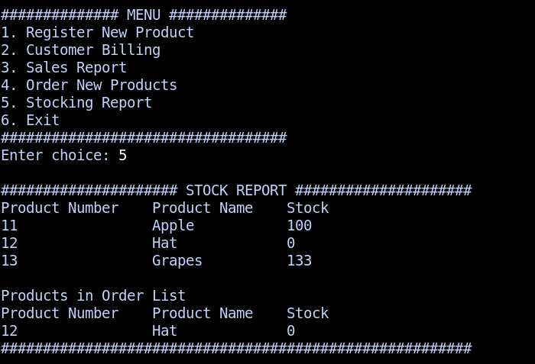

1. 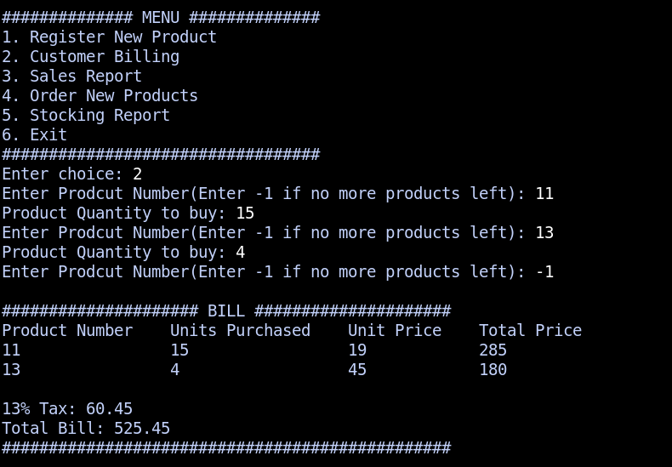**Individual Billing:** When a person shops in the convenient store, a bill will be generated.
2. 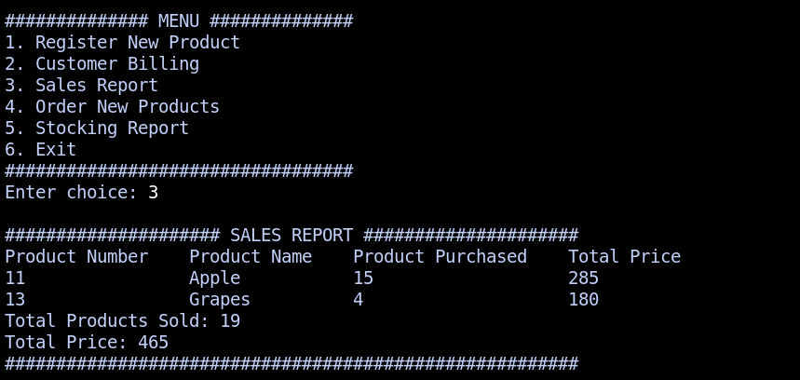**Sales Report:** At end of the day or when requested, the system will create a sales report.