Data Science Assignment # 2

Muhammad Waiz Shabbir

22L-6991

DS-8B

Question 1

DATASET 1
X | Y
3 | 2.5
4 | 3.2
5 | 3.8
6 | 6.5
7 | 11.5
8 | 14.6

Solution:
X | Y | X² | XY
3 | 2.5 | 9 | 7.5
4 | 3.2 | 16 | 12.8
5 | 3.8 | 25 | 19
6 | 6.5 | 36 | 39
7 | 11.5 | 49 | 80.5
8 | 14.6 | 64 | 116.8
Σ=33 | Σ=42.1 | Σ=199 | Σ=275.6

n = 6
X̄ = 33/6 = 5.5
Ȳ = 42.1/6 = 7.0167

Simple Linear Regression
b₁ = (ΣXY - n·X̄·Ȳ) / (ΣX² - n·X̄²)
b₁ = (275.6 - 231.55) / (199 - 181.5) = 44.05 / 17.5 = 2.5171
b₀ = Ȳ - b₁·X̄ = 7.0167 - 2.5171 × 5.5 = -6.8276

Regression Equation: Ŷ = -6.8276 + 2.5171·X

R² Calculation
X | Y | Ŷ | (Y-Ŷ)² | (Y-Ȳ)²
3 | 2.5 | 0.7237 | 3.153 | 20.39
4 | 3.2 | 3.2408 | 0.002 | 14.57
5 | 3.8 | 5.7579 | 3.836 | 10.34
6 | 6.5 | 8.275 | 3.150 | 0.267
7 | 11.5 | 10.792 | 0.503 | 20.09
8 | 14.6 | 13.309 | 1.666 | 57.51
 |  |  | SS_res =12.31 | SS_tot = 123.19

R² = 1 - SS_res/SS_tot = 0.9001
Simple LR explains 90.01% of the variance in Dataset 1.

Polynomial Regression Degree 2

X | Y | X² | X³ | X⁴ | X²Y
3 | 2.5 | 9 | 27 | 81 | 22.5
4 | 3.2 | 16 | 64 | 256 | 51.2
5 | 3.8 | 25 | 125 | 625 | 95
6 | 6.5 | 36 | 216 | 1296 | 234
7 | 11.5 | 49 | 343 | 2401 | 563.5
8 | 14.6 | 64 | 512 | 4096 | 935.4
33 | 42.1 | 199 | 1287 | 8755 | 1900.6

Normal Equations (3×3 system):
[ 8755 1287 199 ] [a₂] [1900.6]
[ 1287 199 33 ] [a₁] = [ 275.6 ]
[ 199 33 6 ] [a₀] [ 42.1 ]
Solving: a₂ = 0.5286, a₁ = -3.2971, a₀ = 7.6200

Poly Equation: Ŷ = 0.5286X² - 3.2971X + 7.6200

R² (Polynomial) = 0.9848
Polynomial Regression explains 98.48% of variance.
Hence Polynomial Regression is significantly better fit than SLR (90.01%).

DATASET 2
X | Y
1 | 2
2 | 4
3 | 9
4 | 16

Solution:
X | Y | X² | XY
1 | 2 | 1 | 2
2 | 4 | 4 | 8
3 | 9 | 9 | 27
4 | 16 | 16 | 64
Σ=10 | Σ=31 | Σ=30 | Σ=101

n = 4
X̄ = 10/4 = 2.5
Ȳ = 31/4 = 7.75

Simple Linear Regression
b₁ = (101 - 4×2.5×7.75)/(30 - 4×6.25)=(101 - 77.5)/(30 - 25) = 23.5/5 = 4.70
b₀ = 7.75 - 4.70×2.5 = 7.75 - 11.75 = -4.00

Regression Equation: Ŷ = -4.00 + 4.70·X

R² (SLR) = 0.9460
Simple Linear Regression explains 94.60% of variance

Polynomial Regression
X | Y | X² | X³ | X⁴ | X²Y
1 | 2 | 1 | 1 | 1 | 2
2 | 4 | 4 | 8 | 16 | 16
3 | 9 | 9 | 27 | 81 | 81
4 | 16 | 16 | 64 | 256 | 256
10 | 31 | 30 | 100 | 354 | 355

Normal equations give
a₂ = 1.25
a₁ = -1.55
a₀ = 2.25
Poly Equation: Ŷ = 1.25X² - 1.55X + 2.25

R² (Polynomial) = 0.9996
Polynomial Regression gives near-perfect fit!

Comparison
Dataset | Simple LR R² | Polynomial R² | Better Model | Reason
Dataset 1 | 0.9001 | 0.9848 | Polynomial | Curved pattern in data
Dataset 2 | 0.9460 | 0.9996 | Polynomial | Data follows quadratic growth

Polynomial Regression (degree 2) outperforms Simple Linear Regression on both datasets because both datasets exhibit non-linear (quadratic) behavior, which SLR cannot capture adequately.

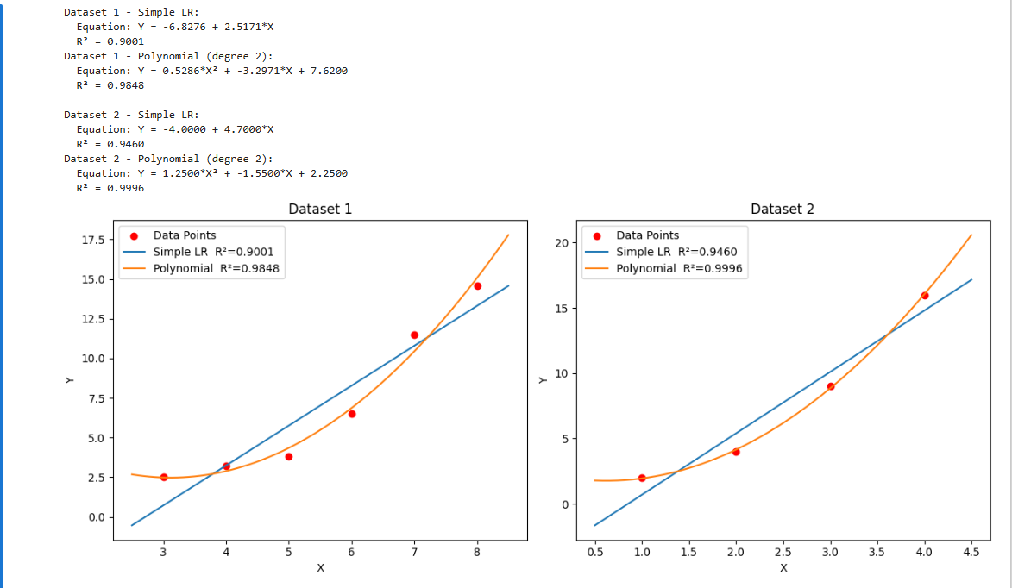

Question 2

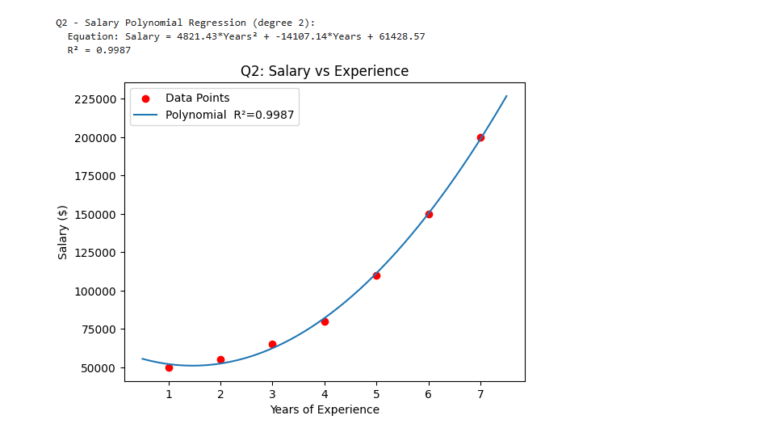

Question 3

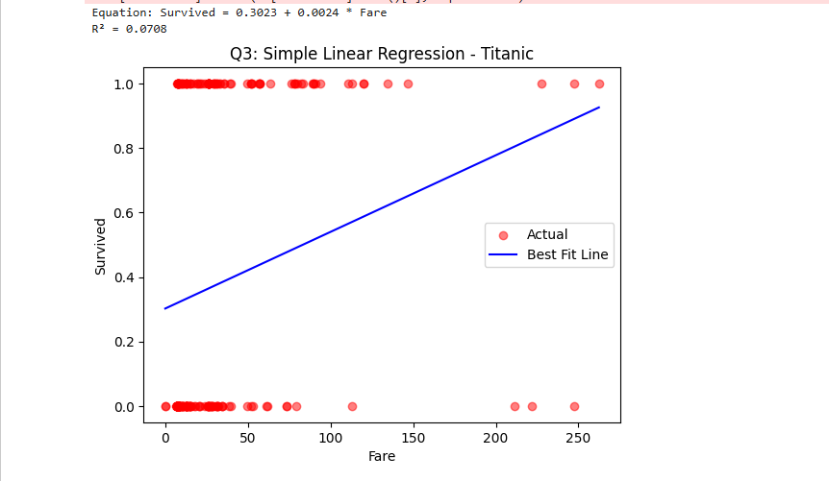

Question 4
T# | A1 | A2 | A3 | A4 | A5 | A6 | A7 | A8 | A9
T1 | 1 | 0 | 0 | 0 | 1 | 1 | 0 | 1 | 0
T2 | 0 | 1 | 0 | 1 | 0 | 0 | 0 | 1 | 0
T3 | 0 | 0 | 0 | 1 | 1 | 0 | 1 | 0 | 0
T4 | 0 | 1 | 1 | 0 | 0 | 0 | 0 | 0 | 0
T5 | 0 | 0 | 0 | 0 | 1 | 1 | 1 | 0 | 0
T6 | 0 | 1 | 1 | 1 | 0 | 0 | 0 | 0 | 0
T7 | 0 | 1 | 0 | 0 | 0 | 1 | 1 | 0 | 1
T8 | 0 | 0 | 0 | 0 | 1 | 0 | 0 | 0 | 0
T9 | 0 | 0 | 0 | 0 | 0 | 0 | 0 | 1 | 0
T10 | 0 | 0 | 1 | 0 | 1 | 0 | 1 | 0 | 0
T11 | 0 | 0 | 1 | 0 | 1 | 0 | 1 | 0 | 0
T12 | 0 | 0 | 0 | 0 | 1 | 1 | 0 | 1 | 0
T13 | 0 | 1 | 0 | 1 | 0 | 1 | 1 | 0 | 0
T14 | 1 | 0 | 1 | 0 | 1 | 0 | 1 | 0 | 0
T15 | 0 | 1 | 1 | 0 | 0 | 0 | 0 | 0 | 1

APRIORI ALGORITHM

Step 1
Item | Support Count | Frequent?(≥3)
A1 | 2 | No — pruned
A2 | 6 | Yes
A3 | 6 | Yes
A4 | 4 | Yes
A5 | 8 | Yes
A6 | 5 | Yes
A7 | 7 | Yes
A8 | 4 | Yes
A9 | 2 | No — pruned

Step 2
Candidate | Support Count | Frequent?
{A2,A3} | 3 | Yes
{A2,A4} | 3 | Yes
{A2,A5} | 0 | No
{A2,A6} | 2 | No
{A2,A7} | 2 | No
{A2,A8} | 1 | No
{A3,A4} | 1 | No
{A3,A5} | 3 | Yes
{A3,A6} | 0 | No
{A3,A7} | 3 | Yes
{A3,A8} | 0 | No
{A4,A5} | 1 | No
{A4,A6} | 1 | No
{A4,A7} | 2 | No
{A4,A8} | 1 | No
{A5,A6} | 3 | Yes
{A5,A7} | 5 | Yes
{A5,A8} | 2 | No
{A6,A7} | 3 | Yes
{A6,A8} | 2 | No
{A7,A8} | 0 | No

Step 3
Candidate | Support Count | Frequent?
{A3,A5,A7} | 3 | Yes
{A5,A6,A7} | 1 | No

Step 4
Frequent Itemset | Support Count
{A3,A5,A7} | 3

All Frequent Itemsets (Apriori): 7 (1-item) + 7 (2-item) + 1 (3-item) = 15 total

FP-GROWTH ALGORITHM

Step 1
Item | Frequency | Sorted Rank
A5 | 8 | 1
A7 | 7 | 2
A2 | 6 | 3
A3 | 6 | 4
A6 | 5 | 5
A4 | 4 | 6
A8 | 4 | 7

Step 2 — Second DB Scan: Reorder & filter each transaction
Each transaction is filtered (remove infrequent items) and sorted by descending frequency:
Transaction | Original Items | Filtered & Sorted
T1 | {A1,A5,A6,A8} | [A5,A6,A8]
T2 | {A2,A4,A8} | [A2,A4,A8]
T3 | {A4,A5,A7} | [A5,A7,A4]
T4 | {A2,A3} | [A2,A3]
T5 | {A5,A6,A7} | [A5,A7,A6]
T6 | {A2,A3,A4} | [A2,A3,A4]
T7 | {A2,A6,A7,A9} | [A7,A2,A6]
T8 | {A5} | [A5]
T9 | {A8} | [A8]
T10 | {A3,A5,A7} | [A5,A7,A3]
T11 | {A3,A5,A7} | [A5,A7,A3]
T12 | {A5,A6,A8} | [A5,A6,A8]
T13 | {A2,A4,A6,A7} | [A7,A2,A6,A4]
T14 | {A1,A3,A5,A7} | [A5,A7,A3]
T15 | {A2,A3,A9} | [A2,A3]

Step 3 — Build the FP-Tree
Insert filtered transactions one by one into the prefix tree. Shared prefixes are merged and counts incremented:
FP-Tree Node | Count | Parent Node | Notes
root | — | —
A5 | 8 | root | Most frequent; appears in T1,T3,T5,T8,T10,T11,T12,T14
A7 | 5 | A5 | Appears after A5 in T3,T5,T10,T11,T14
A7 | 2 | root | Appears first in T7,T13
A6 | 3 | A5 | A5→A6 in T1,T12
A6 | 1 | A5→A7 | A5→A7→A6 in T5
A3 | 3 | A5→A7 | A5→A7→A3 in T10,T11,T14
A4 | 1 | A5→A7 | A5→A7→A4 in T3
A8 | 2 | A5→A6 | A5→A6→A8 in T1,T12
A2 | 2 | root | A2 without A5/A7 in T4,T15
A2 | 2 | A7 | A7→A2 in T7,T13
A3 | 2 | A2 (root branch) | T4,T15

Step 4 — Mine Conditional Pattern Bases
For each frequent item (least frequent first), extract the prefix paths that lead to it in the FP-Tree:
Item | Conditional Pattern Base | Cond. FP-Tree Freq. Items | Frequent Patterns Generated
A8 | [A5,A6]:2, [A2,A4]:1 | None meets min support | No new patterns
A4 | [A2]:1, [A5,A7]:1, [A2,A3]:1, [A7,A2,A6]:1 | None meets min support | No new patterns
A6 | [A5]:2, [A5,A7]:1, [A7,A2]:2, [A5]:1 | A5:3, A7:3 | →{A5,A6}:3, {A6,A7}:3
A3 | [A2]:3, [A5,A7]:3 | A2:3, A5:3, A7:3 | →{A2,A3}:3, {A3,A5}:3, {A3,A7}:3, {A3,A5,A7}:3
A2 | [A7]:2 (only prefix) | None meets min support | No new 2+ patterns
A7 | [A5]:5 | A5:5 | →{A5,A7}:5
A5 | (root-level) | — | →{A5}:8

FP-Growth Frequent Itemsets: Same 15 itemsets as Apriori — results are identical!

Apriori vs FP-Growth: Comparison
Aspect | Apriori | FP-Growth
DB Scans | Multiple (1 per itemset level) | Exactly 2
Candidate Generation | Yes — many candidates generated | No explicit candidates
Memory | High (stores all candidates) | Moderate (FP-Tree)
Speed | Slower on large datasets | Faster (no repeated scans)
Frequent Itemsets | 15 | 15 (same)
Results | Identical | Identical
Best Use | Small datasets, interpretable steps | Large datasets, efficiency needed

Both algorithms produce the identical set of frequent itemsets. FP-Growth is more efficient because it compresses the database into an FP-Tree and mines it without candidate generation, avoiding the bottleneck of multiple database scans.
