

**Operating System Project**

**Disk Organizer**

Group Members:

Abdul Rafay F22CSC001

Asad Ali F22CSC016

Shayan Khurram F22CSC026

Contents

**Introduction** 1

**Problem Statement** 1

**Solution** 1

**Methodology** 1

**Core Functionalities**: 1

**Operational Stages**: 2

**Directory Selection and Initialization** 2

**Technology Stack** 2

**Programming Language** 2

**Core libraries**: 2

**GUI Framework** 2

**Result** 3

**Conclusion** 5

# **Introduction**

## **Problem Statement**

Modern computer users often struggle with efficiently managing their disk space due to a lack of accessible tools for organization, monitoring, and cleaning. Navigating through directories to locate specific files, managing and renaming files, and removing unnecessary temporary files can be time-consuming and inefficient. Without a comprehensive solution, these challenges result in cluttered storage, reduced system performance, and frustration for users.

## **Solution**

Disk Organizer is an all-in-one software that helps manage disk space and optimize computer performance. It includes three main components: Explorer, which simplifies directory browsing and displays file details like name, type, and size, with a search function for quick navigation; Organizer, which allows renaming, deleting, and moving files directly to maintain a clean storage system; and Junk Cleaner, which removes unnecessary files with a single click, showing the size of deleted items for effective storage tracking. These features make disk management user-friendly and efficient.

# **Methodology**

## **Core Functionalities**:

Explorer: select directory, displays folders and files in that directory with name, type and size, also search also available.

Organizer: select directory, displays folders and files in that directory with name, type and size, right click to open delete or rename.

Junk Cleaner: click clean, it cleans the temporary files present on your device and displays

how the size of the deleted files.

## **Operational Stages**:

**Directory Selection and Initialization**:

* User selects a directory to begin the analysis or management process.
* The system initializes by scanning the selected directory to retrieve metadata such as file and folder names, types, and sizes.

**File Exploration:**

* The Explorer module displays the contents of the selected directory in a structured format.
* Users can navigate through the directory, search for specific files or folders, and view details like type and size.

**File Organization:**

* Users select files or folders within the Organizer module.
* Contextual actions such as renaming, deleting, or reorganizing files are performed via a right-click menu, ensuring seamless file management.

**Temporary File Identification:**

* The Junk Cleaner module scans the system for temporary files, cache, or other redundant data that can be safely deleted.

**Junk Cleaning Execution:**

* The user initiates the cleaning process by clicking the "Clean" button.
* Temporary files are removed, and a detailed report showing the size of the deleted files is displayed.

**Technology Stack**

**Programming Language**: Python

**Core libraries**: Os and shutil for file operations , psutil for system information and hashlib for duplicate detection

**GUI Framework**: Tkinter for building a simple user friendly interface.

# **Result**

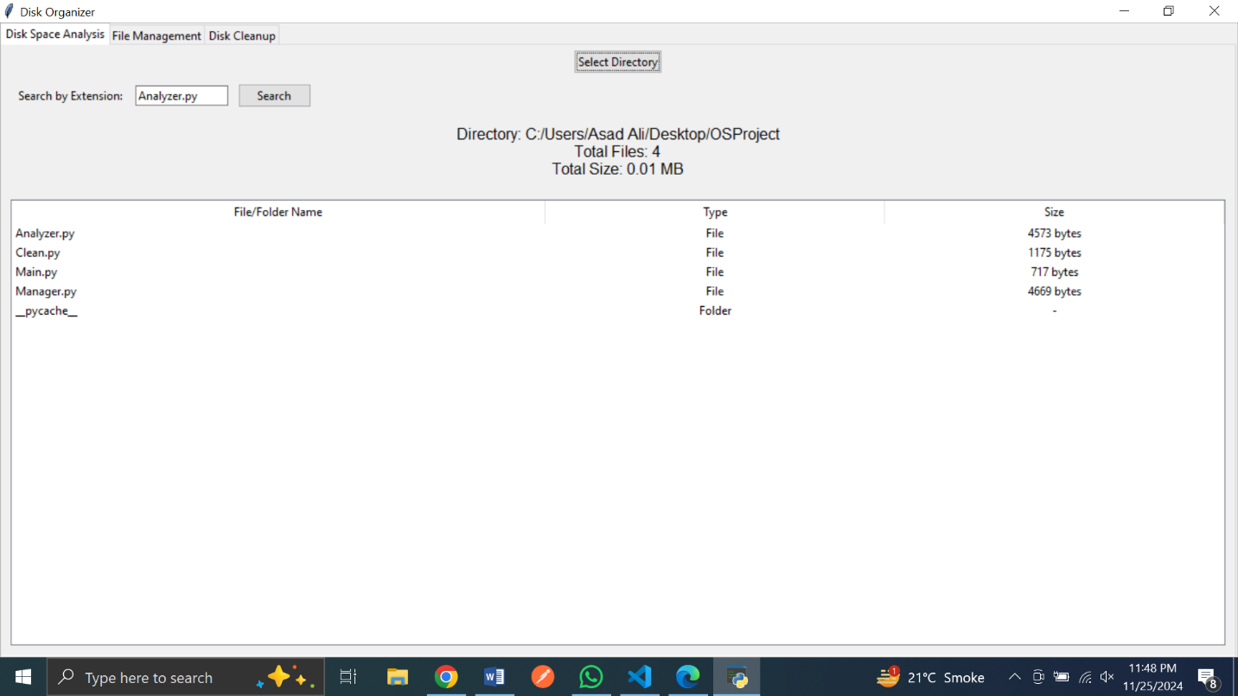

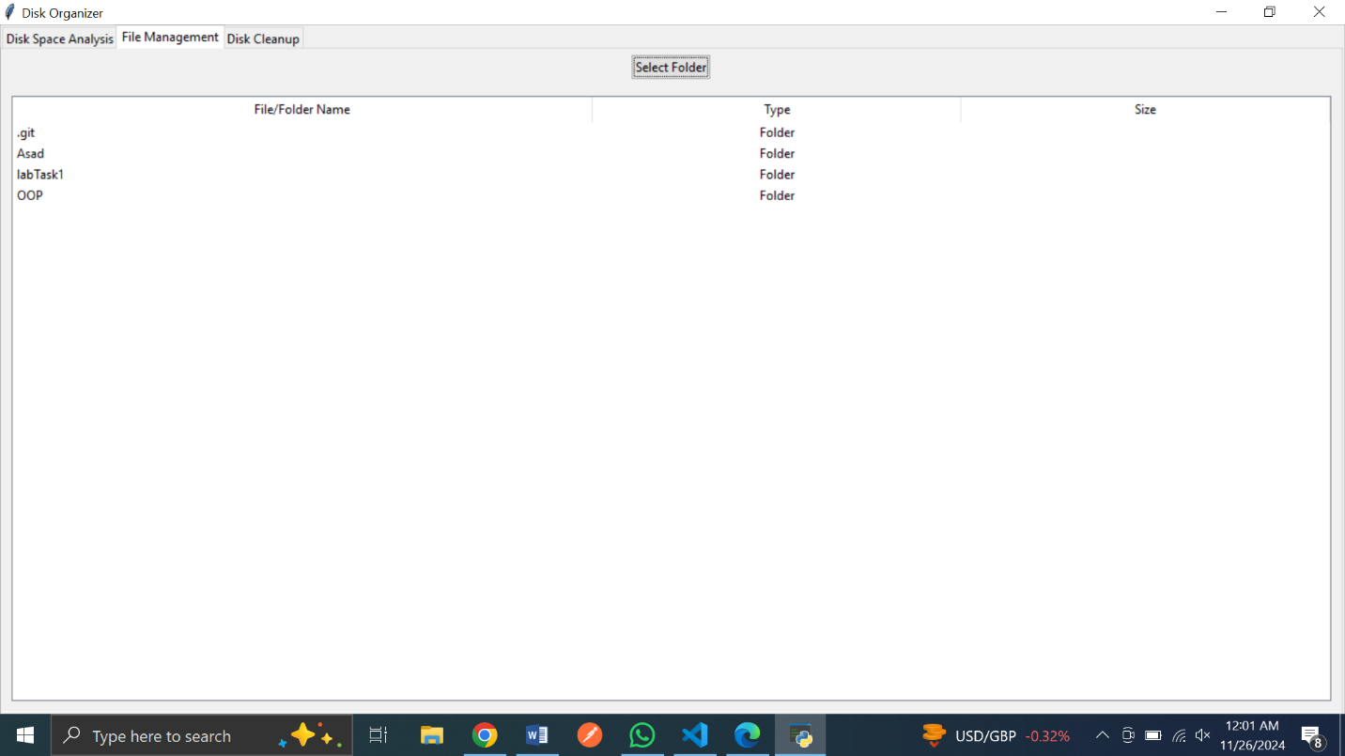

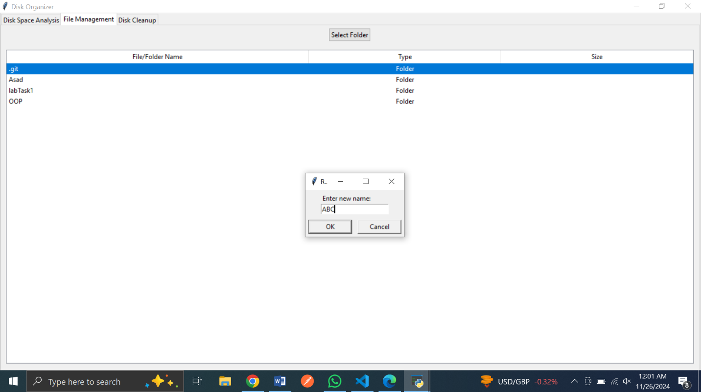

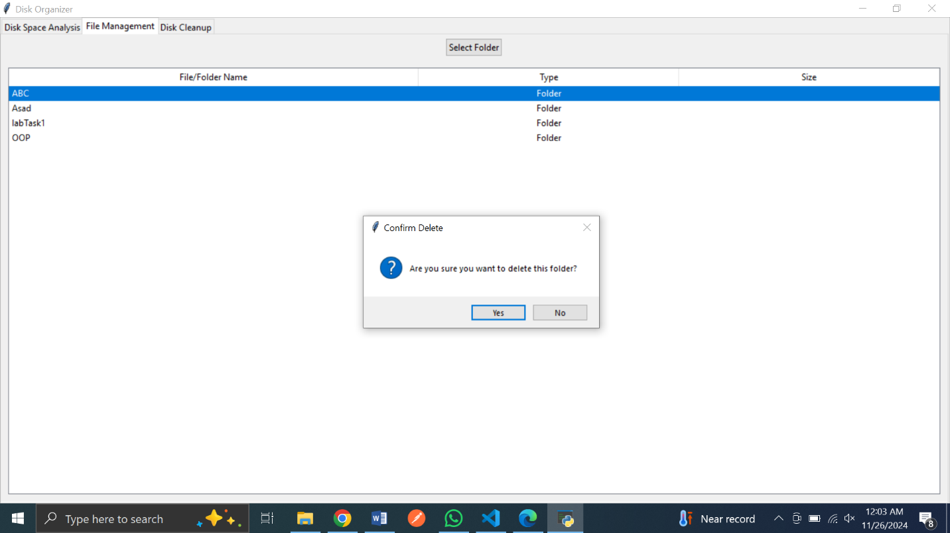

# **Conclusion**

The Disk Organizer is a comprehensive solution designed to tackle the challenges of managing disk space efficiently. By integrating core functionalities such as the **Explorer** for directory navigation and detailed file inspection, the **Organizer** for seamless file management and organization, and the **Junk Cleaner** for removing redundant temporary files, this tool enhances disk utilization and system performance. It empowers users to take control of their storage with intuitive and user-friendly operations, ensuring a clutter-free and optimized digital environment. The Disk Organizer not only streamlines file and folder management but also contributes to improved productivity and system longevity, making it an essential utility for modern computing needs.