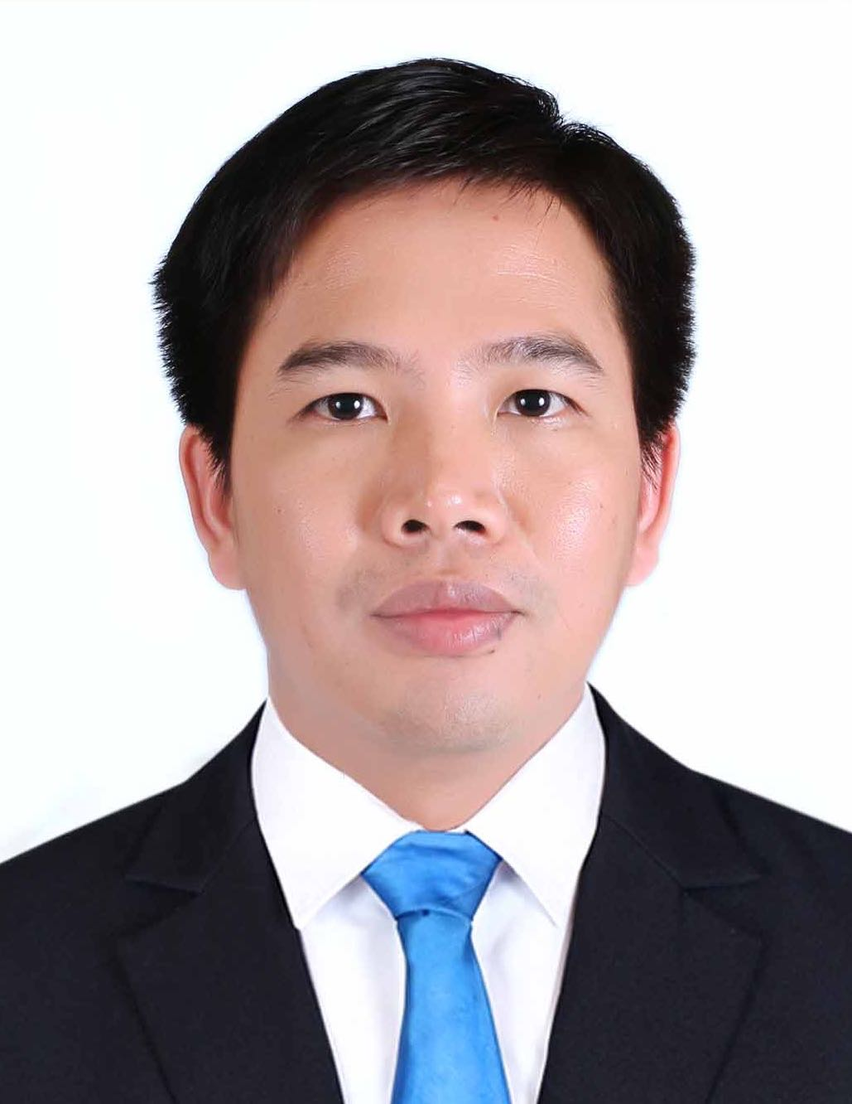
Curriculum Vitae

SUM Roitha

PRESENT ADDRESS
#61, St. A. Borey Piphop Thmey Chhouk Va 1,
Sangkat Kouk Roka, Khan Prek Pnov, Phnom Penh, Cambodia
Mobile : 015 201 202
E-mail : sumroitha@gmail.com

PERSONAL DATA
Sex : Male
Nationality : Cambodian
Marital Status : Married
Date of Birth : April 27, 1983
Place of Birth : Sretachey Village, Choung Moung Commune, Teuk Phos District,
Kampong Chhnang Province

EDUCATION
2007 – 2009 : Student at Phnom Penh International University, Master of Science in Computer Science
2002 – 2006 : Student at Phnom Penh International University, Bachelor of Science in Computer Science

QUALIFICATION
- Certificate of GSMA online training: STIRA, IR.21, RAEX AA.14, IREG, TADIG,
TAP Processes, RAP Processes, Roaming Settlement processes and NRTRDE
- Telecommunications Fraud Professional Certificate of Attendance
- Certificate of Appreciation Roaming and Interconnect project
- Certificate of Appreciation Revenue Assurance project
- Certificate of Appreciation ZTE SMSC project
- Certificate of Appreciation ZTE CvBS project
- Certificate of Level A ZXIN10 at ZTE University
- Certificate of Intelligent Call Assistance Managed Service of StarHome Corporation
- Certificate of Revenue Monitoring System of Redknee Inc
- Certificate of QlikView Reports
- Certificate of Oracle Database 11.2g Administration
OTHER SKILL
- System Analysis and Design
- Software development with Visual Basic.Net, C# and Java
- Database design with MS SQL, MySQL, PostgreSQL and Oracle
- Web Site design with HTML, CSS, JavaScript, VBScript, PHP and ASP.Net
- Advanced in practice Internet and E-mail operation

WORK EXPERIENCE
10/07/13 – Present : Reporting Engineer at Data Management Center (DMC) LTD
01/03/13 – 09/07/13 : Senior Roaming Administrator at Smart Axiata Co., Ltd.
01/10/12 – 28/02/13 : Roaming and Interconnect Senior Engineer at Hello Axiata Company Limited.
01/07/11 – 30/09/12 : Roaming Senior Executive at Hello Axiata Company Limited.
01/01/10 – 30/06/11 : Roaming Executive at Hello Axiata Company Limited.
01/01/09 – 31/12/09 : Billing Senior Officer at Hello Axiata Company Limited.
15/08/07 – 31/12/08 : Billing Officer at Hello Axiata Company Limited.
12/10/05 – 14/08/07 : Programmer at K Digital Solutions Co., Ltd.

Responsibilities of Reporting Engineer at DMC LTD:
- Generate the daily Data Quality Check report of CDR record level
- Check the abnormal case in each KPI of the daily Data Quality Check Report
- Generate daily revenue, traffic and top-up reports
- Analyze daily and monthly data trend
- Break down data anomaly check and escalate it to relevant team
- Keep track on update of new promotion/service/product of all operators
- Reconcile on the monthly revenue, traffic, subscriber and top-up data of all operators

Responsibilities of Roaming and Interconnect at Hello Axiata Company Limited:
- TADIG validation and setup new IR service launching
- CDR collection, processing, integration and enhancement
- International Roaming configuration, charging and billing service management
- Interconnect configuration, charging and billing service management
- System Administration Management for Interconnect and Roaming
- Monthly invoice, data verification and report enhancement
- Project and Vendor Management
- Develop and update the policy/process related to IR and Interconnect
- Strengthen the existing policy/process related to IR and Interconnect

Responsibilities of Roaming at Hello Axiata Company Limited:
- Inter-operator Tariff of international roaming billing setup up on promotion and special offer
- TAP/RAP/HUR/NRTRDE files configuration
- TAP/RAP/NRTRDE files controlling with Data Clearing House (DCH)
- Validate TAP file up on GSMA standard and verify charging and call records
- Test GSM, GPRS, 3G and CAMEL roaming by follow GSMA standard document (IR.24,IR.35,IR.50,IR.60 and IR.32)
- Manage and audit inbound and outbound SIM CARD inventory
- Coordinate international roaming technical work with roaming partners
- International roaming problem solving
- Statistic report of TAP/RAP/NRTRDE files

Responsibilities of Programmer at K Digital Solutions Co., Ltd:
- Data gathering and analysis
- Design and code program (Website development, Database Design, and Tailored-made Programming. Tools utilized: Visual Basic.NET, Visual Basic 6, MS SQL Server, C#, ASP, ASP.NET, PHP, MySQL Server, MS-Access, HTML, JavaScript, Macromedia Dreamweaver, Macromedia Flash, Linux Operating System, and Photoshop)
- Prepare and develop documentation
- Follow-up service with client
- Manage and monitor assistant programmers
- Conduct research and development

LANGUAGES
Khmer : Mother tongue
English : Good writing and speaking, improving daily

HOBBIES : Sport, Reading, Traveling and Listening to music

REFERENCE : Mr. HIN Sam Ath, Senior Vice Rector at Phnom Penh International University (PPIU)
Mobile : 015 810 191

Mr. CHEAM Sithy, IT Lecturer at PPIU and Freeland IT Consultant
Mobile : 012 804 571

