## **Pure Gym**

### **Nature of Service:**

Pure Gym offers a comprehensive suite of fitness services designed to empower individuals of all fitness levels in Abu Dhabi to achieve their health and wellness goals. Our services include personalized training sessions, a diverse range of group fitness classes, and specialized wellness programs. We foster a supportive and dynamic environment with state-of-the-art equipment and expert guidance to ensure a successful fitness journey.

### **Date/Year of Starting the Business:** 1st March2024

### **Location:** Al Reem Island, Abu Dhabi, UAE

### **Owners’ Names:**

* Maryam Raheem
* Fatima Khawarizmi

### **Capital Investment in the Business:**

Pure Gym's initial capital investment of AED 30,000 was contributed equally by the founders, Maryam Raheem and Fatima Khawarizmi. These funds were strategically allocated to secure a prime location on Al Reem Island, Abu Dhabi, procure state-of-the-art fitness equipment, and cover operational expenses during the initial launch phase.

**Unadjusted Trial Balance**

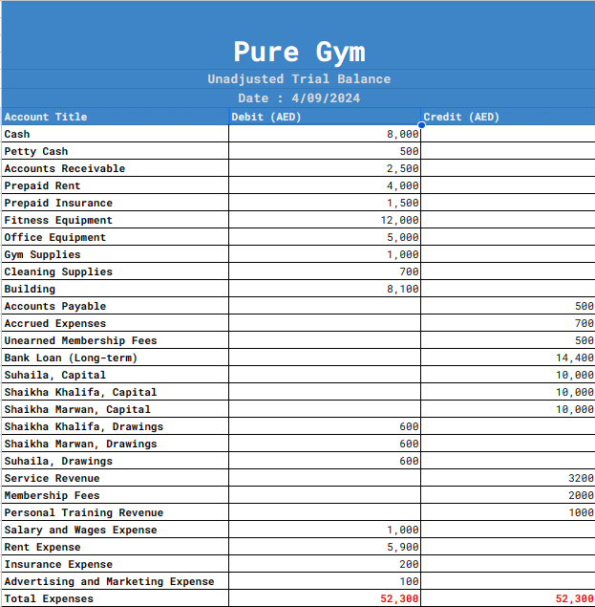

**Transaction for adjustment entries**

**Service on Credit:** Pure Gym rendered fitness services to a customer on credit, resulting in an increase in Accounts Receivable by AED 2,000. This transaction reflects the revenue earned from the service provided, awaiting payment from the customer.

**Supplies Used:** During the period, AED 500 worth of gym supplies were utilized, leading to a reduction in the Supplies Inventory account. This entry acknowledges the cost of supplies consumed during normal operations.

**Prepaid Rent Expense:** A portion of the prepaid rent amounting to AED 7,500 has expired for the period and is now recognized as a Rent Expense. This reduces the Prepaid Rent account and matches the rent expense to the period incurred.

**Prepaid Insurance Expense:** AED 2,000 of the prepaid insurance has expired, necessitating recognition as an Insurance Expense. This reduces the Prepaid Insurance asset while allocating the insurance cost to the appropriate period.

**Depreciation Expense - Equipment:** The equipment depreciation for the period is recorded at AED 10,000. This entry increases the Depreciation Expense, reflecting the usage and wear of the equipment, and accumulates depreciation to decrease the book value of the assets.

**Accrued Salaries:** Employees have earned wages of AED 3,500 that have not yet been paid, necessitating a record as both a Salary Expense and a corresponding Salaries Payable. This ensures that expenses are matched with the period in which the work was performed.

**Accrued Utilities**: The utility bill for the last month, amounting to AED 1,200, has not been received or recorded yet. This transaction records an expense and a payable, ensuring the utilities cost is accounted for in the period it was incurred.

**Unearned Revenue Earned:** Pure Gym provided gym services, earning AED 4,000 from previously received membership fees. This reduces the Unearned Membership Fees liability account and increases Service Revenue, recognizing the revenue for services rendered during the period.

**Adjusting Entries**

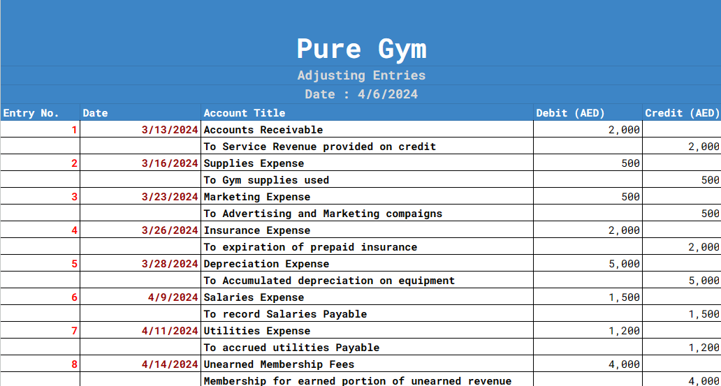

**Adjusted trail balance**

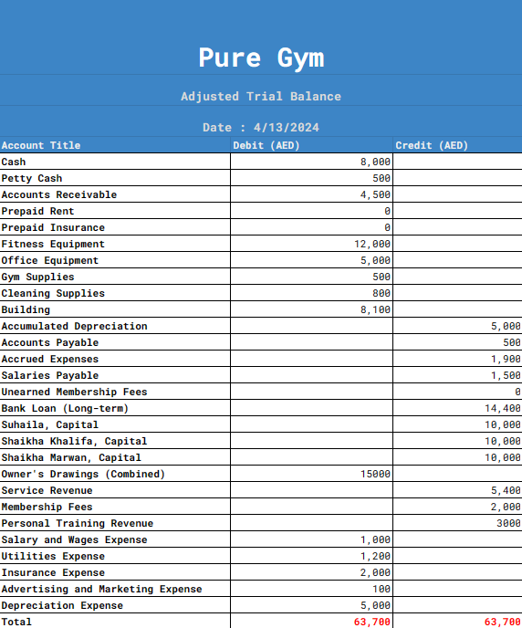

**Financial Statements**

**Income Statement**

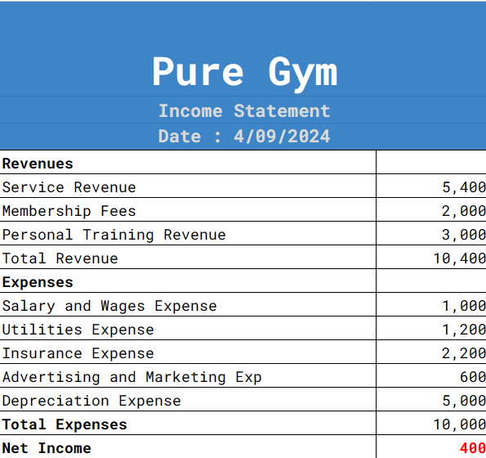

**Owners Equity Statement**

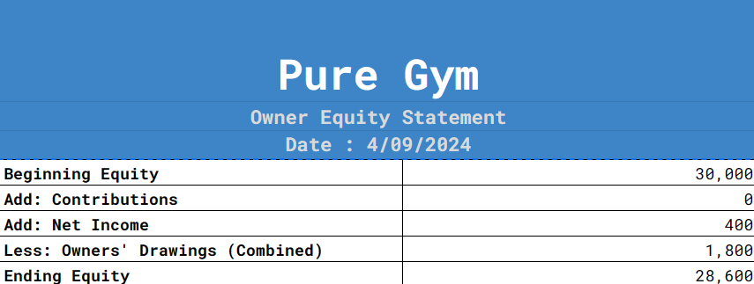

**Balance Sheet**

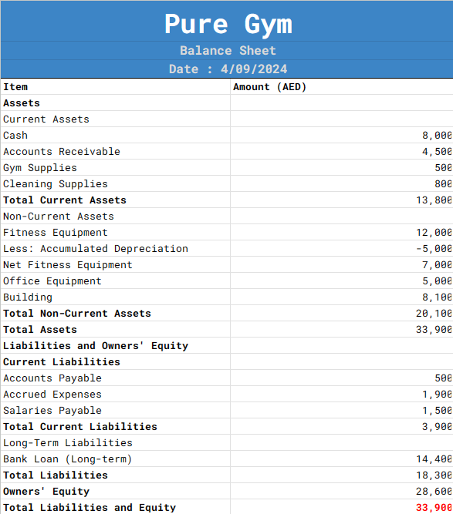

**1. Is the company profitable? What is the reason the company is profitable/not profitable?**

**Profitability:** Yes, Pure Gym is profitable, showing a net income of AED 400 for the period. This indicates that the revenue generated from services such as personal training, membership fees, and other fitness services slightly exceeded the operating expenses. However, the margin of profitability is relatively low.

**Reason for Profitability**: The gym was able to generate sufficient revenue to cover expenses, which totaled AED 10,000, with a revenue of AED 10,400. Major contributors to expenses include high depreciation costs (AED 5,000) and insurance (AED 2,200), which significantly impact the bottom line. The profitability indicates that while the gym is managing to meet its financial obligations and generate a surplus, the margin is thin, suggesting a tight operational control could be beneficial, or a review of cost structures and potential increases in service rates might be necessary to improve profitability.

**Has the owner equity increased compared to the starting capital invested? Give reason for your answer.**

**Change in Owner Equity**: The owner equity has decreased from the initial investment of AED 30,000 to AED 28,600.

**Reason for Change:** The decrease in owner equity is primarily due to the owners' drawings totaling AED 1,800, which was greater than the net income of AED 400. This means that the owners withdrew more funds from the business than the net income generated, leading to a net decrease in the equity. This reduction indicates that while the business is sustaining its operations and generating a small profit, the withdrawals are negatively impacting the growth and reinvestment potential of the company's equity.

**Conclusion**

Pure Gym is currently maintaining profitability but with a very narrow margin, and the owners' equity has decreased due to high drawings compared to the net income, indicating potential challenges in maintaining financial sustainability if the current trend continues without adjustments in operational efficiency or revenue enhancement.