Explain the following questions in two simple sentences

1. What is the use of the git add command?

The git add command adds a change made in the working directory to the staging area. It tells Git what update we want to make in the next commit.

1. Write the command to create a branch “feature-group”.

git branch feature-group

1. What is a pull request? Write the steps involved in creating a pull request.

A Pull Request is a way to notify team members that we have made changes to a branch in a Git repository and would like to merge them into the main branch. The team members review the changes and if everything looks fine, they merge it into the main codebase.

Steps involved in creating a pull request -

1. Create a new branch for our changes.
2. Make the changes to the code(add a feature).
3. Stage and commit the changes.
4. Push code to remote.
5. Go to the repo on GitHub, and click on the compare and pull request for the pushed branch, fill in the details, and create the pull request.
6. How do you add collaborators?
7. Go to the repo you want to add collaborators to.
8. Click on the settings.
9. In the left sidebar, click on the collaborators.
10. Authenticate by typing your password.
11. Click “invite a collaborator”.
12. Enter the collaborators’ email.
13. Click on Invite.
14. What is the command used to commit our changes in github repo?

git commit -m “Write your message about the commit”

1. Create a github account and repository to save all your assignment tasks. Example repository name: rg-assignments
2. Create a branch called feature-java(you can use it later to push all your java related tasks to this branch)
3. Install IntelliJ IDE. Create a simple java project displaying “Hello World!!”and share the screenshot.

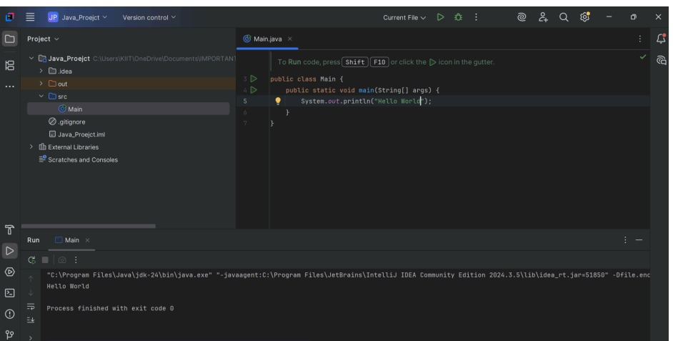

1. In IntelliJ IDE, explore the shortcut keys for the following
   1. To run the project - Shift + F10
   2. To select a line - Ctrl + W, till the entire line is selected.
   3. To comment/uncomment a line - Ctrl + /
   4. To delete a line - Ctrl + Y