TEACHER EDIT SCREENSHOTS

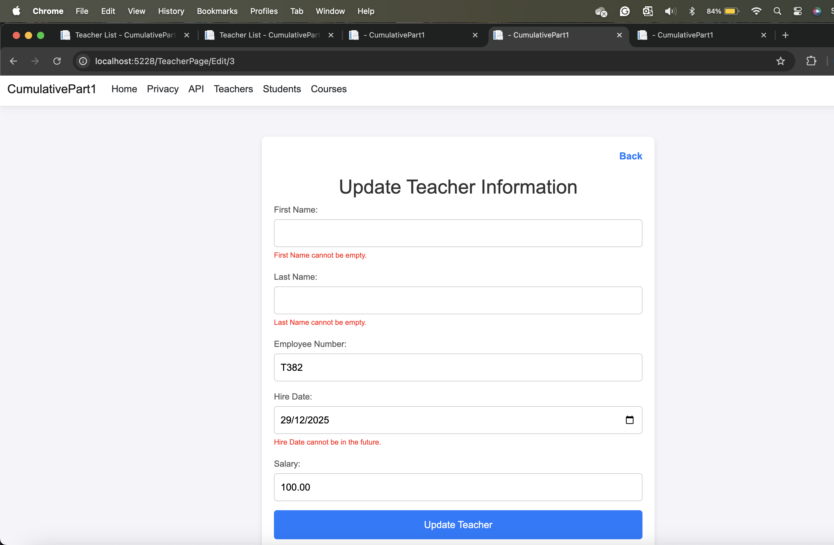

STUDENT EDIT SCREENSHOTS

COURSE EDIT SCREENSHOTS

CURL COMMANDS

