Plots were generated with the following parameters:  
Industry Group = Trade, Periods = True, Start year = 2009, End year = 2022, Sort by = highest interest score first, Industry Digit = 3-Digit, Number of graphs = 3

This can be replicated with the command:  
hours_output_prod_chart('Trade', 'True', 2009, 2022, 'highest interest score first', '3-Digit', 3. "C:\Users\Long_s\Outputs")

The data was grouped into periods and annual percent change was computed within a period for each measure.

An interest score was calculated with the following equation:  
(|.2x| + |.2y| + |.6z|) * b  
Where x is the difference between the percent change in the output index for the 2 most recent datapoints recorded,  
y is the difference between the percent change in the hours index for the 2 most recent datapoints recorded,  
z is the difference between the percent change in the output per hour index for the 2 most recent datapoints recorded,  
b is the number of employees in the most recent datapoint recorded

The charts were then sorted to display in descending order based on calculated interest score.

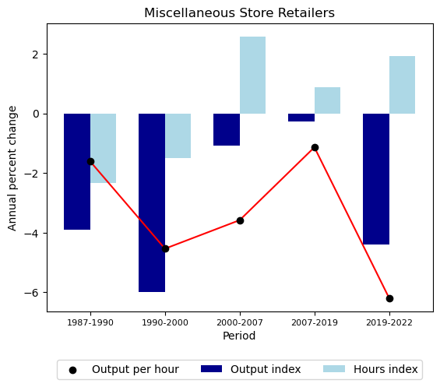

|  |  |  |  |
| --- | --- | --- | --- |
|  | Output index | Hours index | Output per hour |
| 1987-1990 | -3.9 | -2.3 | -1.6 |
| 1990-2000 | -6.0 | -1.5 | -4.5 |
| 2000-2007 | -1.1 | 2.6 | -3.6 |
| 2007-2019 | -0.3 | 0.9 | -1.1 |
| 2019-2022 | -4.4 | 1.9 | -6.2 |

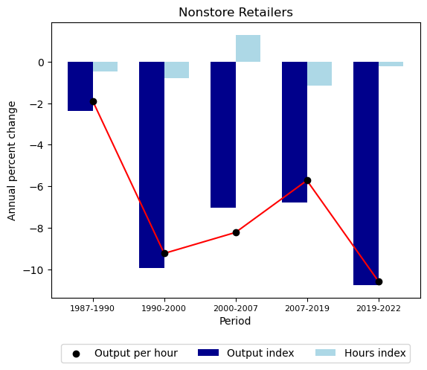

|  |  |  |  |
| --- | --- | --- | --- |
|  | Output index | Hours index | Output per hour |
| 1987-1990 | -2.4 | -0.5 | -1.9 |
| 1990-2000 | -9.9 | -0.8 | -9.2 |
| 2000-2007 | -7.0 | 1.3 | -8.2 |
| 2007-2019 | -6.8 | -1.1 | -5.7 |
| 2019-2022 | -10.7 | -0.2 | -10.6 |

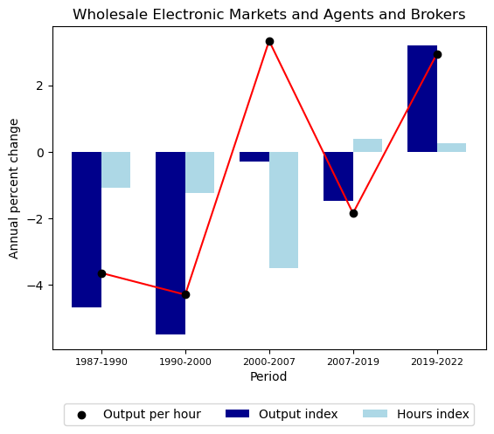

|  |  |  |  |
| --- | --- | --- | --- |
|  | Output index | Hours index | Output per hour |
| 1987-1990 | -4.7 | -1.1 | -3.7 |
| 1990-2000 | -5.5 | -1.2 | -4.3 |
| 2000-2007 | -0.3 | -3.5 | 3.3 |
| 2007-2019 | -1.5 | 0.4 | -1.9 |
| 2019-2022 | 3.2 | 0.2 | 2.9 |