Plots were generated with the following parameters:  
group = Mining, periods = False, start year = 2009, end year = 2022, sorting method = highest interest score first, industry digit = 3-Digit, number of charts = 3

This can be replicated with the command:  
hours_output_prod_chart(Mining, False, 2009, 2022, highest interest score first, 3-Digit, 3)

The year to year percent change was computed for each measure.

An interest score was calculated with the following equation:  
(|.2x| + |.2y| + |.6z|) * b  
Where x is the difference between the percent change in the output index for the 2 most recent datapoints recorded,  
y is the difference between the percent change in the hours index for the 2 most recent datapoints recorded,  
z is the difference between the percent change in the output per hour index for the 2 most recent datapoints recorded,  
b is the number of employees in the most recent datapoint recorded

The charts were then sorted to display in descending order based on calculated interest score.

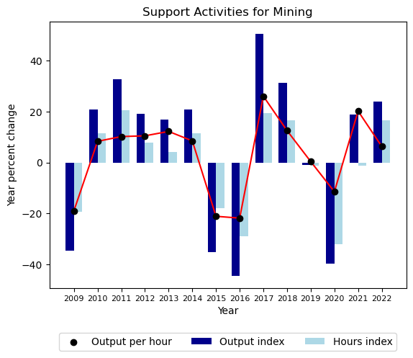

|  |  |  |  |
| --- | --- | --- | --- |
|  | Output index | Hours index | Output per hour |
| 2009 | -34.6 | -19.3 | -19.0 |
| 2010 | 20.8 | 11.6 | 8.3 |
| 2011 | 32.7 | 20.4 | 10.2 |
| 2012 | 19.0 | 7.7 | 10.5 |
| 2013 | 16.9 | 4.2 | 12.2 |
| 2014 | 20.9 | 11.5 | 8.5 |
| 2015 | -35.3 | -17.9 | -21.1 |
| 2016 | -44.5 | -28.9 | -21.9 |
| 2017 | 50.6 | 19.5 | 26.0 |
| 2018 | 31.2 | 16.6 | 12.5 |
| 2019 | -1.0 | -1.4 | 0.3 |
| 2020 | -39.9 | -32.1 | -11.5 |
| 2021 | 18.8 | -1.2 | 20.2 |
| 2022 | 23.8 | 16.5 | 6.3 |

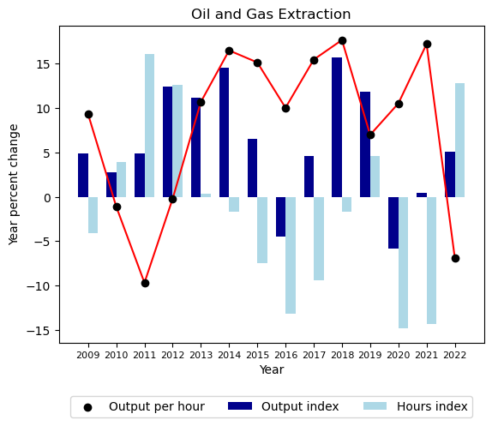

|  |  |  |  |
| --- | --- | --- | --- |
|  | Output index | Hours index | Output per hour |
| 2009 | 4.9 | -4.1 | 9.3 |
| 2010 | 2.8 | 3.9 | -1.1 |
| 2011 | 4.9 | 16.1 | -9.7 |
| 2012 | 12.4 | 12.6 | -0.2 |
| 2013 | 11.1 | 0.4 | 10.7 |
| 2014 | 14.5 | -1.7 | 16.5 |
| 2015 | 6.5 | -7.5 | 15.2 |
| 2016 | -4.4 | -13.2 | 10.0 |
| 2017 | 4.6 | -9.4 | 15.5 |
| 2018 | 15.7 | -1.7 | 17.7 |
| 2019 | 11.9 | 4.6 | 7.0 |
| 2020 | -5.8 | -14.8 | 10.5 |
| 2021 | 0.4 | -14.3 | 17.2 |
| 2022 | 5.1 | 12.9 | -6.9 |

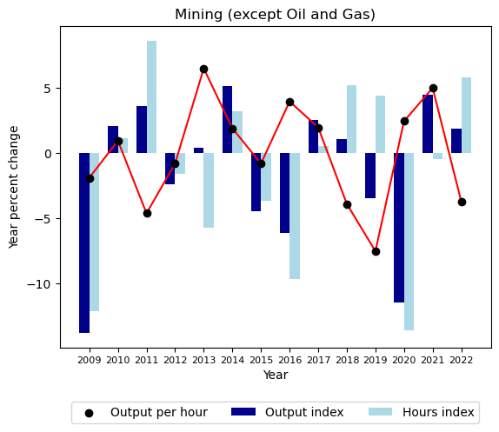

|  |  |  |  |
| --- | --- | --- | --- |
|  | Output index | Hours index | Output per hour |
| 2009 | -13.8 | -12.1 | -1.9 |
| 2010 | 2.1 | 1.1 | 0.9 |
| 2011 | 3.6 | 8.6 | -4.6 |
| 2012 | -2.4 | -1.6 | -0.8 |
| 2013 | 0.4 | -5.7 | 6.5 |
| 2014 | 5.1 | 3.2 | 1.9 |
| 2015 | -4.5 | -3.7 | -0.8 |
| 2016 | -6.1 | -9.7 | 4.0 |
| 2017 | 2.5 | 0.5 | 2.0 |
| 2018 | 1.1 | 5.2 | -3.9 |
| 2019 | -3.5 | 4.4 | -7.5 |
| 2020 | -11.5 | -13.6 | 2.4 |
| 2021 | 4.5 | -0.5 | 5.0 |
| 2022 | 1.8 | 5.8 | -3.7 |