**REPORT**

on

**“Event Management Website”**

# 

# NITTE MEENAKSHI INSTITUTE OF TECHNOLOGY

# Submitted in partial fulfilment of the requirement for the award of degree of bachelor of technology in Information science, Bangalore

**BIG DATA LAB**

# Submitted To: Prashanth B S

# DEPARTMENT OF ISE

# NMIT

# Submitted By: 6th sem ‘C’ Section

**C-2 batch**

1. Suvang : 1NT17IS172
2. Sumukh Vashist : 1NT17IS168
3. Tashwin : 1NT17IS177
4. Shrey Srivastava : 1NT17IS159
5. Tallapalli Swechha Ramaiah : 1NT17IS176
6. Tejashwini H : 1NT17IS179
7. Suprabha Bhat : 1NT17IS169
8. Tejas Tanay : 1NT17IS178
9. Thakur Saurav Chandraprakash : 1NT17IS180
10. Shresht V S : 1NT17IS158
11. Chinmayi R : 1NT17IS041
12. Thanmai Reddy B : 1NT17IS181

# ABSTRACT

The event management tool is a process of organizing and managing the students’ achievements in all fields .It provides real-time up-to date information of the achievements .This is done by organizing and categorizing their achievements into technical and cultural events.It checks the validity of the information by providing a feature for proof of the achievement like certificates i.e., the admin can input student information for participation in events’ along with a certificate and submit it to the database.

The statistics of their achievements can be later viewed depending on the data in the database.

It can lead to error free and a reliable management system. Such a management system reduces the manual efforts taken to organize the data by 80%.Thus,by keeping the information consistent and updated in real-time , time and effort taken in managing the data can be reduced.

**System Requirements**

Front-End language: HTML,css,bootstrap

Back-end/Server-side language: Node.js

Database used : Mongodb

Additionally, handlebars is used as an HTML template , and mongodb compass is used for viewing the tables and data created using mongodb.

**Project Goal**

Our project is a web-based management application which can be used by colleges and school to organize and update the students’ achievements in all fields through a user-friendly GUI .Any changes made are then reflected in the database.

**Project Description**

The project covers the following implementation:

1. **Admin module**: The admin is provided with a username and password . Once the admin logs in , he has access to all the admin features.

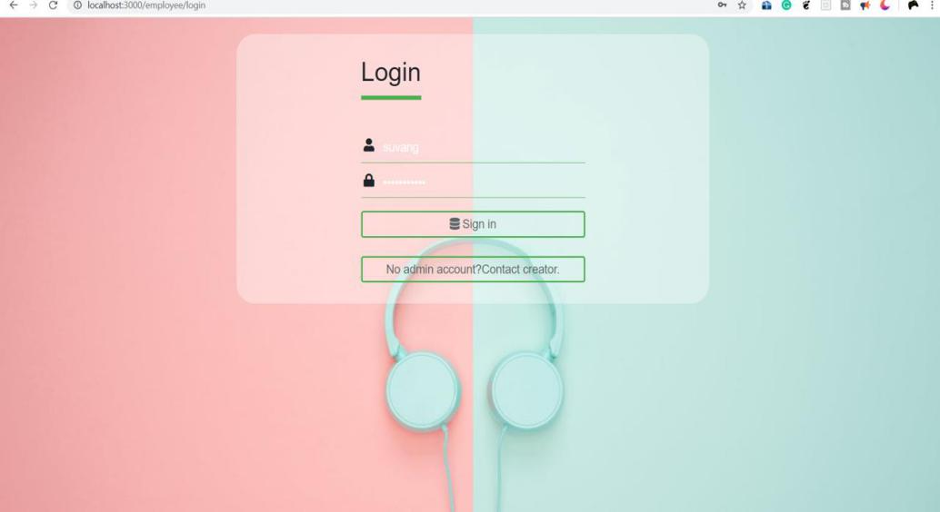

* The admin is presented with an admin panel where he has an option to choose between technical and cultural events .

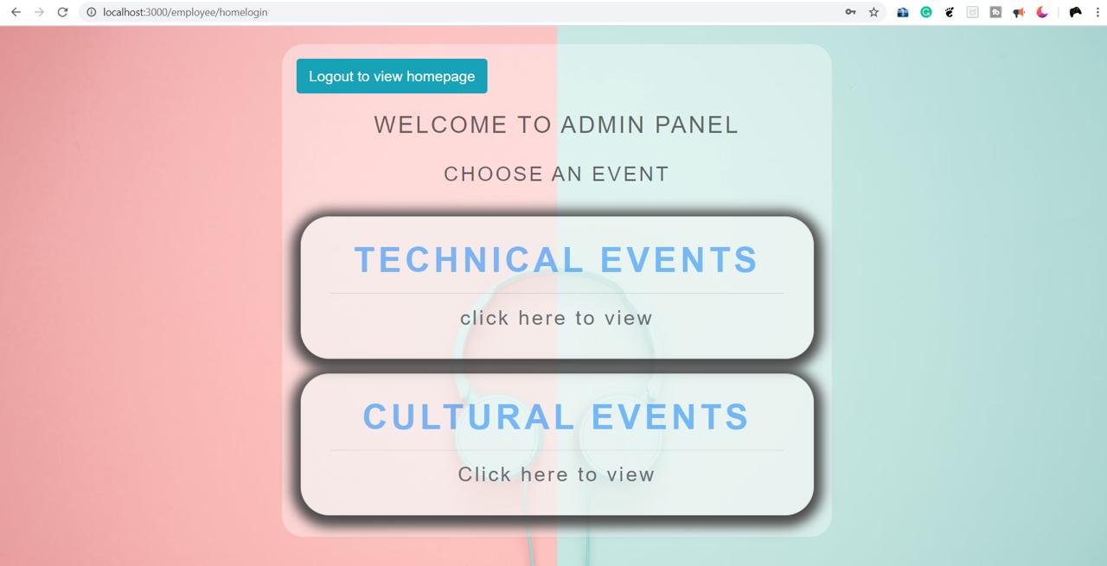

* On choosing an event, the admin can later add the student details for the respective event. The student details to be provided by the admin include name , email , Usn and event type.
* He has an option to upload a proof of the information for example, a certificate.

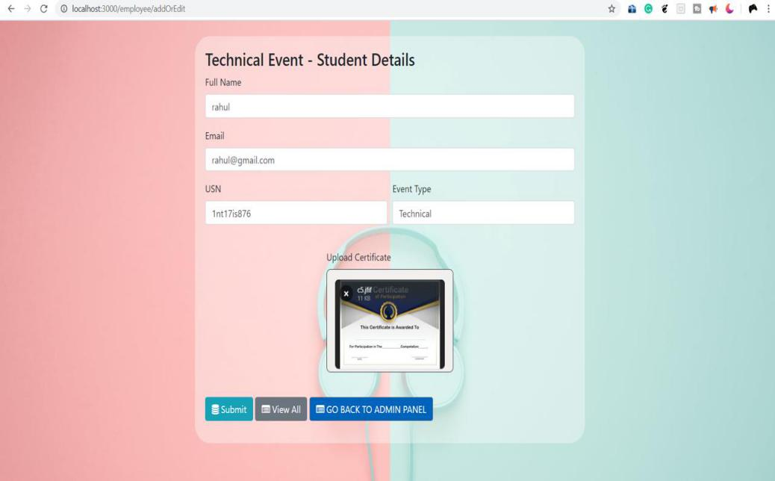

* On clicking submit, the information is later added to the database and can be viewed in the events list.

In the events list, a new event can be created , or any information can be modified or deleted.

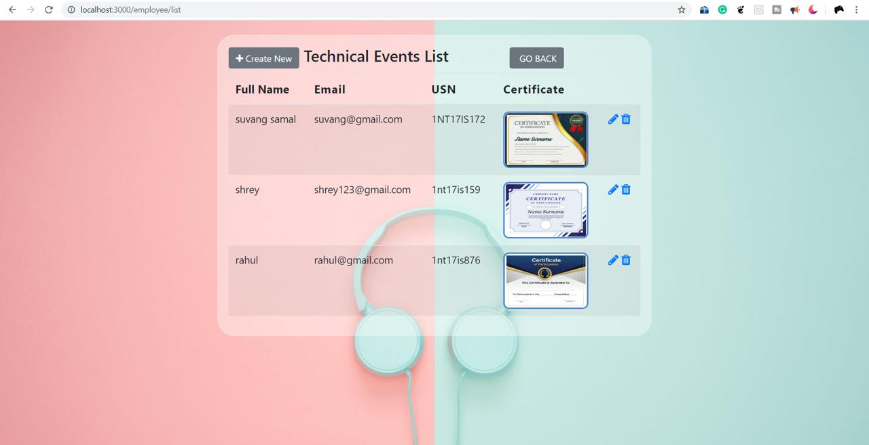

Once the admin logs out, the page is then reloaded to the viewer module.

1. **Viewer module**: This module enables the user to view the event list and view the student details for the respective event type chosen.

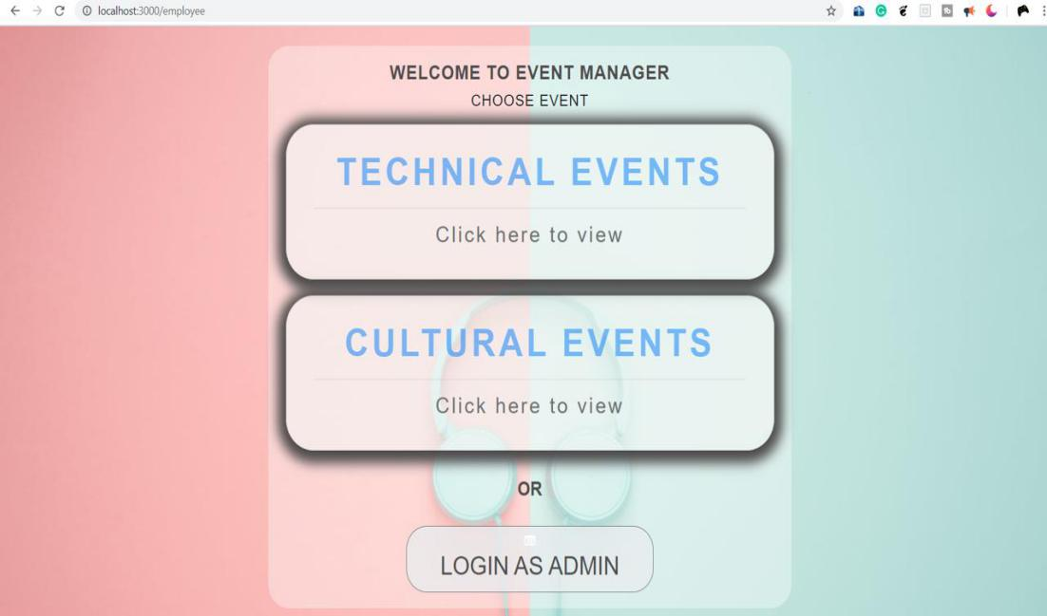

* The user chooses the respective event type to be viewed.The data is later retrieved from the database and the user is provided with the student details along with the certification.

The user can also download the student details with the certification.

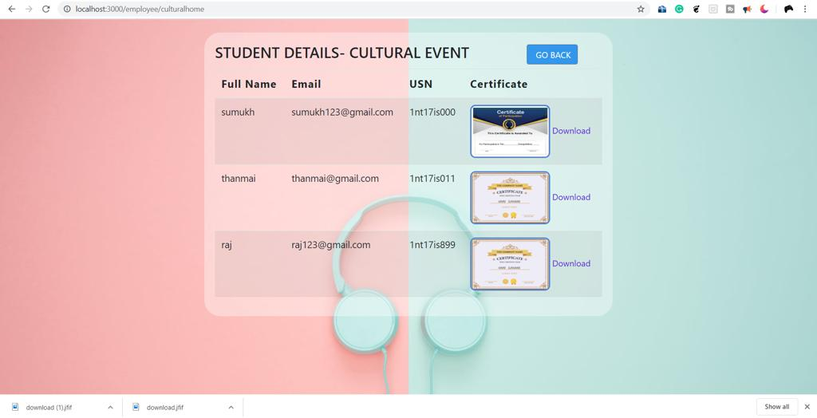

**Conclusion**

Our project can be used to satisfy the needs to manage the records of the student details and their achievements for the respective event.Several user friendly coding have also been adopted.This project satisfies all the requirements needed to organize ,manage and update the data regularly.