MDSC-103P Final Lab Test

- ***23912***

Q1) Wilson problem.

A.

*Let x1, x2 be the no. of dozen(s) of baseballs and softballs produced respectively.*

The problem can be formulated as below:

**Objective function**: (Maximising Profit)

**Max Z** = 7x1 + 10x2

**Subject to**:

5x1 + 6x2 <= 3600 (Total Cowhide sheets available for a day)

1x1 + 2x2 <= 960 (Total minutes available for manufacturing)

x1 <= 500 (Max of 500 dozen baseballs can be produced)

x2 <= 500 (Max of 500 dozen softballs can be produced)

**a) Formulate the problem in the Excel file and generate the sensitivity analysis.**

A. Below is the problem formulation in excel file and the sensitivity report.

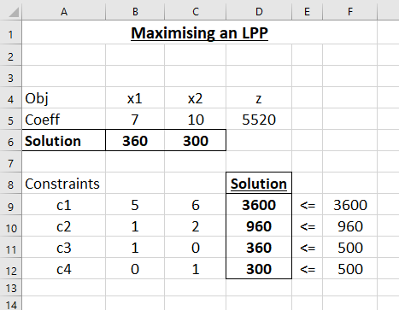

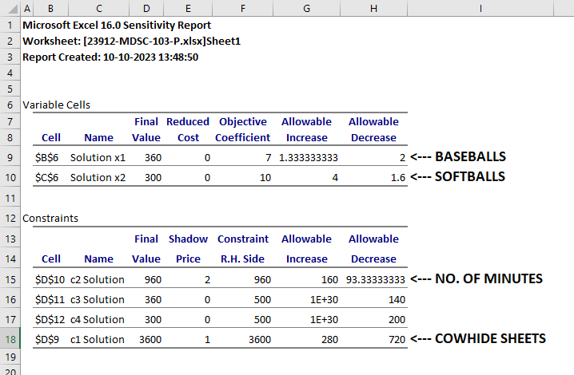

**b) Write on cost coefficient sensitivity analysis.**A.

**i)** The optimal production mix is to produce 360 dozens of baseballs and 300 dozens of softballs.

**ii)** As the objective coefficients of both the balls are 7 and 10, the optimal total profit earned, **Z** is 360(7) + 300(10) = 2520+3000 = **$5520**

**iii)** The optimality ranges for baseballs is (7-2 , 7+1.33), i.e., (5 , 8.33)

The optimality ranges for softballs is (10-1.6 , 10+4), i.e., (8.4 , 14)

It means that, the objective coefficient of x1 can be reduced and increased until the extreme points of its optimality range interval, i.e., 5 and 8.33 respectively. Within this range, the optimal production mix remains same. Beyond this, anything can happen.

Same applies for x2 as well.

**iv)** Reduced Cost is 0 as Allowable Decrease is >1 in both the cases.

**c) Write on Right Hand Side Sensitivity Analysis.**

A.

**i)** ‘**Constraint RHS’** column shows total no. of available resources, i.e., the RHS of our constraints and ‘**Final Value**’ column shows the no. of resources being utilized from total resources to obtain optimal production mix.

As we can see, clearly **Total no. of minutes (c2)** is the only resource that is completely utilized, rest of the others are under-utilized.

**ii)** Shadow/Dual Price tells the value of a particular resource, to be precise, a unit resource. Shadow Price of a particular resource is the profit gained upon increasing one unit of that resource.

**iii)** The feasibility ranges for baseballs is (960-93.3, 960+160), i.e., (866.66, 1120)

The feasibility ranges for softballs is (3600-720, 3600+280), i.e., (2880, 3880)

It means that, the total no. of resources (RHS) of constraint c1 can be reduced and increased until the extreme points of its feasibility range interval, i.e., 866.66 and 1120 respectively. Within this range, the solution remains feasible. Beyond this, anything can happen.

Same applies for x2 as well.

**iv)** Shadow Price is 0 for c3 and c4 as Allowable Increase is <1 in both the cases.

Q2) Gradient Ascend problem.

A. 