echo

Unaware of why or how, you find yourself in a cave trying to escape and figure out what happened. Use your newfound ability of cloning and unravel the mystery of the source of this power by constructing paths and solving puzzles in this arcade-style puzzle platformer. Utilize directional blocks, the ability to jump, switches, and various other tools to guide you in your quest.

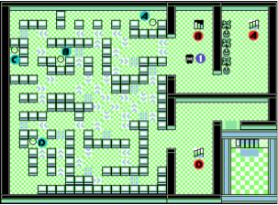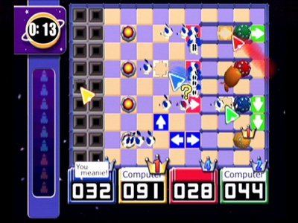

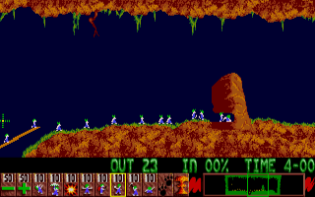

ART STYLE

The game is cartoonish, in an RPG style setting, The idea is to focus more on mechanics and making the game more fun and approachable, without too much worry of art assets. The game is set in top down 2.5D style.

MUSIC / SFX

The character is a guy who is walking throughout the level, jumping over gaps, and reacting to tiles. The sound effects we would need include Cloning, Jumping, Placing a tile, Removing a tile, Play, Pause, Restart, Reaction to a directional tile, Upbeat background music, etc.

Thank you!

Sumukh Anand and Gagan Basandra

[sumukhan@usc.edu](mailto:sumukhan@usc.edu) | [basandra@usc.edu](mailto:basandra@usc.edu)