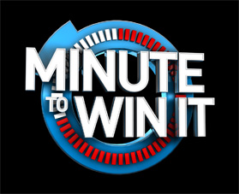

**ENTRY FEE: rs 20**

* Can choose only 4 out of 8 games
* Give it your best shot in 60 seconds and win goodies
* Please visit the counter after playing