BUG REPORT
E-Commerce Website Testing | saucedemo.com
Manual Testing Project — Portfolio
Total Bugs | Critical / Major | Status: Open | Modules Affected
2 | 2 Critical/Major | 2 | 2

Bug Reports

BUG-LGN-001 — Login with Invalid Password — Test Case Failed
Bug ID | BUG-LGN-001
Module | Login
Status | Open
Severity | Major
Priority | High
Environment | Chrome (latest) | Windows 11 | saucedemo.com
Reported By | [Your Name]
Date Found | [Date]
Related TC | TC-LGN-002
Steps to Reproduce
1. Open https://www.saucedemo.com
2. Enter Username: standard_user (valid username)
3. Enter Password: wrongpass (invalid/wrong password)
4. Click Login button
5. Observe the error message and behavior
Expected Result | Error message displayed: Username and password do not match any user in this service. User stays on login page.
Actual Result | TC-LGN-002 was marked FAIL during execution. The actual result did not match the expected error behavior for invalid password login scenario.
Screenshot / Evidence
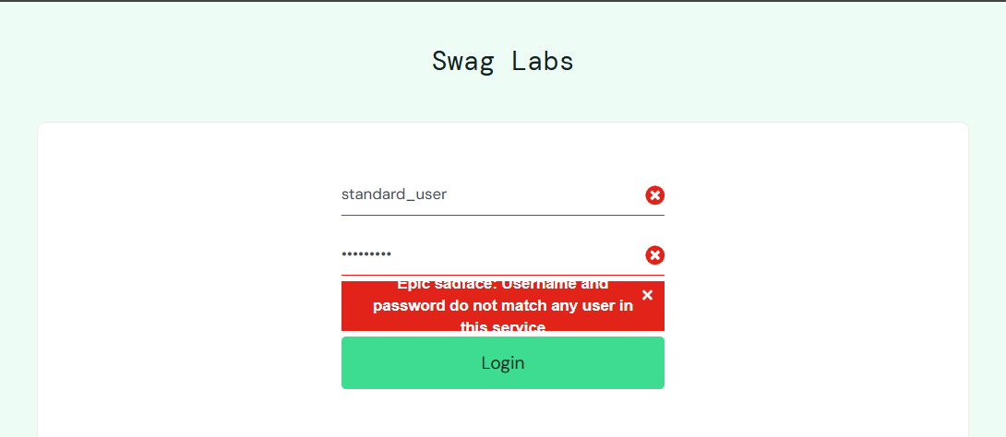

BUG-LO-001 — Cart Not Cleared After Logout and Re-Login
Bug ID | BUG-LO-001
Module | Logout / Shopping Cart
Status | Open
Severity | Major
Priority | High
Environment | Chrome (latest) | Windows 11 | saucedemo.com
Reported By | [Your Name]
Date Found | [Date]
Related TC | TC-LO-004
Steps to Reproduce
1. Login with standard_user / secret_sauce
2. Click Add to Cart on Sauce Labs Backpack
3. Verify cart badge shows 1
4. Click hamburger menu top-left and click Logout
5. Login again with standard_user / secret_sauce
6. Observe the cart badge and cart contents after re-login
Expected Result | Cart should be completely empty after fresh login. Cart badge should not be visible on the inventory page.
Actual Result | Cart was NOT cleared after logout and re-login. Sauce Labs Backpack still present in cart. Badge still shows 1 after fresh login. Session cart data was not properly cleared on logout.
Screenshot / Evidence
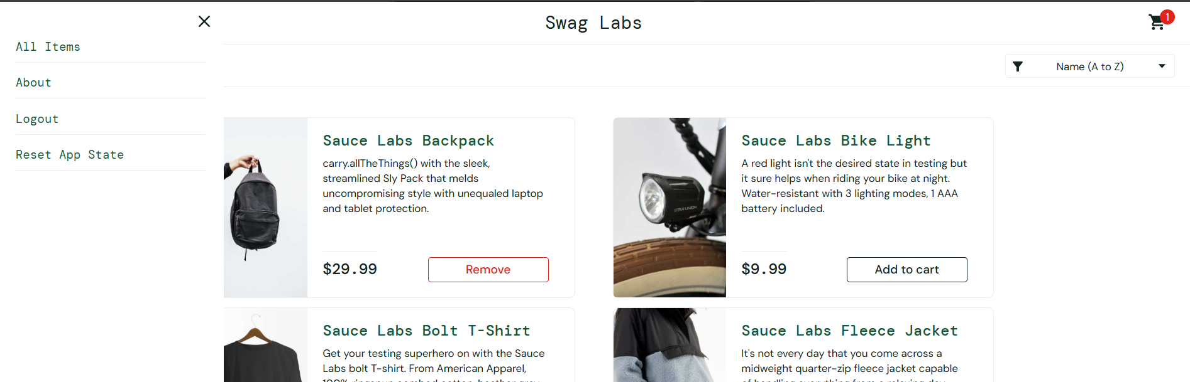

Bug Summary

Bug ID | Title | Module | Severity | Priority | Status
BUG-001 | Cart Not Cleared After Re-Login | Logout | Major | High | Open
BUG-002 | Login Page Exposes All Credentials | Login | Critical | High | Open

Prepared by: Sumaiya Noor | Date: [07/12/2025] | Tool: Manual Testing | App: saucedemo.com

