

**AMERICAN INTERNATIONAL UNIVERSITY–BANGLADESH (AIUB)**

**FACULTY OF SCIENCE & INFORMATION TECHNOLOGY**

**INTERNSHIP AFFILIATIONREPORT ON**

***Teaching Assistant at***

***American International University-Bangladesh (AIUB)***

An Internship Report Presented to the

OFFICE OF PLACEMENT and

DEPARTMENT OF COMPUTER SCIENCE

In Partial Fulfillment of the Requirements for the Degree

***Bachelor of Science in Computer Science& Engineering***

**Supervised By**

MR. MASHIOUR RAHMAN  
Associate Professor

Associate Dean, Computer Science

Faculty of Science and Technology

American International University-Bangladesh

**Submitted By**

**FARHEEN SHUCHI**

**ID: 14-27893-3**

Date of Submission: 27.04.2019

**LETTER OF SUBMITTAL**

I am solely satisfied and honored to submit my internship report entitled “Teaching Assistant in American International University- Bangladesh”. The experience being a Teaching assistant let me to taste the noble and prestigious profession of teaching from a very closer periphery. Throughout the report, I have tried to sum up what all the activities I had been performing during my internship period in the stated university.

I was assigned as a Laboratory Assistant for the course COMPUTER GRAPHICS Section: A, B1 and Section: B2, C respectively. The laboratory demonstrates a very basic of respective broader field in computer science of graphics design. As a teaching assistant, I have discovered many loopholes where exactly the students get stuck and regarding their shortcomings in understanding the basics. I have tried to perform all my duties in these two labs. I have interacted with the students and tried to solve their problem and also teach them how they can solve a problem. My respected faculty member is very much aware of those and corrected the students accordingly which also let me to get notified where the drawbacks are. My supervisor was also very much helpful in the case of any difficulties that I have faced and also regarding the detailed preparation of this internship report. My assigned course teachers also taught me how to interact with the students and help them according to their need and when not to.

Above all, I was really content to take part of the internship program inaugurated by AIUB. It has enabled me to explore a greater horizon of teaching profession to opt for it in the near future. I would like to cordially thank my supervisor and assigned course teachers to assist me their best upon successful completion of my internship program in the university.

Yours sincerely,

___________________________

FARHEEN SHUCHI

ID:14-27893-3

Date: 27.04.2019

**Letter of Endorsement**

The Internship Affiliation Report entitled “Teaching Assistant at American International University -Bangladesh*”*, has been submitted to the Office of Placement and Department of Computer Science in partial fulfillment of the requirements for the degree of Bachelor of Science (BSc.) in Computer Science & Engineering by FARHEEN SHUCHI, ID: 14-27893-3. This report is presented to the Internship Defense Committee for evaluation and has been accepted.

|  |  |  |
| --- | --- | --- |
| MR. MASHIOUR RAHMAN  *(*Internship Supervisor*)* (academic) Associate Professor  Associate Dean, Computer Science  Faculty of Science and Technology  American International University-Bangladesh |  | KANIZ FATEMA  *(*Internship Supervisor*)* (industry)  Assistant Professor  Department of Computer Science  American International University-Bangladesh |
| KAWSER IROM RUSHEE  *(*Internship Supervisor*)* (industry)  Lecturer  Department of Computer Science  American International University-Bangladesh |  | D. M M MAHBUBUL SYEED  Associate Professor  Head (Undergraduate), Computer Science  Faculty of Science and Technology  American International University-Bangladesh |

**Acknowledgement**

First of all, I would like to thank Almighty, for his grace in accomplishing my internship report on time. I would like to express my gratitude to the **Faculty of Science & Information Technology** to keep internship credit in the curriculum of the graduation program and give me a scope of tasting the flavor of industry-oriented tasks and the field of work with my interest. I am also grateful to the **Faculty of Science & Information Technology & Office of Placement & Alumni**, AIUB to arrange an opportunity for choosing an own interested organization and complete internship there. In the procedure of accomplishing the report, the university itself and the internship supervisor **MR. MASHIOUR RAHMAN** deserve the gratitude as they have allowed me choose a company for internship according to my wish. I am also thankful to my organization supervisor **KAWSER IROM RUSHEE** and **KANIZ FATEMA** from the core of my heart for their kind support, guidance, constructive, supervision, instructions and advice and for motivating me to do my internship smoothly.

Finally, I would like to thank everyone who supported me is any respect for the successful realization of my internship, as well as expressing my apology that I could not mention personally one by one. I am pleased to complete the report on the given subject properly and authentically.

# Table of Contents

|  |  |  |
| --- | --- | --- |
| **TOPICS** | | ***Page no*.** |
|  | |  |
| 1. **Title Page** | | 1 |
| 1. **Letter of Submittal** | | 2 |
| 1. **Letter of Endorsement** | | 3 |
| 1. **Acknowledgement** | | 4 |
| 1. **Table of Content** | | 5 |
|  | |  |
| 1. **Introduction** | | 6 |
| * 1. Rationale | | 6 |
| * 1. Background | | 6 |
| * 1. Objectives | | 9 |
| 1. **Activities** | | 10 |
| * 1. Work Load | | 10 |
| * 1. Organization Wide | | 13 |
| * 1. Other Relevant Activities | | 13 |
| 1. **Constraints/Challenges** | | 15 |
| * 1. Identified/Observed in the Organization | | 15 |
| * 1. Academic Preparation | | 15 |
| * 1. Personal/Professional Skills | | 15 |
| 1. **Acquired Knowledge** | | 16 |
| * 1. Consequences to Organization | | 16 |
| * 1. Implications to University’s Internship Program | | 17 |
| * 1. Effects on Personal/Professional Skills | | 18 |
| 1. **Concluding Statements** | | 20 |
| * 1. Summary | | 20 |
| * 1. Recommendations/Suggestions for future strategic actions | | 20 |
|  |
| 1. **Recommendation Letters** | | 21 |
| 1. **References** 2. **Appendices** | | 22  23 |
|  | |  |

1. **INTRODUCTION**
   1. **Rationale**

An internship report provides the faculty the information which qualifies the students for graded credit; it also provides the faculty with in-depth information about the profession they are responsible for preparing students to participate in. Furthermore, and of considerable importance, the internship report increases the student’s responsibility by requiring the student intern to gather information and plan the report throughout the work experience. The student then has an opportunity to demonstrate maturity as a technical writer by presenting analyzing, and evaluating his or her own work on the job. Being an intern the main challenge was to translate the theoretical concepts into real life experience.

* 1. **American International University – Bangladesh:**

American International University - Bangladesh (AIUB) is a government approved private university founded in 1994 by Dr. Anwarul Abedin. The university is an independent organization with its own Board of Trustees. Dr. Carmen Z. Lamagna is the present Vice-Chancellor of the university. AIUB currently operates under four distinct faculties: Faculty of Arts and Social Science (FASS), Faculty of Business Administration (FBA), Faculty of Engineering (FE) and Faculty of Science and Information Technology (FSIT). AIUB ranked as an International University by UNESCO which is published by UNESCO in the International University Handbook, 2006 edition.

* + 1. **Vision**

AMERICAN INTERNATIONAL UNIVERSITY-BANGLADESH (AIUB) envisions promoting professionals and excellent leadership catering to the technological progress and development needs of the country.

* + 1. **Mission**

AMERICAN INTERNATIONAL UNIVERSITY-BANGLADESH (AIUB) is committed to provide quality and excellent computer-based academic programs responsive to the emerging challenges of the time. It is dedicated to nurture and produce competent world class professional imbued with strong sense of ethical values ready to face the competitive world of arts, social science and technology.

* + 1. **Goals**

Continue to upgrade educational services and facilities responsive of the demands for change and needs of the society.

▪ Inculcate professional culture among management, faculty and personnel in the attainment of the institution's vision, mission and goals.

▪ Enhance research consciousness in discovering new dimensions for curriculum development and enrichment.

▪ Implement meaningful and relevant community outreach programs reflective of the available resources and expertise of the university.

▪ Establish strong networking of programs, sharing of resources and expertise with local and international educational institutions and organizations.

▪ Accelerate the participation of alumni, students and professionals in the implementation of educational programs and development of projects designed to expand and improve global academic standards

* + 1. **Linkage & Networking**
* Microsoft Security Cooperation Program
* Microsoft IT Academy
* MSDNAA
* CCNA and IT Essentials in collaboration with CISCO
* Authorized Sun Education Centre
* Education Partner of Bangladesh Cricket Board
* Oracle Academy
* Certifies Internet Web (CIW) Professional Program
* CTP Authorized Training Academy
* The Duke of Edinburgh's International Award
  + 1. **Institutional Member**
* Asia Pacific Quality Network (APQN)
* International Association of Universities (IAU)
* International Association of University Presidents (IAUP)
* American Association of University Administrators (AAUA)
* Association of Universities of Asia and Pacific (AUAP - Board Member)
* Global University Network for Innovation (GUNI)
* Association of Management Development in South Asia (AMDISA)
  + 1. **Member**
* American Chamber of Commerce in Bangladesh (AmCham)
* Association of Management Development Institutions of Bangladesh (AMDIB)
  + 1. **Facilities at AIUB**

A university is a fountainhead of knowledge. New knowledge, skills and meaningful experiences spring from the university. To quench the thirst of individuals who are in search for wider horizon of learning and discover novel challenges in life is the inherent intention of AIUB even at the time of its conception. Students are honed and nurtured to become Leaders in their respective chosen discipline. It continuously transforms students into active participants in the development process in both curricular and extra-curricular activities. It has built and maintained its reputation as a leader in the pursuit of quality and excellence. The primary beneficiaries are the students who stand to benefit from all the resources and services provided by the university. Under the stewardships of dedicated and visionary founders, dynamic management, competent faculty and skillful support staff, the university continues to be the venue for change and producing leaders in various arenas of endeavors. To cope with the demand of the times and the needs of the learners, the university is backed up with adequate state facilities:

* Concerned for quality output
* Internationally affiliated institution
* World Class State-of-the-art facilities
* Full time faculty with adequate academic and professional exposure
* Qualified and accommodating academic and non-academic staff
* Medium of instruction is English
* Located in a serene part of the cosmopolitan city
* Friendly and exciting campus life
* Guidance and counseling services
* Fully air-conditioned library with regularly updated collection of reference books, journals and periodic.
* On campus cafeteria
* Air-conditioned class rooms with audio-visual facilities
  + 1. **Laboratory facility**

American International University has modern laboratory facilities. The university has Physics Lab, Chemistry Lab, Language Lab, Computer Lab, Multimedia Lab, Architecture Studios and some others Labs as well.

* 1. **Objectives**

This internship report is prepared primarily to fulfill the Bachelor of Science (B. Sc.) in Computer Science & Engineering (CSE) degree requirement under the Faculty of Science & Information Technology (FSIT). The purpose of the internship program is to help students focus on their career interests and potentials. The whole program entitles to give the opportunity to learn, observe and determine their goals and aims. At the end of the period, the study allows them to gather information and construct a report on their observations, knowledge and experience. It helps to gain knowledge of professional environment and prepare for future career. As stated earlier the study also assists students in completing their academic credit.

1. **ACTIVITIES**

The activity schedule is the work distribution of an internee in order to complete the internship program. The efficiency and maturity with which a teacher schedule the activities related to teaching determines the teacher understands of his/her work. Scheduling determines the necessary tasks and allocates each task the necessary time. The internship program allows interns to understand how processes work and what needed to be able to perform efficiently.

* 1. **Work Related**

The main responsibility was to assist the teacher in the laboratory classes by guiding the students and solving their problems related to the course materials. In the laboratory classes the students of Introduction To Database used to learn about how to create tables, how write sql commands etc. And in the Data Structure course the students used to learn about different kinds of sorting algorithms, stack, queue etc. The workload was distributed as two laboratory classes per week. The respective teachers used to teach the students the theoretical aspects in the lectures allotted for theoretical discussions. Afterwards the students had to implement the acquired knowledge in the laboratory. I had to assist the Teachers in the laboratory classes by helping the students to implement the theories they have learnt in the theory classes. I also assessed their performance when they were asked to do some tasks. Some lab task given below:

Example 1**:** Create a table

Solution: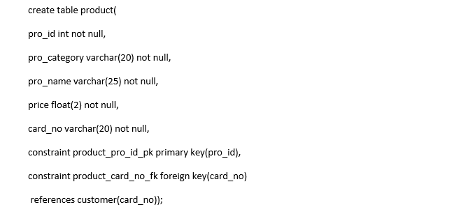

Figure: 1

Example 2**:** Insert data into database table.

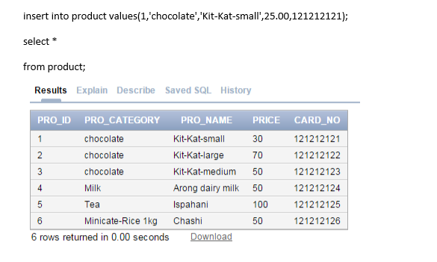

Figure: 2

Example 3**:** Select a particular data from database table.

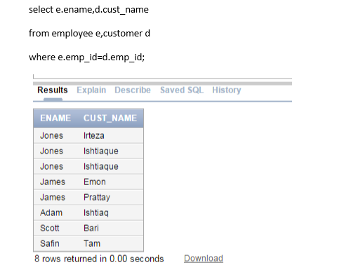

Figure: 3

Example 4**:** Bubble Sort

void bubbleSort(int ar[])

{

for (int i = (ar.length - 1); i >= 0; i--)

{

for (int j = 1; j ≤ i; j++)

{

if (ar[j-1] > ar[j])

{

int temp = ar[j-1];

ar[j-1] = ar[j];

ar[j] = temp;

}

}

}

}

Example 5**:Insertion Sort**

void insertionSort(int[] ar)

{

for (int i=1; i ‹ ar.length; i++)

{

int index = ar[i];

int j = i;

while (j > 0 && ar[j-1] > index)

{

ar[j] = ar[j-1];

j--;

}

ar[j] = index;

}

* 1. **Organization-Wide**

American International University – Bangladesh (AIUB) has some prescribed rules and regulations for teaching and evaluating students. The evaluation procedure is elaborated in the following section:

**Theory** Quiz (Best Two) 40

Class Attendance 10

Term Exam 50

Total 100

**Lab** Class Attendance 10

Lab Works/Assignments 10

Lab Exam 20

Total 40

**Mid Term** 40% of Lab + 60% of Theory

**Final Term** 40% of Lab + 60% of Theory

**Grand Total** 40% of Mid Term + 60% of Final Term

After each of the term exams I had to assist the respective teachers in calculating the grades of the students. The evaluation process of the students has a great importance for justifying the teaching to students: how much they could learn, how much knowledge they could apply in practical etc. These processes were to be done flawlessly.

* 1. **Other Relevant Activities**

As a teaching assistant of laboratory classes, I have gained firsthand experience with lab works, and student management. Additionally, I also had a considerable amount of student interaction on multiple levels: helping, advising, and providing feedback. My supervisor was very open minded and allowed to interact with the students freely. He gave me constructive feedback to improve my public speaking and presentation/teaching skills. This has been a very positive and valuable learning experience for me. An understanding of student development has helped me as a co-instructor for the course. I was, and continue to be, mindful of psychosocial development theories when working with the students. These theories inform my interaction with individuals, as well as my work with all of them in a large group setting. My supervisor has also encouraged me to think about more ways to teach and circulate the information. He has a broad understanding of various learning theories and has helped me to utilize different teaching styles when presenting information to the students. Finally, I find myself using a number of helping skills both in the labs and one-on-one with the students. As I facilitate lab discussions I often use attending (exploration) and challenging (insight) skills. I find these skills help to continue the discussion and push their thoughts and reasoning to the next level. While interacting personally with students, I often use attending, challenging, and action-oriented skills. For instance, I praise if someone answers correctly, but I also respond to question with another question. Many of my one-on-one meetings with student conclude with a plan of action, whether it is about something personal or something group/assignment related. I have certainly practiced and enhanced my professional competencies while in this internship. I have been actively involved in the implementation of the course, and, subsequently, have practiced/improved student management, communication, leadership, mediation, and facilitation skills. As the primary contact for the students I have had to practice my verbal and written communication skills by way of facilitating lab discussion, email correspondence, as well as communicate student concerns to the instructor. Also, I have given numerous suggestions to the students about how they should approach towards the courses. This has helped me to improve my public speaking skills and advising skills. Since many of my lesson plans include activities and student discussion, I have also improved my ability to facilitate classroom/student discussions. Working with the instructor has definitely been a challenge, in terms of making the student understand easily. However, it has gotten better with time and I feel that I have improved my ability to work as a team.

1. **CONSTRAINTS/CHALLENGES**
   1. **Identified in the Organization:**

American International University - Bangladesh is a fountainhead of knowledge. New knowledge, skills and meaningful experiences spring from this university. To quench the thirst of individuals who are in search for wider horizon of learning and discover novel challenges in life is the inherent intention of AIUB even at the time of its conception. Students are honed and nurtured to become Leaders in their respective chosen discipline. It continuously transforms students into active participants in the development process in both curricular and extra-curricular activities. It has built and maintained its reputation as a leader in the pursuit of quality and excellence. The primary beneficiaries are the students who stand to benefit from all the resources and services provided by the university. Under the stewardships of dedicated and visionary founders, dynamic management, competent faculty and skillful support staff, the university continues to be the venue for change and producing leaders in various arenas of endeavors.

* 1. **Academic Preparation**

There lies a vast difference between the students and who stand in front of them to teach and help them to learn. During this internship affiliation, the learning’s at my Web technology course have helped me a lot to support the students to complete their tasks in the lab classes. Sometimes, I needed to revise the course materials before the classes. It helped me a lot to recapitulate what I have learnt earlier which made my knowledge base strong for the future.

* 1. **Professional skills:**

Learning new teaching techniques and teach it to the students was a big challenge. In my classes I need to give time to each student. Managing the student was another challenging task. As the first learning task of mine, I had to revise shell programming knowledge. I had to work outside lab that I can complete my learning task in time. So it seemed challenging to me. To make them understand I need to think differently. It was a new experience for me.

1. **ACQUIRED KNOWLEDGE**
   1. **Consequences to Organization**

Form the learning and experience point of view I can say that I really enjoyed my internship period as a Teaching Assistant at Department of Computer Science, American International University –Bangladesh. From the very first day, I am confident that this 3 months’ internship program will definitely help me to realize my further carrier in the job market as an academician. Everything is not so sufficient to measure and express perfectly within this short time of my internship period. But it is a great opportunity for me to get used to the noble teaching profession. I have tried by soul to incorporate the necessary relevant information in my report. During the period of internship, I have tried to learn the art of teaching and deliver the theoretical knowledge to the students what I have gathered and going to acquire from various courses. Sometime academic knowledge becomes insufficient for performing well in job life. So, this problem can be solved by doing internship in a university. It can be said as, getting an introduction of future job world. I have acquired several knowledge’s from my internship. During the tenure of my internship the major aspects that I have been familiar with are discussed briefly in the following sections.

* + 1. **Culture**

Every organization has its own culture at the same time Department of Computer Science, American International University – Bangladesh does have their own organizational culture. Within a very few days I successfully adapted their culture. I have acquired a tremendous upgrade in my self-assessment condition, now I optimized my confidence level in a way that gives me hidden backup of working with the teachers of such a department. I also learned maintaining time, working under pressure and manage to different types of people.

* + 1. **Working Environment:**

This department has a very good teaching and learning environment. This is very motivating to the teachers as well as the students. A good environment results in better education. The rights of both teachers and students are strictly maintained so both are secured. High level of ethics is evident among the people. Teachers are free to educate the students at any given level of pressure. My supervisor was very helpful in assisting me. She never misbehaved if I made any mistakes rather she helped me to correct my faults. The students were very cooperative and it was exciting to learn from them too.

* + 1. **Communication:**

Throughout the internship program one of the most valuable and important thing I learned is how to communicate. This department highly emphasize on communication, they prefer direct communication rather than virtual communication.

* + 1. **Time Management:**

One of the good things that I have learned from the experience is time management. I badly needed to learn the time management because I had faced serious problems to manage both my work and study. This highly increases the efficiency and performance and reduces time wastage. Time management skills helped me a lot to cope up with big assignments and important meetings with the supervisors.

* + 1. **Professionalism:**

Working at the department taught me to be a professional. They highly emphasize on professionalism. It is also one of the standards to fulfill requirements. They are casual but very professional on the academic procedures. The professionalism increases the efficiency and reduces the errors which ensure standard and quality service as a result maximum student satisfaction is received. It is all about being accurate, reducing mistakes, following standards, and acting as situations demands.

* 1. **Implications to University’s Internship Program:**

I would like to take this opportunity to thank the people who have given me invariable support while pursuing my internship curriculum. Overall the internship program of American International University– Bangladesh is very good. It is quite different and standard than other University. Better facilities are provided to be a prospective employee by the end of the day. There are benefits as well as some lacking. I hope the university will make it more beneficial.

**4.3. Effect on personal/professional skills**:

**4.3.1. Ability to Learn:**

Changes can make humans either immortal or ordinary. In my case, there occurred a radical change in me too. Somehow, I have the power of learning work exceptionally well.

**4.3.2. Dependability:**

The word ‘Dependability’ itself bears a lot of gravity. Sometimes it is seen that many university do not want to give opportunity to intern. In my university, I as well my other co-intern member’s initial hard working convinced our supervisor very positively. All these evidences are clear enough to bear the testimony of my dependability.

**4.3.3. Problem solving:**

It is very common scene to fall in different kinds of assignment during the implementation of any assignment. So, if someone faces problem in completing his/her task then she/he should ask help from the respective faculty. If the problem is relates with the programming then searching in the internet is the best option to get solution. So, one must try to solve the problems related with his/her task.

**4.3.4. Punctuality:**

Tardiness was a nonexistent phenomenon for me throughout these three months. Every day I used to go labs in time that enabled me to keep ahead of time. However, whenever there was any possibility of lateness or absence, I always tried to inform it to my supervisor with a formal SMS or simple Voice Call. I have tried my best to use my class time for greater productivity. I hope that this punctuality and regularity will enhance a better disciplinary attitude in me and pave my way to success.

**4.3.5. Error solving and exception handling:**

During the internship period, I’ve learnt how I can face different errors and exception. I’ve faced several errors and exceptions to complete my task. When I saw error or exception during my work, I searched about that problem on internet and made them solve.

**4.3.6. Quick learning:**

As I mentioned before that I had no experience about teaching before joining in the university. To cope with the working flow of an office one must should be quick learner. Because technologies are developing day by day and if someone fails to understand/realize this, then she/he will lag behind. Then she/he would get negative performing rate from the office. So to emulate with the educational institute, one should be quick learner.

**4.3.7. Professional manner:**

By doing my internship, I’ve learnt about the professional behavior and manners of an office. I’ve learnt how should I make conversation with students, what behaviors are perfect to talk with seniors, how a problem can be managed etc.

1. **CONCLUDING STATEMENTS**

**5.1 Summary**:

Department of Computer Science, American International University – Bangladesh provides a world class education to its students both in undergraduate and graduate program. All the teachers are qualified to the highest extent and can provide quality education and knowledge to the students. They also encourage the students to various research works, practical implementation of various theories for the betterment of the mankind etc. These facilitate the students of this department with a world class quality. Working with people of this great group has taught me many useful things that will be beneficial for me in the future.

**5.2 Recommendation for Future Strategic Actions**:

The internship opportunities as a teaching assistant develop the quality to teach students. This opportunity is only provided for the lab classes. It would be better if more facilities are offered for the theory classes like as, demo lecture by the intern students in presence of the respective teachers, preparation of the course materials, setting question papers, checking scripts according to the guidance of the respective teachers etc.

During my internship, I was regularly briefed by the respective teacher for the various duties and responsibilities of mine. But it would be better if all the intern students are mentored together for their duties and responsibilities throughout the internship period. It would provide the intern students to have group discussions among them. This will calibrate their efficiency more perfectly for various teaching techniques.

1. **RECOMMENDATION LETTER**

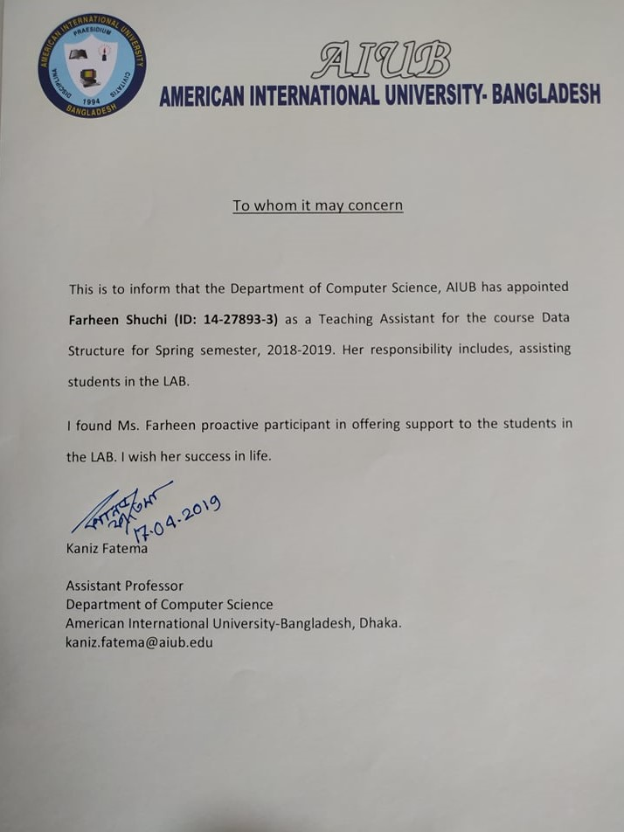

1. **References**

The following sources were used to collect information for preparing this report:

* http://www.aiub.edu
* http://fsit.aiub.edu

1. **Appendices**



**RESUME OF**

**SHUCHI FARHEEN**

Address : KA-160, Kuril Mridha Bari Road,

Dhaka-1229

Mobile : 01785846165

E-mail : shuchifarheen@gmail.com

**Objective:**

To work hard succeed among all the twists and turns of life with diligence and efficiency.

**Educational Qualification :**

* **B. Sc (Bachelor of Science)**

Institute : American International University Bangladesh

Dept : CSE (Computer Science & Engineering)

**Result : CGPA- 3.39( Up to 11th Semester)**

* **HSC (Higher Secondary Certificate)**

Institute : Jessore Shikkha Board Model School & College, Jessore.

Group : Science

GPA : 4.70

* **SSC (Secondary School Certificate),**

Institute : Jessore Govt. Girls’ High School, Jessore.

Group : Science

GPA : 4.75

**Computer Skill:**

Web Based skills: HTML, CSS, PHP and C#.

Database skills: Oracle & MySQL.

Expert in Computer Application Package

(MS-Word, MS-Excel, MS-Power Point,

Windows Operating & Internet Browsing)

**Language Proficiency:**

* Well Command both on Written & Spoken English
* Strong Command both on written & spoken Bengali (Mother Tongue)

**Personal Details :**

Name : **Shuchi Farheen**

Father’s Name : Md. Maqsud Al Habib

Mother’s Name : Shelina Sultana

**Permanent Address** : House # 195/4, Ghope Pilu khan Road By lane,

Jessore-7400.

**Present Address**  : KA-160, Kuril Mridha Bari Road, Dhaka-1229.

Date of Birth : 5th January 1997

Religion : Islam (Sunni)

Nationality : Bangladeshi by born.

Marital Status : Unmarried.

Blood Group : B + (positive)

**Declaration:**

I hereby consciously ascertain that all the particulars mentioned above are true. I myself will be liable for any misinformation mentioned herewith.

**Reference:**

**Md. Al Amin**

Lecturer

Department of Computer Science

American International University-Bangladesh

Mobile: 01710-004078