Tutorial: calculate the cross coefficient to determine the .tif quality

1. Open calCorr_everyFrame.m in Matlab
2. Change parameters:

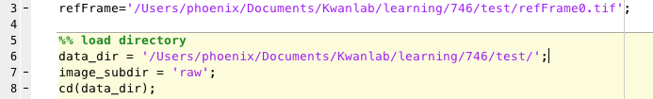

**refFrame**: path of the reference frame you used to calculate the cross correlation. (I use the average projection acquired by ImageJ, since we use this refframe to do the motion correction)

**data_dir**: the path of the directory where you keep the data

**image_subdir**: the directory which contains the .tif files which you want to calculate the cross correlation (this directory should be under the data_dir path)

1. Run (the .m file saves the coefficient vector in coefficient subdirectory.)

Here is a test example (only 10 .tifs, ~400 frames were calculated)

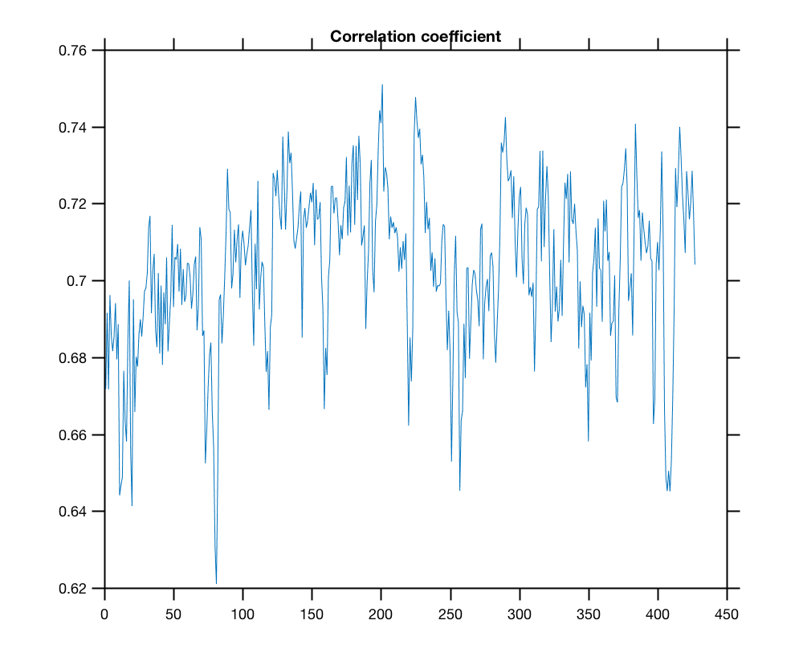

#note: the cross-correlation coefficient is between 0 – 1. I am not quite sure what value indicate the frame is too bad to be motion corrected. Yet this test dataset seems to be motion corrected successfully, thus I assume coefficient > 0.62 would be fine.