Undergraduate Final Year Project Proposal

[Investigating the Restaurant Advisor Website System]

[Su Myat Noe Lwin]

[Business Information Technology]

[Banner ID- 000860937]

Overview
Nowadays, there are so many websites that give services of the best hotels, restaurant and so on to people. In this project, I would like to investigate user roles and processes of restaurant services website. Most of these services websites are restricted and must need to pay advertising fees by those concern restaurants. In this situation, people can search a few restaurants that are advertised in those websites. But oppositely, this project will develop the restaurant advisor system that are free for all restaurants and users, and then researching mainly for three user roles – Guest level, Member level and Admin level.
The Guest user can view and search for restaurant information. After sign up, the guest become member user and they can entry restaurant information, ranking, review and comment to other restaurants, and also along photo upload such as dishes or restaurant decoration. Admin will manage all users and restaurants information.
For this project, I will develop a prototype using one of the Open Source Languages_ Ruby languages with Rails Framework (ROR) on Ubuntu 14.04 OS. And then I intend to use MySQL for database together with ROR.

Aim
The main aim of the project is to develop a website that is authorizing with roles, functions used with gems (ROR plugins) and giving helpful information to users. It is helpful using DSDM methodology for future analysis skill. For technology, using Ruby on Rails with MySQL database, the newly experience of programming skill will be received.
Then, for customer view, they can easily search the restaurants suitable with their needs and they also can enjoy reviewing with comments, uploading photos, etc.

Objectives
The following activities are included as the main objective;

- Investigation of existing restaurant advisor system
  - Research and collect the restaurant information that will be desired from the existing website
  - Examine how ranking system is worked from existing website
  - Examine user role

- Investigation and analysis the system requirement
  - Define the system scope
  - Search required technologies and features

- Define system design and database
  - Produce UML Design such as Sequence Diagram or Use Case
  - Produce class diagram for database

- Implement the projected system
  - Develop the prototype
  - Design and implement the system website using timeboxes

- Testing the developed system
  - Test the whole system works properly
  - Test the system is relevant with the requirement

Legal, Social, Ethical and Professional

Any resources, information or photo will be used in the website must be referenced to the original and if any permission needed, I’ll request to the original owner for authorization. Some reference websites and books are written at the end of final report as Reference.

Initial References
www.tabelog.com
- Access date: 13/8/2014
- For system scenario

www.tripadvisor.com
- Access date: 12/8/2014
- For system scenario

Appendix A - Schedule of Work

- Project Plan and Gantt Chart
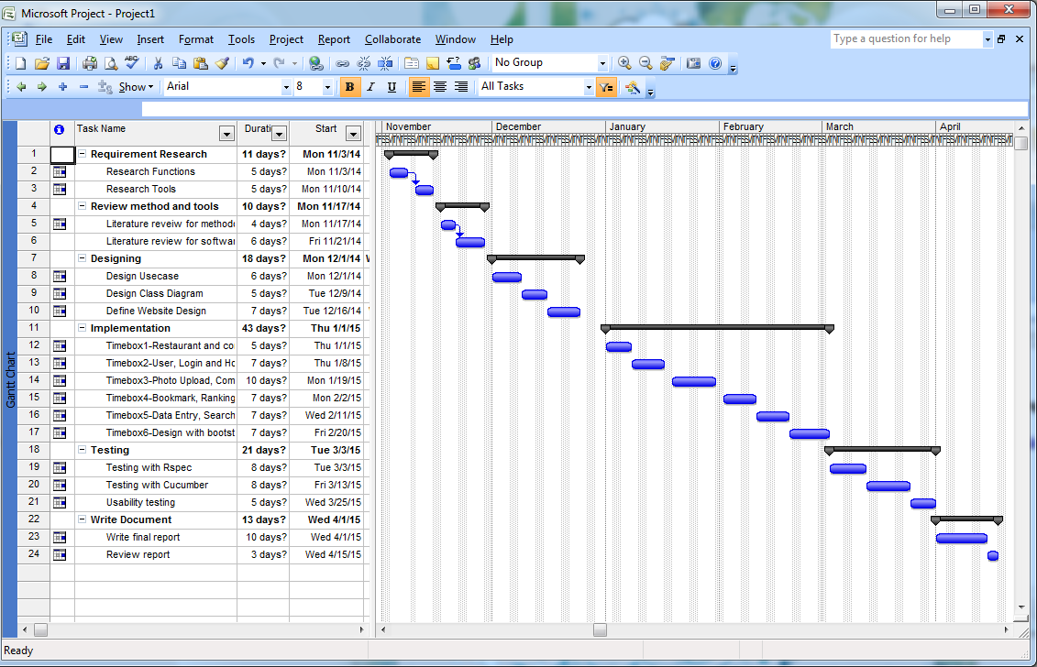

Use Case for Restaurant List Process (Overall)
Guest Level
Admin/ Member Level
Add Bookmark
Remove Bookmark
Edit Comment
Add Comment
Search Restaurant
View Comment

Delete Comment
Delete Photo
View Photo
Add Photo
Add Ranking
Update Restaurant
New Restaurant
Delete Restaurant
View Restaurant

Use Case For Member process
Admin Level
New Member
Update Member
Delete Member
View Member
Guest Level
Member Level

Use Case For Admin Level
Delete Sub city
Add Category
Add Sub city
Delete City
Add City
Delete Category
Admin Level

