**MS804 – Systems Development & Project Management**

**Group Number:** Group 18

**Assignment:** Initial draft of the Group Assignment

**Date of Submission:** 01/11/2024

***“In submitting this assignment, I confirm that it is entirely my own work. I understand that all submissions are covered by and subject to the University of Galway Academic Integrity Policy and Code of Practice.”***

Table of Contents

Functional Decomposition Diagram (FDD) 4

Requirement 4

Content 4

Personal Statement 5

Data Flow Diagram (DFD) 5

Requirement 5

Content 6

The Context-Level DFD 6

The Systems-Level DFD 7

Personal Statement 8

Data Flow Diagram (DFD) Below the Systems-Level 9

Requirement 9

Content 9

System – Level 1 DFD 9

Personal Statement 10

UML Use Case Diagram 11

Requirement 11

Content 11

UML Use Case Diagram Design Ideas: 11

Diagrams and Descriptions 13

Conclusion 22

Personal Statement 22

Sequence Diagram 23

Requirement 23

Content: 23

Customer Submit Equipment Reservation 23

Customer Rent Equipment 25

Customer Return Rented Equipment 27

Customer Purchase Used Equipment 28

Order New Equipment 30

Process New Inventory 31

Personal Statement 32

State Machine Diagram 33

Requirement 33

Content 33

Personal Statement 34

**Figure 1 functional decomposition diagram** 4

**Figure 2 the context-level DFD** 6

**Figure 3 the systems-level DFD** 7

**Figure 4 system-level1 DFD** 9

**Figure 5 rental reservation system** 13

**Figure 6 equipment rental systems** 15

**Figure 7 equipment return system** 16

**Figure 8 used equipment system** 18

**Figure 9 new equipment order system** 19

**Figure 10 new inventory processing system** 21

**Figure 11 Customer Submit Equipment Reservation** 23

**Figure 12 Customer Rent Equipment** 25

**Figure 13 Customer Return Rented Equipment** 27

**Figure 14 Customer Purchase Used Equipment** 28

**Figure 15 Order New Equipment** 30

**Figure 16 Process New Inventory** 31

**Figure 17 State Machine Diagram** 33

# Functional Decomposition Diagram (FDD)

## Requirement

Create a Functional Decomposition Diagram (FDD) showing the hierarchy of all processes in  
the system.

## Content

**Figure 1 functional decomposition diagram**

A comprehensive overview of the fundamental operations needed to handle equipment reservations, rentals, sales, and inventories can be seen in the System's Functional Decomposition Diagram (FDD). By breaking down complicated procedures into simpler ones, such processing rentals, handling returns, monitoring inventory levels, and verifying bookings, this methodical approach makes them easier to understand. It also has important reporting features to monitor reservations, sales, and inventory levels, guaranteeing smooth system operations and workflow.

**Functional Decomposition Diagram (FDD) for Teton Whitewater Kayak are as follows：**

1. Reservation Management
   1. Submit Equipment Reservation
   2. Check Equipment Reservation
   3. Confirm Reservation
2. Equipment Rental
   1. Process Equipment Rental
   2. Check Equipment Availability
   3. Calculate Rental Fees
   4. Print Rental Agreement
   5. Equipment Return
   6. Process Equipment Return
   7. Calculate Late Fees
   8. Print Return Receipt
3. Sales Management
   1. Process Equipment Sales
   2. Check Equipment Availability
   3. Calculate Sales Fees
   4. Generate Order
4. Inventory Management
   1. Run Inventory Report
   2. Generate Re-order Request
   3. Obtain Item Pricing
   4. Consolidate Orders
   5. Process Delivery Order
   6. Attach Unique ID
   7. Enter Item Details
   8. Create Equipment Record
5. Reporting
   1. Rental Agreement Report
   2. Unreturned Equipment Report
   3. Returned Equipment Report
   4. Equipment Sales Report
   5. Inventory Report

## Personal Statement

Working on this assignment as part of a peer-assisted learning (PAL) environment proved invaluable to our understanding and progress. Working closely with my group gave me a platform for active problem-solving and brainstorming in addition to a strong support network. Because each group member contributed special abilities and perspectives, we were able to split the task according to our areas of strength and make sure that every aspect of the project was carefully examined. For example, some team members had a greater technical experience and helped explain more difficult ideas, while others were very structured and helped arrange our work effectively. I was able to improve in areas where I lacked confidence because to this division and exchange of experience, which also allowed me to clarify what I already knew.

# Data Flow Diagram (DFD)

## Requirement

Create a context-level Data Flow Diagram (DFD) and systems-level Data Flow Diagram (DFD)

## Content

### The Context-Level DFD

**Figure 2 the context-level DFD**

The content of equipment ordering management system context level DFD are as follows:

**External entities**: Customer, Admin/Employee, Supplier

**Main Process**: Equipment Ordering Management System

**Dataflows**: Customer Info, Reservation Info, Equipment Info, Order Info, Purchase Info

**Data Flows:**

The interactions are as follows：

1. Costumers submit reservations to the system
2. The system manages the entire business process
   1. Costumers rent/return/purchase equipment via the system
   2. The system processes matters according to the order type and provides reports to managers
   3. Conduct business with suppliers through the system

3. Admin/Employee manage and make decisions on the entire business through the system

### The Systems-Level DFD

**Figure 3 the systems-level DFD**

The content of equipment ordering management system context level DFD are as follows:

The main process will be divided into 8 parts: Reservation Process, Rental Management, Return Management, Sales Management, Inventory Management, Order Management, Report Management, Purchase Management

1. Reservation Process:
   1. Handles customer reservations
   2. Process business according to reservation type
   3. Create and store customer/reservation data
2. Rental/ Management
   1. Manages the equipment return process
   2. Generates rental/return-related reports.
   3. Records the order details about device type, return date, fee, status, etc.
3. Return Management
   1. Manages the equipment return process
   2. Generates return-related reports.
   3. Update the order details about fee, status, receipt,etc.
4. Sales Management
   1. Manages the equipment sales process
   2. Records the sales details and related reports
5. Inventory Management
   1. Manages all equipment information
   2. Manages and update all equipment status
   3. Manages purchased equipment
6. Order Management
   1. Generates orders and related reports
   2. Store and manage orders and provide them to admin/employee
7. Report Management
   1. Manages all types of report
   2. Supports printing reports
8. Purchase Management
   1. Generates purchase order to supplier
   2. Manages purchase orders

## Personal Statement

In this group assignment, I have learnt the importance of teamwork and the impact of peer feedback on my thinking. The model we adopted in our group was that one person would be responsible for one diagram. after discussing the general business process, each of us would first complete the part we were responsible for and then review and discuss it within the group. It means each person's diagram will be evaluated and commented on by the remaining 5 people in the group.

At the beginning, I had limited understanding of data flow diagrams. First, I completed the first draft based on my understanding of the business process, but in the process of completing it, I would have some doubts. For example, the rental/return process is better to be separated or merged and there are many uncertainties. But working with my group members during the review process allowed me to gain different perspectives and insights, which greatly enhanced my understanding.

We reviewed the entire assignment 5 or more times, with each review being a double-check of the part we were responsible for. Feedback from the group pointed out the lack of clarity in some of our process definitions, which prompted us to revisit and correct them, which greatly ensured the correctness, completeness, and user readability of our flowcharts.

Another thing that I think helped me a lot is that since everyone is responsible for different modules, during the review we can summarize the key parts of the diagrams we are responsible for (e.g., DFD diagrams focusing on entity, data flow, etc.) and share what we have learnt recently with the group, and everyone will be checking for detecting and fill deficiencies.

All in all, by working together in a group, we utilized our individual strengths, and the feedback from other groups provided us with key suggestions for improvement. Not only have I improved my professional knowledge, but I have also developed the ability to collaborate and think critically, all of which will have a positive impact on my future studies and projects.

**References:**

Valacich, J., George, J., Hoffer, J., Valacich, J., George, J., Hoffer, J., Valacich, J., George, J., Hoffer, J., & Valacich, J. (2015). *Essentials of systems analysis and design, global edition*. Pearson Education, Limited.

Video references: <https://www.youtube.com/watch?v=bL00UAW_ygE>

# Data Flow Diagram (DFD) Below the Systems-Level

## Requirement

Create a Data Flow Diagram (DFD) at the level below the systems-level diagram

## Content

### System – Level 1 DFD

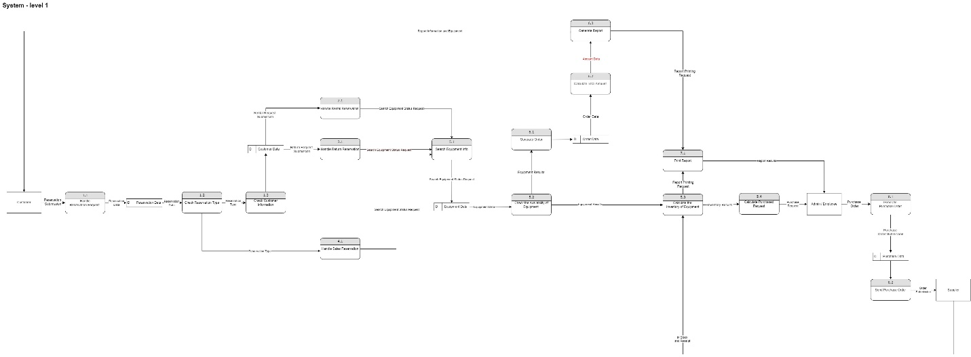

**Figure 4 system-level1 DFD**

**The content of System - Level 1 DFD is as follows:**

In this level 1 system flow diagram, I have refined and expanded it based on context-level flow diagram and system-level data flow diagram to make the flow more detailed.

1. Reservation Process - In this process, I have broken it down into 3 small steps:
   1. Handle Reservation Requests
   2. Check Reservation Type
   3. Check Customer Information
2. Rental Management - In this process, I have broken it down into:
   1. Handle Rental Reservation (point to 5.1)
3. Rental Management - In this process, I have refined it to.
   1. Handle Rental Reservation (pointing to 5.1)
4. Sales Management - In this process, I break it down as:
   1. Handle Sales Reservation (pointing to 5.1)
5. Inventory Management - In this process, I break it down into 4 small steps:
   1. Search Equipment Info
   2. Check the Availability of Equipment
   3. Calculate the Inventory of Equipment
   4. Calculate Purchased Request
6. Order Management - In this process, I have broken it down into 3 small steps:
   1. Generate Order
   2. Calculate Total Amount
   3. Generate Report
7. Report Management - In this process, I have broken it down into.
   1. Print Report
8. Purchase Management - In this process, I have broken it down into 2 small steps:
   1. Generate Purchase Order
   2. Send Purchase Order
9. Databases - A total of 5 databases exist, they are:
   1. Reservation Data
   2. Customer Data
   3. Equipment Data
   4. Order Data
   5. Purchase Data (remember to change it)

## Personal Statement

In this group assignment, we used a lottery system to fairly distribute the tasks among all group members. The main focus of this project was on drawing various types of diagrams, and I was responsible for creating the system-level1 diagram. Throughout the process, our group engaged in multiple in-depth discussions and exchanges, specifically revolving around the expansion and integration of the key elements in sections (2), (3), and (4) of the level1 diagram. Through continuous modifications and refinements, we eventually established the connections and flow between these three sections.

During the drawing phase, I encountered several challenges, such as how to accurately represent the complex system structure in a clear and intuitive manner, and how to ensure that each element in the diagram could function independently while maintaining seamless integration with the other parts. With the frequent exchange of ideas within the group, I received valuable feedback and suggestions that helped me resolve these issues. Thanks to the collective support of my team, I gradually improved the system-level1 diagram, ensuring that it not only met the project requirements but also clearly demonstrated the hierarchy and logic of the system.

After completing my portion, I further deepened my understanding of different diagramming techniques by applying what I had learned in class. During the internal peer review sessions, we exchanged our experiences and insights from the drawing process, making several updates and improvements based on the feedback. This not only helped me learn how to quickly adjust and optimize the diagram but also made me realize the importance of collaboration in group projects.

On the 4th of November, we completed the peer group assessment, and after analysing the other groups' content, we also returned to our own content to make new checks and fill in the gaps. A few days later, we also received the relevant assessment, based on which our group met again to analyse others' insights on our group work and to revise controversial points.

Through this assignment, I gained more than just technical knowledge; I also significantly improved my communication and teamwork skills. The process of solving problems and completing the tasks allowed me to deeply appreciate the power of collective wisdom. I now feel more confident and look forward to applying these skills in future work. This experience has shown me that collaboration is not just a means to accomplish a task, but an essential way to enhance personal abilities and broaden perspectives.

# UML Use Case Diagram

## Requirement

Create a UML Use Case diagram for any of the main processes within the system

## Content

### UML Use Case Diagram Design Ideas:

**UML use case diagram design concept:**

The following is the behavioral model of a system comprising different components explained through a UML Use Case diagram. It shows the expected interaction across various different actors in the system, with the different use cases that comprise the system. The design concept for the diagram will be explained as follows:

**1. Actors Identification:**

In this figure, there are two major participants: 'Customer' and 'Employee'. Here, 'Customer' would refer to a person who uses the services of a system, and 'Employee' would refer to the internal staff that performs specific tasks.

**2. Identify Use Cases:**

Several use cases have been listed in the diagram, each of them functionally performing or describing a particular function or service of the system. Example: 'Rental Reservation System', 'Equipment Rental Systems', 'Equipment Return System ', 'Used Equipment System', 'New Equipment Order System and New Inventory Processing System'.

**3. Describe the routine as :**

Each use case has an elaboration of associated activities or steps describing how the actor interacts with the system and vice-versa. For instance, in the Rental Reservation System, a customer can send a request for a reservation; the system checks rental history and availability, adds customer information, and provides the details of the rental.

**4. Associate participants with use cases:**

- Use arrow lines to connect actors and use cases, which point out the relationship between actors and use cases. Such as, a line to connect 'Customer' and 'Rental Reservation System', it means the customer can use reservation service.

**5. Detailed description of use case：**

For each use case, further break down its behavior by a series of steps. Equipment Rental Systems can be broken down into providing booking confirmation, displaying data and amounts, increasing the amount of customer deposits, among many others.

**6. Describe the system flow:**

Drawing lines and arrows, draw the flow of how the system is working. For example, Equipment Return System: Record the time when the Customer returned the equipment, calculate cost, and return deposit.

**7. Describe the system in relation to other systems.**

It further enumerates the interaction between the systems. For example, New Equipment Order System needs to talk to the New Inventory Processing System for the renovation of the inventory records.

**8. Diagram the system visually:**

- Shapes can be used to represent different elements: ovals for use cases, rectangles for systems boundary, humanoid ICONS for actors and arrows for interactions.

**9. Clear and consistency:**

While designing, attention must be drawn towards clean and consistent drawing without confusion and overlap of lines. This way it will be easy for the readers to understand and read.

**10. Iterative Improvement:**

During the design, one must constantly review and revise that the use case diagram exactly reflects the requirement and functionality of the system.

This UML use case diagram follows the standard specification in UML to provide developers with an easy understanding of the goals and functions the system under development is supposed to have, by clearly presenting the interactions between the system and the actors. It helps ensure teamwork for better collaboration and facilitates the working of the system as expected.

### Diagrams and Descriptions

The following figures show a system architecture with six subsystems. Each subsystem has functions and interaction relationships.

**Figure 5 rental reservation system**

1. **Rental Reservation System：**
   1. The customer requests a reservation.
   2. The system checks the history of rentals and their completion.
   3. The system adds customer information.
   4. The system gives rental details.

**Actors:** Customer, Employee.

**Customer Actions:**

* To make a reservation
* To see the availability of rentals
* To record the details of bookings
* To provide equipment information

**Employee Actions:**

* Add or review customer information.
* Provide customer with renting equipment.
* Give preview of equipment to customer.
* Inform customer about status.
* Write down details of booking and purchase.
* Produce confirmation of rentals along with data, etc.

- Users request rentals: Users can request rentals through the system for equipment on rent by mentioning the type of equipment needed and the duration for which it will be required.

- It would confirm the rental history of, and the availability status of, the vehicle with respect to user rental history and current availability. After that, the system would check if it could meet the requirements of the user.

- System adds customer information: This system will add all user information to the database for subsequent operations and management.

- Details of Rental Provided by System: It shall show respective details to the user about rentals, such as fee against rental, deposit, and also duration for which it has been rented.

**Figure 6 equipment rental systems**

1. **Equipment Rental Systems：**
   1. Permit Confirmation of Reservations.
   2. Show Data and Quantities.
   3. Add Customer Deposits.
   4. Ability to Print Unpaid Bills Status.

**Actors:** Customer, Employee.

**Customer Actions:**

* Check reservation conditions
* Provide personal ID.
* Receiving equipment's information.

**Employee Actions:**

* Record customer information.
* Verify details of customer.
* Write down the rental records and sign contracts.
* Check and prepare equipment for delivery.
* Calculate rental charges.
* Request and process payment.
* Print rental agreement and issue receipt.

- Reservation Confirmation: Upon a user submitting his/her rental application, the system gives a reservation confirmation to the user by confirming the particular details of the rental.

- Popup of data and quantity of the rent on the screen: Relevant data and quantity of the rental will pop up in the screen for easy convenience of the user in order to cross-check the data and confirm it.

- Increase customer deposit: During renting, the system is going to increase his deposit so that he may use the equipment safely.

- Print unpaid bill status: when the users haven't paid all the rent or deposit on time, it prints status of the unpaid bill to remind users to pay it in the right time.

**Figure 7 equipment return system**

1. **Equipment Returning System：**
   1. Time recording
   2. Selection of equipment returning
   3. Deposit charging and returning

**Actors**: Customer and Employee.

**Customer Actions:**

* Show the equipment to be returned.
* Verify the conditions for return.
* Request return.

**Employee Actions:**

* Check the condition of returned equipment.
* Calculate late fines
* Enter the return details.
* Update Customer's History.
* Return Record and Final Review.
* Process Extra Charges if Any and/or Clearance.
* Return of Security Deposits, if Any.

- Return time: This system shall record the time used after the user returns the device, to be used for further statistical data and research.

- Equipment to return: Let the user select any device they want to return, and have the system automatically determine the device's information.

- Charging the rent and returning the deposit: Depending on the condition and length of time in which the equipment has been used, the system will determine the appropriate fee and refund the deposit.

- Providing Rent Information: The system will provide all the detailed rental information, including rental fees, deposits, and rental periods.

**Figure 8 used equipment system**

1. **Used Equipment System：**
   1. Sell and Resell Equipment.
   2. Equipment sales to customers.
   3. Updating of employee information.

**Actors** :Customer and Employee

**Customer Actions:**

* Identifying and listing those items for sale that they want to buy.
* Payment for the selected items.

**Employee Action**

* Login to the system with sale and equipment being sold
* Computation of fees and charges on equipment sold
* Printing of Sales Receipt
* Completion of Transaction and issuance of Equipment to the customer.

- Resale and sale of equipment can be included, and the users can select the equipment regarding their requirement as per the resale or sale.

- Equipment Selection for Sales: The user can select the equipment that needs to be sold, and automatically the system will detect the information of the equipment.

- Update Employee Information: The employee information shall be updated in the system for further operations and management.

**Figure 9 new equipment order system**

1. **New Equipment Order System：**
   1. Obtain requests for purchase orders.
   2. Compare forecast of demand with the actual demand.
   3. Modify the order quantities.
   4. Give Quotes.
   5. Determine shipping costs.
   6. Place purchase orders.

**Actors:** Employee and Supplies

**Employee Actions:**

* access inventory reports.
* answer order inquiries
* print out prices generate quote for orders.
* Log purchase orders on the system.
* approved orders and calculate surcharges.
* Cancel purchase orders.
* Get orders shipped.

**Supplies Actions:**

* Provide Quotes.
* Provide Shipping Quotes.
* Issue Purchase Orders.

- Generating Purchase Order Request: The system will auto-generate a request for the purchase order, including but not limited to equipment model, quantity, and price.

- Compare demand forecast with actual demand: System will compare demand forecast with the actual demand for any changes in order quantities.

- Order quantity adjustment: The system is going to adjust the quantity to best fit market demand, depending on the actual condition.

- Pricing: The system will introduce the price of equipment that can enable the user to make decisions based on one's needs.

- Shipping costs: The system will calculate costs incurred in shipment of equipment so the user may appreciate what the total cost is.

- Purchase order: The system sends purchase orders to the supplier so that production arrangements may be made.

**Figure 10 new inventory processing system**

1. **New Inventory Processing System：**
   1. Inventory marking
   2. Establish new records
   3. Equipment status establishment

**Actors:** Employee and Inventory System.

**Employee Actions:**

* Listing and review of new inventory.
* Generation of equipment codes and updating on the system.
* Processing equipment information for new listing.

**Inventory Staff Actions:**

* Labeling of new equipment.
* Finalize item placement within storage systems.

- Mark inventory: The system should mark the inventory for further operations and management.

- Create new records: The system should create a new inventory record, including model, quantity, price, etc.

- Device status setup: The system will create the device status, like available/unavailable, for the user to enable the understanding of the condition of the device.

### Conclusion

The following system structure diagram describes how various subsystems interact with and depend on each other. Using such subsystems will enable users to handle all the aspects of equipment renting business. For example, the users will book the equipment using the rental reservation system. After use, when the equipment is returned, the system should calculate the usage fees and return the deposit. In case of any requirement for new equipment, it should be ordered through the new equipment purchase system. Furthermore, the system includes used equipment management and inventory handling functions. Broadly speaking, the whole system is designed in such a way to enhance efficiency, reduce costs, and ensure proper control and management of all spheres of business. Following descriptions provide further specific details on the process of operation of each subsystem, and would therefore mean in fact working together in support of day-to-day operation of Teton Whitewater Kayak.

### Personal Statement

**Early in the completion of the assignment**: when constructing the uml use case diagram framework model, I sought the opinions of my group members. In terms of the number of graphs and the level of detail, I asked the other student who preferred a simple single picture, but I personally preferred to use more pictures to show and describe the detailed flow of the different processes. During our first group meeting, I asked the group members for their opinions, and the group members' thoughts were in agreement with mine, and finally we chose to use more pictures to describe the processes in more detail.

**Midway through the assignment:** After completing the first draft of the use case diagram, we had another group meeting to discuss the use case diagram I drew, and we had a discussion about whether actors need to keep the database system or not, and some members of the group thought that they needed to keep the database system because they thought it was involved in a lot of the operational processes, but some group members thought that they didn't need it , Some of them thought that the database system should be retained because it is involved in a lot of operational processes, but some of the group thought that the database system should not be retained because it is a sub-system within the whole leasing system and does not need to be included in actors. I personally prefer the latter. So we made some deletions from the original draft.

**At the end of the assignment's completion:** we discussed the aesthetics of the use case diagrams, the consistency of the words used and letter case issues. With the help of the entire group of six, we were able to complete the final version, thanks to the constructive suggestions my group members gave me regarding my use case diagram.

# Sequence Diagram

## Requirement

Create sequence diagrams for major processes to better see the interactions between modules.

## Content:

The flow are as follows：

### Customer Submit Equipment Reservation

**Figure 11 Customer Submit Equipment Reservation**

The image shows a **sequence diagram** for a lease application process. It illustrates the interactions between a **Customer**, an **Employee**, and a **System** as part of an equipment leasing workflow. Here's a step-by-step breakdown of the diagram:

1. **Lease Application**: The process begins with the customer sending a lease application to the employee.
2. **Verify Lease History: The employee verifies the customer's lease history with the system.**
3. **Alternative Scenarios:**
   1. **[has record]**:If the system finds a prior lease record for the customer, it retrieves and checks the record.
   2. **[else]**:If no record is found, the employee inquires about the information and inputs the customer into the system’s customer list.
4. **Rental Information:**
   1. The employee enters the new rental information into the system.
   2. The system queries the device availability information and returns the information to the employee.
5. **Check Availability**: The employee asks the system if the desired time for the rental is available.
6. **Alternative Scenarios for Availability**:
   1. **[available]**:
      1. **[today]**: If the equipment is available on the requested day, the system provisions the equipment
      2. **[not today]**: If available but not on the current day, a lease confirmation is provided.
   2. **[Unavailable]**: If the equipment is unavailable, the employee notifies the customer.

This diagram uses **alternative fragments** to handle different cases based on the availability of customer records and equipment, ensuring clarity in decision-making processes during the lease application process.

### Customer Rent Equipment

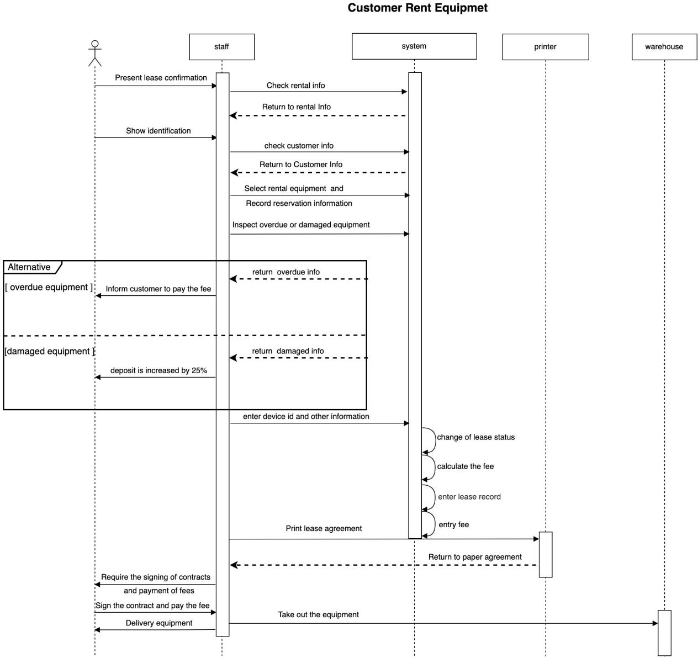

**Figure 12 Customer Rent Equipment**

This diagram shows a **sequence diagram for customer equipment rental**, describing the interactions between the customer, staff, system, printer, and warehouse during the equipment rental process. Here's a detailed breakdown:

1. **Customer presents lease confirmation**: The customer first shows the lease confirmation to the staff.
2. **Show identification**: The customer provides identification, and the staff verifies it.
3. **System checks rental information**:
   1. The staff checks the rental information through the system, and the system returns the rental details to the staff.
   2. The staff then checks the customer's information, and the system returns the customer’s details.
4. **Select equipment and record information:**
   1. **The staff selects the equipment for rental and records the reservation information in the system.**
   2. **The system inspects if there are any overdue or damaged equipment.**
5. **Alternative scenarios:**
   1. **[Overdue equipment]: If there is overdue equipment, the system returns the overdue information, and the staff informs the customer to pay the overdue fees.**
   2. **[Damaged equipment]: If there is damaged equipment, the system returns the damage information, and the staff informs the customer that the deposit will be increased by 25%.**
6. **Enter device ID and other information**: The staff enters the device ID and other relevant details into the system.
7. **Print the lease agreement**: The system generates the lease agreement and sends it to the printer for printing.
8. **Contract signing and payment**:
   1. The staff requires the customer to sign the lease contract and pay the relevant fees.
   2. The customer signs the contract and pays the fees.
9. **Equipment delivery**:
   1. After receiving the confirmation, the warehouse prepares the equipment and delivers it to the customer.

The diagram also shows important backend operations, such as changing the lease status, calculating fees, recording lease information, and entering fees into the system. At the end of the process, all related paper agreements are returned to the designated location, completing the entire rental process.

This sequence diagram uses **alternative fragments** to handle specific scenarios such as overdue equipment and damaged equipment, clarifying the rental process in different situations.

### Customer Return Rented Equipment

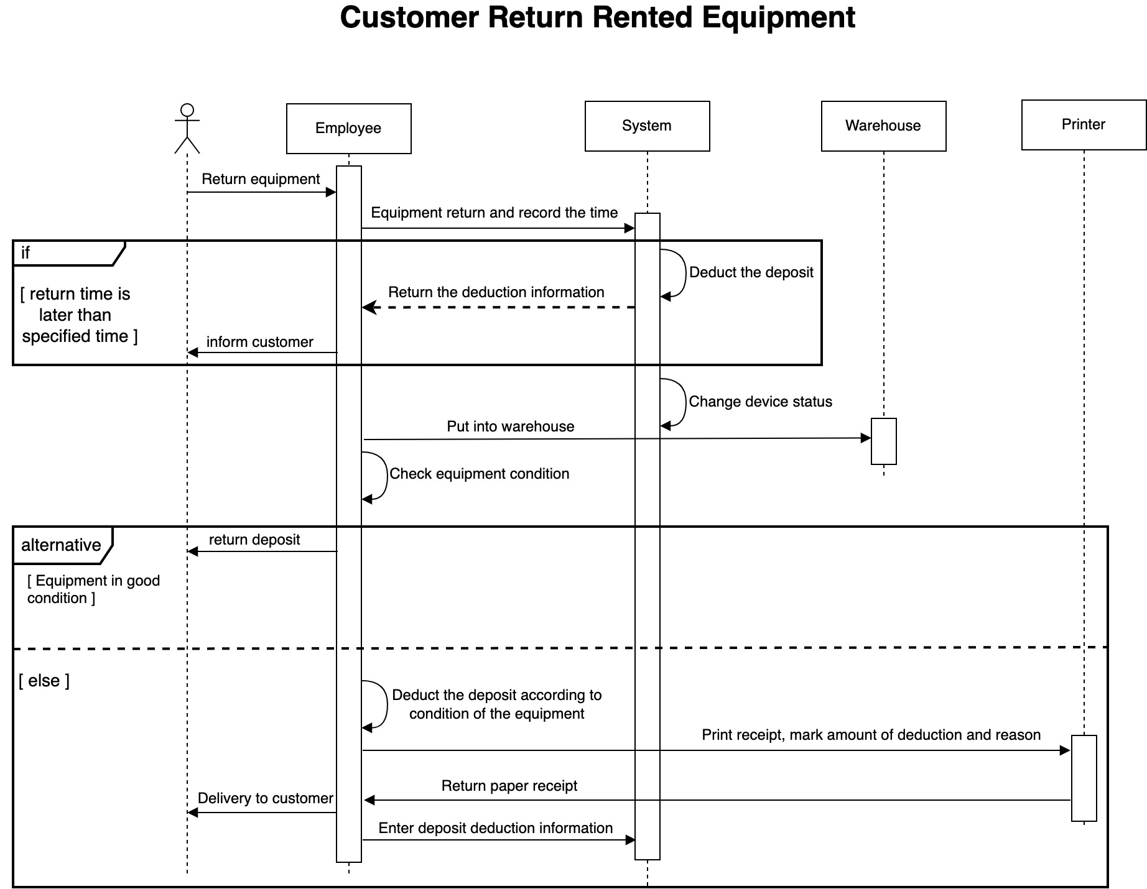

**Figure 13 Customer Return Rented Equipment**

This diagram illustrates a **sequence diagram for customer returning rented equipment**, describing the interactions between the customer, employee, system, warehouse, and printer during the equipment return process. Here's a detailed explanation:

1. **Customer returns equipment**: The customer first returns the equipment to the employee.
2. **Record return time**: The employee records the return time in the system.
3. **Check return time**:
   1. **[If return time is later than specified time]**: If the return time exceeds the scheduled return time, the employee informs the customer that a deposit deduction will be made.
   2. The system returns the deduction information based on the late return, and the corresponding amount is deducted from the deposit.
4. **Store the equipment**:
   1. Equipment is placed in the warehouse, and warehouse personnel check the condition of the equipment.
   2. The system changes the status of the equipment to "returned."
5. **Alternative scenarios:**
   1. **[Equipment in good condition]**: If the equipment is in good condition, the employee returns the deposit to the customer.
   2. **[Else]**: If the equipment is damaged or has other issues, the system deducts an appropriate amount from the deposit based on the equipment's condition.
      1. The system generates and prints a receipt that specifies the amount deducted and the reason for it.
      2. This receipt is returned to the customer, and the employee enters the deposit deduction information into the system.
6. **Completion of the return process**: Once the equipment is returned and all necessary actions are taken, the equipment return process is completed.

This sequence diagram uses **if conditions and alternative fragments** to handle different situations that may arise during the equipment return, such as late returns and equipment damage, ensuring that each step of the process is clearly defined with appropriate actions.

### Customer Purchase Used Equipment

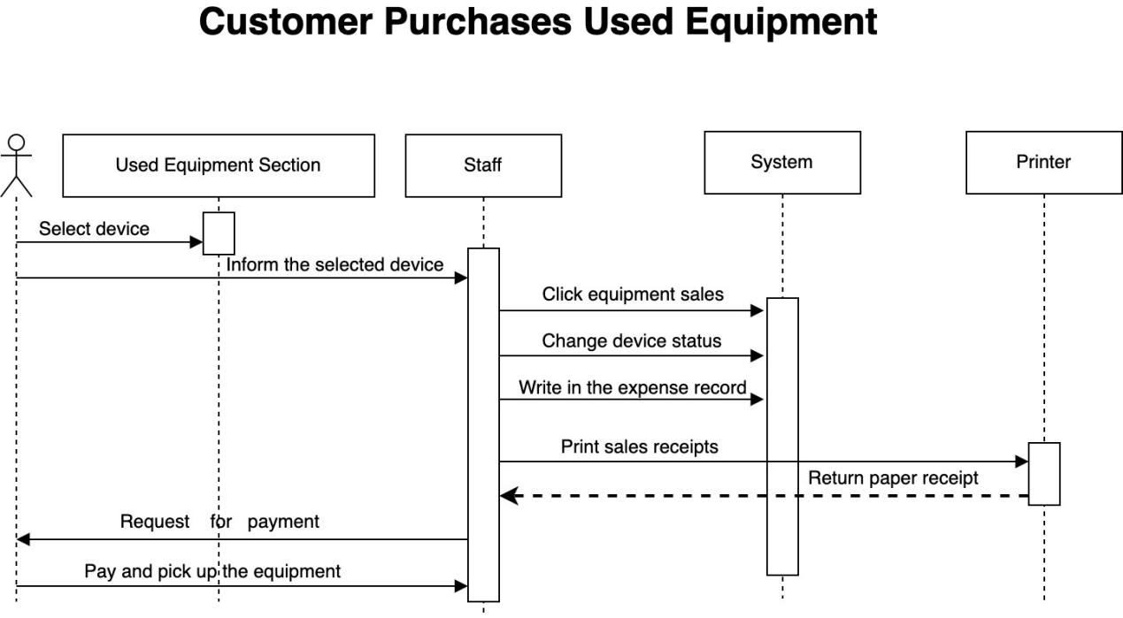

**Figure 14 Customer Purchase Used Equipment**

This diagram depicts a **sequence diagram** for a customer purchasing used equipment, outlining the interactions between the customer, staff, system, and printer during the purchasing process. Here's a detailed explanation:

1. **Customer selects equipment**: The process begins with the customer selecting the desired device from the **Used Equipment Section**.
2. **Inform the staff**: Once the equipment is selected, the customer informs the **staff** about the selected device.
3. **Staff actions**:

The **staff** takes action by performing several key operations:

* 1. **Click Equipment Sales: The staff triggers the sales process in the system by selecting the device for sale.**
  2. **Change device status: The system updates the status of the device to indicate that it has been sold.**
  3. **Record transaction in expense records: The sales transaction is recorded in the system's expense records.**
  4. **Print sales receipt: The system sends the transaction details to the printer to generate a sales receipt.**

1. **Generate and print receipt**: The **printer** prints the sales receipt, which includes details of the equipment purchase.
2. **Request for payment**: The customer is requested to make payment for the equipment.
3. **Complete transaction**:
   1. After payment is made, the customer receives the printed receipt.
   2. The customer then collects the equipment and the purchase process is completed.

This sequence diagram clearly defines each step in the equipment purchasing process, from equipment selection to payment, including the role of the system in managing sales records and printing receipts. It also captures how the staff interacts with both the customer and the system to ensure a smooth transaction.

### Order New Equipment

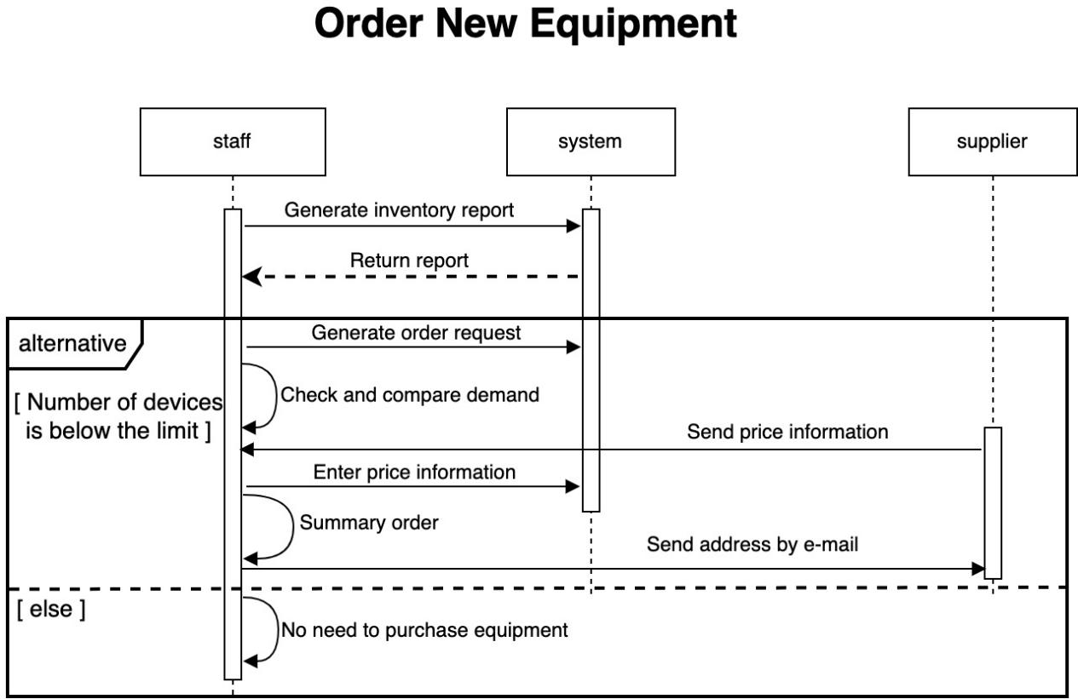

**Figure 15 Order New Equipment**

This diagram represents a **sequence diagram** for ordering new equipment, detailing the interactions between the **staff**, **system**, and **supplier**. Here’s a detailed explanation:

1. **Generate inventory report**:
   1. The **staff** initiates the process by generating an inventory report to assess the current stock.
   2. The **system** returns the report back to the **staff**.
2. **Alternative Scenario**: The diagram includes two alternative paths based on whether the number of devices is below the limit.
   1. **[If the number of devices is below the limit]**:
      1. **Generate order request**: If stock is insufficient, the **staff** generates an order request.
      2. **Check and compare demand**: The **system** checks and compares the demand with available inventory.
      3. **Send price information**: The **system** requests price information from the **supplier**.
      4. **Enter price information**: The **system** receives the price information from the **supplier** and enters it into the system.
      5. **Summary order**: The **staff** reviews the price information and creates a summary order.
      6. **Send address by email**: The **system** sends the delivery address and order details to the **supplier** via email.
   2. **[Else]**: If the inventory is sufficient, there is **no need to purchase equipment**, and the process ends without any further actions.

This sequence diagram showcases two possible outcomes when ordering equipment, with the system automating key steps like generating reports, requesting supplier information, and sending order details. It ensures that orders are only placed if the inventory level falls below the specified threshold.

### Process New Inventory

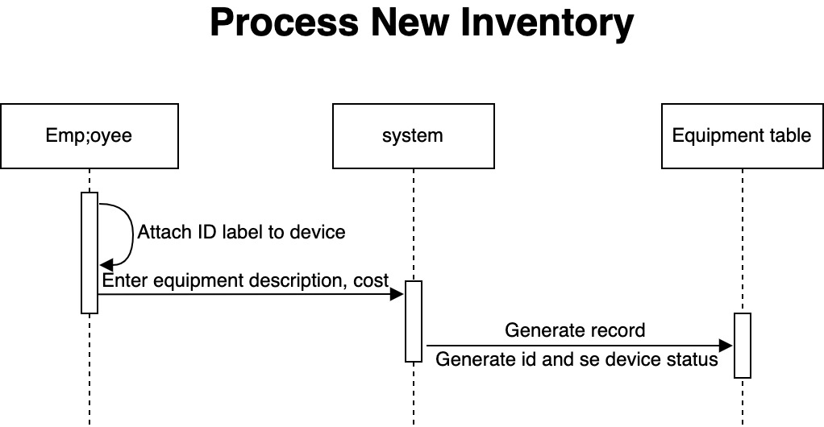

**Figure 16 Process New Inventory**

This diagram illustrates a **sequence diagram** for processing new inventory, showing the interactions between the **employee**, **system**, and **equipment table** during the inventory registration process. Here’s a detailed breakdown:

1. **Attach ID label to the device**:

The **employee** initiates the process by attaching an ID label to the new equipment.

1. **Enter equipment description and cost:**

**The employee then inputs the equipment’s description and cost into the system.**

1. **Generate Record**:
   1. The **system** processes the entered information and generates a record for the new equipment.
   2. The system assigns a unique ID to the equipment and updates the **equipment table** with the device status.

The diagram demonstrates a straightforward inventory process, where the employee registers the new equipment and the system manages the necessary data entry, including generating an ID and recording the equipment status in the inventory system.

## Personal Statement

In this Assignment, I was deeply involved in several system design and business process optimization tasks, and drew a number of sequence diagrams, such as “Customer Purchase of Equipment” and “Returned Equipment Processing”, etc. These diagrams not only helped me sort out the complex system logic, but also provided a clear process reference for the whole team. These diagrams not only helped me to sort out the complex system logic, but also provided a clear process reference for the whole team.

First of all, the diagrams I drew mainly centred on the key processes in daily operations, such as equipment purchase, equipment return, and new inventory processing. These processes often involve complex interactions between multiple players, such as customers, employees, systems, and vendors. With these diagrams, I visualize the steps each role takes in a given business scenario and how the system responds.

In the drawing process, I used the sequence diagram method in UML, which allowed me to describe the actions of each role step by step and to show the dynamic response of the system in detail. For example, in the flowchart for “Customer returns equipment”, I showed the system's logic for handling different situations (e.g., when the equipment is damaged or when it is returned after the time limit) through conditions and alternative paths. These details help us to anticipate the complexities that we may encounter in actual operations and provide intuitive solutions to these problems.

Of course, the process of charting was challenging. In order to ensure that each process was presented in a clear and concise manner without missing key steps, I constantly communicated with team members to ensure consistent understanding. At the same time, I avoided making the diagrams overly complex to avoid confusion for subsequent development. With this approach, I managed to make the diagrams balanced between informativeness and readability.

For this project, I used Draw.io as the main drawing tool. Its flexibility and manoeuvrability allowed me to quickly make the transition from sketches to refined designs. With feedback from the team, I continued to optimize the diagrams to make them compatible with various requirements. In the subsequent development and implementation process, team members agreed that these diagrams provided strong support for system development, effectively improving work efficiency and reducing communication costs.

Overall, through the design and application of this series of diagrams, I have improved my ability in process design and system modelling, which is very rewarding.

# State Machine Diagram

## Requirement

Create a State Machine Diagram for any of the processes within the system

## Content

**Figure 17 State Machine Diagram**

1. The first is the initial state, where the user starts to submit the device reservation. If the user has rented the device before, the user rents the device first and directly enters the device rental state. then the personal information is added to the customer list. If the equipment type is not available, inform customer. Since no equipment has been rented, the status of the customer still returns to the customer list.
2. If the equipment type is available, When the status is changed to equipment rental, the equipment will be changed from in stock to Rented.
3. If the equipment is damaged or overdue, it will need to go through two other states before it can be Rented.
4. After the employee print and customer sign the contract, the customer can retrieve equipment from storage. And then we go into the Customer Returns Rented Equipment state, If the return date is later than the due date, a late fee charge is calculated and deducted from the rental deposit.
5. Then the system changes the equipment status to "in stock" and the equipment is returned to the storage area. If the equipment is inspected, the process is over. In addition, the system will retain all or a portion of the deposit and the employee prints receipt, and then end the process.
6. I drew a state machine diagram that reflects the whole process from the customer's reservation to the return of the equipment, which more intuitively reflects the flow of states.

## Personal Statement

After finishing this assignment, our team held a meeting to determine the division of labor for each person, and set the time for the next meeting to communicate with each other about the tasks they have completed. There will be weekly meetings, once or twice a week. At first my task was to make the final summary, but later due to some changes, my task was changed to draw the state machine diagram. I initially asked some questions using ChatGPT, but felt that it was not detailed enough and not very standardized, so I ended up looking for video tutorials online to learn. At the beginning, the whole process from booking to returning equipment to ordering new equipment was drawn several times. However, the whole process was drawn on a single drawing instead of drawing the whole process into several parts, which made the whole drawing too long, which was inconvenient to understand and reflect the whole process, and inconvenient for team members to review and discuss. So after the meeting, it was decided to draw the state machine diagram from reservation to return. The last few meetings were online and there were a couple of disagreements, a lot of heated discussions, but at the end of the day, everyone's assignment was decided.