Service Request Triage Assistant
Case study: keyword rules vs AI for triaging customer-service emails
Xinyi Zhang | November 2026 | Built and tested on synthetic data

Summary
A service team that handles a shared mailbox spends time reading, categorising and prioritising every email by hand. In my simulated dataset of 300 emails, 44% of first responses missed their SLA target (P1: 65%, P2: 54%, P3: 37%). Urgent tickets were the most likely to be late.
I built a triage prototype in two layers: (1) a keyword-rules baseline in Python, and (2) an AI reading of the same email using Claude, shown side by side in a small web app. Both recommend a category, a priority, the SLA target and whether a human should handle the email.
The rules looked strong on paper (97.7% category accuracy, 89.3% priority accuracy) but failed in predictable ways on real-sounding language. Testing seven difficult emails showed where AI helps and where it creates new risks, mainly draft replies that make promises the business may not be able to keep.
An Excel dashboard on the same data shows how big the SLA problem is and lets me test a what-if scenario for faster triage. The scenario uses assumed time savings, so it illustrates sensitivity rather than proving an improvement.
Role and tools: I defined the scenario, categories, priority and SLA rules, and the human-review rules; generated the synthetic data; and tested and documented every case. The code and the Excel dashboard were built with AI assistance (vibe coding), and I checked the outputs against expected answers.
Demo: Service Request Triage Assistant (the AI panel needs a Claude sign-in; screenshots are in the appendix).

1. Scenario and goal
A company that sells and repairs office equipment receives about 40 service emails a day in one shared mailbox. Two coordinators read each email, decide the type and urgency, forward it and reply. At peak times urgent emails get buried.
SLA (Service Level Agreement) here means the first-response target for each priority:
- P1 urgent (equipment down, business blocked): 1 hour
- P2 high (degraded service, late delivery, double charge, clear complaint): 4 hours
- P3 normal (routine request): 1 working day
Goal: classify each email into one of five categories (Repair/Fault, Order/Delivery, Billing/Invoice, Technical Support, Complaint), set its priority, and decide whether it is safe to auto-draft a reply or must go to a human.

2. Approach
- Data: 300 synthetic emails over 8 working days, each with a correct category and priority label, the SLA target and a simulated manual first-response time. No real customer data was used.
- Layer 1, keyword rules (Python): keyword lists per category and priority. Anything that is P1, a complaint or uncertain is routed to a human.
- Layer 2, AI reading (Claude): the same email and the same category, priority and SLA definitions are given to Claude, which returns category, priority, routing, a one-sentence reason and a draft reply.
- SLA dashboard (Excel): formula-driven dashboard on the same 300 emails, with editable what-if assumptions (section 4).
- Safeguard: every draft reply is labelled “needs human review”. Nothing is sent automatically.

3. Results

3.1 Keyword rules on the full synthetic dataset
Measure | Result | Comment
Category accuracy | 97.7% | 7 errors out of 300
Priority accuracy | 89.3% | 32 errors: 16 “not urgent” read as urgent, 8 “as soon as possible” read as urgent, 8 polite complaints under-prioritised
True P1 emails caught | 26 of 26 | All urgent emails were flagged for a human
Emails sent to a human | 26% | P1, complaints and low-confidence emails
These numbers should not be read as real-world performance (see Limitations).

3.2 Seven difficult emails, rules vs AI
I picked seven emails that I expected to be hard, ran each through both layers, and compared them with the expected answer. Screenshots are in the appendix.
# | Email | Expected | Keyword rules | AI (Claude) | What happened
1 | “Wi-Fi printing question”, says “Not urgent” | Technical Support, P3 | Technical Support, P1  Wrong priority | Technical Support, P3  Correct, auto-draft | Rules saw the word “urgent” and ignored the “Not”. A routine question was escalated.
2 | “Re: ticket from Monday”: machine is dead, “losing orders” | Repair/Fault, P1 | Order/Delivery, P1  Wrong category | Repair/Fault, P1  Correct | Rules matched “orders” and sent it to the wrong queue. AI understood the context.
3 | “Feedback on last visit”: polite complaint | Complaint, P2 | Complaint, P3  Priority too low | Complaint, P2  Correct | Rules found no strong words, so a complaint sat at the slowest SLA. Tone is not in the keyword list.
4 | “Charged twice”, “as soon as possible” | Billing/Invoice, P2 | Billing/Invoice, P1  Over-escalated | Billing/Invoice, P2  Correct | “As soon as possible” is everyday politeness, not a reliable urgency signal.
5 | “Invoice and printer issue”: two problems in one email | Billing/Invoice, P3 (dataset label; arguable) | Billing/Invoice, P3  Auto-draft, ignores printer fault | Billing/Invoice, P2  More cautious, human review | AI’s reason and draft covered both issues; the rules saw only one. The priority differs from the label, but AI’s caution is defensible.
6 | “printer wont print, deadlien 3pm”: typos | Repair/Fault, P1 | Repair/Fault, P1  Correct by coincidence | Repair/Fault, P1  Correct | Both right, but the rules only matched because “dead” appears inside the typo “deadlien”.
7 | “printr brokn”: heavy typos, “asap”, everyone waiting | Repair/Fault, P1 | Unclassified, P3  Missed, but sent to a human | Repair/Fault, P1  Correct | Rules cannot read misspelled words. The human-review fallback still caught it.

3.3 Scorecard on these seven cases
 | Keyword rules | AI (Claude)
Category correct | 5 of 7 | 7 of 7
Priority correct (vs expected) | 3 of 7 | 6 of 7
Read this carefully: this is seven hand-picked difficult emails, chosen after I already knew where the rules struggled. It illustrates failure patterns. It is not a statistical measure and does not prove that AI is generally more accurate.

3.4 What the failures teach
- Negation: “Not urgent” triggered an urgent flag (case 1).
- Everyday phrases: “As soon as possible” is too common to signal urgency (case 4).
- Wrong context: a keyword can point at the wrong category, e.g. “losing orders” (case 2).
- Tone: a polite but serious complaint has no “angry” words (case 3).
- More than one issue: one email, one label; the second problem disappears (case 5).
- Typos: a correct result can be luck (case 6) and the rules fail on real misspellings (case 7).
- Human fallback works: in case 7 the rules were wrong but “unclassified” still went to a person, so the email was not lost.

3.5 A new risk introduced by AI: promises in draft replies
I told the AI in its instructions not to make promises the business cannot keep. It still wrote drafts such as “A technician will contact you within the hour to arrange immediate repair or replacement” (case 2) and repeated “within 4 hours” in other cases, echoing the SLA times it had been given. Nobody has authorised a repair-or-replace commitment, and a missed promise is worse than a slow reply. Drafts therefore need human review before sending, and in a real deployment the allowed wording should be restricted (for example, acknowledge and give a reference number, but leave commitments to staff).

4. SLA dashboard
To size the problem, I built an Excel dashboard on the same 300 simulated emails. It uses formulas throughout, so every figure updates when the data or the assumptions change.

4.1 Today: how often the first response met its SLA
Priority | Tickets | SLA target | Avg first response | SLA met
P1 urgent | 26 | 60 min | 117 min | 34.6%
P2 high | 89 | 240 min | 344 min | 46.1%
P3 normal | 185 | 480 min | 494 min | 63.2%
All | 300 | – | 417 min | 55.7%
The more urgent the email, the more likely it was late. P1 emails averaged almost twice their one-hour target, and only about a third met it.

4.2 What-if: faster triage (an assumption, not a result)
The dashboard has three editable assumptions: how much faster the first response would be for each priority if urgent emails were recognised and routed immediately. To illustrate, I set P1 at 60% faster, P2 at 30% faster and P3 unchanged. Under those assumptions the share of first responses meeting SLA would rise from 55.7% to 66.3% overall (P1 from 34.6% to 76.9%, P2 from 46.1% to 69.7%, P3 unchanged at 63.2%), and missed SLAs would fall from 133 to 101 tickets.
Important: these time savings are my assumptions. They show how sensitive SLA performance is to faster triage. They do not prove that the prototype achieves them; that would need a pilot with real mailbox data. The dashboard also uses the dataset’s correct priority labels rather than the triage tool’s output, so it shows the size of the problem, not the accuracy of the tool.
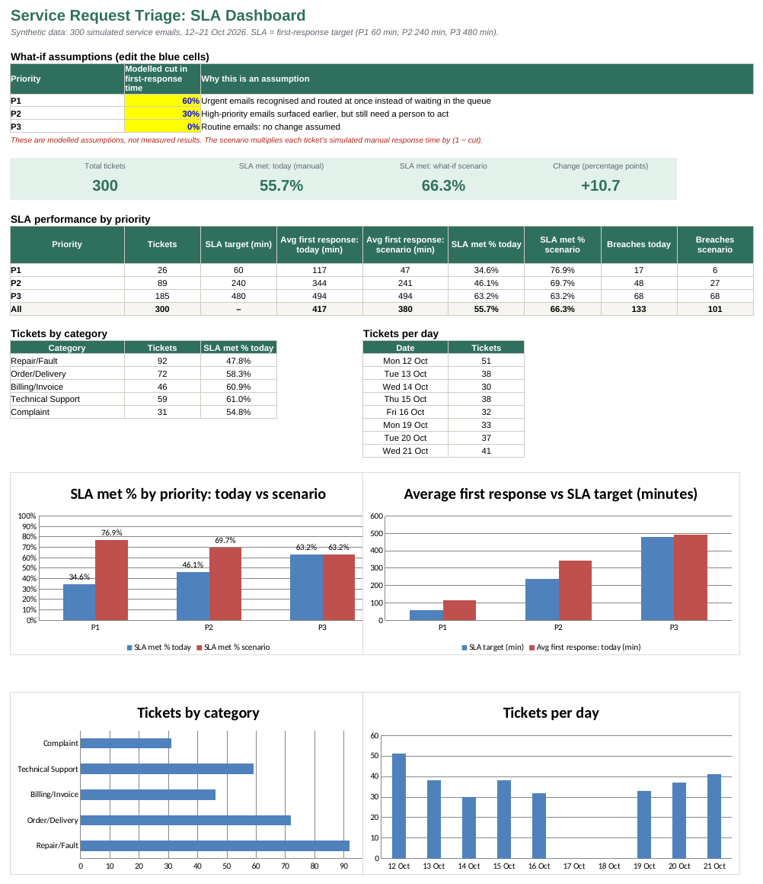
Excel SLA dashboard: key figures, SLA by priority, what-if assumptions and charts.

5. Limitations
- Synthetic data. All 300 emails and their labels were generated with AI from a limited set of templates. Real emails are messier and more varied, so real accuracy is likely lower than 97.7% and 89.3%.
- Rules were written with knowledge of the data. Like sitting an exam after seeing the question types, this makes the baseline look better than it would on unseen emails.
- Errors cluster. Half of the priority errors (16 of 32) came from one repeated email template that contains “not urgent”. With real data, errors would be spread across many wording variations.
- Small, hand-picked comparison. Seven cases cannot show that AI beats rules in general. AI answers can also vary from run to run.
- SLA simplified. Only first response is measured, and working hours, weekends and holidays are not excluded.
- Dashboard scenario is assumed. The 60% and 30% time savings are illustrative inputs, not measured effects, and the averages can be pulled up by a few very slow tickets.
- No real customer data. A real deployment would need a data-protection (GDPR) review before any customer email is sent to an AI service.

6. Next steps
- Replace assumptions with evidence: in a pilot, record real first-response times with and without triage support and feed them into the dashboard instead of assumed savings.
- Measure properly: run the AI on all 32 flagged difficult emails, repeat each run several times, and compare with the rules on a fresh set of emails that neither layer has seen.
- Improve the rules: handle negation, drop over-common phrases, and add tolerance for typos, then re-measure.
- Limit draft replies: constrain wording so that drafts acknowledge and route but never commit to repairs, refunds or timeframes.
- Pilot with a human in the loop: with real mailbox data, track SLA performance and how often staff edit or reject drafts.

Appendix: test screenshots

Case 1: “Wi-Fi printing question” (negation)
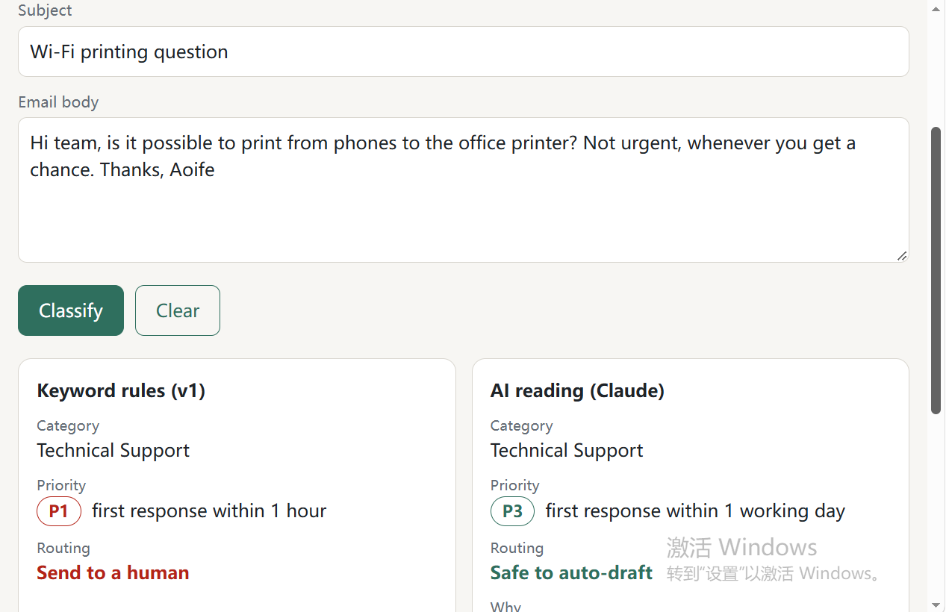
Rules escalate to P1 and a human; AI judges P3 and safe to auto-draft.

Case 2: “Re: ticket from Monday” (wrong context, and a promise in the draft)
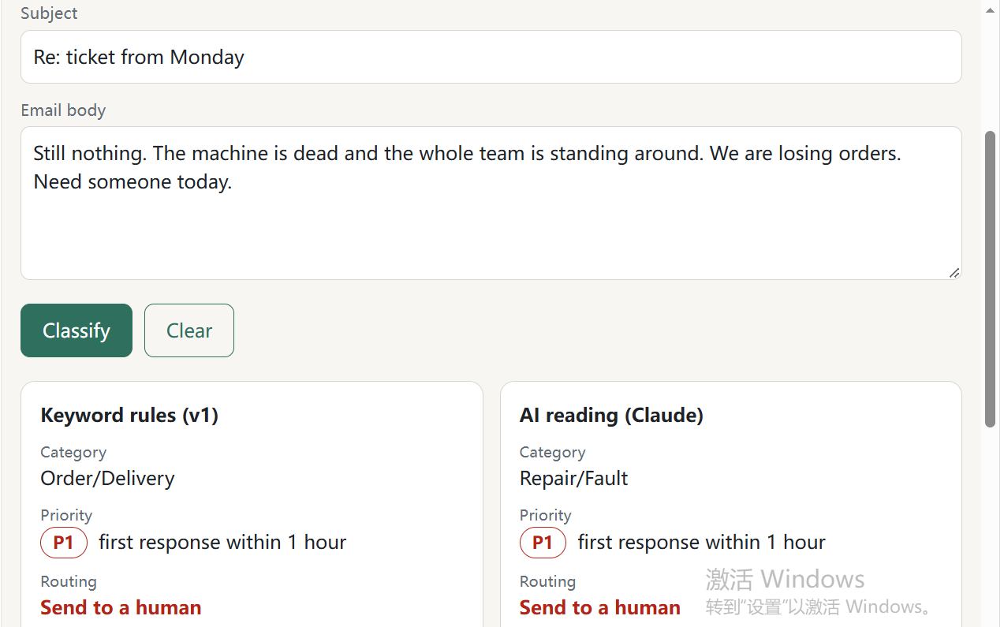
Rules choose Order/Delivery; AI chooses Repair/Fault. Both rate P1.
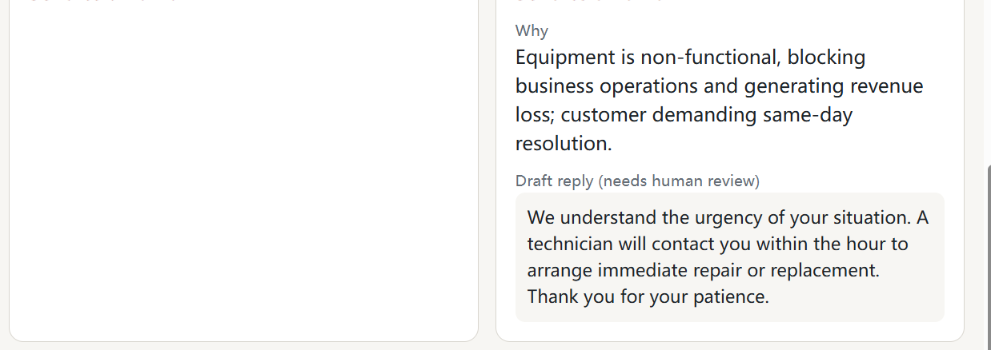
AI draft promises a technician “within the hour” and “immediate repair or replacement”.

Case 3: “Feedback on last visit” (polite complaint)
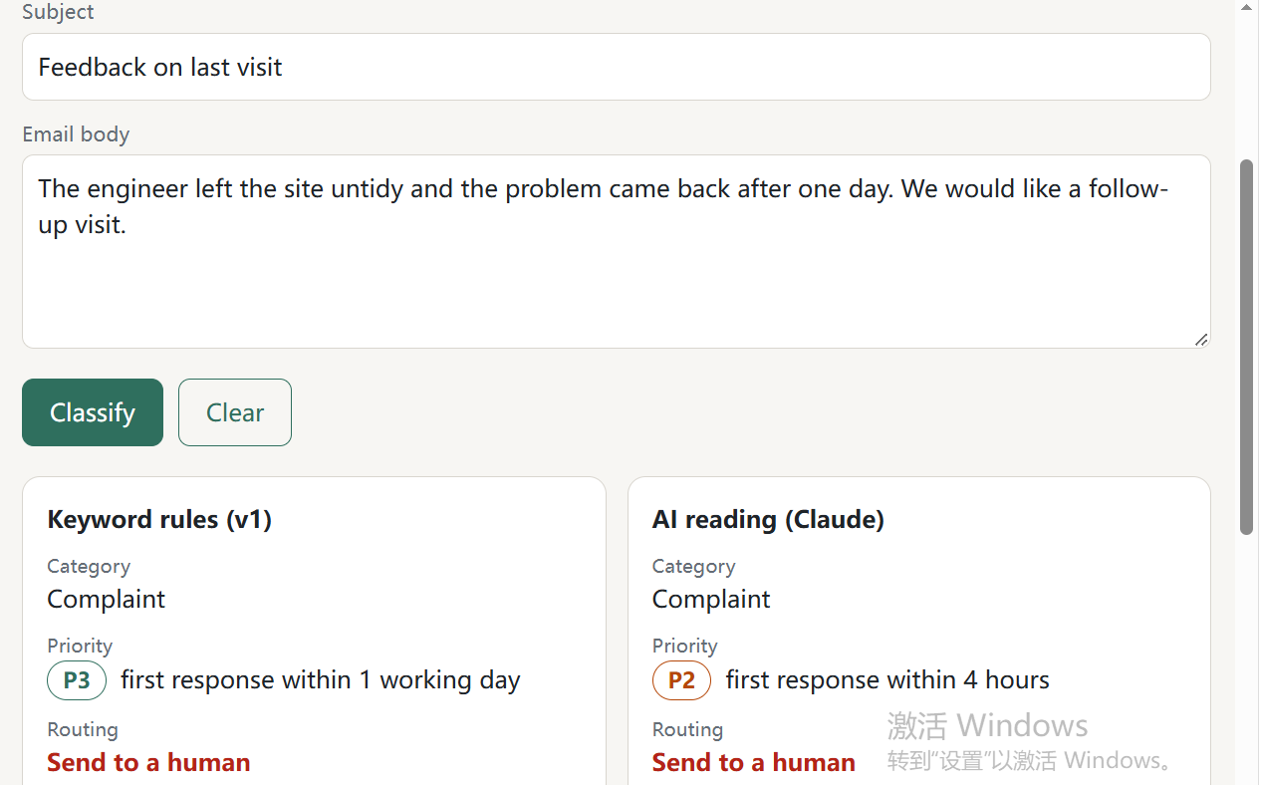
Both choose Complaint; rules give P3, AI gives P2.

Case 4: “Charged twice” (common phrase)
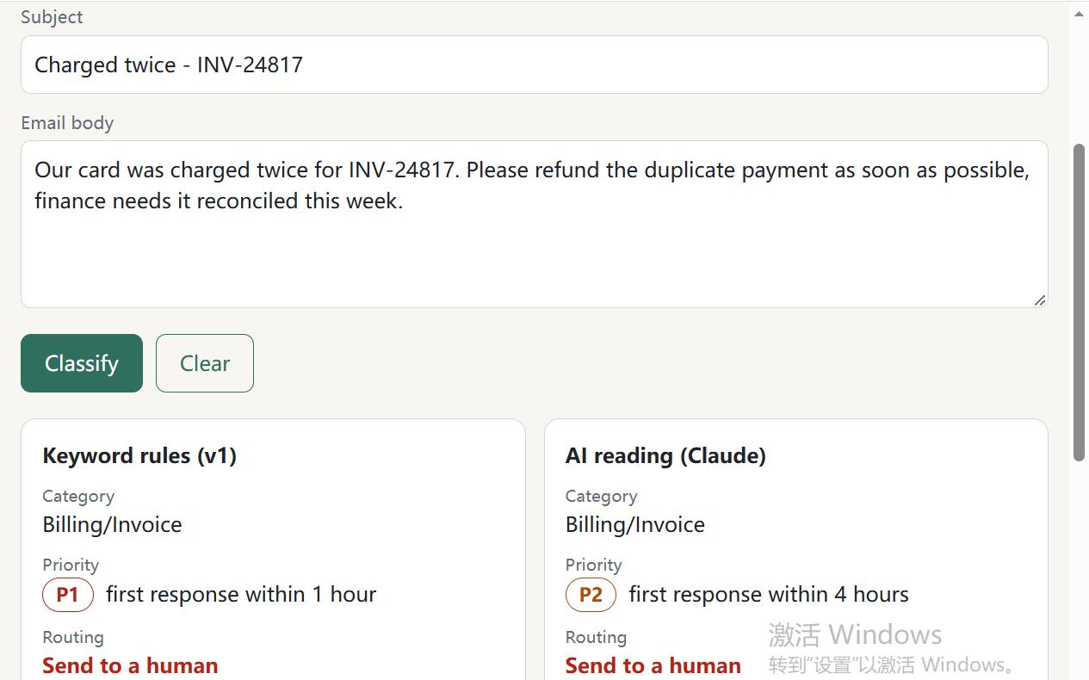
Rules over-escalate to P1 because of “as soon as possible”; AI judges P2.

Case 5: “Invoice and printer issue” (two problems in one email)
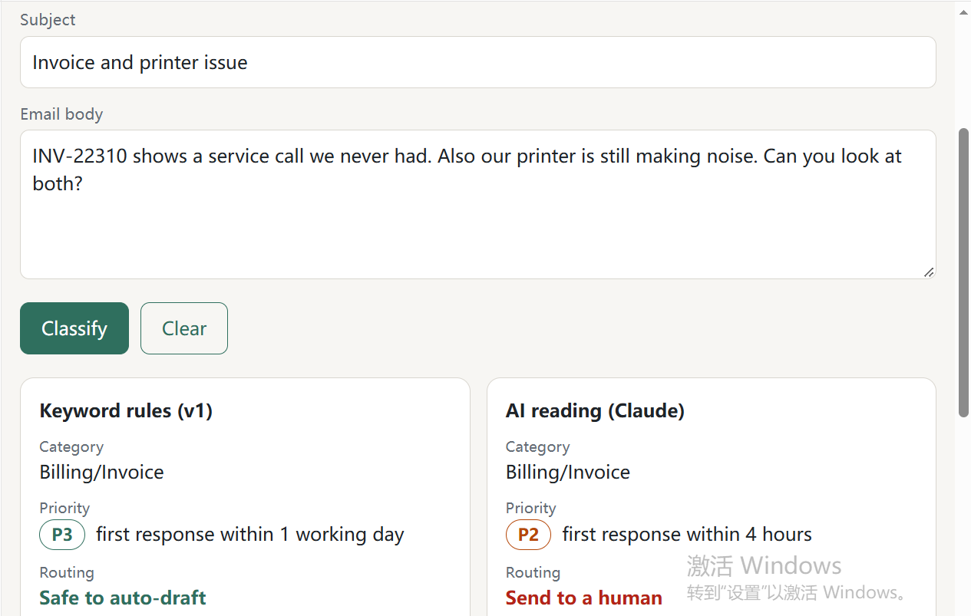
Rules judge P3 and auto-draft; AI judges P2 and sends to a human.

Case 6: “printer wont print, deadlien 3pm” (typos, correct by coincidence)
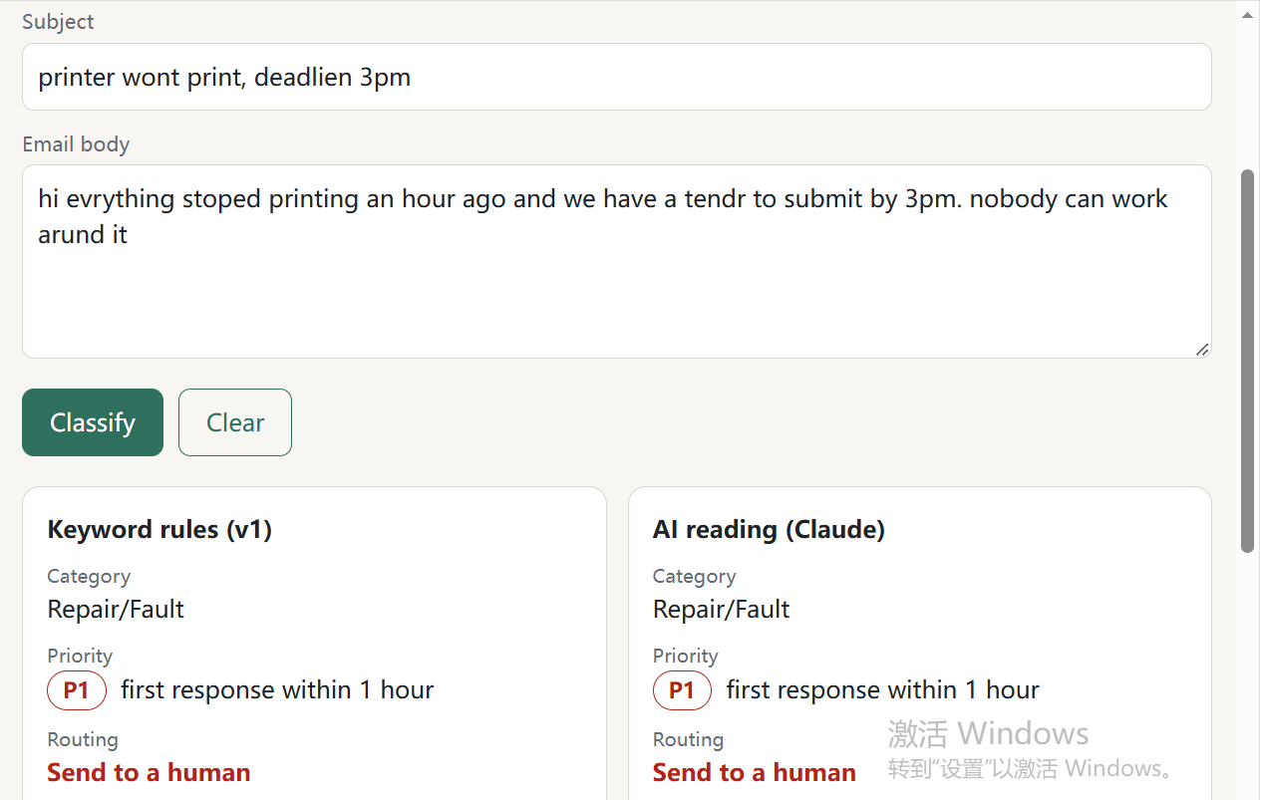
Both correct; the rules matched “dead” inside the misspelled “deadlien”.

Case 7: “printr brokn” (typos)
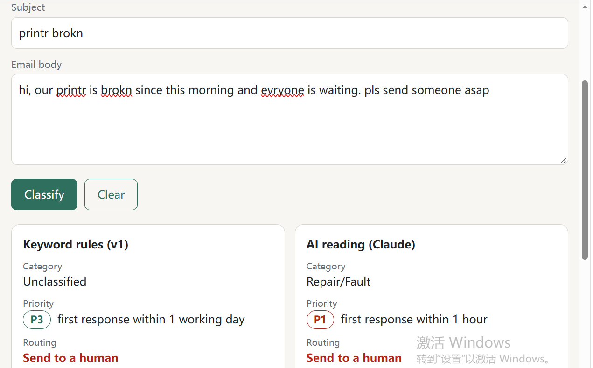
Rules cannot classify the email (P3) but route it to a human; AI judges Repair/Fault, P1.
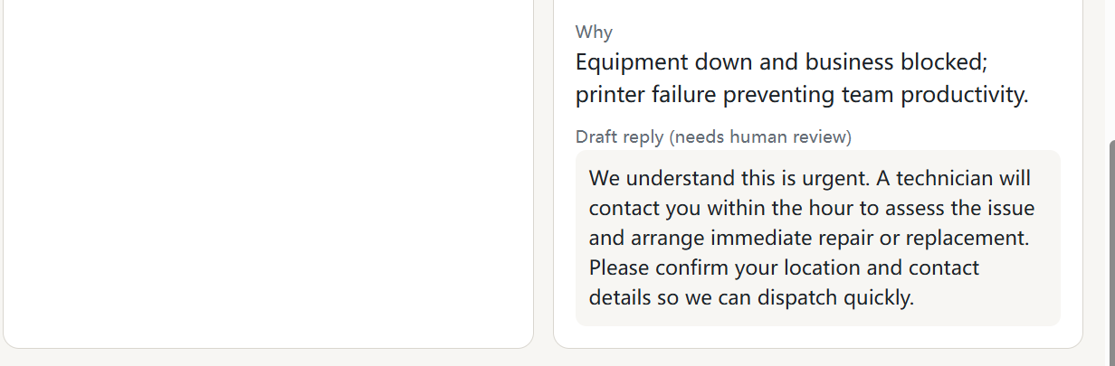
AI reason and draft reply (the draft again commits to a timeframe).

