NVIDIA × NEBIUS GLOBAL AI HACKATHON 2026
CallLens
A support call console where three NVIDIA Nemotron models share the work, and the caller only ever waits for the smallest one
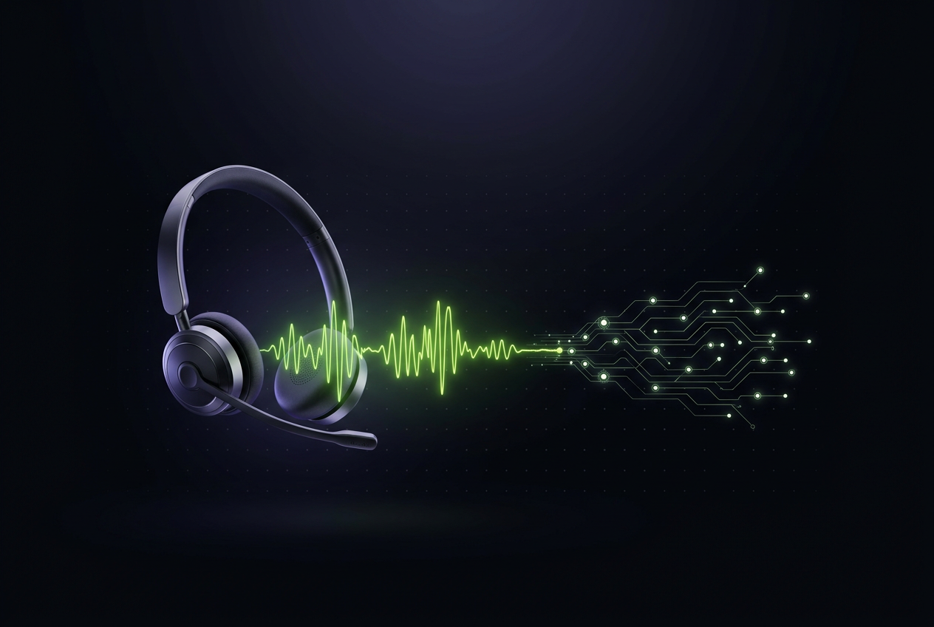
Aria answers the call. Nemotron Nano classifies it, Super speaks it, Ultra writes it down.
CallLens turns a routine support call into two artefacts — a conversation the caller can hear, and a structured record the business can use. It runs on Nebius Token Factory, uses three NVIDIA open models, and needs nothing installed beyond Node.js.
Event | NVIDIA × Nebius Global AI Hackathon
Track | Best Apps and Agents
Build window | 28 – 30 October 2026
Prototype status | Working end to end in mock mode; live path wired and awaiting an API key
Repository | Public GitHub repository, Apache 2.0
Live demo | Deployed on Render — link submitted with the entry

About this report
This document describes CallLens as it stands at the end of the submission window: what it does, how it is put together, why each decision was made, and — just as important — what has actually been tested versus what is still an assumption.
It is written for three readers at once:
• A judge, who needs to understand the idea and verify the claims quickly.
• An engineer, who needs to run it, read the code, and know where the sharp edges are.
• The team that inherits it, who need to know what to do next without re-deriving it.
Section 13 is deliberately blunt about the difference between verified and unverified work. Nothing in this document claims a live model call that did not happen.
Reading map
If you have | Read
Two minutes | Section 1, and the figures
Five minutes | Sections 1 to 6
A technical review | Sections 4, 5, 10, 11 and 13
A deployment or handover | Sections 12 and 17, plus Appendix A

1. Executive summary
CallLens is a browser-based support call console. An AI agent named Aria answers customer calls. While the call is happening, a second model reports what is going on — intent, sentiment, urgency, the order number being discussed, and what should happen next. When the call ends, a third model writes the record that the human agent would normally skip: a headline, a summary, the issue, the resolution, the follow-up, the risk, and a copy-ready CRM note.
The design decision that defines the project is model tiering. Instead of putting one large model behind every turn, three NVIDIA Nemotron models are placed on three different clocks:
• Nano runs before the agent speaks, on every turn. It must be fast or the interface feels dead.
• Super produces the words the caller actually hears, streamed token by token.
• Ultra runs exactly once, after the line closes, when nobody is waiting.
That is the whole thesis. Latency-critical work goes to the smallest model that can do it well; quality-critical work goes to the mid model; expensive reasoning moves off the live path entirely.
At a glance
What it is | A working web app: call console, live analysis rail, post-call record
Models | NVIDIA Nemotron Nano, Nemotron Super, Nemotron 3 Ultra, via Nebius Token Factory
Stack | Node.js standard library, plain HTML/CSS/JS, zero dependencies, no build step
Interface | Dark single-surface console with voice in, voice out, and a streaming transcript
Safety rule | Answers come only from an approved knowledge block; anything else becomes a human handoff
Honest limit | It is a browser call, not a telephone call. See section 16

The rest of this report takes each of those apart.

2. Problem and audience
A support agent on a live call is doing three jobs at once: listening, deciding, and talking. On top of that, every call ends with paperwork — the ticket, the disposition code, the follow-up. In practice the paperwork is skipped or written badly, because the agent is already on the next call.
Teams that automate this usually drop a single large model behind the whole conversation. That produces three problems:
1. Latency. A large model on every turn makes the caller wait in silence. Callers notice a pause of more than a second; they hang up on three.
2. Cost. Most turns are trivial — "are you open on Sunday?", "where is my parcel?" — and do not need a frontier model's capability.
3. No record. The conversation gets answered but never summarised, so the operational value is lost. The thing a support manager actually wants is the record, not the chat.
Audience: small and mid-size support teams that already record calls but cannot afford a per-seat AI copilot, and want both the live answer and the post-call record from one system. It also fits the more common case of a single person covering a support line, where there is no second colleague to hand a call to.
Why this is worth doing now. Open-weight models small enough to answer in well under a second are now good enough to run the routine turn, while a much larger model is available on the same API for the once-per-call reasoning. That split was expensive and awkward a year ago; today it is a routing decision, not a procurement decision.

3. What was built
Capability | Detail
Live call console | Caller and agent turns rendered as they happen; agent replies streamed token by token
Live analysis rail | Intent, sentiment, urgency (1–5), extracted order id and next action, updated every turn
Three-tier routing | Nemotron Nano, Super and Ultra, each on its own endpoint call with its own prompt
Grounded replies | Answers restricted to an approved knowledge block; anything else becomes a human handoff
Voice | Browser speech recognition for the caller, speech synthesis for the agent
Web context | Optional Tavily lookup when the caller names a company, with a hard timeout
Post-call record | Headline, summary, issue, resolution, actions, follow-up, risk, CRM note
Mock mode | Full UI and streaming path with no API key, clearly labelled in the badge
Deployment | Plain Node process; runs on Render's free tier or in Docker
Transparency | /health reports the live mode and the model ids actually in use

What was deliberately not built: authentication, a database, telephony integration and a retrieval layer. Each is listed in section 17 with the reason it was deferred.

4. Architecture
4.1 System overview
Three processes, one connection:
• The browser holds all interaction state: the transcript, the analysis rail, the routing timings and the voice controls. It never holds an API key and never calls Nebius.
• The Node server owns every model call. It classifies, prompts, streams, times out, and shapes the output. It is the only component that knows a model exists.
• Nebius Token Factory serves all three tiers from one OpenAI-compatible endpoint, so swapping a tier is a configuration change rather than a code change.
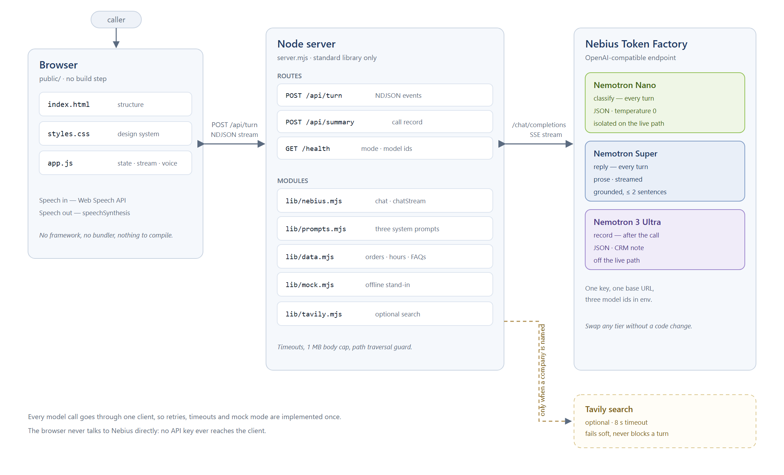
Figure 1 — System architecture. The browser only talks to the Node server; the server is the only holder of the API key and the only caller of the model tiers.
The split matters for two reasons. First, the API key never reaches the client, so the app can be published without leaking a secret. Second, every model call passes through one client module, which is where retries, timeouts, JSON repair and mock mode are implemented — once, instead of three times.
4.2 One turn, end to end
A turn is six steps, and their order is the design:
1. The caller speaks (or types). The browser posts { caller, history } to /api/turn.
2. The server calls Nano with a short, schema-constrained prompt at temperature 0. The reply is parsed as JSON and merged onto safe defaults, so one malformed field cannot break a turn.
3. The classification is pushed to the browser immediately as an analysis event.
4. If the caller named a company and TAVILY_API_KEY is set, a search runs and arrives as a context event. It has an 8-second ceiling and fails silently.
5. The server calls Super with the transcript plus a closed knowledge block, and forwards each token as a delta event.
6. A done event closes the turn with timings. The browser commits the agent message to local history and speaks it aloud if voice output is on.
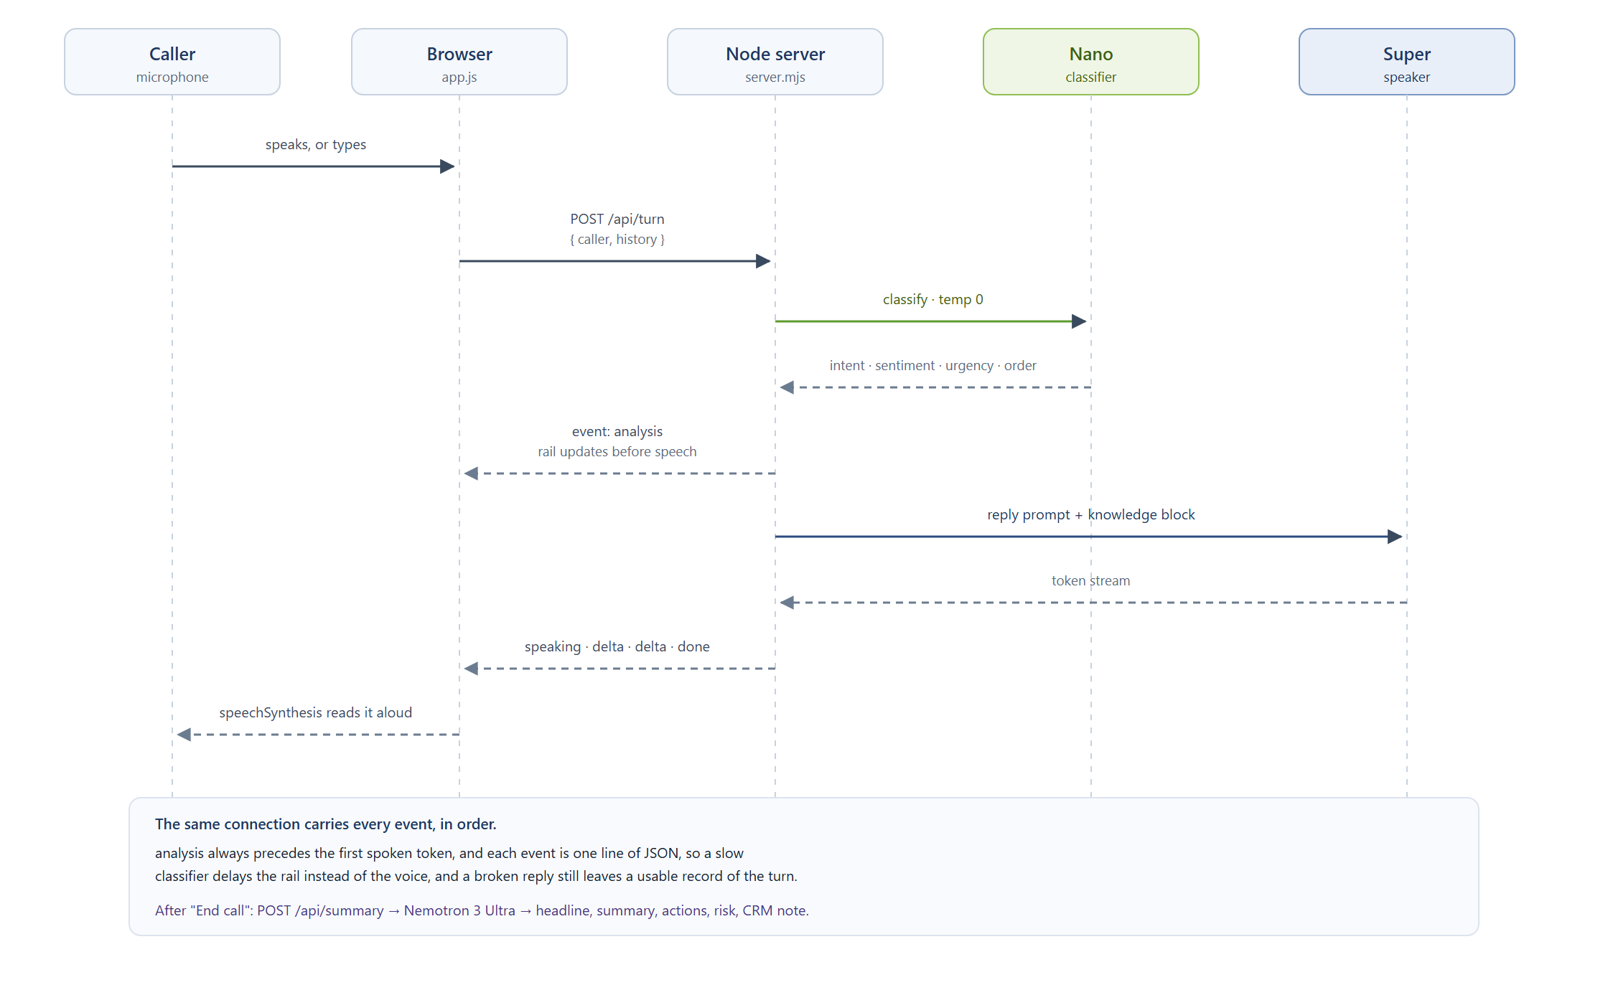
Figure 2 — The lifecycle of a single call turn. The classifier's result is pushed to the interface before the reply model has produced its first token.
Two details in that sequence are deliberate. The classification is pushed before the reply model is called, so the rail updates while the agent is still formulating its answer. And the browser, not the server, speaks the reply: the server streams text, the client decides whether voice output is on.
4.3 Why NDJSON on one connection
The obvious alternative was three round trips per turn: classify, fetch context, then reply. That triples the number of things that can fail and makes ordering a matter of luck.
NDJSON over a single response gives one connection, one degradation path, and a guaranteed order: analysis always arrives before the first spoken token. Each line is an independent JSON object, so the client can add new event types without a version negotiation, and a half-finished stream still leaves a readable partial reply.
4.4 Endpoint contract
POST /api/turn — request { "caller": string, "history": [{ "role", "text" }] }
Event | Payload | Meaning
analysis | model, ms, data | Nano's classification for this turn
context | query, items[] | Tavily results, only when a company was mentioned
speaking | model | Super is about to stream
delta | text | One fragment of the reply
done | model, ms, analysis | The turn is closed
error | message | A model or network failure, surfaced in the UI

POST /api/summary — request { "history", "analysis": [] } → { model, ms, summary }.
GET /health → { mode, models, tavily, base }. The badge in the interface is driven entirely by this endpoint, which is why mock mode can never be mistaken for a live model.
4.5 Failure behaviour
Failure | What the caller experiences
Classifier times out | Rail stays on the previous turn; the reply still streams
Classifier returns broken JSON | Defaults merged in; the turn continues with a generic intent
Reply model times out | An error event and a toast; the transcript keeps what was already spoken
Wrong model id | A 404 from Token Factory, surfaced as a model error, not a silent hang
Tavily fails or is slow | Ignored after 8 seconds; the turn is unaffected
No API key at all | Mock mode, with the badge stating it plainly

The rule behind the table: a failure should degrade one thing, never the call.

5. The tiering design in detail
The split is easiest to see as a timeline. Each row is one model's work during a single four-turn call, and the shaded band is the only stretch of time in which the caller is waiting for anything.
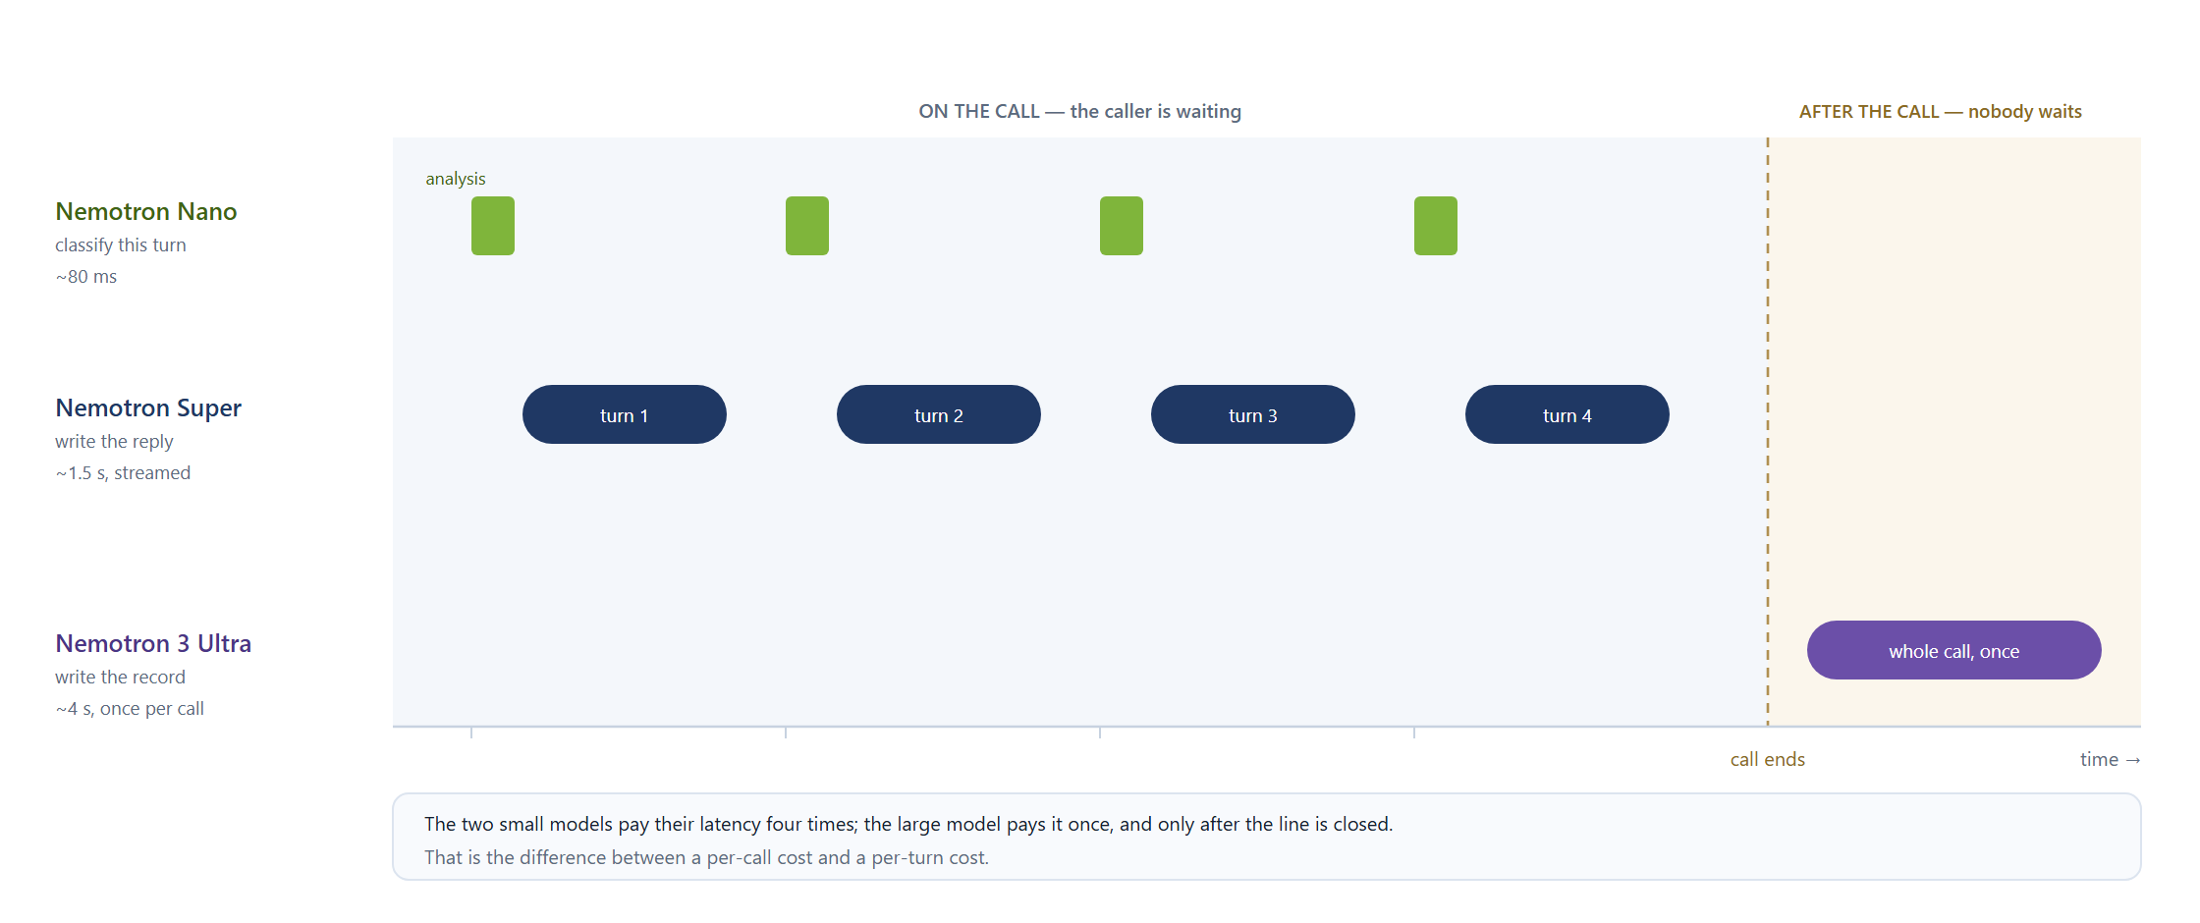
Figure 3 — The same call on three clocks. The two small models pay their latency on every turn; the large model pays it once, after the caller has gone.
 | Nano | Super | Ultra
Question it answers | "what is happening?" | "what do we say?" | "what happened, overall?"
Output | JSON, ~8 fields | speakable prose, ≤ 2 sentences | JSON, 10 fields
Temperature | 0 | 0.4 | 0.2
Constraints | short schema, no prose | no markdown, no lists, no invented facts | facts only from the transcript
Runs | every turn | every turn | once per call
Failure impact | the rail is stale | the caller hears nothing | there is no record
Mitigation | defaults merged in | error event and toast | retry, plus a mock-shaped fallback

Why not one model? A single large model pays its latency on every turn, including the trivial ones, and its cost grows with the length of the conversation rather than with the difficulty of the work. The split means the expensive model runs once per call, on the part of the job that genuinely needs reasoning: reconciling what the caller wanted with what actually happened, and writing it down in a form a human can act on.
Why not three models everywhere? Nano cannot write a good call record, and Ultra is wasted on intent classification. Each tier is deliberately unable to do the others' job — that is what makes the routing meaningful rather than decorative.
What the split buys, concretely. In a four-turn call the two small models are invoked eight times and the large one once. If the caller is waiting on eight of those nine calls and not on the ninth, the expensive model has been moved entirely out of the caller's perceived latency, without reducing what the business gets at the end.
What it costs in complexity. Three prompts instead of one, three failure modes instead of one, and a routing panel in the interface to keep all of it honest. The prompts in lib/prompts.mjs are the actual product logic; the rest of the code is plumbing.

6. Grounding and safety
A support agent that invents a delivery date is worse than one that says "let me get you a human". Three rules enforce that.
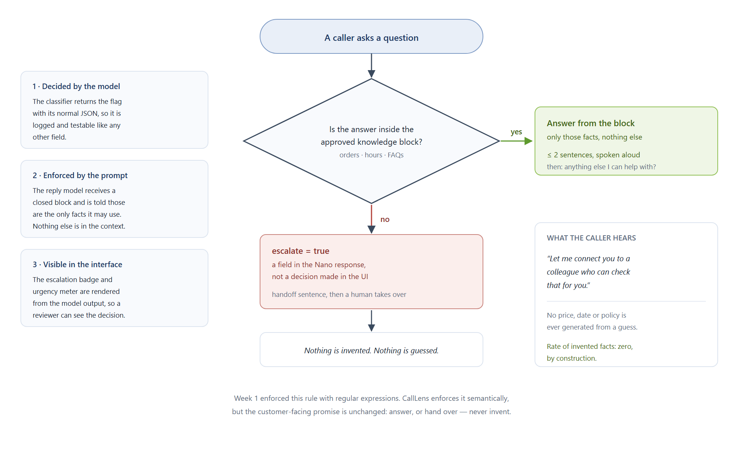
Figure 4 — The grounding rule as a decision. The escalation flag is a model output, so it is logged, testable and visible, not hidden in the interface.
1. Closed knowledge block. The reply model receives only the approved orders, hours and FAQs, and is told those are the only facts it may answer from. It is not asked to be careful; it is given nothing else to be careless with.
2. Escalation is a model output, not a UI guess. The escalate boolean comes from the classification tier. The interface renders it and never decides it.
3. Underivable questions fall back. Anything outside the block becomes a handoff sentence. The Week 1 prototype enforced this with regular expressions; the rule survives, the enforcement is now semantic.
The sample data is fictional and is labelled as such in lib/data.mjs and in the README, so a reader cannot mistake the demo orders for customer data.
What this does not claim. Grounding constrains the reply model; it does not make the classifier infallible. A misclassified turn can still produce a confident, wrong routing decision. That is why the rail shows the intent and the urgency rather than hiding them, and why the transcript is the record of truth when the two disagree.

7. Voice
• Input: SpeechRecognition / webkitSpeechRecognition in Chrome and Edge. Interim results fill the composer as the caller speaks; the final result sends itself.
• Output: speechSynthesis reads the completed reply, with a mute toggle in the header. It speaks the finished sentence, not the token stream, so the caller never hears a half-built sentence.
• Why browser speech instead of telephony: a SIP trunk and a phone number are a procurement problem, not an engineering one, and they would not have been ready in a two-day window. Browser speech keeps the demo self-contained and still proves the loop that matters — speech in, model decision, speech out.
• Honest limit: this is not a phone call. There is no PSTN, no barge-in, no echo cancellation and no hold music. Section 17 says what replacing it would take.

8. The interface
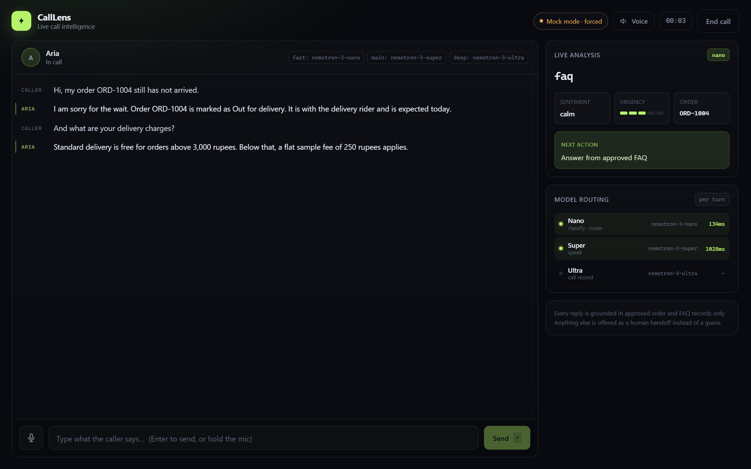
Figure 5 — The console after two turns: the transcript on the left, the live analysis rail and the per-tier routing timings on the right. The badge states that this is mock mode.
The interface is one surface, because a support agent should not be switching tabs while a customer is talking. Reading left to right, it answers three questions in order: what was said, what is happening, and how the machine decided.
• The transcript is the primary object. Caller and agent turns are visually distinct, and agent turns stream in rather than appearing whole, so the reader can see the model working.
• The analysis rail shows intent, sentiment, urgency as a five-segment meter, the order id the model extracted, and the suggested next action.
• The routing panel shows the three tiers, their model ids and their last measured latency. This is the part most support tools hide; showing it makes the tiering a visible design decision rather than a claim in a README.
• The mode badge states live or mock at all times. It exists because a demo in mock mode that looks live is a lie, and because a judge should never have to guess.
Design notes: a near-black background with a single lime accent keeps urgency and escalation signals legible; colour is never the only carrier of meaning, since each state also has a label; the layout collapses to a single column below 1080 px, and the composer stays reachable on small screens.

9. The post-call record
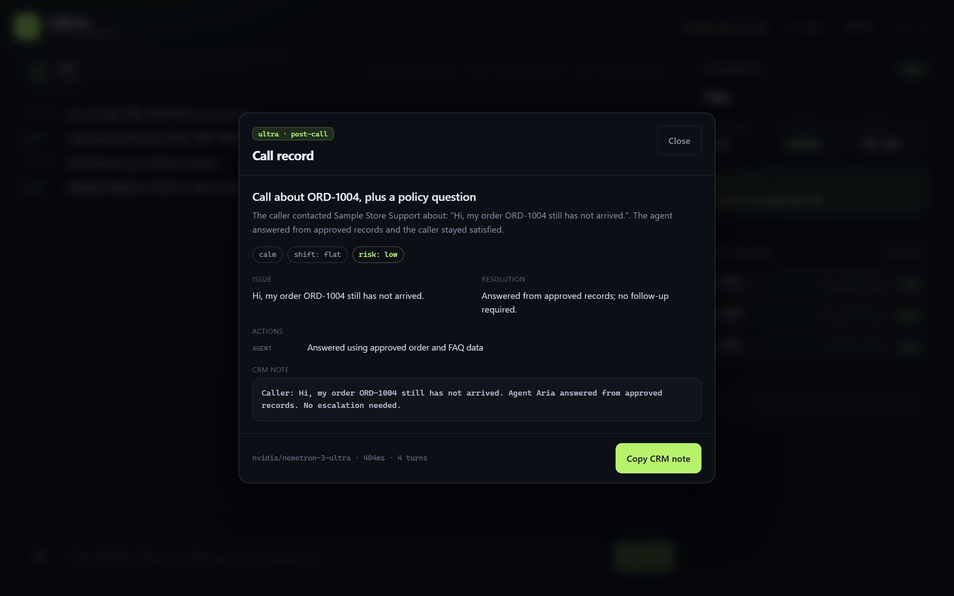
Figure 6 — The record written by Nemotron 3 Ultra after the caller hangs up. The model badge and the elapsed time are part of the artefact.
The record is the part of a support call that is most often lost and most useful later. CallLens asks Ultra for a fixed set of fields rather than a paragraph, so the output can be pasted into a ticket, read by a manager, or compared across calls.
Field | What it is for
headline | One line a queue can be sorted by
summary | Three sentences of context for whoever picks it up
issue | The reason for the call, in the caller's terms
resolution | What the agent did, and whether anything is outstanding
sentiment, sentiment_shift | How the caller felt, and whether it changed
actions | Who does what next, split between agent and human team
follow_up | The promise made to the caller, or null
risk | Low, medium or high, for triage
crm_note | A compact, copy-ready note in the format a CRM expects

The model call happens after the line closes, so a four-second generation costs the caller nothing. The copy button is deliberately the only action: writing back to a CRM is a permission and schema problem per customer, and pretending to solve it would be worse than leaving it as an explicit next step.

10. Technology choices
Choice | Reason | Trade-off accepted
Node standard library only | one command to run, nothing to install, nothing to break on a judge's machine | no framework ergonomics
Plain HTML, CSS and JavaScript | no build step means no build failure | manual DOM work
NDJSON streaming | ordering is guaranteed, one connection | a small custom parser in the client
Environment-configured model ids | any Nemotron size can be swapped without a code change | one more setup step, mitigated by npm run models
Mock mode with the same shapes | UI work and demo rehearsal without spend | a demo could run in mock mode, mitigated by the always-visible badge
Static knowledge block | a small, auditable set of facts that cannot drift | no retrieval; scaling it is section 17

The dependency count is zero on purpose. A judge cloning the repository runs one command, and there is no lockfile to rot, no native module to compile and no version conflict to debug on a machine we cannot see.

11. Code map
Every file, and what it owns:
File | Lines* | Responsibility
server.mjs | ~230 | HTTP routing, NDJSON turn stream, summary endpoint, static files, timeouts
lib/nebius.mjs | ~150 | Token Factory client: chat, chatStream, parseJSON, mode detection
lib/prompts.mjs | ~110 | the three system prompts; the actual behaviour lives here
lib/data.mjs | ~110 | approved orders, hours, FAQs, order-id extraction, knowledge block
lib/mock.mjs | ~140 | offline classifier, reply generator, summary generator
lib/tavily.mjs | ~40 | optional web search with soft failure
public/index.html | ~190 | console, rail, routing panel, summary modal, voice controls
public/styles.css | ~600 | design system and layout
public/app.js | ~430 | state, stream reader, rendering, voice, summary modal
scripts/check-models.mjs | ~30 | prints the model ids available to the API key
scripts/build_report.py | ~330 | regenerates this document, cover and figures included
docs/images/ | — | the cover image, four generated diagrams and two screenshots

\* approximate, for orientation only.
The distribution is deliberate: the prompts and the client are small and read in one sitting, while the interface carries most of the code because it carries most of the product.

12. Running it
cp .env.example .env # Windows: copy .env.example .env
npm start # http://localhost:3000
npm run models # list the model ids available to your key
npm run report # regenerate REPORT.docx from REPORT.md

With no NEBIUS_API_KEY the app runs in mock mode and says so in the badge. With a key and three model ids it runs live. Deployment is a plain Node process: on Render, build with npm install and start with npm start, then set the environment variables from Appendix A. In Docker: docker build -t calllens . && docker run -p 3000:3000 --env-file .env calllens.
Regenerating this document needs Python with python-docx installed (pip install -r requirements-dev.txt), and regenerating the diagrams needs only a browser: each figure is an HTML file in docs/images/src/ rendered to PNG.

13. Testing — what was actually verified
Verified
Check | Method | Result
GET /health | curl | returns mode, model ids, Tavily flag
POST /api/turn | curl | analysis, speaking, deltas and done, in the correct order
POST /api/summary | curl | structured record with a CRM note
Order-status intent | curl | ORD-1004 extracted, grounded reply returned
Business-hours intent | curl | grouped hours spoken as one sentence
FAQ intent | curl | answer restricted to the matching approved entry
Full UI flow | headless Chrome over the DevTools protocol | four turns, rail updates, End call, populated record
Escalation path | headless Chrome | handoff intent, escalation badge, urgency 5
Order-id carry-over | headless Chrome | a follow-up turn inherits ORD-1002 without repeating it
Static assets and 404 | curl | 200 for CSS and JS, 404 for an unknown path
Console errors | browser console | none across the flows above
Voice wiring | browser | mic present and enabled, mute toggle round-trips, no console errors
Report rendering | python-docx output | six figures, no empty placeholders, no literal markup left in the document

Defects found during the build, and fixed
Defect | Cause | Fix
The summary modal was visible on load | a design rule overrode the hidden attribute | a global [hidden] rule with !important
A follow-up question was answered as an order query in mock mode | the classifier carried the order id forward and let it win | explicit question keywords now take precedence; carry-over only applies to follow-ups
Every FAQ produced the returns answer in mock mode | one placeholder reply for all FAQ intents | the mock now routes to the matching approved FAQ answer
A two-question call produced a contradictory record | the headline came from one turn and the issue from another | the record is derived from the call's opening question and its topic
The report rendered --- and stray backticks literally | the markdown renderer was too literal | horizontal rules and nested code spans are handled explicitly

Not verified — stated plainly
• No live Nemotron call has been made from this repository. Every model call above ran through the mock path. The live path is structurally identical and compiles, but the first real request is still unproven.
• The model ids in .env.example are placeholders. They must be replaced from npm run models; a wrong id produces a 404 from Token Factory.
• Microphone recognition was not exercised. Headless Chrome has no microphone. The code path is reachable and error-handled, but the acoustic path is untested here.
• No deployment was performed. The Render instructions are documented but unexecuted.
• Latency figures in the interface are mock timings. The routing panel is real
instrumented code, but the numbers it shows in mock mode measure the mock, not Nemotron.

14. Mapping to the judging criteria
Criterion | How this project answers it
Technological implementation | Three Nemotron sizes with distinct prompts, streamed replies, structured output with defaults, hard timeouts, graceful degradation and honest mode reporting
Design | One coherent console rather than a proof of concept: transcript, live analysis, routing telemetry and a post-call record in a single surface
Potential impact | The post-call record is the part support teams actually lose today, and the tiering is what makes it affordable to produce on every call
Quality of idea | Model tiering as a latency design, not a cost trick, and the split is visible in the interface rather than hidden in a config file

15. Change from the Week 1 prototype
The Week 1 internship prototype was a Python, standard-library, rule-based CLI support agent with 27 unit tests and no model at all. This project keeps the domain and the safety rule, and replaces the intelligence and the interface.
Week 1 | CallLens
Python command-line tool | Browser console
Regex intent detection | Nemotron Nano classification
Template replies | Nemotron Super, streamed and grounded
No post-call artefact | Nemotron 3 Ultra record and CRM note
Text only, in a terminal | Speech in, speech out
No external context | Optional Tavily enrichment
27 unit tests, one process | End-to-end flows across four processes, plus a mock path

What was kept on purpose: the same fictional sample data, the same "answer or hand over, never invent" rule, and the same short, speakable reply style. The rewrite is of the mechanism, not of the promise made to the customer.

16. Limitations and risks
1. Voice is browser-native. Recognition works in Chrome and Edge only, and there is no telephony. A real deployment needs a media-stream provider behind the same tiering.
2. Single session. No authentication, no database; a refresh clears the call.
3. Static knowledge. No retrieval layer yet; the block is small and hand-written, which is a strength for auditability and a ceiling for scale.
4. Demo risk. A wrong model id or an expired key degrades the agent to error events. Mitigated by /health, npm run models and the mode badge.
5. Mock realism. Mock mode is keyword-based and could be mistaken for model quality if the badge were cropped out of a video. It is deliberately always visible, and this report states which results came from it.
6. One language pair is proven in prompt, not in practice. The reply prompt tells Aria to answer in the caller's language, including Roman Urdu. That behaviour has not been reviewed by a native speaker of every language it might meet.

17. Next steps
1. Telephony. Twilio or Telnyx media streams behind the same tiering. The server already streams, which is the hard part.
2. Retrieval. Replace the static knowledge block with search over approved client documents, keeping the same closed-book rule.
3. CRM write-back. The copy button becomes an API call, behind a per-customer schema.
4. Latency budget. Track p50 and p95 per tier and show them next to the model ids, so the routing panel becomes an operational instrument rather than a demo.
5. Barge-in. Interrupt the agent when the caller starts speaking. This is the difference between a demo and something a person will tolerate on a bad line.
6. Evaluation. A fixed set of recorded calls with expected intents and expected escalations, run on every prompt change. The prompts are the product; they need tests.

Appendix A — environment variables
Variable | Required | Purpose
NEBIUS_API_KEY | for live | Token Factory key; empty means mock mode
NEBIUS_BASE_URL | no | defaults to https://api.tokenfactory.nebius.com/v1
NEBIUS_MODEL_FAST | live | Nano model id
NEBIUS_MODEL_MAIN | live | Super model id
NEBIUS_MODEL_DEEP | live | Ultra model id
TAVILY_API_KEY | no | enables the web-context panel
PORT | no | defaults to 3000
MOCK_MODELS | no | 1 forces mock mode even when a key is present
REQUEST_TIMEOUT_MS | no | per-request ceiling, defaults to 25000

Appendix B — glossary
Term | Meaning here
Tier | One of the three model roles: classify, speak, record
Grounding | Restricting an answer to a fixed set of approved facts
Handoff | Passing the caller to a human instead of guessing
NDJSON | One JSON object per line, streamed over a single connection
SSE | Server-sent events, the streaming format Token Factory uses
p95 | The latency below which 95 percent of requests complete
Mock mode | An offline path that mimics the models' output shapes

Appendix C — repository layout
calllens/
server.mjs HTTP server, routing, NDJSON turn stream
package.json scripts: start, models, report
.env.example configuration template, safe to publish
lib/
nebius.mjs Token Factory client and mode detection
prompts.mjs the three system prompts
data.mjs approved orders, hours and FAQs
mock.mjs offline classifier, replies and record
tavily.mjs optional web search
public/
index.html console, rail, modal
styles.css design system
app.js state, stream reader, voice
scripts/
check-models.mjs prints model ids for the key
build_report.py renders REPORT.md to REPORT.docx
docs/images/ cover, diagrams and screenshots
README.md setup, deployment and limitations
SUBMISSION.md entry text and feedback notes
VIDEO_SCRIPT.md timed demo script
LICENSE Apache 2.0

*CallLens is a prototype built during the NVIDIA × Nebius Global AI Hackathon, 28–30 October 2026. All customer, product and policy data in it is fictional sample data.*

