

UNIVERSITY OF CENTRAL PUNJAB
Lahore, Pakistan
Faculty of Information Technology (FOIT)
Course: Cloud Computing
Assignment 1: Research Paper
Multiresource Accelerated Genetic Algorithm for Energy Efficient VM Placement in Cloud Data Centers
Submitted by: | Sumyia Butt Student ID: L1S24BSCS0067
 | Indiviual
Group: | [3]
Program and Section: | BSCS, Section F1
Submitted to: | Sir Zulkifl Hasan
Base paper: | Hormozi et al. (2022), Energy (Elsevier), doi: 10.1016/j.energy.2022.123884
Dataset: | Google Cluster Usage Traces
Submission date: | 30 October 2026

Multiresource Accelerated Genetic Algorithm for Energy Efficient VM Placement in Cloud Data Centers
Sumyia Butt¹ and Muhammad Zunnurain Hussain^{2,*}
¹ Faculty of Information Technology (FOIT), University of Central Punjab, Lahore, Pakistan
² Department of Computer Science, Bahria University Lahore Campus, Lahore, Pakistan
* Corresponding Author: zulkifl.hasan@ucp.edu.pk
Abstract: Virtual machine placement strongly affects the energy use of cloud data centres. Genetic algorithms produce good placements but are costly, and recent accelerated variants simplify the fitness function to a residual resource term that looks at CPU only. This paper extends that idea to two resources. We study a multiresource accelerated genetic algorithm with three components: a multi seed initial population built from first fit decreasing variants, a fitness function that combines CPU and memory residual resources with a capacity penalty, and a targeted consolidation mutation. The method is evaluated on samples of the Google cluster usage traces at three scales (1350, 2242 and 5365 virtual machines). Placement uses requested resources, and SLA violations are assessed with measured usage over 5 minute windows, across five independent runs. Against a two resource first fit decreasing baseline, the proposed algorithm lowers energy by 3.1 to 3.7 percent and activates 3.4 to 11.8 fewer hosts, while SLA violations stay within run to run variation. Against CPU only methods it uses 2.4 to 3.7 percent more energy, and its SLA advantage is visible only at the small scale. An ablation study shows that the whole gain comes from selecting among the seeds with the multiresource fitness, while crossover, mutation and consolidation add nothing in any run. The energy saving against the two resource baseline is unchanged for power model shape constants of 2, 3 and 4. The results describe a trade off rather than a uniform improvement.
Keywords: virtual machine placement; genetic algorithm; energy efficiency; multiresource fitness; SLA violation; cloud data centre

1 Introduction
Cloud data centres host a very large number of virtual machines (VMs) on physical machines (PMs), and the placement of VMs on PMs decides how many hosts stay powered on. Idle servers still draw a large share of their peak power, so packing VMs onto fewer hosts is one of the most direct ways to lower energy use [1]. Placement is an NP hard problem, and heuristics such as first fit decreasing (FFD) are fast but can leave room for improvement. Genetic algorithms (GAs) search the placement space globally, but each generation requires repeated fitness evaluation, which becomes expensive at large scale.
Hormozi et al. [1] addressed this cost by replacing the exponential power based fitness with a residual resource term obtained from a Taylor expansion, and reported about 8 percent lower energy than FFD and 66 percent lower GA execution time than a standard GA on Google trace samples. Their fitness considers CPU utilisation only, SLA violations are not evaluated, and placement is static. Other recent work considers several resources and SLA directly. Alourani et al. [2], for example, combine adaptive thresholds with a GA whose fitness weighs energy and SLA violations, but they evaluate with synthetic task types in a simulator at up to 300 VMs.
This paper studies whether the accelerated residual fitness of [1] remains useful when memory is treated as a second resource, and how such a method behaves when SLA violations are measured with real usage data. Our contributions are as follows.
1. A multiresource residual fitness that combines CPU and memory residuals with a capacity penalty, which keeps the linear cost of the fitness of [1].
2. A multi seed initial population built from FFD orderings by CPU, memory, their maximum and their sum, combined with a targeted consolidation mutation.
3. A reproducible evaluation protocol on the Google cluster usage traces that places by requested resources and measures SLA violations on measured 5 minute usage, with full code released, together with an honest account of where the expected gains did not appear.
4. An ablation and sensitivity study that identifies which component produces the gain, and shows that the result holds for different shape constants of the power model and different fitness weights.
The rest of the paper is organised as follows. Section 2 reviews related work, Section 3 presents the method, Section 4 describes the experimental setup and data, Section 5 reports results, ablation and sensitivity analyses, Section 6 discusses them, Section 7 covers threats to validity, and Section 8 concludes.
2 Related Work
GA based placement has been studied extensively. Hormozi et al. [1] formulate placement as a constrained optimisation problem and design a fitness function that sums squared host utilisations, derived from the standard power model by Taylor expansion. Their evaluation on 24 hour samples of the Google traces covers small, medium and large data centres, and they list static placement as a limitation. The article does not provide a link to code or processed data, which limits direct reproduction.
Alourani et al. [2] present a GA with adaptive thresholds that classify hosts as underloaded, normal or overloaded and add a middle threshold to use lightly loaded hosts better. Their fitness combines normalised energy and SLA violation, and their experiments use CloudSim with 100 hosts and 50 to 300 VMs. They report energy reductions between 13 and 15 percent over a utility based approach. Their host utilisation includes CPU, memory and storage through a weighted sum, so multiple resources are already common in this line of work, and our contribution should be read as a study of the accelerated residual fitness under two resources rather than as the first use of memory.
Other work targets related objectives. Li et al. [3] optimise multiple resources collaboratively for adaptive placement, Peake et al. [4] parallelise ant colony optimisation for placement, Muteeh et al. [5] balance multiple resources with ant colony optimisation, and Malik et al. [6] use queuing and thresholds for load balancing in workflow scheduling. On the autoscaling side, Pintye et al. [7] select relevant internal metrics to drive a machine learning autoscaler and report fewer QoS violations and fewer VMs, which points to a possible coupling between scaling and placement that we leave for future work. Table 1 summarises how the closest studies differ from the present one.

Table 1. Comparison of closely related studies.
Study | Method | Resources in fitness or load | SLA evaluated | Workload | Code or data
Hormozi et al. [1] | GA, residual fitness | CPU | No | Google trace sample | Not linked
Alourani et al. [2] | GA with adaptive thresholds | CPU, memory, storage (weighted) | Yes | CloudSim task types | Supplement
Pintye et al. [7] | ML autoscaler | Internal metrics (128) | QoS violations | Own cloud testbed | On request
This work | GA, multi seed, residual fitness | CPU and memory | Yes (measured usage) | Google trace sample | Open code

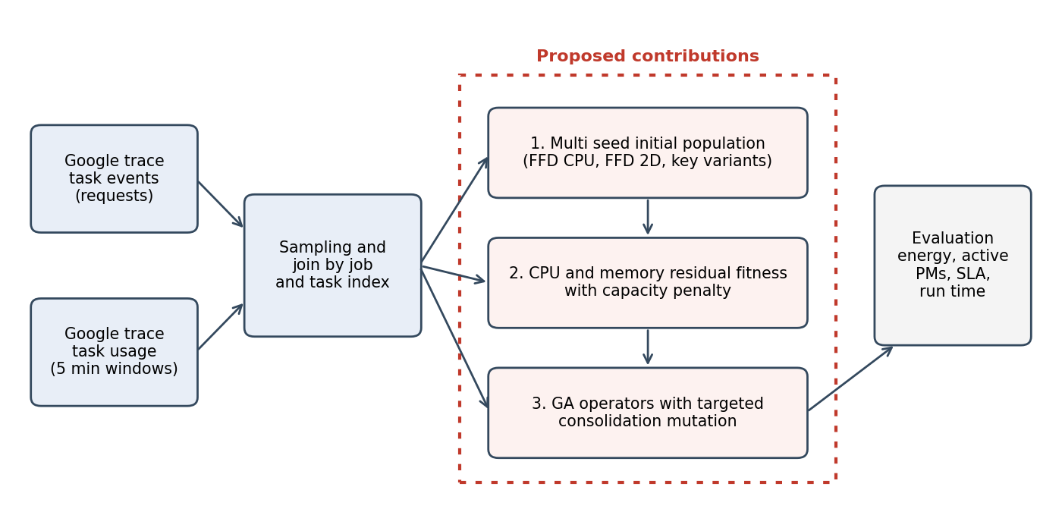
Fig. 1. Overview of the proposed framework. The dotted box marks the three proposed contributions.

3 Proposed Methodology
3.1 System model
A data centre has N homogeneous hosts with normalised capacity of 1 for CPU and 1 for memory. VM i requests c_i of CPU and m_i of memory, and a placement assigns each VM to one host. For host j the utilisations are u_cpu,j and u_mem,j, the sums of the requests of the VMs assigned to it. A host is active if it holds at least one VM, and inactive hosts are switched off. Host power follows the model used in [1]:
P(u) = Pmax − (Pmax − Pmin) / exp(α·u) (1)
where Pmin and Pmax are idle and peak power and α shapes the curve. The energy of a placement over a period T is
E = T · Σ over active hosts j of P( min(u_cpu,j , 1) ) (2)
which keeps CPU as the only input of the power model, as in [1]. Memory therefore affects energy only through the number of hosts that must stay active.
3.2 Fitness functions
Three fitness functions are compared. The standard GA minimises the energy sum of Eq. (2) directly. The base paper GA of [1] minimises the residual CPU term:
F_base = Σ over active j of ( 1 − u_cpu,j² ) (3)
The proposed multiresource residual fitness adds memory and a penalty for capacity violations:
F_prop = Σ over active j of [ 1 − ( w·u_cpu,j² + (1 − w)·u_mem,j² ) ] + λ·Σ over j of [ max(0, u_cpu,j − 1) + max(0, u_mem,j − 1) ] (4)
with w = 0.5 and λ = 1000. Each evaluation needs one pass over the VMs and one pass over the hosts, so the cost stays linear in the number of VMs and active hosts, as for Eq. (3).
3.3 Genetic algorithm
A chromosome stores the host index of every VM. The initial population contains FFD solutions obtained by sorting VMs by CPU, by memory, by the larger of the two, and by their sum. The solution with the best fitness becomes the elite, and the remaining individuals are copies in which 5 percent of the genes are moved to hosts already used in the seed. Parents are chosen by tournament selection with a tournament size of 16, offspring are produced by uniform crossover with rate 0.5, and each gene mutates with probability 0.015 by moving to a random used host.
In addition, with probability 0.3 a consolidation mutation selects one of the five least loaded active hosts and tries to move all of its VMs to other active hosts that have room for them in every considered resource. The move is applied only if the host can be emptied completely. The algorithm keeps the elite, stops after 50 generations without improvement, and allows at most 999 generations. The two CPU only GAs use a CPU only FFD seed and CPU only feasibility checks, so that every method uses the information its own fitness considers.
3.4 Algorithms
Algorithm 1 gives the complete placement procedure and Algorithm 2 the consolidation mutation.
Algorithm 1. Multi seed multiresource placement
Input: CPU and memory requests, N hosts
1 for key in {CPU, memory, max, sum}:
2 S_key = FFD(sorted by key, check CPU and memory)
3 elite = seed with lowest F_prop
4 P = {elite} + other seeds + perturbed copies
5 repeat
6 evaluate F_prop for every individual
7 select parents by tournament (size 16)
8 uniform crossover (0.5), mutation (0.015)
9 with probability 0.3: consolidate(child)
10 keep elite
11 until 50 generations without improvement
12 return best placement

Algorithm 2. Consolidation mutation
Input: placement x, requests
1 pick one of the 5 least loaded active hosts h
2 for each VM v on h:
3 find an active host g with room for v
4 if none: return x unchanged
5 move v to g (best fit by CPU)
6 return x with h emptied

3.5 Complexity
Let n_v be the number of VMs and n_p the number of active hosts. One FFD seed costs O(n_v log n_v) for sorting plus the cost of finding a host with room, which is O(n_v · n_p) in the worst case. Evaluating F_prop costs O(n_v + n_p). One generation with population P costs O(P · (n_v + n_p)) for evaluation, and the consolidation mutation costs at most O(n_v · n_p) per application. Memory use is O(P · n_v) for the population. These costs match those of the CPU only residual fitness of [1], up to a constant factor for the second resource.
4 Experimental Setup
4.1 Data
We use the Google cluster usage traces released with [8]. Requests come from the task events table, where we keep submit events with positive CPU and memory requests and remove duplicate task identifiers. Usage comes from the task usage table, which reports mean CPU rate and memory usage over 5 minute windows. The two tables are joined on job and task index, and only tasks with at least 12 usage windows (one hour) are kept, so each retained task has a complete usage profile. Each run draws a different random sample of tasks. All values are normalised by the trace, so host capacity is 1 for both resources.
The scales follow Table 3 of [1]: small with 1350 VMs and 1000 hosts, medium with 2242 VMs and 2000 hosts, and large with 5365 VMs and 3000 hosts. We use one part file of each table, and the retained long running tasks are somewhat heavier than average, which we discuss as a limitation.
4.2 Methods and metrics
Five methods are compared: FFD sorted by CPU (FFD CPU), FFD sorted by CPU with a memory check (FFD 2D), the standard GA, the base paper GA and the proposed GA. Metrics are the energy of Eq. (2) over 24 hours in kWh, the number of active hosts, the GA run time, and the SLA violation. We define the SLA violation as the percentage of pairs of an active host and a 5 minute window in which the measured CPU demand or memory demand of the assigned VMs exceeds the capacity of one. We also count hosts whose requested memory exceeds capacity, which shows what a CPU only method ignores.
4.3 Implementation and parameters
All algorithms are implemented in Python with NumPy, and the code is available as described in the data availability statement. Table 2 lists the parameters. The shape constant α is not given in [1], so we chose 3 to approximate the curve in their power model figure, and Pmin and Pmax are read from the same figure. The runs use seeds 0 to 4, and results are reported as mean and standard deviation over the five runs. The additional ablation and sensitivity experiments use the small and medium scales with five runs each.
4.4 Characteristics of the sampled workload
Fig. 2 and Table 3 describe the sampled tasks. Requests are small relative to a host, with a mean CPU request of 0.050 and a mean memory request of 0.038. CPU and memory requests are positively but not strongly correlated (correlation 0.47), so a task that is light in CPU can still be heavy in memory, which is the situation in which a CPU only method misplaces VMs. Measured usage is far below the request for most tasks (median ratio 0.08 for CPU and 0.25 for memory), yet about 13 percent of tasks use more than they requested, and these tasks produce the overload events counted in the SLA metric.
4.5 Software environment
Experiments were run with Python 3.12.3 and NumPy 2.4.4. Random seeds are fixed for each run, so every table in this paper can be regenerated from the released code and the two trace part files.
Table 2. Parameters of the experiments.
Parameter | Value
Pmin, Pmax (W) | 160, 220
Shape constant α | 3
Population size | 64
Tournament size | 16
Crossover (uniform) | 0.5
Mutation rate per gene | 0.015
Consolidation probability | 0.3
Stall limit, max generations | 50, 999
Fitness weight w, penalty λ | 0.5, 1000
Runs per scale | 5 (seeds 0 to 4)

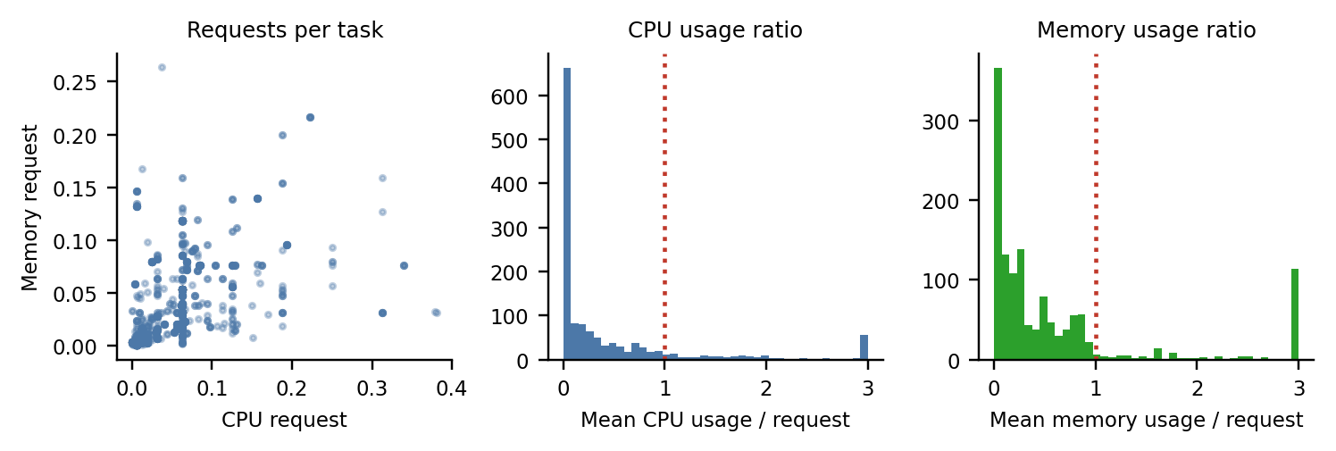
Fig. 2. Sampled workload: CPU against memory requests, and the ratio of measured usage to request.
Table 3. Characteristics of the sampled tasks.
Quantity (mean over five small samples) | CPU | Memory
Mean request per task (normalised) | 0.050 | 0.038
Mean measured usage per task | 0.017 | 0.021
Median of usage divided by request | 0.08 | 0.25
Share of tasks whose usage exceeds the request (%) | 12.9 | 13.5
Largest request in a sample | 0.38 | 0.31
Correlation between CPU and memory requests | 0.47

Table 4. Results on Google cluster usage trace samples (mean ± standard deviation over five runs). Run time of the FFD methods is below 0.3 s.
Scale | Method | Energy (kWh) | Active PMs | SLA (%) | Run time (s)
Small | FFD CPU | 356.8 ± 12.7 | 68.6 ± 2.5 | 8.42 ± 1.98 | under 0.3
 | FFD 2D | 379.5 ± 10.5 | 73.8 ± 1.9 | 6.23 ± 1.53 | under 0.3
 | Standard GA | 356.8 ± 12.7 | 68.6 ± 2.5 | 8.42 ± 1.98 | 0.69
 | Base paper GA | 356.8 ± 12.7 | 68.6 ± 2.5 | 8.42 ± 1.98 | 0.68
 | Proposed GA | 365.5 ± 10.7 | 70.4 ± 2.1 | 6.68 ± 1.51 | 0.71
Medium | FFD CPU | 593.4 ± 16.7 | 114.0 ± 3.2 | 7.15 ± 0.17 | under 0.3
 | FFD 2D | 630.7 ± 15.3 | 122.4 ± 3.0 | 7.21 ± 0.61 | under 0.3
 | Standard GA | 593.4 ± 16.7 | 114.0 ± 3.2 | 7.15 ± 0.17 | 0.78
 | Base paper GA | 593.4 ± 16.7 | 114.0 ± 3.2 | 7.15 ± 0.17 | 0.85
 | Proposed GA | 611.0 ± 13.3 | 117.6 ± 2.5 | 7.20 ± 1.12 | 0.84
Large | FFD CPU | 1416.2 ± 39.8 | 272.0 ± 7.7 | 8.06 ± 0.26 | under 0.3
 | FFD 2D | 1518.6 ± 40.6 | 294.6 ± 7.9 | 8.03 ± 0.70 | under 0.3
 | Standard GA | 1416.2 ± 39.8 | 272.0 ± 7.7 | 8.06 ± 0.26 | 1.42
 | Base paper GA | 1416.2 ± 39.8 | 272.0 ± 7.7 | 8.06 ± 0.26 | 1.35
 | Proposed GA | 1468.4 ± 37.5 | 282.8 ± 7.2 | 8.17 ± 1.03 | 1.48
Table 5. Paired differences of the proposed GA against the baselines (mean ± standard deviation of the per run difference, five runs).
Scale | Energy vs FFD 2D (%) | Active PMs vs FFD 2D | SLA vs FFD 2D (points) | Energy vs FFD CPU (%) | SLA vs FFD CPU (points)
Small | −3.7 | −3.4 ± 0.9 | 0.45 ± 1.51 | +2.4 | −1.73 ± 1.14
Medium | −3.1 | −4.8 ± 0.8 | −0.01 ± 0.85 | +3.0 | 0.05 ± 1.18
Large | −3.3 | −11.8 ± 1.9 | 0.14 ± 0.83 | +3.7 | 0.12 ± 1.12

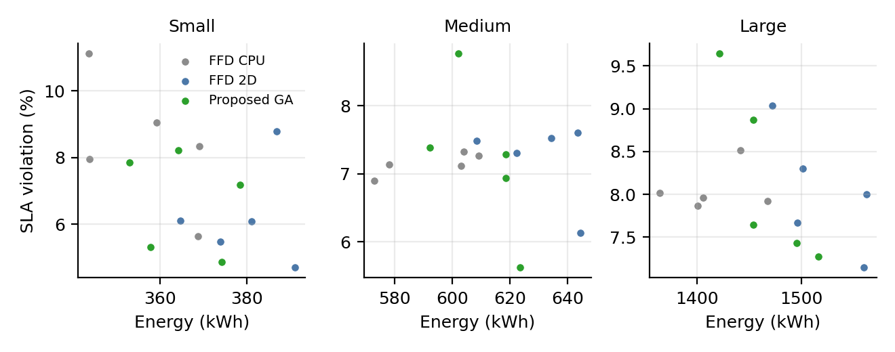
Fig. 3. Energy and SLA violation of individual runs for FFD CPU, FFD 2D and the proposed GA.

5 Results
5.1 Main comparison
Table 4 and Figs. 3 to 6 report the main results, and Fig. 3 plots the energy and SLA of individual runs. FFD CPU, the standard GA and the base paper GA produce identical placements in every run, so their numbers coincide. With CPU requests only, FFD already packs close to the lower bound given by the total requested CPU (for the first small sample, 64.3 hosts of capacity 1 against 65 used by FFD), and no GA run improved on it.
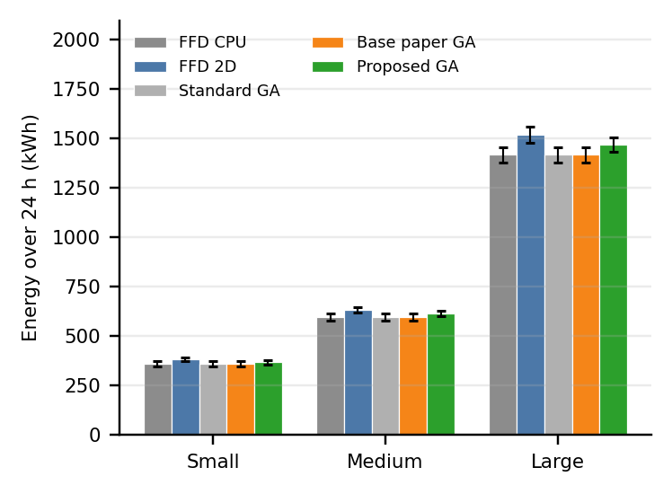
Fig. 4. Energy over 24 hours (mean and standard deviation).
Against FFD 2D, which respects memory as well, the proposed GA lowers energy by 3.7, 3.1 and 3.3 percent at the small, medium and large scales, and uses 3.4, 4.8 and 11.8 fewer hosts (Fig. 5). The per run differences in Table 5 are consistent across the five runs, with standard deviations well below the means.
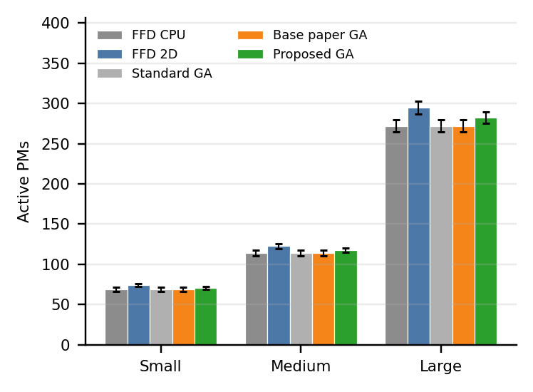
Fig. 5. Number of active hosts (mean and standard deviation).
The SLA results are less clear (Fig. 6). Relative to FFD 2D, the SLA difference is 0.45, −0.01 and 0.14 percentage points at the three scales, which is within the run to run standard deviation. Relative to FFD CPU, the proposed GA lowers the SLA violation by 1.73 points at the small scale, but the difference at the medium and large scales is not distinguishable from zero. Against CPU only methods, the proposed GA uses 2.4, 3.0 and 3.7 percent more energy, because it keeps more hosts active to respect memory.
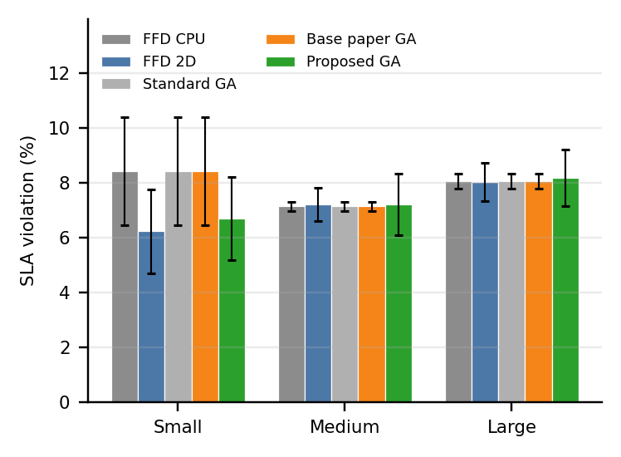
Fig. 6. SLA violation (mean and standard deviation).
5.2 Memory at host level
The memory check matters at the reservation level. On requested demand, the CPU only methods leave on average 11.6, 19.8 and 50.4 hosts at the three scales with more memory requested than the host provides, while FFD 2D and the proposed GA leave essentially none (at most 0.4 hosts on average). Fig. 7 shows the distribution for the first small sample. The CPU only placement fills hosts to a mean CPU utilisation of 99 percent but has 9 hosts above the memory capacity, with the worst host requesting 333 percent of it. The proposed placement keeps every host within capacity, with a mean CPU utilisation of 96 percent and a mean memory utilisation of 74 percent, compared with 71 percent for FFD 2D.

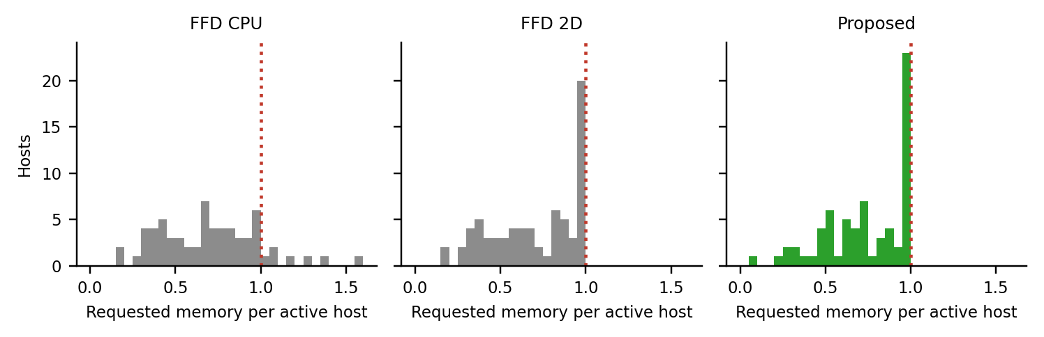
Fig. 7. Requested memory per active host in the first small sample. The dotted line marks the host capacity.
Table 6. Ablation study (mean over five runs). Energy in kWh, SLA in percent.
Variant | Small energy | Small PMs | Small SLA | Medium energy | Medium PMs | Medium SLA
FFD 2D (single seed, no GA) | 379.5 | 73.8 | 6.23 | 630.7 | 122.4 | 7.21
Single seed + GA operators | 379.5 | 73.8 | 6.23 | 630.7 | 122.4 | 7.21
Multi seed selection only (no GA) | 365.5 | 70.4 | 6.68 | 611.0 | 117.6 | 7.20
Multi seed + GA, no consolidation | 365.5 | 70.4 | 6.68 | 611.0 | 117.6 | 7.20
Full proposed GA | 365.5 | 70.4 | 6.68 | 611.0 | 117.6 | 7.20

Table 7. Sensitivity of energy to the shape constant α of the power model (placements computed with α = 3 and evaluated at each α).
Scale | Alpha | FFD CPU (kWh) | FFD 2D (kWh) | Proposed (kWh) | Proposed vs FFD 2D (%)
Small | 2 | 348.3 | 370.1 | 356.5 | −3.7
 | 3 | 356.8 | 379.5 | 365.5 | −3.7
 | 4 | 360.0 | 383.4 | 369.0 | −3.8
Medium | 2 | 579.3 | 614.9 | 595.8 | −3.1
 | 3 | 593.4 | 630.7 | 611.0 | −3.1
 | 4 | 598.6 | 637.1 | 616.9 | −3.2

Table 8. Time to evaluate one fitness value of a placement (microseconds, average of 300 evaluations).
Scale | Standard (µs) | Base paper (µs) | Proposed (µs)
Small | 19.5 | 17.9 | 23.6
Medium | 26.0 | 22.9 | 33.3
Large | 52.7 | 52.2 | 68.5

5.3 Ablation
Table 6 removes one component at a time. Running the GA operators from the single FFD 2D seed returns the FFD 2D placement unchanged, so crossover, mutation and consolidation alone do not improve it. Selecting the best of the four seeds with the multiresource fitness, without any GA, already gives the result of the full proposed method, and adding the GA operators with or without consolidation changes nothing. The whole gain over FFD 2D therefore comes from the seed ranking by F_prop, and the evolutionary part of the algorithm adds no improvement on these samples.
5.4 Sensitivity
Table 7 re evaluates the same placements with α equal to 2, 3 and 4. The saving of the proposed method against FFD 2D stays at about 3.7 percent at the small scale and about 3.1 percent at the medium scale for all three values, so the conclusion does not depend on our assumed shape constant. We also ran the proposed GA with fitness weights w of 0.3, 0.5 and 0.7. The energy, the number of hosts and the SLA violation were identical for all three weights, which shows that the ranking of the four seeds does not change with w on these samples.
5.5 Cost of fitness evaluation
Table 8 measures the time of a single fitness evaluation. The base paper fitness is faster than the standard energy sum by about 9 percent at the small scale and 12 percent at the medium scale, and the difference vanishes at the large scale. The proposed fitness costs more than the base fitness, by about 32 percent at the small scale and 31 percent at the large scale, because it reads memory as well. These differences are small in absolute terms, a few tens of microseconds, and much smaller than the 80 percent reduction of fitness time reported in [1] for their implementation. We attribute this to our vectorised NumPy implementation, in which the exponential in the standard fitness is cheap.
6 Discussion
The central finding is a trade off. Treating memory as a second resource avoids memory overcommitment at reservation time and lowers energy compared with a plain two resource FFD, but it cannot match the energy of CPU only methods, since those methods pack on CPU alone. For a provider that must respect memory, the relevant baseline is FFD 2D, and against it the proposed method saves energy at all three scales. The SLA benefit that one might expect from memory awareness is small here and is clear only at the small scale, partly because measured usage in the trace is well below the requests for most tasks, so overload in measured usage is rare and driven by a minority of tasks whose usage exceeds their request.
Two results deserve a clear statement. First, the ablation shows that the evolutionary operators did not improve on the best seed in any run. The contribution of this work is therefore best described as a multiresource residual fitness used to rank several FFD seeds, and not as an improved genetic search. Second, we could not reproduce the execution time advantage reported in [1]. Our measurements show only a small difference between the standard and the residual fitness, and the proposed fitness is slightly more expensive. We therefore make no claim of acceleration beyond what the base paper reports on its own implementation.
A practical consequence is that a provider can obtain the reported saving with a simple procedure: run a few FFD variants and keep the one with the best residual fitness. A GA becomes useful only if its operators are strengthened so that they find placements the seeds do not contain, which we leave for future work.
7 Threats to Validity
Internal validity: the baselines were implemented by us, and the power model constant α is assumed, although Table 7 shows that the main conclusion is unaffected. The SLA metric is a proxy based on host overload in 5 minute windows and not a full simulator metric. External validity: the study uses one part file of each trace table and only tasks with at least one hour of usage, which biases the sample towards long running work, and results may differ for short tasks or other clusters. Construct validity: placement is static and does not model migrations, boot times or network effects, and the evaluation uses a custom simulator, not CloudSim. Statistical validity: five runs per scale give standard deviations that are large relative to some SLA differences, which is why we do not claim an SLA benefit beyond the small scale.
8 Conclusions
We examined a multiresource version of the accelerated residual fitness for GA based VM placement and evaluated it on Google cluster trace samples with SLA measured from real usage. The proposed method lowers energy by about 3 to 4 percent and uses fewer hosts than a two resource FFD baseline at three scales, a result that holds for different shape constants of the power model, while its SLA behaviour is similar to the baselines within run to run variation. Compared with CPU only methods it consumes more energy and shows an SLA benefit only at the small scale, but it avoids the memory overload that CPU only placements create. The ablation shows that the gain comes from ranking FFD seeds with the multiresource fitness, and that the evolutionary operators added no improvement. Future work should strengthen the operators, for example with swap based moves and repair, extend the study to dynamic placement with migrations, couple placement with autoscaling as suggested by [7], and validate the results on more trace segments and in CloudSim.
Data Availability: The code, processed sample definitions and result files are available at GitHub: [https://github.com/sumyiabutt/vm-placement-genetic-algorithm]. The Google cluster usage traces are publicly available from Google [8].
Funding Statement: [State funding, or that the authors received no specific funding].
Author Contributions: [The first author was responsible for conceptualization, literature review, methodology development, analysis, and manuscript preparation. The second author's contributions should be specified according to their actual involvement in research supervision, methodology review, and manuscript revision].
Conflicts of Interest: [Confirm: The authors declare no conflicts of interest].
Ethics Statement: Not applicable. The study uses public, anonymised trace data.
References
[1] E. Hormozi, S. Hu, Z. Ding, Y. C. Tian, Y. G. Wang, Z. G. Yu and W. Zhang, “Energy efficient virtual machine placement in data centres via an accelerated genetic algorithm with improved fitness computation,” Energy, vol. 252, Art. no. 123884, 2022. doi: 10.1016/j.energy.2022.123884.
[2] A. Alourani, A. Khalid, M. Tahir and M. Sardaraz, “Energy efficient virtual machines placement in cloud datacenters using genetic algorithm and adaptive thresholds,” PLoS ONE, vol. 19, no. 1, Art. no. e0296399, 2024. doi: 10.1371/journal.pone.0296399.
[3] Z. Li, M. Pan and L. Yu, “Multi resource collaborative optimization for adaptive virtual machine placement,” PeerJ Computer Science, vol. 8, Art. no. e852, 2022. doi: 10.7717/peerj-cs.852.
[4] J. Peake, M. Amos, N. Costen, G. Masala and H. Lloyd, “PACO VMP: parallel ant colony optimization for virtual machine placement,” Future Generation Computer Systems, vol. 129, pp. 174–186, 2022. doi: 10.1016/j.future.2021.11.019.
[5] A. Muteeh, M. Sardaraz and M. Tahir, “MrLBA: multi resource load balancing algorithm for cloud computing using ant colony optimization,” Cluster Computing, vol. 24, no. 4, pp. 3135–3145, 2021. doi: 10.1007/s10586-021-03322-3.
[6] N. Malik, M. Sardaraz, M. Tahir, B. Shah, G. Ali and F. Moreira, “Energy efficient load balancing algorithm for workflow scheduling in cloud data centers using queuing and thresholds,” Applied Sciences, vol. 11, no. 13, Art. no. 5849, 2021. doi: 10.3390/app11135849.
[7] I. Pintye, J. Kovács and R. Lovas, “Enhancing machine learning based autoscaling for cloud resource orchestration,” Journal of Grid Computing, vol. 22, Art. no. 68, 2024. doi: 10.1007/s10723-024-09783-1.
[8] C. Reiss, J. Wilkes and J. L. Hellerstein, “Google cluster usage traces: format and schema,” Google Inc., White Paper, 2011.

