(1)
« 博客园首页

CMake入门指南
作者：sinojelly 来源：博客园 发布时间：2010-05-22 03:03 阅读：6454 次 原文链接 [收藏]
CMake是一个比make更高级的编译配置工具，它可以根据不同平台、不同的编译器，生成相应的Makefile或者vcproj项目。
通过编写CMakeLists.txt，可以控制生成的Makefile，从而控制编译过程。CMake自动生成的Makefile不仅可以通过make命令构建项目生成目标文件，还支持安装（make install）、测试安装的程序是否能正确执行（make test，或者ctest）、生成当前平台的安装包（make package）、生成源码包（make package_source）、产生Dashboard显示数据并上传等高级功能，只要在CMakeLists.txt中简单配置，就可以完成很多复杂的功能，包括写测试用例。
如果有嵌套目录，子目录下可以有自己的CMakeLists.txt。
总之，CMake是一个非常强大的编译自动配置工具，支持各种平台，KDE也是用它编译的，感兴趣的可以试用一下。

准备活动：
（1）安装cmake。
下载地址：http://www.cmake.org/cmake/resources/software.html
根据自己的需要下载相应的包即可，Windows下可以下载zip压缩的绿色版本，还可以下载源代码。
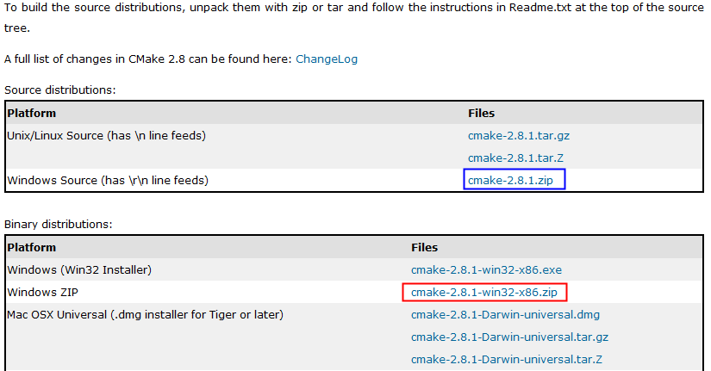
（2）运行cmake的方法。（GUI、命令行）
http://www.cmake.org/cmake/help/runningcmake.html
CMake使用步骤：
运行GUI的cmake界面：
cmake-2.8.1-win32-x86\bin\cmake-gui.exe
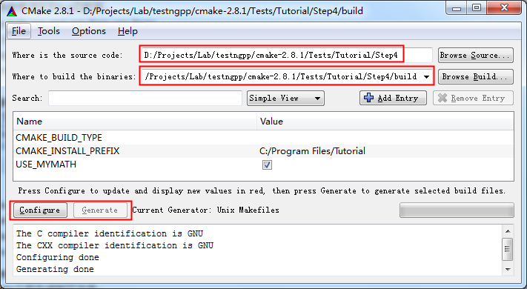
执行Configure：
运行之后，生成了如下文件：
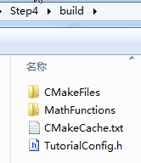
生成Makefile：
执行Generate之后生成如下文件：
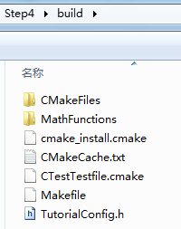
运行make进行编译：
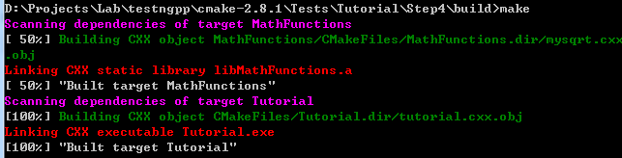
编译完成后，在build目录生成Tutorial.exe，运行Tutorial.exe 25就可以看到运行结果：
运行make install安装程序：
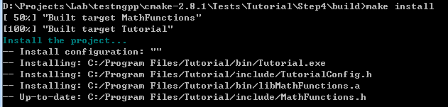
运行make test进行测试：
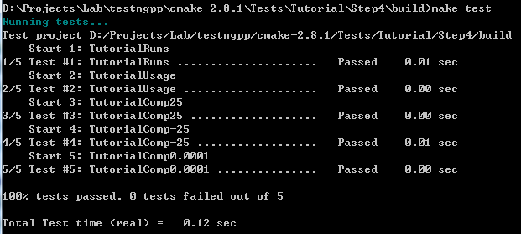

通过cmake tutorial学习CMake配置方法
http://www.cmake.org/cmake/help/cmake_tutorial.html
可以在源代码的Tests/Turorial目录中找到这个手册对应的代码。
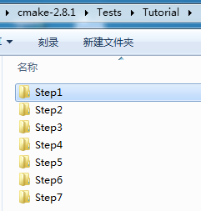
1、Step1。
（如果不知道如何使用cmake，以及如何使用编译产生的Turorial.exe，可先看下前面“CMake使用步骤”的说明，它以Step4为例详细介绍了使用过程，Step1的配置可能不够完全，比如无法运行make install，无法运行make test，但可以参考。）
简单的程序编译。
（1）运行GUI的cmake，指定要编译的源代码路径和二进制文件路径（会自动创建）。
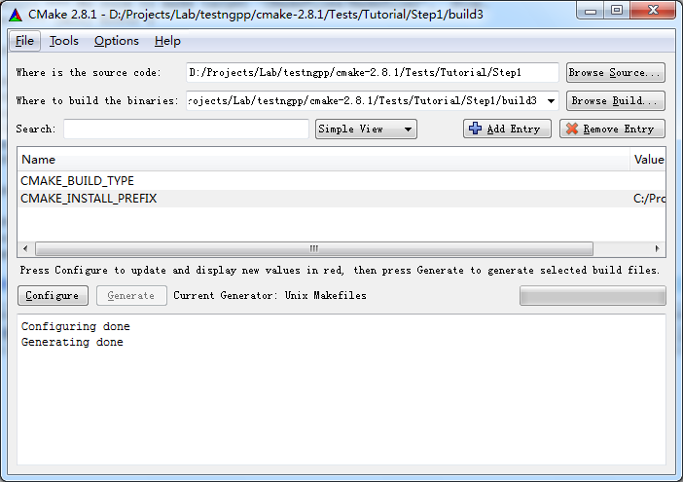
（2）点击Configure，配置成功后，再点击Generate。
配置需要选择合适的编译器，虽然我安装了VC2008，但没有配置成功；选择Unix Makefiles，配置成功，它自动找到了DevC++下的gcc.exe等编译器。
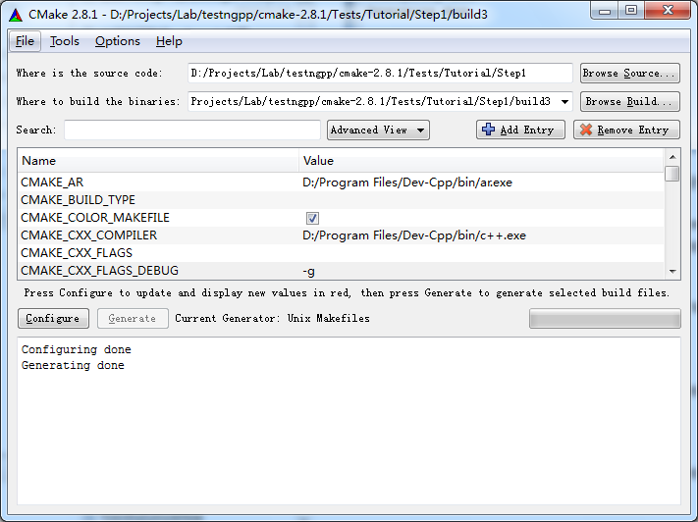
（3）在build3目录执行make，就能够编译生成Turorial.exe了。
D:\Projects\Lab\testngpp\cmake-2.8.1\Tests\Tutorial\Step1\build3>make
Linking CXX executable Tutorial.exe
[100%] Built target Tutorial
可以运行一下Turorial.exe：
D:\Projects\Lab\testngpp\cmake-2.8.1\Tests\Tutorial\Step1\build3>Tutorial.exe
Tutorial.exe Version 1.0
Usage: Tutorial.exe number
D:\Projects\Lab\testngpp\cmake-2.8.1\Tests\Tutorial\Step1\build3>Tutorial.exe 4
The square root of 4 is 2
2、Step2
把子目录编译为库，并且链接到最终的可执行文件。
include_directories ("${PROJECT_SOURCE_DIR}/MathFunctions")
add_subdirectory (MathFunctions) # 使得子目录MathFunctions也能被编译

# add the executable
add_executable (Tutorial tutorial.cxx)
target_link_libraries (Tutorial MathFunctions)
产生makefile：
在GUI上点击Configure，之后Generate还是灰色，再次点击Configure，Generate就可以点击了。
编译：
在build目录运行make，即可开始编译，但是开始会报告sh.exe运行异常，应该是Tools下的UnxUtils的sh.exe与Win7不兼容，发现有如下make文件，估计是它导致的，于是把它重命名，不使用UnxUtils下的make，就OK乐。
D:\Tools\CMD\UnxUtils\usr\local\wbin\make.exe
编译过程：
D:\Projects\Lab\testngpp\cmake-2.8.1\Tests\Tutorial\Step2\build>make
[ 50%] Building CXX object MathFunctions/CMakeFiles/MathFunctions.dir/mysqrt.cxx
.obj
Linking CXX static library libMathFunctions.a
[ 50%] Built target MathFunctions
Linking CXX executable Tutorial.exe
[100%] Built target Tutorial
3、Step3
支持make install把程序安装到系统指定目录，并且运行一些测试检查它是否能够正常工作。
a、安装时使用的基础目录，由CMAKE_INSTALL_PREFIX指定。
b、可以通过一个很简单的用例检查程序是否运行起来，没有出现异常。（TurotialRuns只是一个用例名字）
add_test (TutorialRuns Tutorial 25)
c、macro方式进行多组数据的测试是非常简洁方便的。
#define a macro to simplify adding tests, then use it
macro (do_test arg result)
add_test (TutorialComp${arg} Tutorial ${arg})
set_tests_properties (TutorialComp${arg}
PROPERTIES PASS_REGULAR_EXPRESSION ${result})
endmacro (do_test)

# do a bunch of result based tests
do_test (25 "25 is 5")
do_test (-25 "-25 is 0")
执行make install：
D:\Projects\Lab\testngpp\cmake-2.8.1\Tests\Tutorial\Step3\build>make install
[ 50%] "Built target MathFunctions"
[100%] "Built target Tutorial"
Install the project...
-- Install configuration: ""
-- Installing: C:/Program Files/Tutorial/bin/Tutorial.exe
-- Installing: C:/Program Files/Tutorial/include/TutorialConfig.h
-- Installing: C:/Program Files/Tutorial/bin/libMathFunctions.a
-- Installing: C:/Program Files/Tutorial/include/MathFunctions.h
安装结果：
C:\Program Files\Tutorial>tree /f
C:.
├─bin
│ libMathFunctions.a
│ Tutorial.exe
│
└─include
MathFunctions.h
TutorialConfig.h
执行make test：
D:\Projects\Lab\testngpp\cmake-2.8.1\Tests\Tutorial\Step3\build>make test
Running tests...
Test project D:/Projects/Lab/testngpp/cmake-2.8.1/Tests/Tutorial/Step3/build
Start 1: TutorialRuns
1/5 Test #1: TutorialRuns ..................... Passed 0.01 sec
Start 2: TutorialComp25
2/5 Test #2: TutorialComp25 ................... Passed 0.01 sec
Start 3: TutorialNegative
3/5 Test #3: TutorialNegative ................. Passed 0.01 sec
Start 4: TutorialSmall
4/5 Test #4: TutorialSmall .................... Passed 0.00 sec
Start 5: TutorialUsage
5/5 Test #5: TutorialUsage .................... Passed 0.00 sec

100% tests passed, 0 tests failed out of 5

Total Test time (real) = 0.13 sec
修改一个测试用例，让它不过：
修改顶层CMakeLists.txt，然后重新Configure和Generate，然后make test即可看到结果。
D:\Projects\Lab\testngpp\cmake-2.8.1\Tests\Tutorial\Step3\build>make test
Running tests...
Test project D:/Projects/Lab/testngpp/cmake-2.8.1/Tests/Tutorial/Step3/build
Start 1: TutorialRuns
1/5 Test #1: TutorialRuns ..................... Passed 0.01 sec
Start 2: TutorialComp25
2/5 Test #2: TutorialComp25 ...................***Failed Required regular expre
ssion not found.Regex=[25 is 3
] 0.01 sec
Start 3: TutorialNegative
3/5 Test #3: TutorialNegative ................. Passed 0.01 sec
Start 4: TutorialSmall
4/5 Test #4: TutorialSmall .................... Passed 0.01 sec
Start 5: TutorialUsage
5/5 Test #5: TutorialUsage .................... Passed 0.01 sec

80% tests passed, 1 tests failed out of 5

Total Test time (real) = 0.13 sec

The following tests FAILED:
2 - TutorialComp25 (Failed)
Errors while running CTest
make: *** [test] Error 8
4、Step4
检查系统是否支持log和exp函数。（log和exp都是数学运算函数）
检查方法：
（1）顶层配置中使用CheckFunctionExists.cmake
# does this system provide the log and exp functions?
include (CheckFunctionExists.cmake)
check_function_exists (log HAVE_LOG)
check_function_exists (exp HAVE_EXP)
（2）修改.in文件，定义宏。（修改TutorialConfig.h.in，cmake执行中会把宏定义为合适的值，生成TurorialConfig.h，供编译时使用）
// does the platform provide exp and log functions?
#cmakedefine HAVE_LOG
#cmakedefine HAVE_EXP
（3）在代码中使用宏和log函数等。
// if we have both log and exp then use them
#if defined (HAVE_LOG) && defined (HAVE_EXP)
result = exp(log(x)*0.5);
#else // otherwise use an iterative approach
Step4的完整配置、生成Makefile、编译、运行、安装、测试过程，参见最前面的“CMake使用步骤”。
5、Step5
动态生成源文件，自动把源文件编译进系统中。
make的时候出错了：
D:\Projects\Lab\testngpp\cmake-2.8.1\Tests\Tutorial\Step5\build>make
Scanning dependencies of target MakeTable
[ 25%] Building CXX object MathFunctions/CMakeFiles/MakeTable.dir/MakeTable.cxx.
obj
Linking CXX executable MakeTable.exe
[ 25%] "Built target MakeTable"
[ 50%] Generating Table.h
'.' 不是内部或外部命令，也不是可运行的程序
或批处理文件。
make[2]: *** [MathFunctions/Table.h] Error 1
make[1]: *** [MathFunctions/CMakeFiles/MathFunctions.dir/all] Error 2
make: *** [all] Error 2
问题分析：
首先看build/makefile文件，关于MakeTable有如下规则：
# Build rule for target.
MakeTable: cmake_check_build_system
$(MAKE) -f CMakeFiles/Makefile2 MakeTable
.PHONY : MakeTable
再看Makefile2文件，找到出错时正在编译的目标。
# All Build rule for target.
MathFunctions/CMakeFiles/MakeTable.dir/all:
$(MAKE) -f MathFunctions/CMakeFiles/MakeTable.dir/build.make MathFunctions/CMakeFiles/MakeTable.dir/depend
$(MAKE) -f MathFunctions/CMakeFiles/MakeTable.dir/build.make MathFunctions/CMakeFiles/MakeTable.dir/build
$(CMAKE_COMMAND) -E cmake_progress_report D:/Projects/Lab/testngpp/cmake-2.8.1/Tests/Tutorial/Step5/build/CMakeFiles 1
@echo "Built target MakeTable"
.PHONY : MathFunctions/CMakeFiles/MakeTable.dir/all
Make规则的执行顺序是按照命令的先后顺序：
如果Makefile内容如下：
all:
echo "First line."
echo "Second line."
那么make结果：
D:\Users\Desktop>make
echo "First line."
First line.
echo "Second line."
Second line.
由此，Built target MakeTable输出之后才失败的。
6、Step6
生成各种平台Windows/Ubuntu/etc.上的安装包，包括二进制安装包和源码安装包。
可以把依赖的系统库也打包。include (InstallRequiredSystemLibraries)
使用CPack。
由于Step1-7，后面一步的配置都包含了前面一步的配置，所以从Step5开始，就会遇到make的问题。
为了编译通过，可以修改MathFunctions目录下的CMakeLists.txt和mysqrt.cxx，去掉所有对Table.h 的依赖。
运行make package可以生成安装包：
第一次，因为没有安装nsis，提示如下问题：
D:\Projects\Lab\testngpp\cmake-2.8.1\Tests\Tutorial\Step6\build>make package
[ 50%] "Built target MathFunctions"
[100%] "Built target Tutorial"
Run CPack packaging tool...
CPack Error: Cannot find NSIS registry value. This is usually caused by NSIS not
being installed. Please install NSIS from http://nsis.sourceforge.net
CPack Error: Cannot initialize the generator NSIS
make: *** [package] Error 1
安装NSIS之后，运行成功：
D:\Projects\Lab\testngpp\cmake-2.8.1\Tests\Tutorial\Step6\build>make package
[ 50%] "Built target MathFunctions"
[100%] "Built target Tutorial"
Run CPack packaging tool...
CPack: Create package using NSIS
CPack: Install projects
CPack: - Run preinstall target for: Tutorial
CPack: - Install project: Tutorial
CPack: Compress package
CPack: Finalize package
CPack: Package D:/Projects/Lab/testngpp/cmake-2.8.1/Tests/Tutorial/Step6/build/T
utorial-1.0.1-win32.exe generated.
生成了如下的Windows安装包文件：
安装完成后，还可以很方便的卸载它：
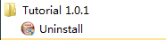
运行make package_source可以产生源代码包。（我的电脑上提示找不到合适的zip程序）
D:\Projects\Lab\testngpp\cmake-2.8.1\Tests\Tutorial\Step6\build>make package_sou
rce
Run CPack packaging tool for source...
CPack Error: Cannot find a suitable ZIP program
CPack Error: Cannot initialize the generator ZIP
make: *** [package_source] Error 1
7、Step7
把结果发布到dashboard。
下面网址是一个公开的dashboard：
http://www.cdash.org/CDash/index.php?project=PublicDashboard
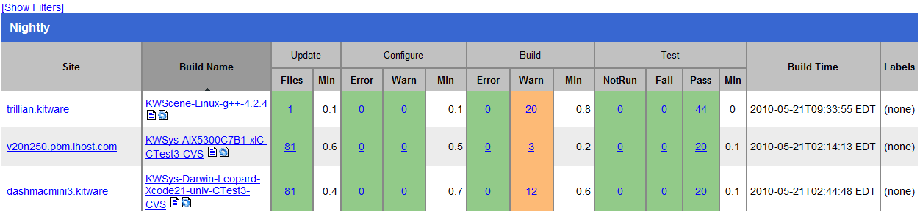
dashboard上显示的项目名称通过如下方式设置：
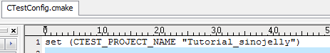
需要先把cmake\bin目录加入path中，然后执行ctest -D Experimental。这里遇到了一个错误。
D:\Projects\Lab\testngpp\cmake-2.8.1\Tests\Tutorial\Step7\build>ctest -D Experim
ental
Site: JELLY-PC2
Build name: Win32-make
Create new tag: 20100521-1833 - Experimental
Configure project
Each . represents 1024 bytes of output
. Size of output: 0K
Build project
Each symbol represents 1024 bytes of output.
'!' represents an error and '*' a warning.
. Size of output: 0K
0 Compiler errors
0 Compiler warnings
Test project D:/Projects/Lab/testngpp/cmake-2.8.1/Tests/Tutorial/Step7/build
Start 1: TutorialRuns
1/9 Test #1: TutorialRuns ..................... Passed 0.01 sec
Start 2: TutorialUsage
2/9 Test #2: TutorialUsage .................... Passed 0.01 sec
Start 3: TutorialComp4
3/9 Test #3: TutorialComp4 .................... Passed 0.01 sec
Start 4: TutorialComp9
4/9 Test #4: TutorialComp9 .................... Passed 0.01 sec
Start 5: TutorialComp5
5/9 Test #5: TutorialComp5 .................... Passed 0.01 sec
Start 6: TutorialComp7
6/9 Test #6: TutorialComp7 .................... Passed 0.01 sec
Start 7: TutorialComp25
7/9 Test #7: TutorialComp25 ................... Passed 0.01 sec
Start 8: TutorialComp-25
8/9 Test #8: TutorialComp-25 .................. Passed 0.01 sec
Start 9: TutorialComp0.0001
9/9 Test #9: TutorialComp0.0001 ............... Passed 0.01 sec

100% tests passed, 0 tests failed out of 9

Total Test time (real) = 0.19 sec
Performing coverage
Cannot find any coverage files. Ignoring Coverage request.
Submit files (using http)
Using HTTP submit method
Drop site:http://
Error when uploading file: D:/Projects/Lab/testngpp/cmake-2.8.1/Tests/Tutoria
l/Step7/build/Testing/20100521-1833/Build.xml
Error message was: couldn't connect to host
Problems when submitting via HTTP
Errors while running CTest
产生了如下一些文件：
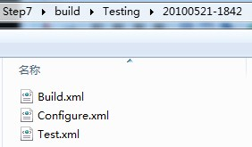

(2)
CMake Tutorial

Below is a step-by-step tutorial covering common build system issues that CMake helps to address. Many of these topics have been introduced in Mastering CMake as separate issues but seeing how they all work together in an example project can be very helpful. This tutorial can be found in the Tests/Tutorial directory of the CMake source code tree. Each step has its own subdirectory containing a complete copy of the tutorial for that step.
A Basic Starting Point (Step 1)
The most basic project is an executable built from source code files. For simple projects a two line CMakeLists file is all that is required. This will be the starting point for our tutorial. The CMakeLists file looks like:
cmake_minimum_required (VERSION 2.6)
project (Tutorial)
add_executable(Tutorial tutorial.cxx)
Note that this example uses lower case commands in the CMakeLists file. Upper, lower, and mixed case commands are supported by CMake. The source code for tutorial.cxx will compute the square root of a number and the first version of it is very simple, as follows:
// A simple program that computes the square root of a number
#include <stdio.h>
#include <math.h>
int main (int argc, char *argv[])
{
if (argc < 2)
{
fprintf(stdout,"Usage: %s number\n",argv[0]);
return 1;
}
double inputValue = atof(argv[1]);
double outputValue = sqrt(inputValue);
fprintf(stdout,"The square root of %g is %g\n",
inputValue, outputValue);
return 0;
}

Adding a Version Number and Configured Header File
The first feature we will add is to provide our executable and project with a version number. While you can do this exclusively in the source code, doing it in the CMakeLists file provides more flexibility. To add a version number we modify the CMakeLists file as follows:
cmake_minimum_required (VERSION 2.6)
project (Tutorial)
# The version number.
set (Tutorial_VERSION_MAJOR 1)
set (Tutorial_VERSION_MINOR 0)

# configure a header file to pass some of the CMake settings
# to the source code
configure_file (
"${PROJECT_SOURCE_DIR}/TutorialConfig.h.in"
"${PROJECT_BINARY_DIR}/TutorialConfig.h"
)

# add the binary tree to the search path for include files
# so that we will find TutorialConfig.h
include_directories("${PROJECT_BINARY_DIR}")

# add the executable
add_executable(Tutorial tutorial.cxx)
Since the configured file will be written into the binary tree we must add that directory to the list of paths to search for include files. We then create a TutorialConfig.h.in file in the source tree with the following contents:
// the configured options and settings for Tutorial
#define Tutorial_VERSION_MAJOR @Tutorial_VERSION_MAJOR@
#define Tutorial_VERSION_MINOR @Tutorial_VERSION_MINOR@
When CMake configures this header file the values for @Tutorial_VERSION_MAJOR@ and @Tutorial_VERSION_MINOR@ will be replaced by the values from the CMakeLists file. Next we modify tutorial.cxx to include the configured header file and to make use of the version numbers. The resulting source code is listed below.
// A simple program that computes the square root of a number
#include <stdio.h>
#include <math.h>
#include "TutorialConfig.h"

int main (int argc, char *argv[])
{
if (argc < 2)
{
fprintf(stdout,"%s Version %d.%d\n",
argv[0],
Tutorial_VERSION_MAJOR,
Tutorial_VERSION_MINOR);
fprintf(stdout,"Usage: %s number\n",argv[0]);
return 1;
}
double inputValue = atof(argv[1]);
double outputValue = sqrt(inputValue);
fprintf(stdout,"The square root of %g is %g\n",
inputValue, outputValue);
return 0;
}
The main changes are the inclusion of the TutorialConfig.h header file and printing out a version number as part of the usage message.
Adding a Library (Step 2)
Now we will add a library to our project. This library will contain our own implementation for computing the square root of a number. The executable can then use this library instead of the standard square root function provided by the compiler. For this tutorial we will put the library into a subdirectory called MathFunctions. It will have the following one line CMakeLists file:
add_library(MathFunctions mysqrt.cxx)
The source file mysqrt.cxx has one function called mysqrt that provides similar functionality to the compiler’s sqrt function. To make use of the new library we add an add_subdirectory call in the top level CMakeLists file so that the library will get built. We also add another include directory so that the MathFunctions/mysqrt.h header file can be found for the function prototype. The last change is to add the new library to the executable. The last few lines of the top level CMakeLists file now look like:
include_directories ("${PROJECT_SOURCE_DIR}/MathFunctions")
add_subdirectory (MathFunctions)

# add the executable
add_executable (Tutorial tutorial.cxx)
target_link_libraries (Tutorial MathFunctions)
Now let us consider making the MathFunctions library optional. In this tutorial there really isn’t any reason to do so, but with larger libraries or libraries that rely on third party code you might want to. The first step is to add an option to the top level CMakeLists file.
# should we use our own math functions?
option (USE_MYMATH
"Use tutorial provided math implementation" ON)
This will show up in the CMake GUI with a default value of ON that the user can change as desired. This setting will be stored in the cache so that the user does not need to keep setting it each time they run CMake on this project. The next change is to make the build and linking of the MathFunctions library conditional. To do this we change the end of the top level CMakeLists file to look like the following:
# add the MathFunctions library?
#
if (USE_MYMATH)
include_directories ("${PROJECT_SOURCE_DIR}/MathFunctions")
add_subdirectory (MathFunctions)
set (EXTRA_LIBS ${EXTRA_LIBS} MathFunctions)
endif (USE_MYMATH)

# add the executable
add_executable (Tutorial tutorial.cxx)
target_link_libraries (Tutorial ${EXTRA_LIBS})
This uses the setting of USE_MYMATH to determine if the MathFunctions should be compiled and used. Note the use of a variable (EXTRA_LIBS in this case) to collect up any optional libraries to later be linked into the executable. This is a common approach used to keep larger projects with many optional components clean. The corresponding changes to the source code are fairly straight forward and leave us with:
// A simple program that computes the square root of a number
#include <stdio.h>
#include <math.h>
#include "TutorialConfig.h"
#ifdef USE_MYMATH
#include "MathFunctions.h"
#endif

int main (int argc, char *argv[])
{
if (argc < 2)
{
fprintf(stdout,"%s Version %d.%d\n", argv[0],
Tutorial_VERSION_MAJOR,
Tutorial_VERSION_MINOR);
fprintf(stdout,"Usage: %s number\n",argv[0]);
return 1;
}

double inputValue = atof(argv[1]);

#ifdef USE_MYMATH
double outputValue = mysqrt(inputValue);
#else
double outputValue = sqrt(inputValue);
#endif

fprintf(stdout,"The square root of %g is %g\n",
inputValue, outputValue);
return 0;
}
In the source code we make use of USE_MYMATH as well. This is provided from CMake to the source code through the TutorialConfig.h.in configured file by adding the following line to it:
#cmakedefine USE_MYMATH

Installing and Testing (Step 3)
For the next step we will add install rules and testing support to our project. The install rules are fairly straight forward. For the MathFunctions library we setup the library and the header file to be installed by adding the following two lines to MathFunctions’ CMakeLists file:
install (TARGETS MathFunctions DESTINATION bin)
install (FILES MathFunctions.h DESTINATION include)
For the application the following lines are added to the top level CMakeLists file to install the executable and the configured header file:
# add the install targets
install (TARGETS Tutorial DESTINATION bin)
install (FILES "${PROJECT_BINARY_DIR}/TutorialConfig.h"
DESTINATION include)
That is all there is to it. At this point you should be able to build the tutorial, then type make install (or build the INSTALL target from an IDE) and it will install the appropriate header files, libraries, and executables. The CMake variable CMAKE_INSTALL_PREFIX is used to determine the root of where the files will be installed. Adding testing is also a fairly straight forward process. At the end of the top level CMakeLists file we can add a number of basic tests to verify that the application is working correctly.
# does the application run
add_test (TutorialRuns Tutorial 25)

# does it sqrt of 25
add_test (TutorialComp25 Tutorial 25)

set_tests_properties (TutorialComp25
PROPERTIES PASS_REGULAR_EXPRESSION "25 is 5")

# does it handle negative numbers
add_test (TutorialNegative Tutorial -25)
set_tests_properties (TutorialNegative
PROPERTIES PASS_REGULAR_EXPRESSION "-25 is 0")

# does it handle small numbers
add_test (TutorialSmall Tutorial 0.0001)
set_tests_properties (TutorialSmall
PROPERTIES PASS_REGULAR_EXPRESSION "0.0001 is 0.01")

# does the usage message work?
add_test (TutorialUsage Tutorial)
set_tests_properties (TutorialUsage
PROPERTIES
PASS_REGULAR_EXPRESSION "Usage:.*number")
The first test simply verifies that the application runs, does not segfault or otherwise crash, and has a zero return value. This is the basic form of a CTest test. The next few tests all make use of the PASS_REGULAR_EXPRESSION test property to verify that the output of the test contains certain strings. In this case verifying that the computed square root is what it should be and that the usage message is printed when an incorrect number of arguments are provided. If you wanted to add a lot of tests to test different input values you might consider creating a macro like the following:
#define a macro to simplify adding tests, then use it
macro (do_test arg result)
add_test (TutorialComp${arg} Tutorial ${arg})
set_tests_properties (TutorialComp${arg}
PROPERTIES PASS_REGULAR_EXPRESSION ${result})
endmacro (do_test)

# do a bunch of result based tests
do_test (25 "25 is 5")
do_test (-25 "-25 is 0")
For each invocation of do_test, another test is added to the project with a name, input, and results based on the passed arguments.
Adding System Introspection (Step 4)
Next let us consider adding some code to our project that depends on features the target platform may not have. For this example we will add some code that depends on whether or not the target platform has the log and exp functions. Of course almost every platform has these functions but for this tutorial assume that they are less common. If the platform has log then we will use that to compute the square root in the mysqrt function. We first test for the availability of these functions using the CheckFunctionExists.cmake macro in the top level CMakeLists file as follows:
# does this system provide the log and exp functions?
include (CheckFunctionExists.cmake)
check_function_exists (log HAVE_LOG)
check_function_exists (exp HAVE_EXP)
Next we modify the TutorialConfig.h.in to define those values if CMake found them on the platform as follows:
// does the platform provide exp and log functions?
#cmakedefine HAVE_LOG
#cmakedefine HAVE_EXP
It is important that the tests for log and exp are done before the configure_file command for TutorialConfig.h. The configure_file command immediately configures the file using the current settings in CMake. Finally in the mysqrt function we can provide an alternate implementation based on log and exp if they are available on the system using the following code:
// if we have both log and exp then use them
#if defined (HAVE_LOG) && defined (HAVE_EXP)
result = exp(log(x)*0.5);
#else // otherwise use an iterative approach
. . .

Adding a Generated File and Generator (Step 5)
In this section we will show how you can add a generated source file into the build process of an application. For this example we will create a table of precomputed square roots as part of the build process, and then compile that table into our application. To accomplish this we first need a program that will generate the table. In the MathFunctions subdirectory a new source file named MakeTable.cxx will do just that.
// A simple program that builds a sqrt table
#include <stdio.h>
#include <math.h>

int main (int argc, char *argv[])
{
int i;
double result;

// make sure we have enough arguments
if (argc < 2)
{
return 1;
}

// open the output file
FILE *fout = fopen(argv[1],"w");
if (!fout)
{
return 1;
}

// create a source file with a table of square roots
fprintf(fout,"double sqrtTable[] = {\n");
for (i = 0; i < 10; ++i)
{
result = sqrt(static_cast<double>(i));
fprintf(fout,"%g,\n",result);
}

// close the table with a zero
fprintf(fout,"0};\n");
fclose(fout);
return 0;
}
Note that the table is produced as valid C++ code and that the name of the file to write the output to is passed in as an argument. The next step is to add the appropriate commands to MathFunctions’ CMakeLists file to build the MakeTable executable, and then run it as part of the build process. A few commands are needed to accomplish this, as shown below.
# first we add the executable that generates the table
add_executable(MakeTable MakeTable.cxx)

# add the command to generate the source code
add_custom_command (
OUTPUT ${CMAKE_CURRENT_BINARY_DIR}/Table.h
COMMAND MakeTable ${CMAKE_CURRENT_BINARY_DIR}/Table.h
DEPENDS MakeTable
)

# add the binary tree directory to the search path for
# include files
include_directories( ${CMAKE_CURRENT_BINARY_DIR} )

# add the main library
add_library(MathFunctions mysqrt.cxx ${CMAKE_CURRENT_BINARY_DIR}/Table.h )
First the executable for MakeTable is added as any other executable would be added. Then we add a custom command that specifies how to produce Table.h by running MakeTable. Next we have to let CMake know that mysqrt.cxx depends on the generated file Table.h. This is done by adding the generated Table.h to the list of sources for the library MathFunctions. We also have to add the current binary directory to the list of include directories so that Table.h can be found and included by mysqrt.cxx.
When this project is built it will first build the MakeTable executable. It will then run MakeTable to produce Table.h. Finally, it will compile mysqrt.cxx which includes Table.h to produce the MathFunctions library.
At this point the top level CMakeLists file with all the features we have added looks like the following:
cmake_minimum_required (VERSION 2.6)
project (Tutorial)

# The version number.
set (Tutorial_VERSION_MAJOR 1)
set (Tutorial_VERSION_MINOR 0)

# does this system provide the log and exp functions?
include (${CMAKE_ROOT}/Modules/CheckFunctionExists.cmake)

check_function_exists (log HAVE_LOG)
check_function_exists (exp HAVE_EXP)

# should we use our own math functions
option(USE_MYMATH
"Use tutorial provided math implementation" ON)

# configure a header file to pass some of the CMake settings
# to the source code
configure_file (
"${PROJECT_SOURCE_DIR}/TutorialConfig.h.in"
"${PROJECT_BINARY_DIR}/TutorialConfig.h"
)

# add the binary tree to the search path for include files
# so that we will find TutorialConfig.h
include_directories ("${PROJECT_BINARY_DIR}")

# add the MathFunctions library?
if (USE_MYMATH)
include_directories ("${PROJECT_SOURCE_DIR}/MathFunctions")
add_subdirectory (MathFunctions)
set (EXTRA_LIBS ${EXTRA_LIBS} MathFunctions)
endif (USE_MYMATH)

# add the executable
add_executable (Tutorial tutorial.cxx)
target_link_libraries (Tutorial ${EXTRA_LIBS})

# add the install targets
install (TARGETS Tutorial DESTINATION bin)
install (FILES "${PROJECT_BINARY_DIR}/TutorialConfig.h"
DESTINATION include)

# does the application run
add_test (TutorialRuns Tutorial 25)

# does the usage message work?
add_test (TutorialUsage Tutorial)
set_tests_properties (TutorialUsage
PROPERTIES
PASS_REGULAR_EXPRESSION "Usage:.*number"
)

#define a macro to simplify adding tests
macro (do_test arg result)
add_test (TutorialComp${arg} Tutorial ${arg})
set_tests_properties (TutorialComp${arg}
PROPERTIES PASS_REGULAR_EXPRESSION ${result}
)
endmacro (do_test)

# do a bunch of result based tests
do_test (4 "4 is 2")
do_test (9 "9 is 3")
do_test (5 "5 is 2.236")
do_test (7 "7 is 2.645")
do_test (25 "25 is 5")
do_test (-25 "-25 is 0")
do_test (0.0001 "0.0001 is 0.01")
TutorialConfig.h looks like:
// the configured options and settings for Tutorial
#define Tutorial_VERSION_MAJOR @Tutorial_VERSION_MAJOR@
#define Tutorial_VERSION_MINOR @Tutorial_VERSION_MINOR@
#cmakedefine USE_MYMATH

// does the platform provide exp and log functions?
#cmakedefine HAVE_LOG
#cmakedefine HAVE_EXP
And the CMakeLists file for MathFunctions looks like:
# first we add the executable that generates the table
add_executable(MakeTable MakeTable.cxx)
# add the command to generate the source code
add_custom_command (
OUTPUT ${CMAKE_CURRENT_BINARY_DIR}/Table.h
DEPENDS MakeTable
COMMAND MakeTable ${CMAKE_CURRENT_BINARY_DIR}/Table.h
)
# add the binary tree directory to the search path
# for include files
include_directories( ${CMAKE_CURRENT_BINARY_DIR} )

# add the main library
add_library(MathFunctions mysqrt.cxx ${CMAKE_CURRENT_BINARY_DIR}/Table.h)

install (TARGETS MathFunctions DESTINATION bin)
install (FILES MathFunctions.h DESTINATION include)

Building an Installer (Step 6)
Next suppose that we want to distribute our project to other people so that they can use it. We want to provide both binary and source distributions on a variety of platforms. This is a little different from the instal we did previously in section Installing and Testing (Step 3), where we were installing the binaries that we had built from the source code. In this example we will be building installation packages that support binary installations and package management features as found in cygwin, debian, RPMs etc. To accomplish this we will use CPack to create platform specific installers as described in Chapter Packaging with CPack. Specifically we need to add a few lines to the bottom of our toplevel CMakeLists.txt file.
# build a CPack driven installer package
include (InstallRequiredSystemLibraries)
set (CPACK_RESOURCE_FILE_LICENSE
"${CMAKE_CURRENT_SOURCE_DIR}/License.txt")
set (CPACK_PACKAGE_VERSION_MAJOR "${Tutorial_VERSION_MAJOR}")
set (CPACK_PACKAGE_VERSION_MINOR "${Tutorial_VERSION_MINOR}")
include (CPack)
That is all there is to it. We start by including InstallRequiredSystemLibraries. This module will include any runtime libraries that are needed by the project for the current platform. Next we set some CPack variables to where we have stored the license and version information for this project. The version information makes use of the variables we set earlier in this tutorial. Finally we include the CPack module which will use these variables and some other properties of the system you are on to setup an installer.
The next step is to build the project in the usual manner and then run CPack on it. To build a binary distribution you would run:
cpack -C CPackConfig.cmake
To create a source distribution you would type
cpack -C CPackSourceConfig.cmake

Adding Support for a Dashboard (Step 7)
Adding support for submitting our test results to a dashboard is very easy. We already defined a number of tests for our project in the earlier steps of this tutorial. We just have to run those tests and submit them to a dashboard. To include support for dashboards we include the CTest module in our toplevel CMakeLists file.
# enable dashboard scripting
include (CTest)
We also create a CTestConfig.cmake file where we can specify the name of this project for the dashboard.
set (CTEST_PROJECT_NAME "Tutorial")
CTest will read in this file when it runs. To create a simple dashboard you can run CMake on your project, change directory to the binary tree, and then run ctest –D Experimental. The results of your dashboard will be uploaded to Kitware's public dashboard here.

