Huangqingbo (Paul) Sun, huangqis

My project is focusing on the evolutionary trees. Especially, I am interested in the differences between evolutionary trees fitted by different methods.

To study such differences, I firstly constructed trees with maximum likelihood, neighbor-joining, minimum-evolution, UPGMA and maximum parsimony methods with HIV/SIV viruses’ genome. There are only some minor differences between those trees due to the distinct patterns in their genome and relatively short lengths of the genome.

Then, I moved to construct the evolutionary trees with bacteria genome. Especially, I selected 17 bacteria and constructed trees with their 5S, 16S and 23S rRNA.

Here, I show the results of 3 trees (constructed using 5S, 16S and 23S rRNA) by UPGMA method. We might see that the tree structures of 16S and 23S rRNA are more similar to each other comparing to the structure of 5S rRNA, which may give us insight on studying genetic conservativeness of different genes across different species. On the other side, we can also study the variation of tree structures fitted by different methods (due to the page limitation, I didn’t put on the results here).

I am now trying to simulate some data (ground-truth) and see the performances of different tree constructing methods.

(Also, I am very glad to hear some suggestions of future directions if possible. Thanks!)

5S: 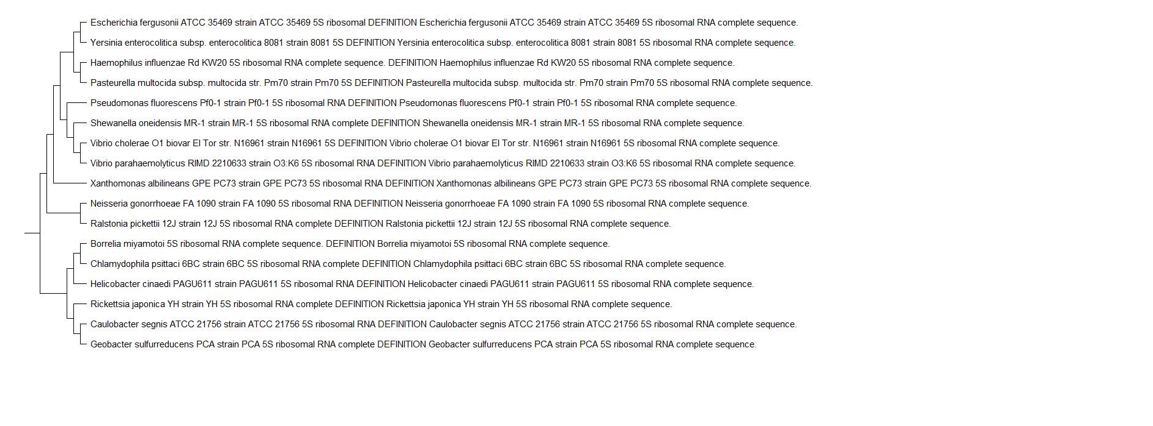

16S:

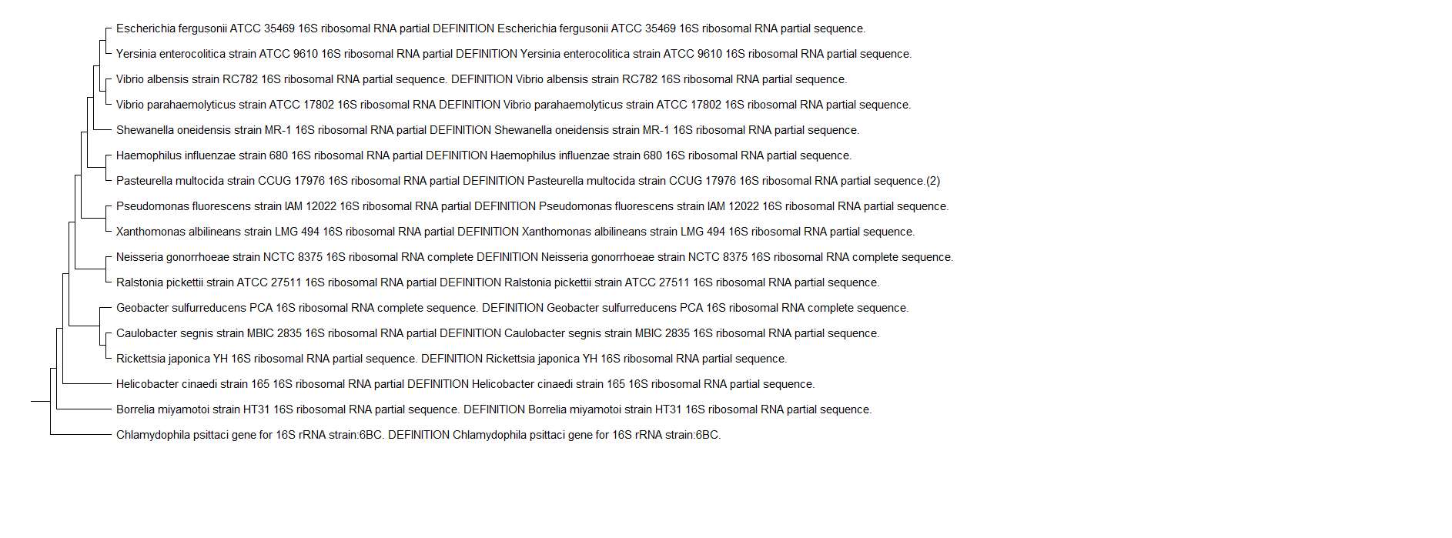

23S:

