CH4_PRODUCTROUTES_PART1

in server.js add app.use (“products “)
now in routes folder create new file product.route.js
now create product model(schema )
updated server.js

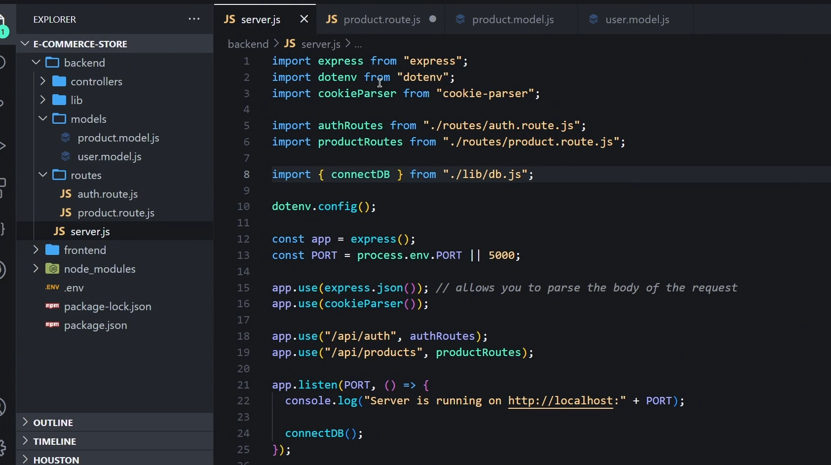
product.route.js

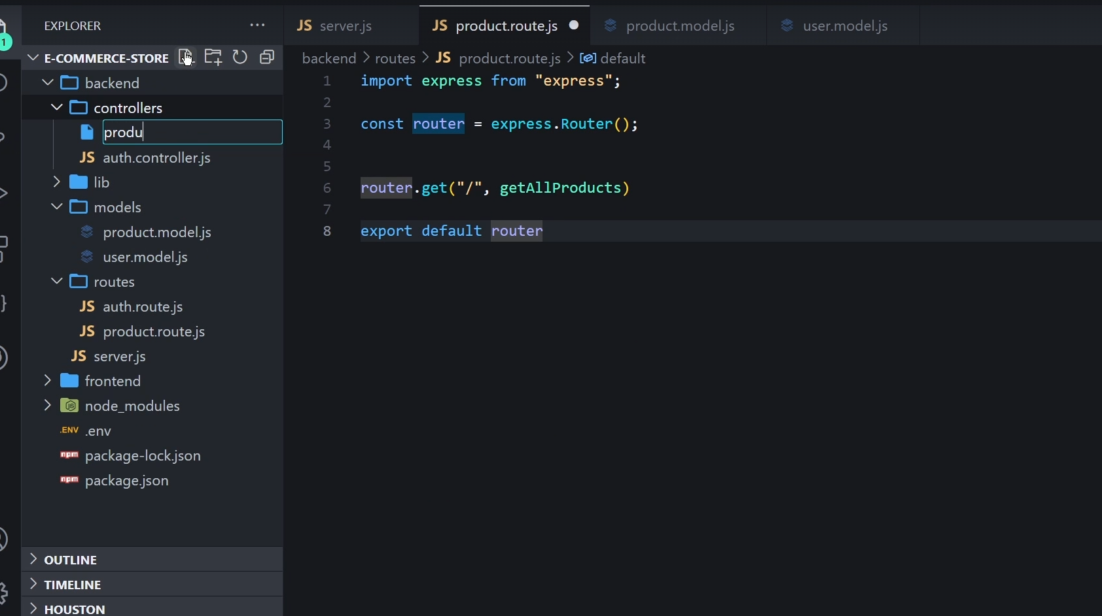
product mongoose schema

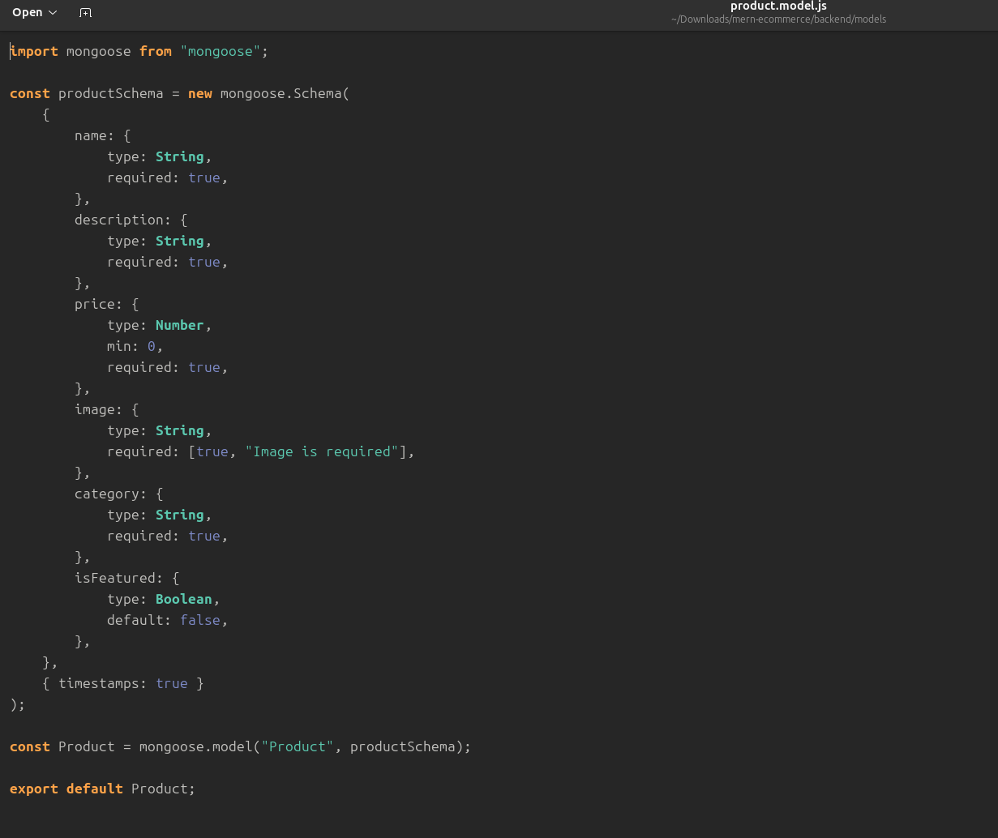
lets write the controller now

but in routes u need to add middle ware before

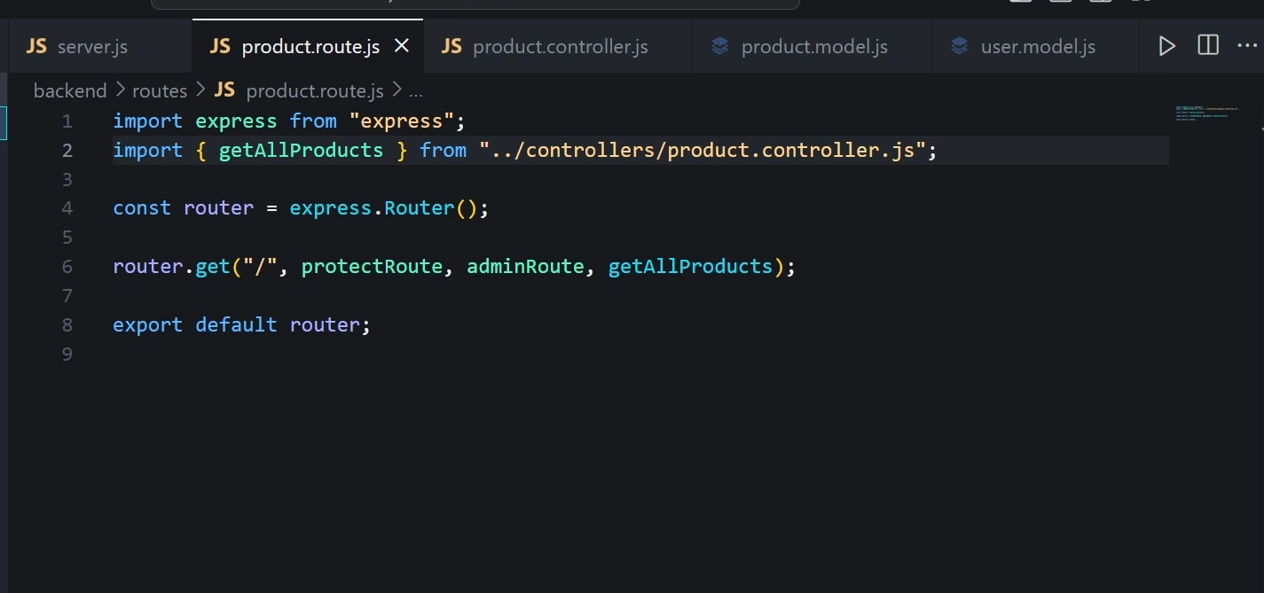
create a middle ware folder then create auth.middleware.js

purpose of middle ware is to make sure if the user enters the url of admin he doesn’t get it without authentication.

Heres the middle ware

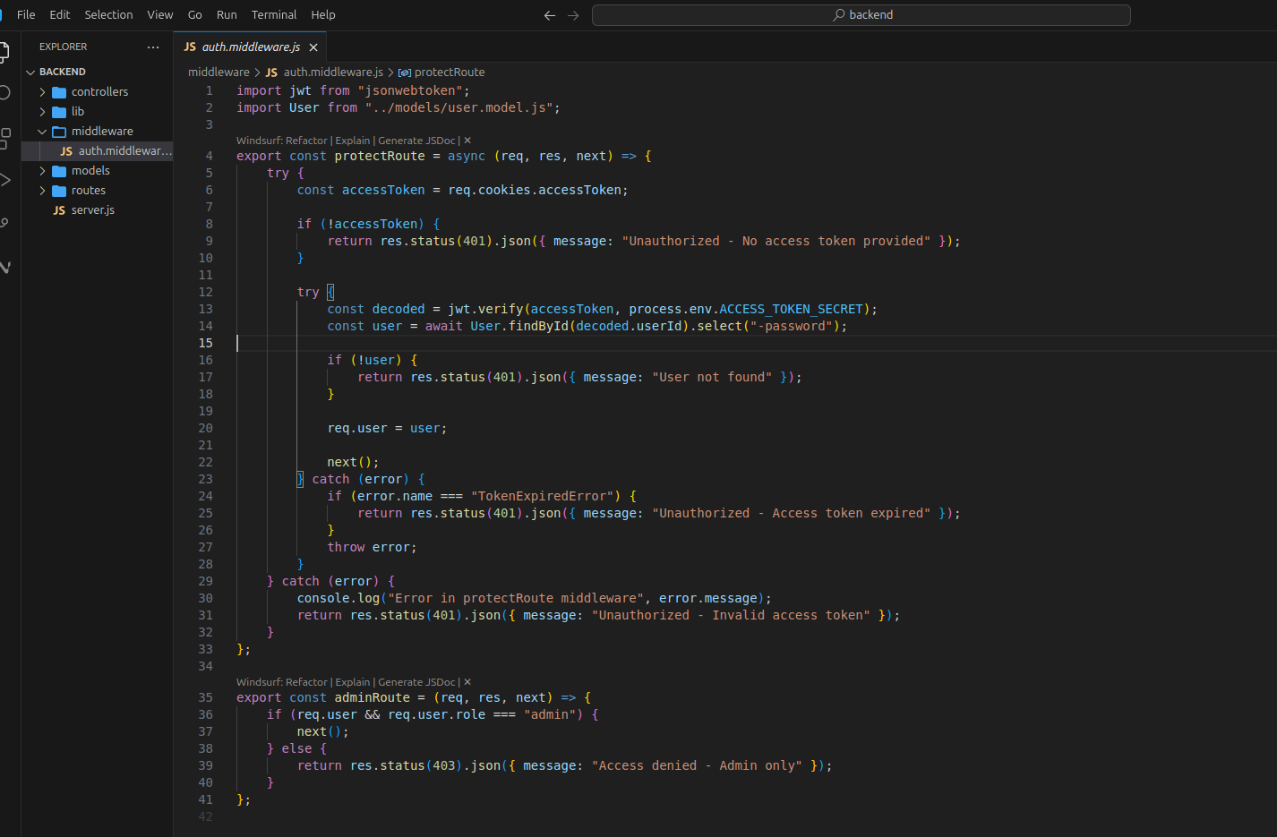

now test the application with postman
1)run the application
2)logout to get rid of cookies
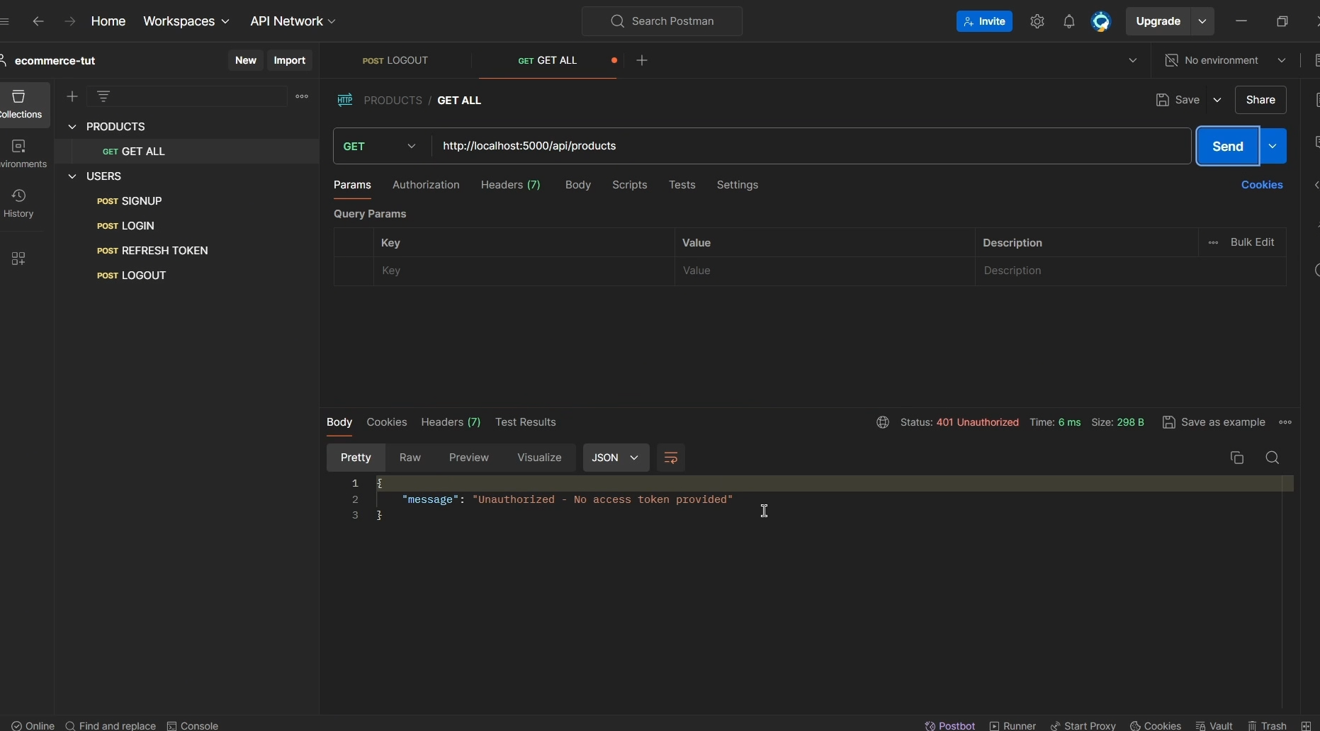

now lets login

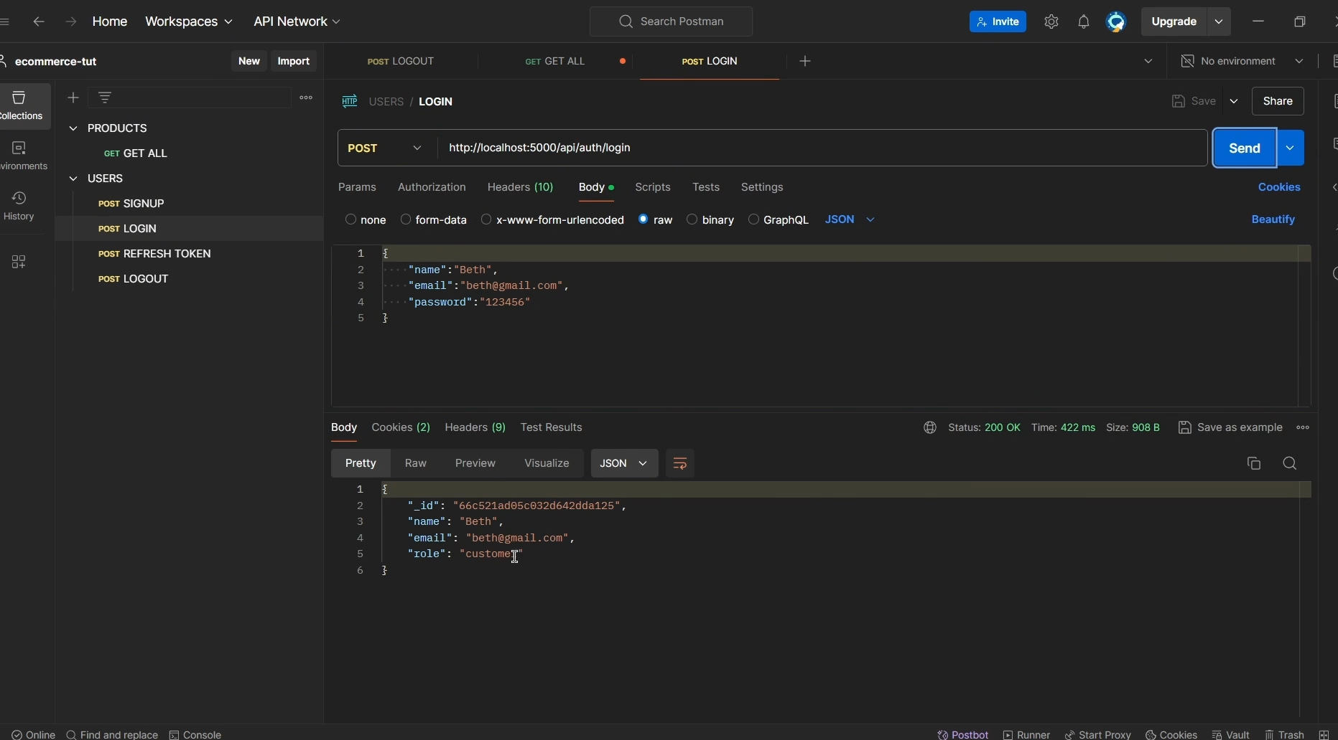
now is it admin ?

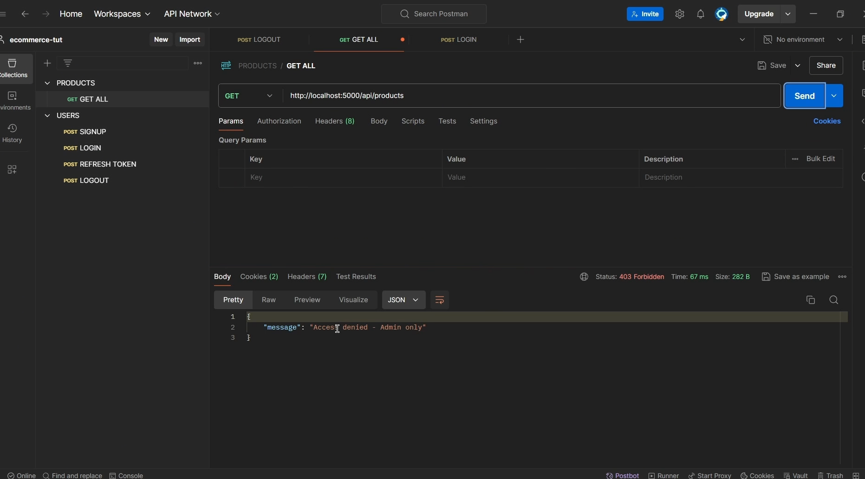
Now we got to know na then go and write all the routes of the products that to be called

write products

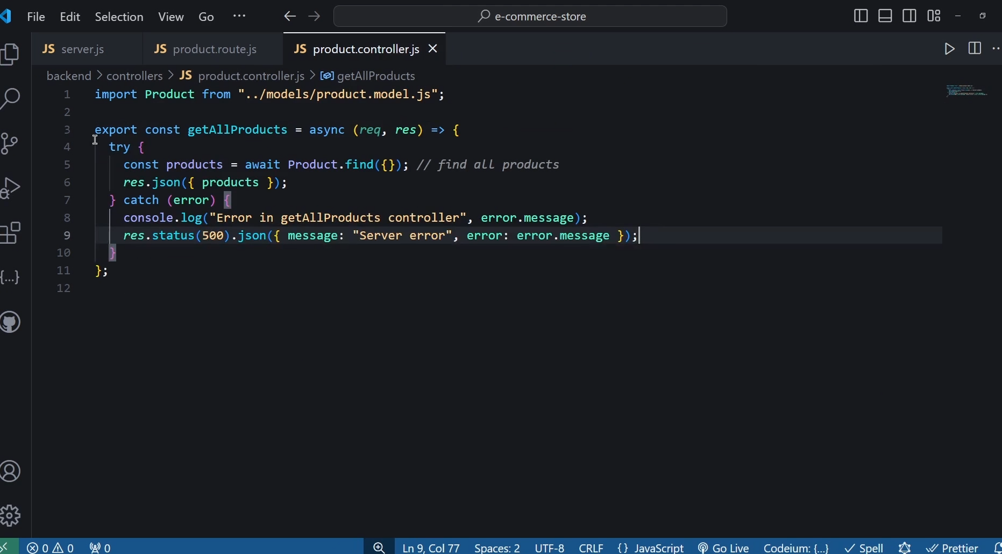
now we store the images in the redis to make this faster and if not in mongo db then we need to find images in mongodb

generally mongodb return mongdb objects but returning javascript objects makes it lot more faster

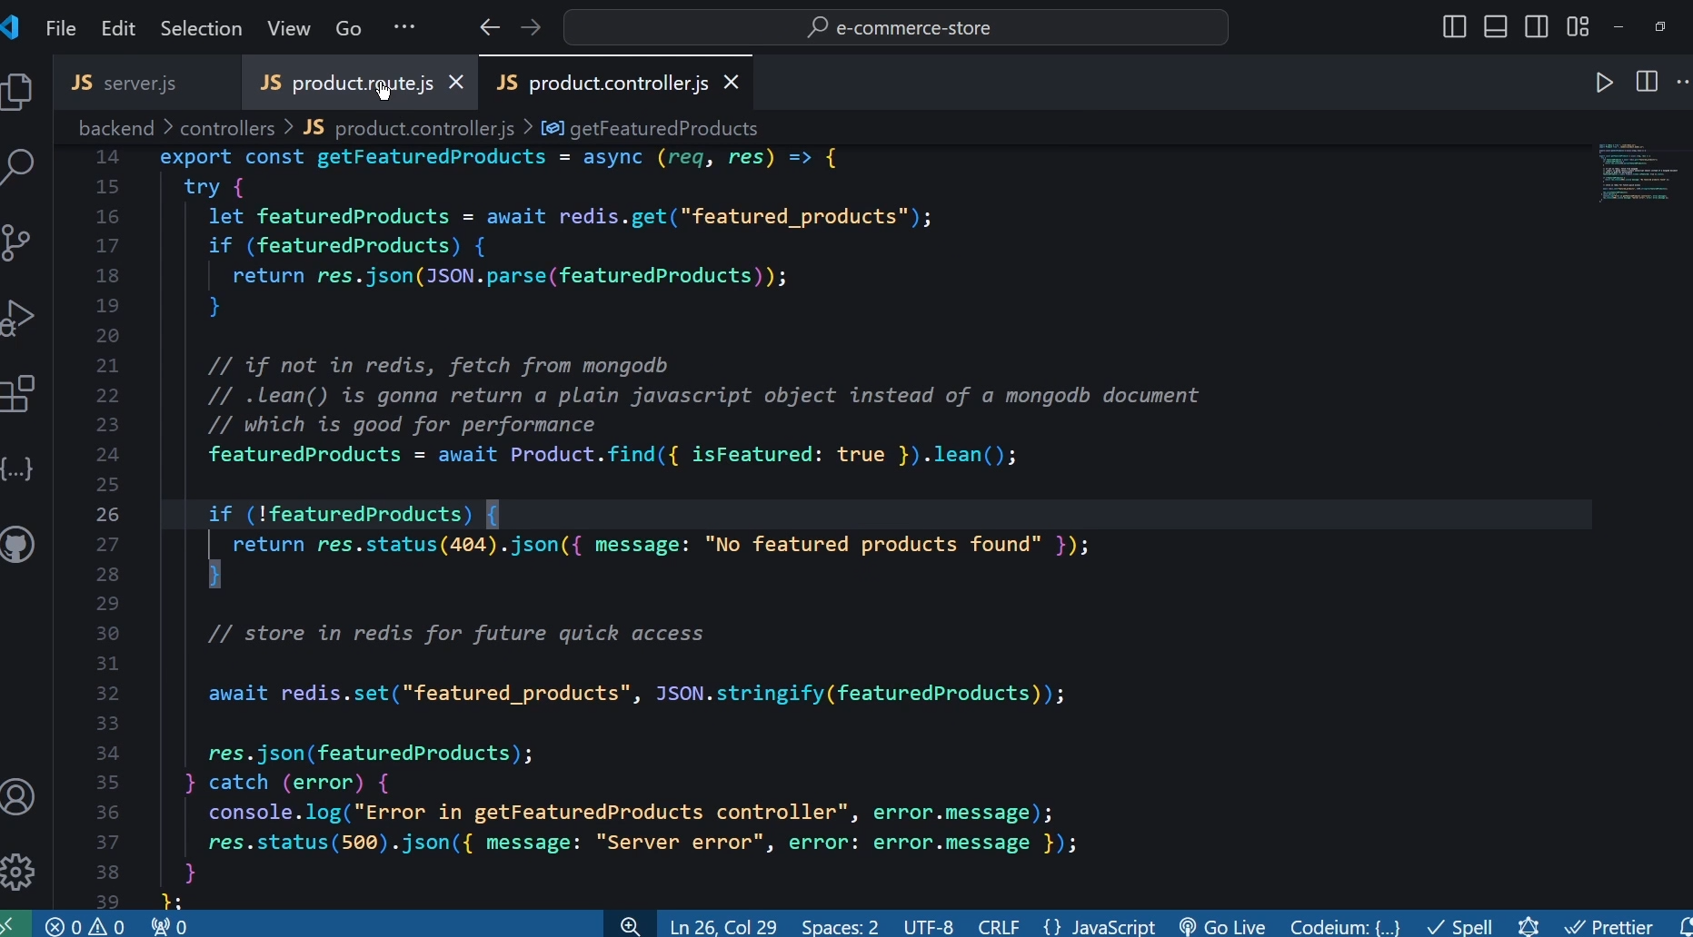
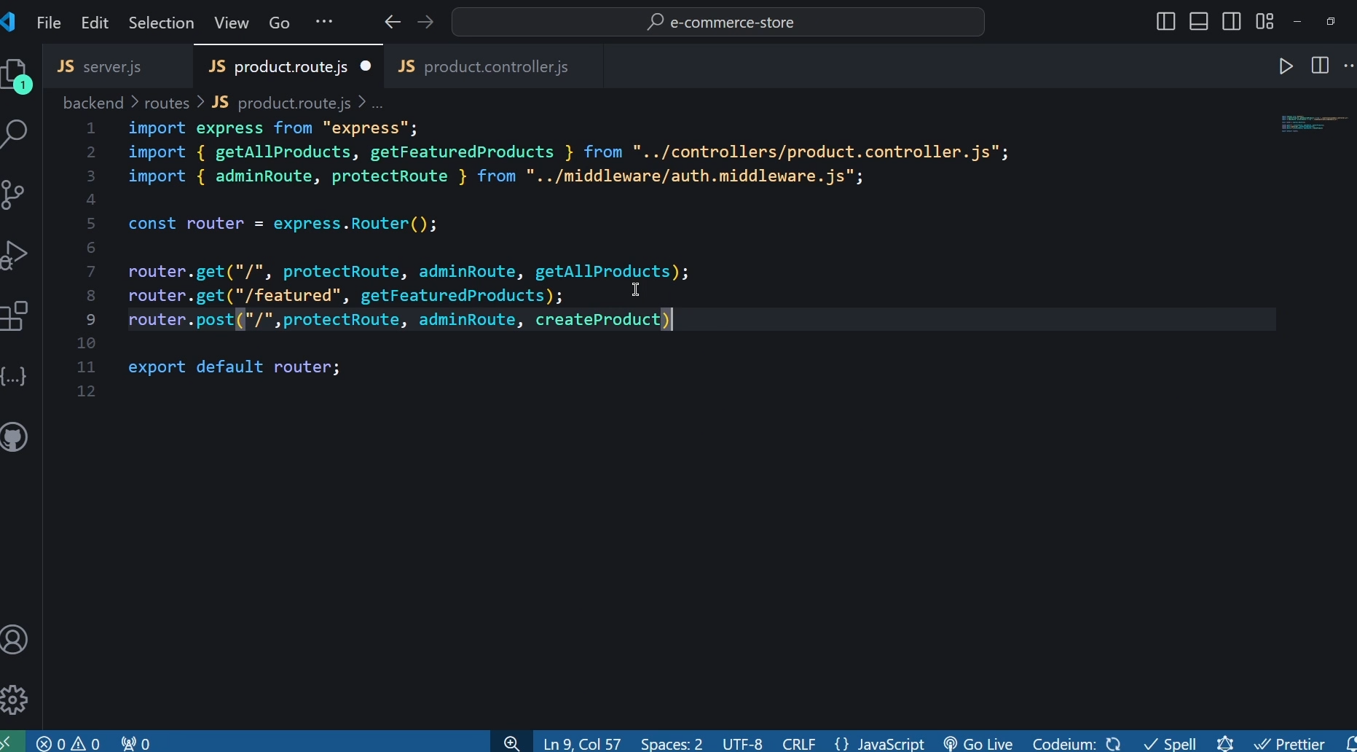
in the next chapter we will be doing coudinary an image uplodaing platform to diaply our images :

