Testing with Postman and logic for apis

CREATE new workspace e-commerce
add a new collection name it conveneitnly
add request in collection choose method post get patch and put

in the server.js add …...app.use(express.json) to parse the data

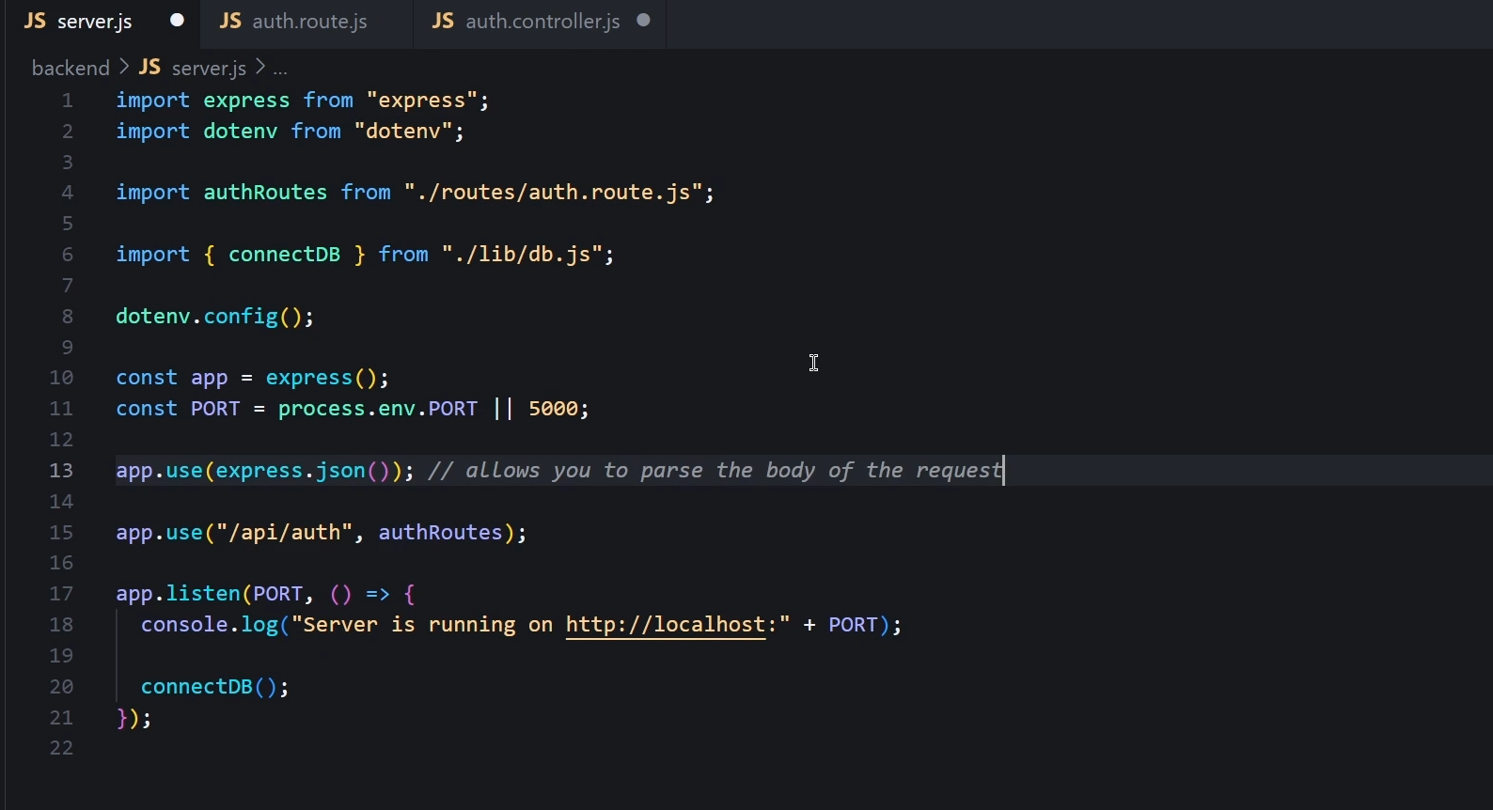
now write the logic for signup
import the schema
get the details from the body
find whether he exists or not
if exists retrun an error
if not we can save hiim to the databae
now send a code for successful additn in the databae

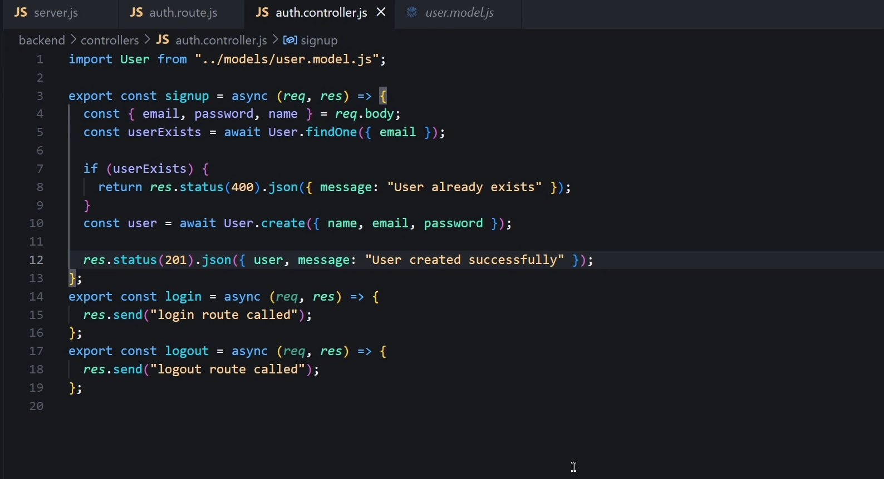
now test it with postman

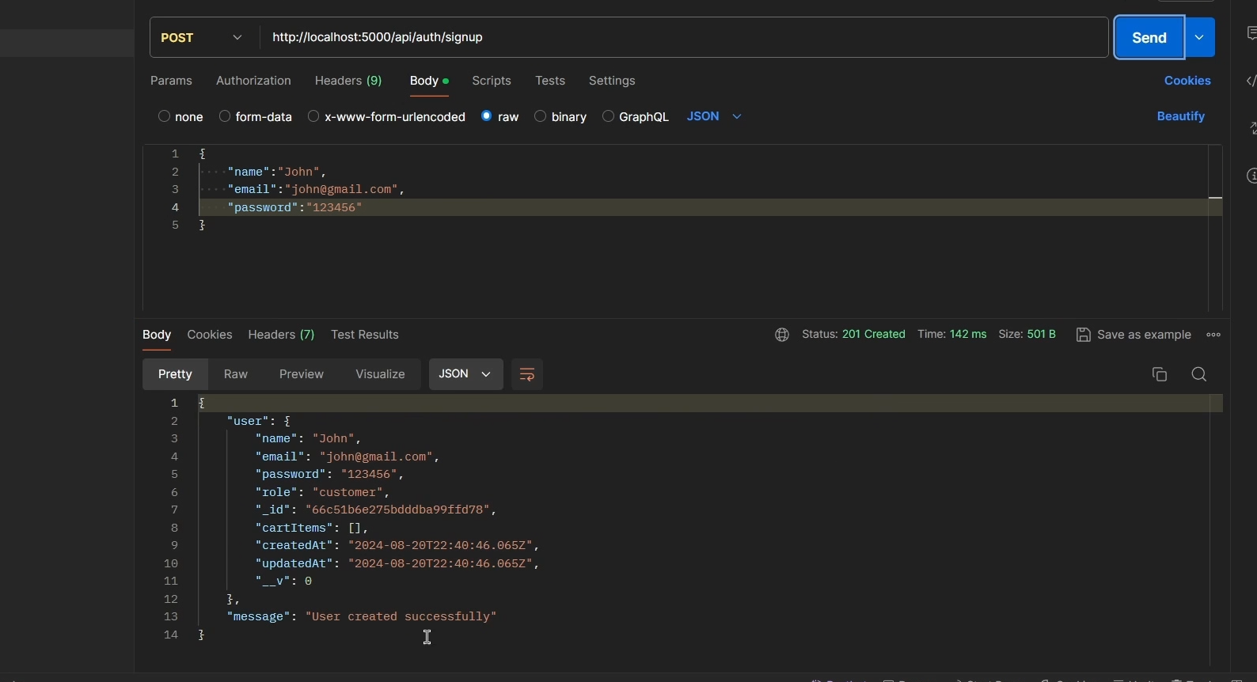
DATABASE IMAGE

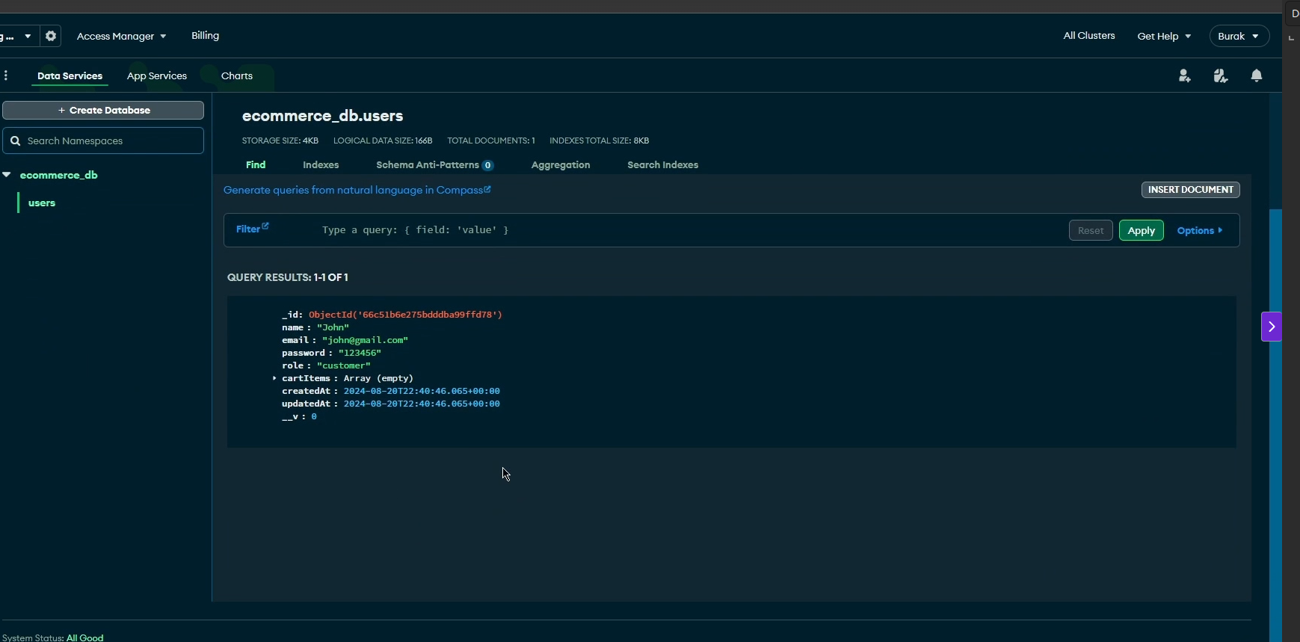
password didn’t get hased

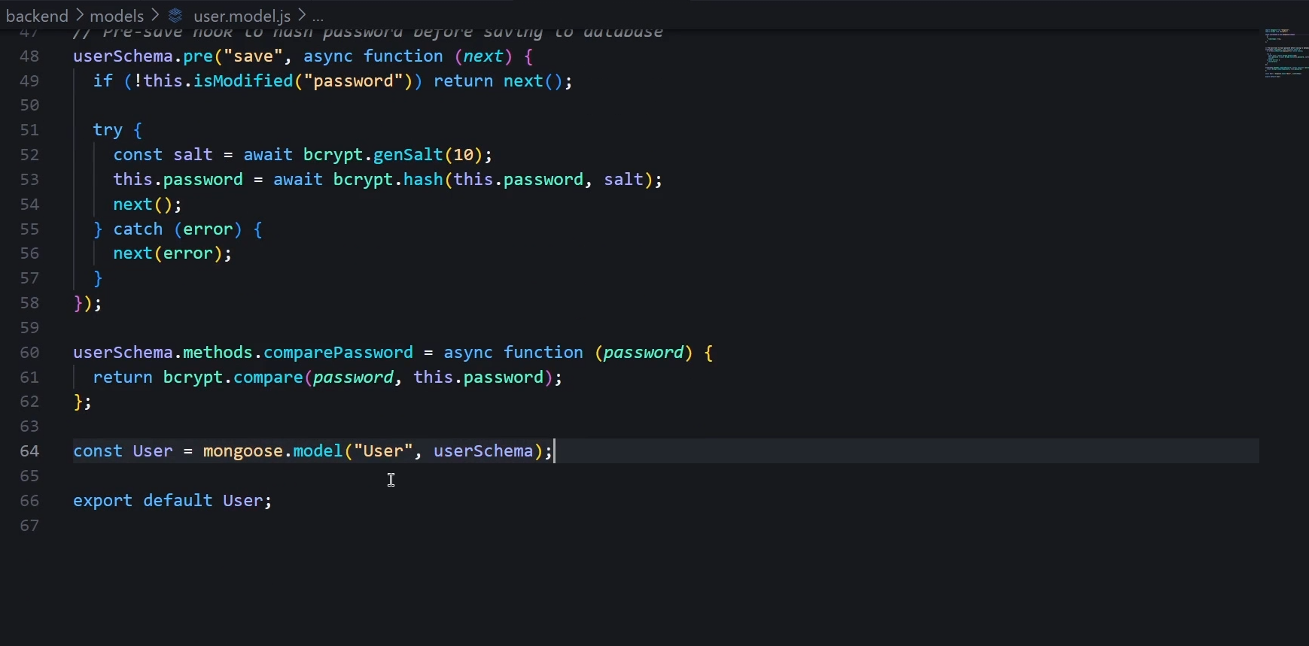
it should be in this order

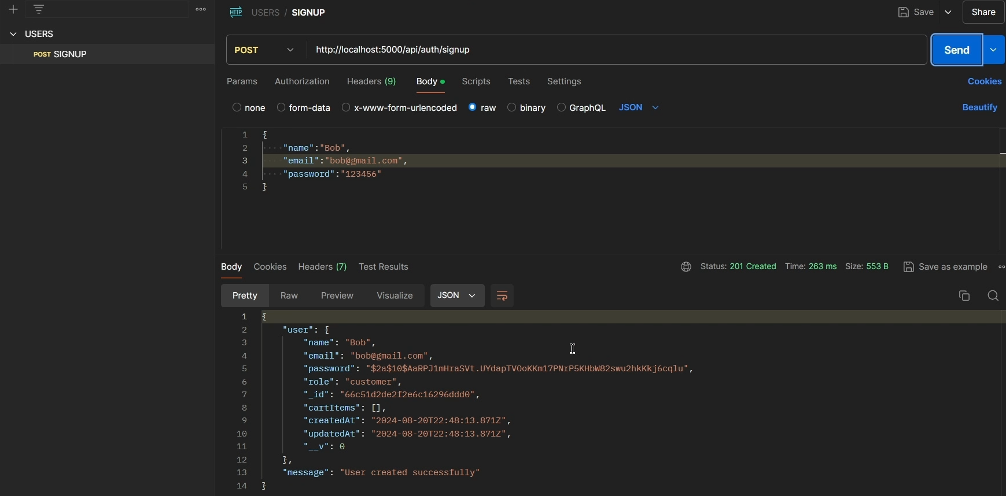
now it is getting hashed

now here we didn’t authenticate the user hence we have to authenticate the user authentication is done by jsonwebtokens (access token and refresh token ) and for this we are using a third party upstash redis (which is a super fats cache memory )

1)create a database
2)connnect with node
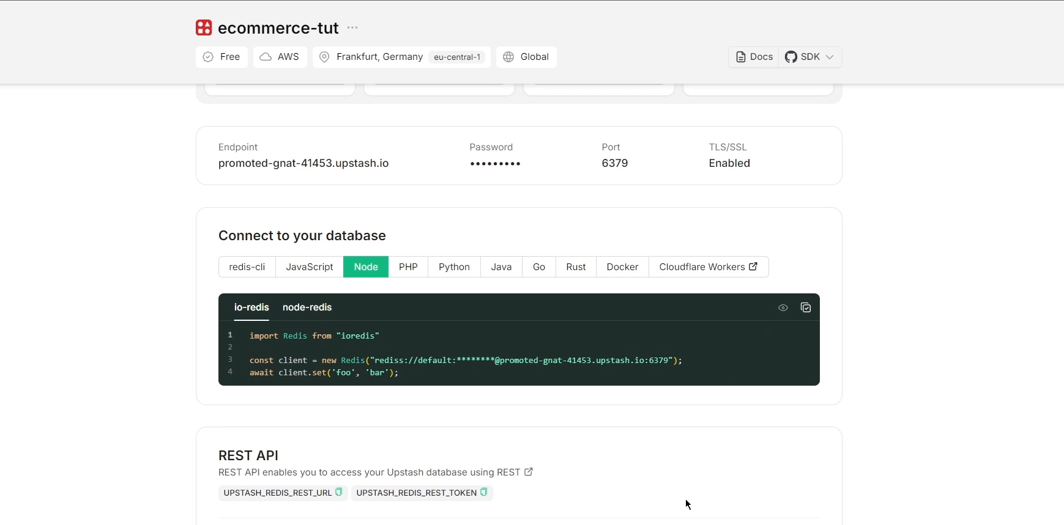
then
3)under the lib create the file redis.js and paste the code

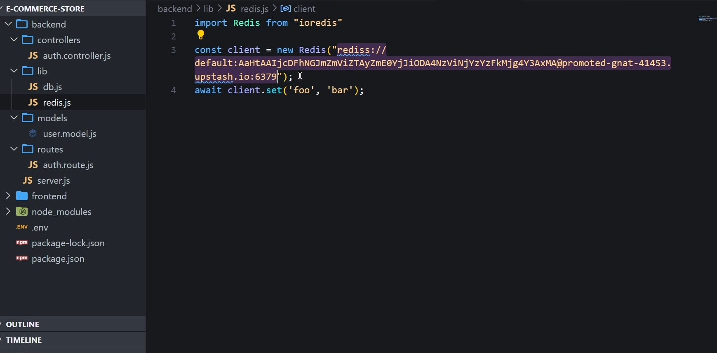
now
set it up in env variable
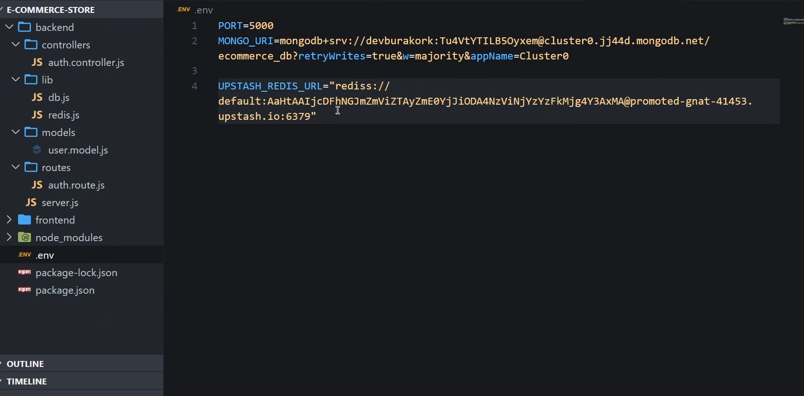

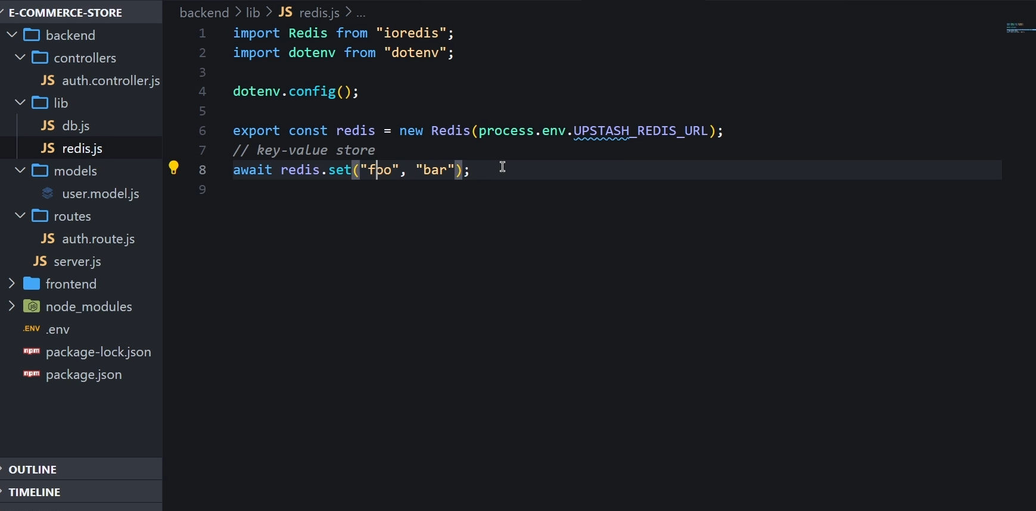
then to run the redis exclusively type

node .\backend\lib\redis.js

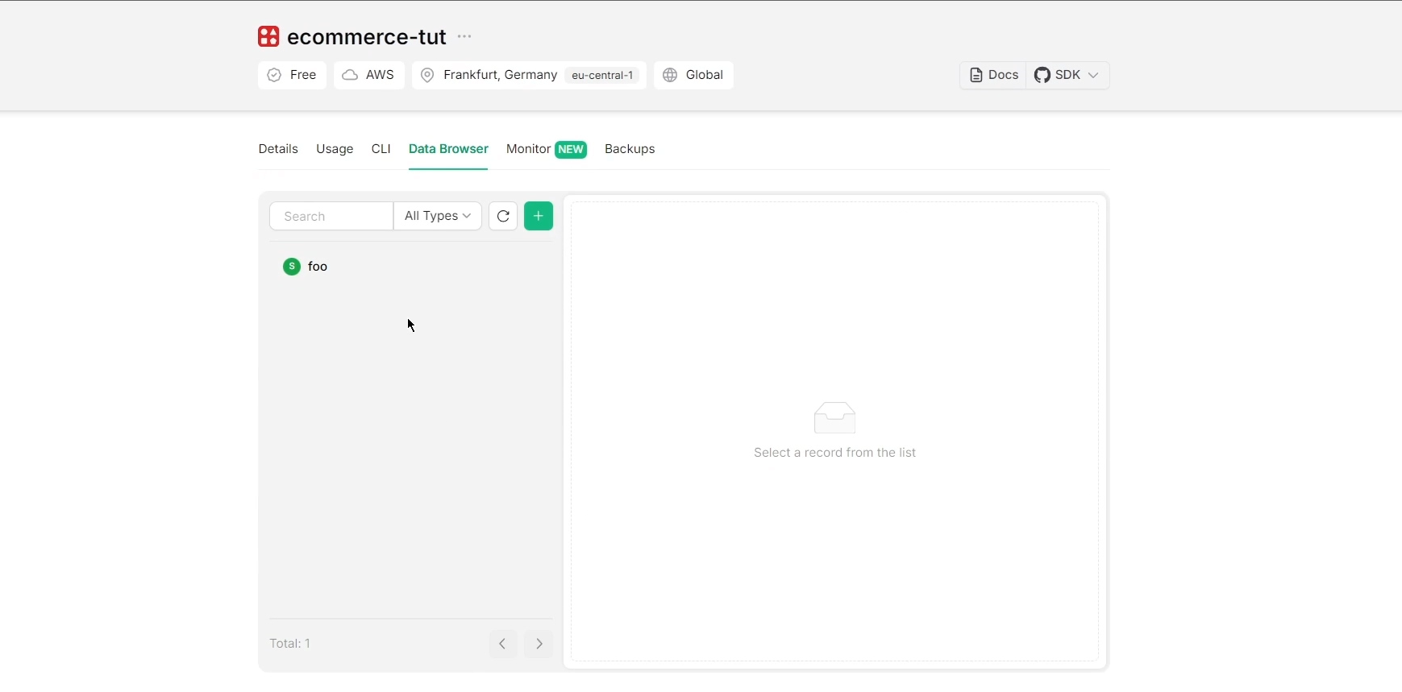

deletee some of the content in redis.js

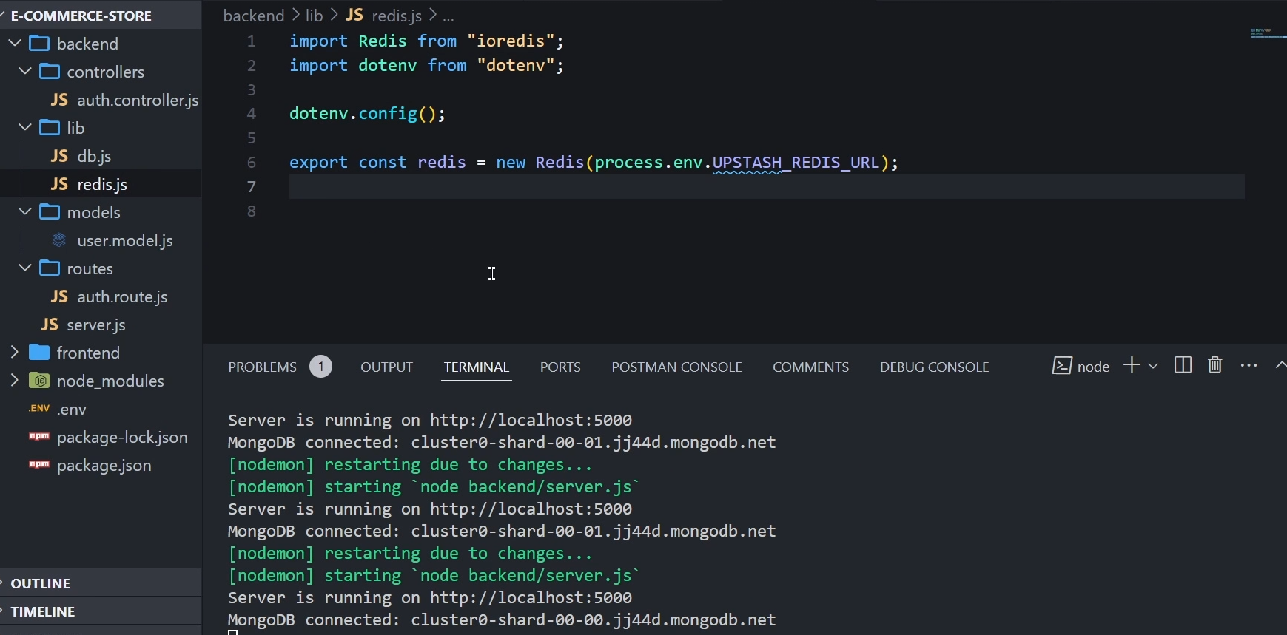
it is time to authenticate this user now

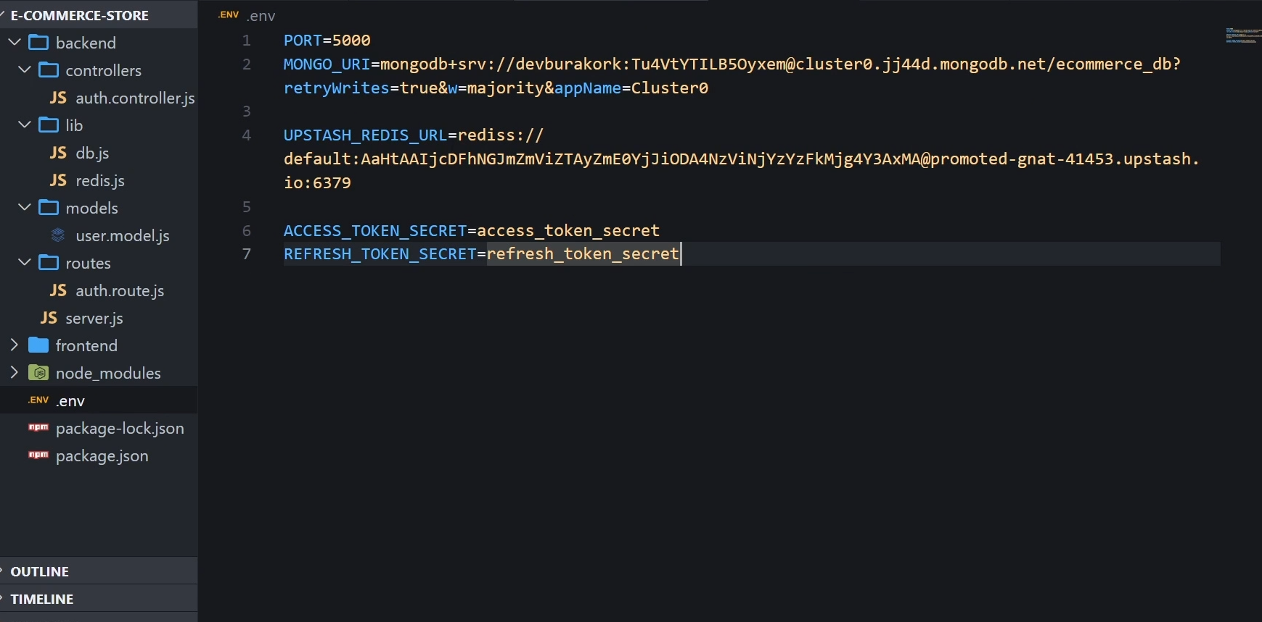
now

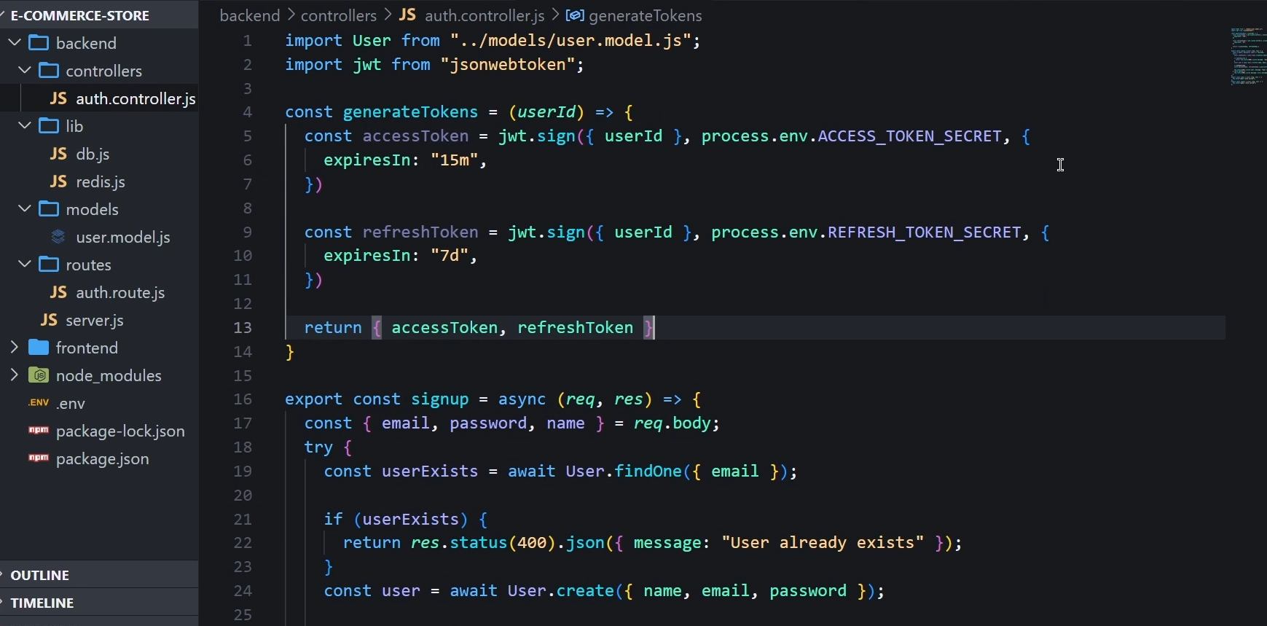
now store the refresh token in the redi databse

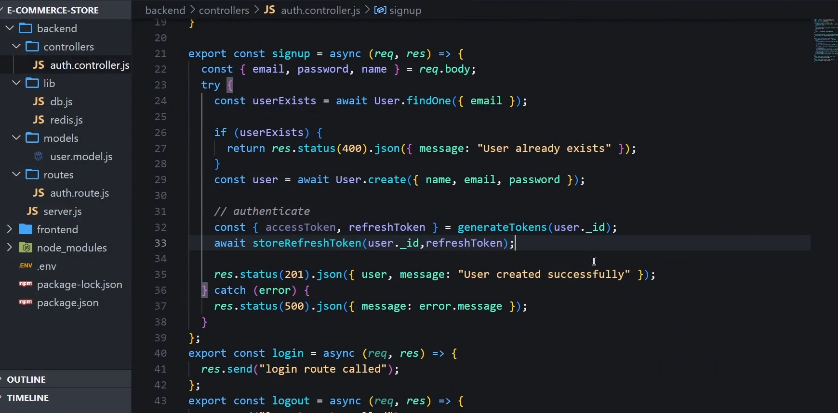
now after storing what

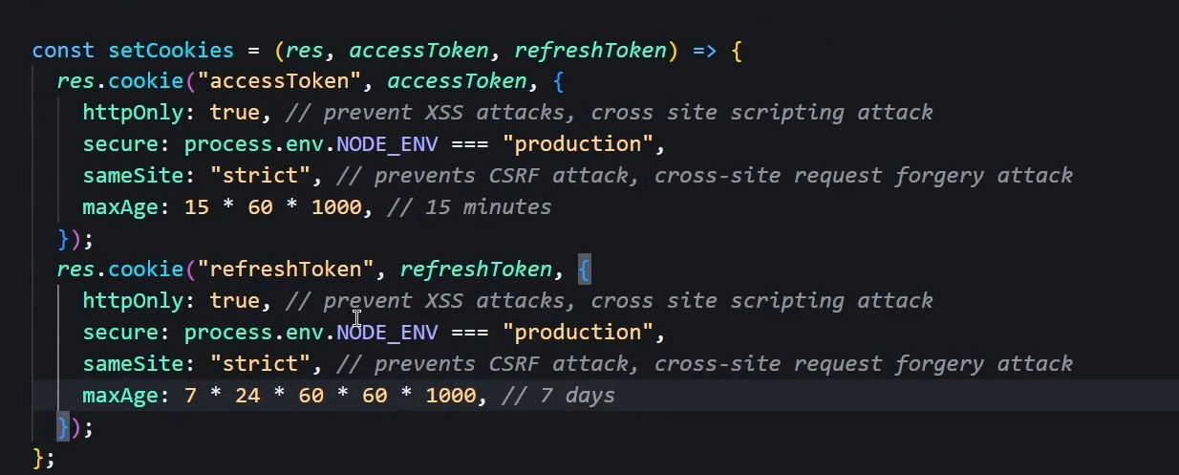
now we will get cookies

complete code snippet

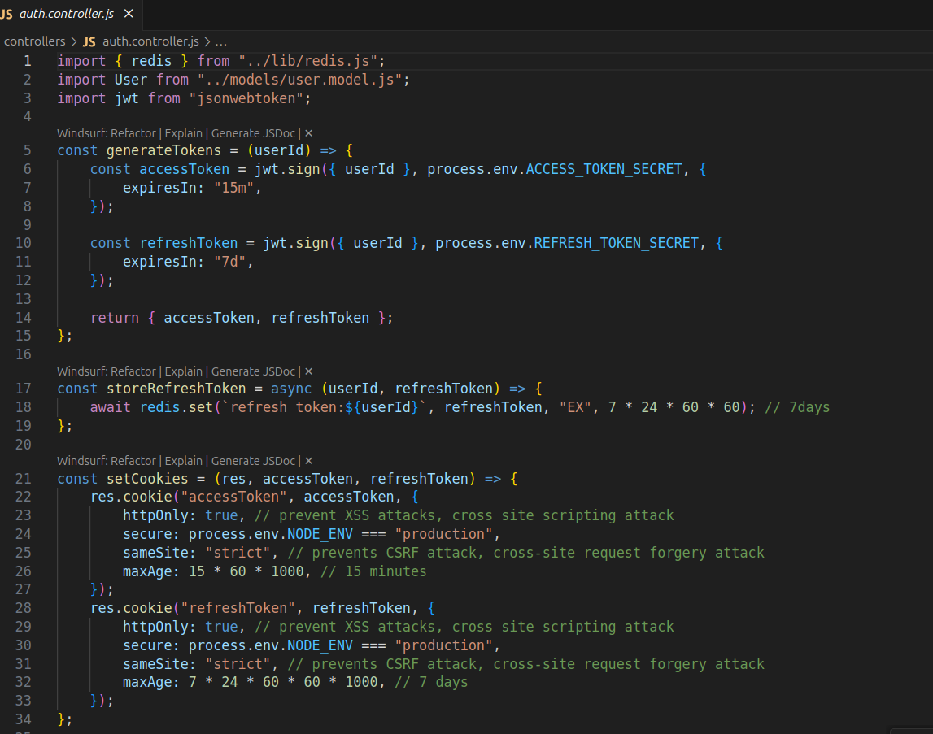

signup



