CH3 _PART3 _LOGIN AND LOGOUT

change server.js

1)import cookie parser and app.use(cookieParser())

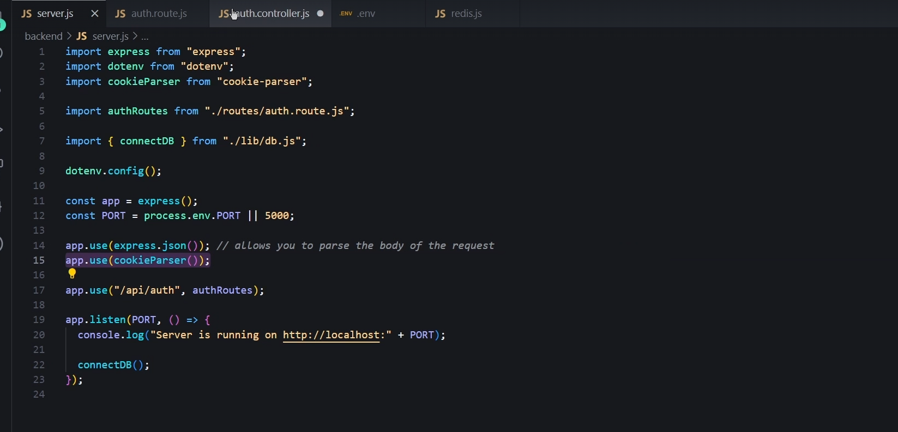
to access cookies we do it
now lets implement the refresh token

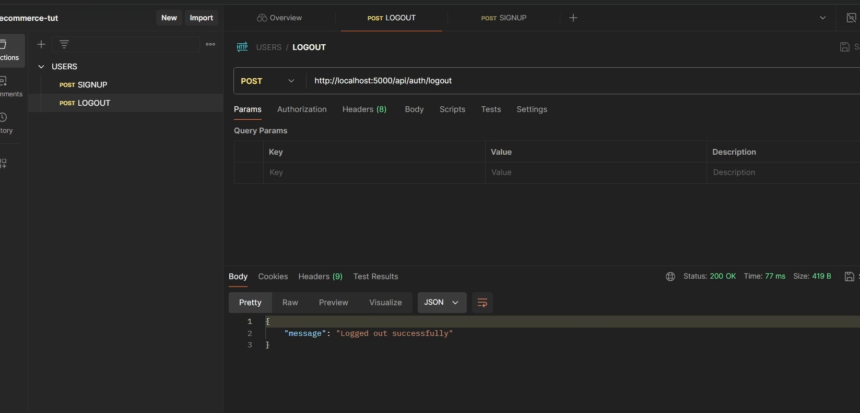
here logged out successfully

redis one will also be deleted

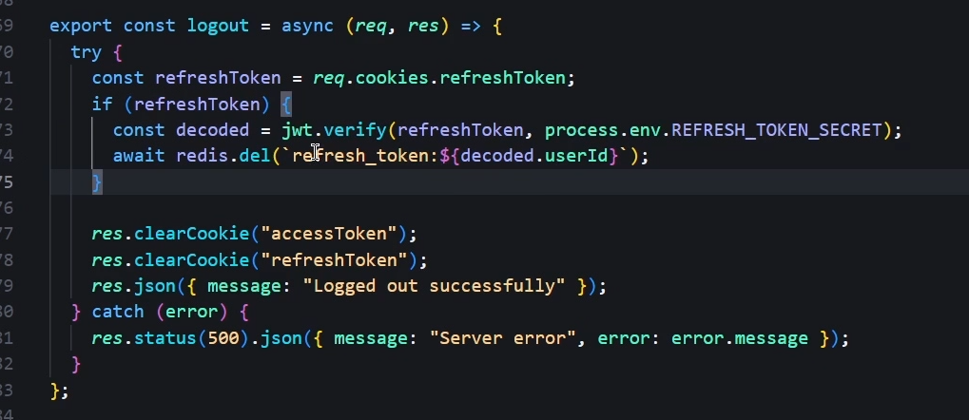
logout code snippet

NOW LOGIN PART

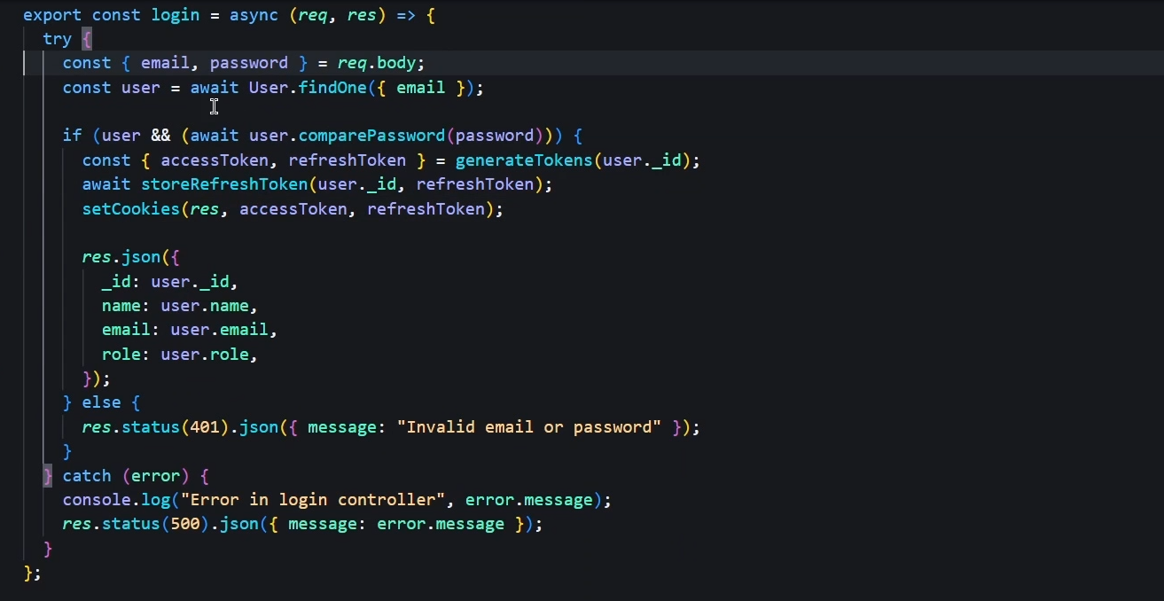
hes doing something more

