Part 1: delayPlusPropModel
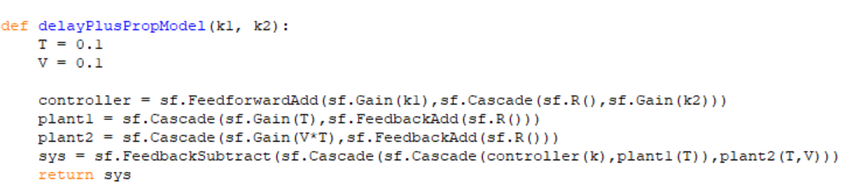
Part 2: Gains
