Part 1: anglePlusPropModel
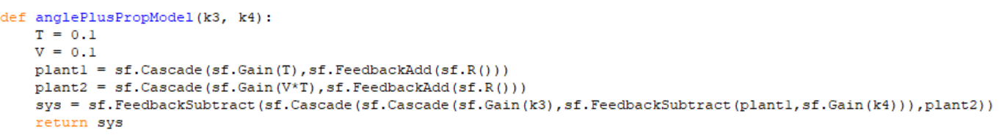
Part 2: Gains
