**Project Name : UDEMY**



Overview : Online learning platform consists of free and paid courses containing millions of courses in different domains.

Homepage :

* Logo
* Search bar
* Icons : My Learning, wishlist, cart, notification, profile
* Different domains of courses
* Image
* Top picks
* Recommended Courses
* Featured Topics
* other companies logo
* Become an instructor
* Footer : Udemy business, About us, Contact us, Career, Help & Support, Terms, Privacy policy, udemy logo.

Signup Page:

* Name
* Email
* Password
* Signup button

Login Page:

* Continue with Google
* Continue with facebook
* Continue with apple
* Email
* Password
* Login
* Forgot password

Become an instructor:

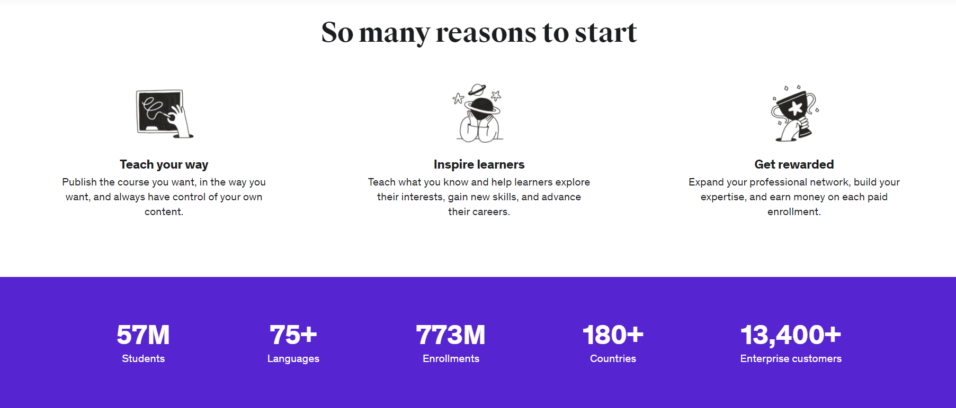

* Footer

About Us:



Contact Us:



Help & Support:

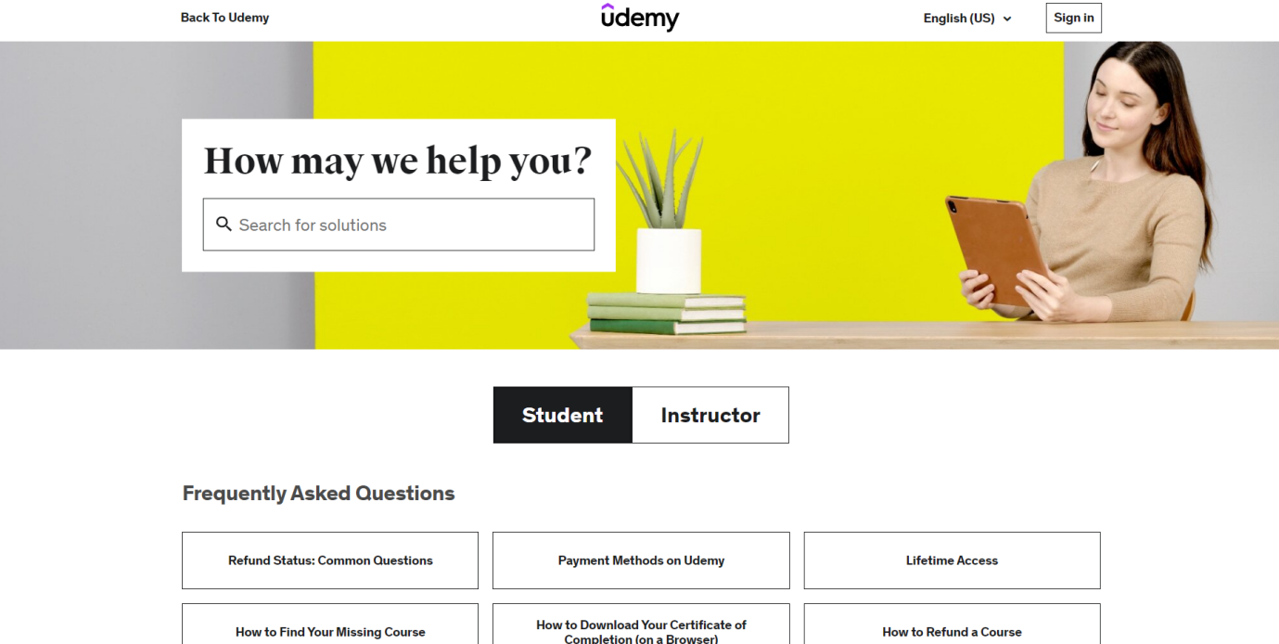

*https://github.com/sun-shine-57/udemydoc/blob/main/doc/project_doc.docx*